@startuml

class Transmitter
class Object
class ObjectManager
class PowerPlug
class Heater
class Thermostat
class OCC
class ZWaveController
class BDCC
class RACC
class Socket

class Object{
void run()
abstract readFile()
abstract writeFile()
}

class ObjectManager{
void stop()
}

class Heater{
readFile()
}

class Thermostat{
readFile()
}

class PowerPlug{
readFile()
}

class RACC{
void receiveOrder()
}

class Transmitter{
void executOrder()
void extractOrder()
}

Transmitter -up->ObjectManager
ObjectManager -right->OCC
OCC-right->ZWaveController
ObjectManager-up->Object

Object-up-|>Heater
Object-up-|>PowerPlug
Object-up-|>Thermostat

Transmitter--|>ObserverA
Transmitter-left->BDCC
BDCC--|>ObservableA
ObservableA-->ObserverA

Transmitter-right->RACC
RACC--|>ObserverB
RACC-->Socket
Socket--|>ObservableB
ObservableB-right->ObserverB
RACC--|>ObservableA

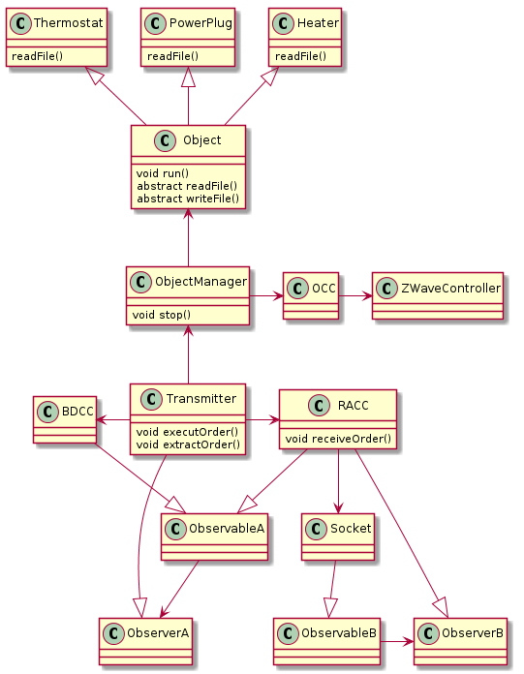
@enduml

