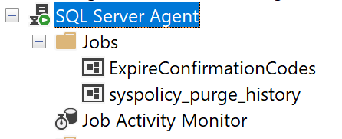

Пкм по агенту – start, new – job и ввести название “ExpireConfirmationCodes”

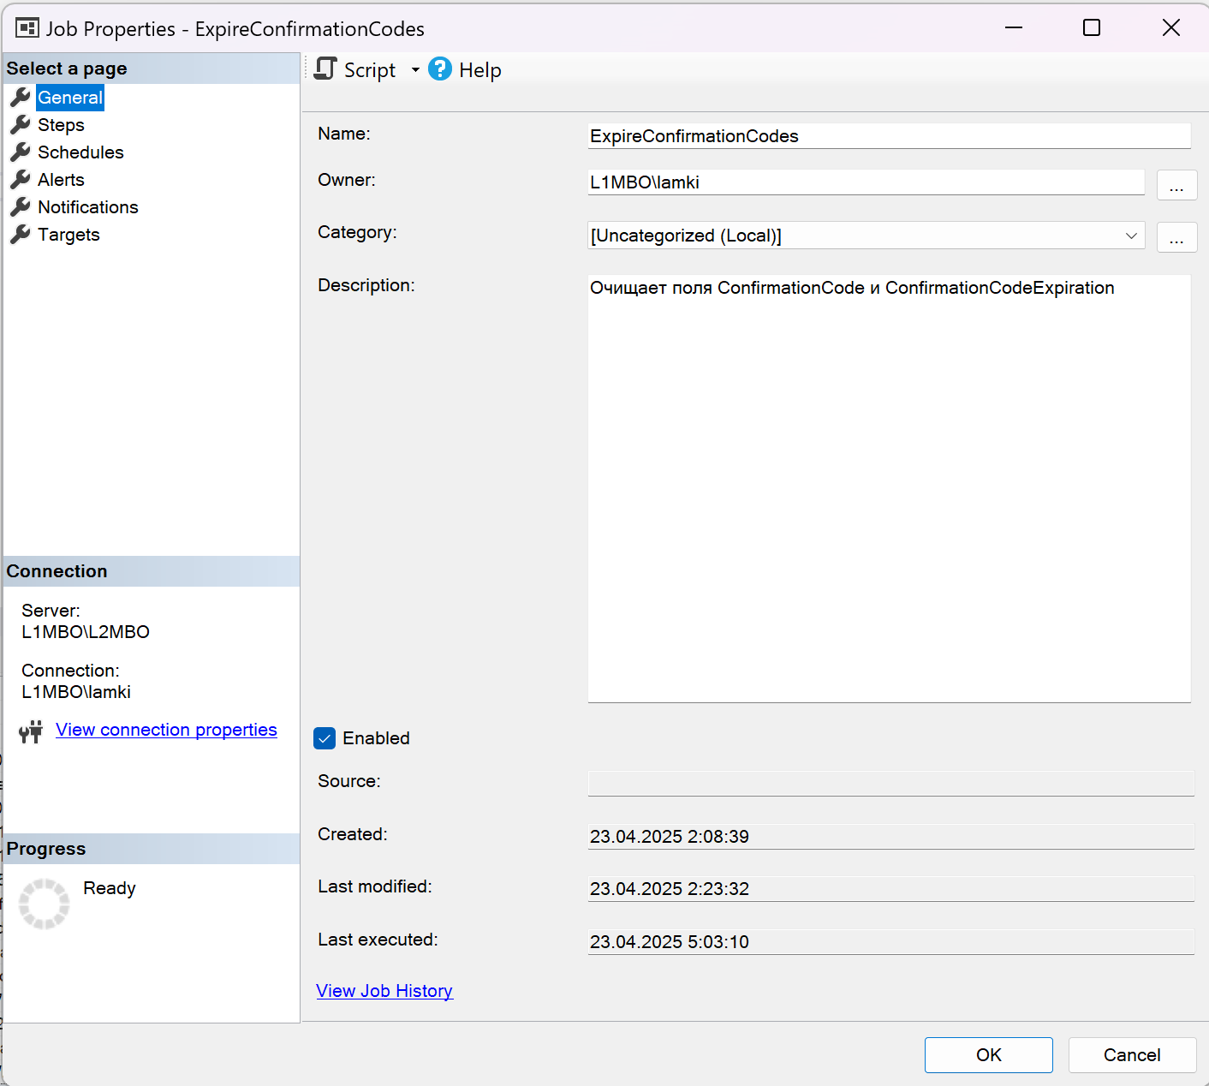

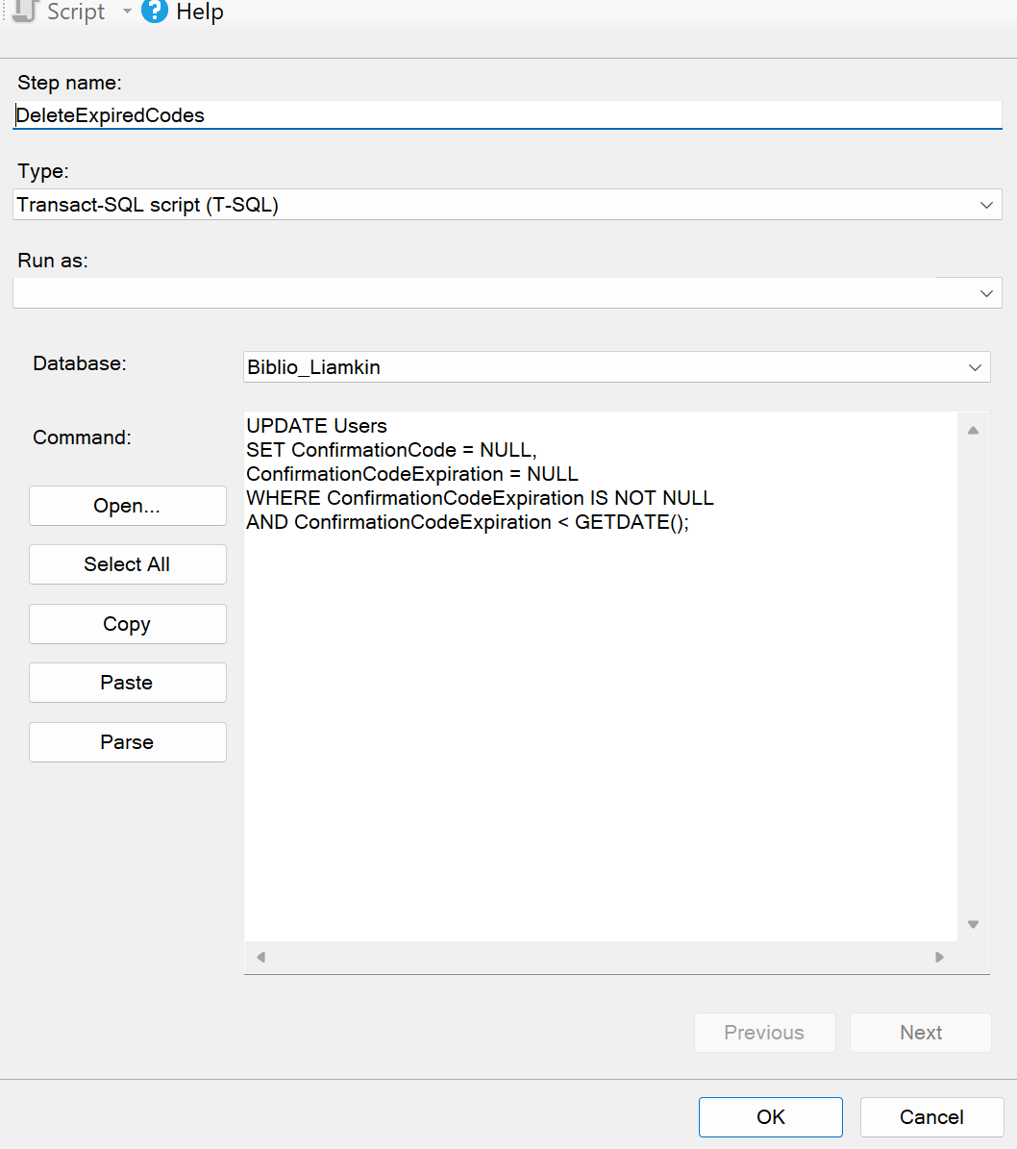

UPDATE Users

SET ConfirmationCode = NULL,

ConfirmationCodeExpiration = NULL

WHERE ConfirmationCodeExpiration IS NOT NULL

AND ConfirmationCodeExpiration < GETDATE();

