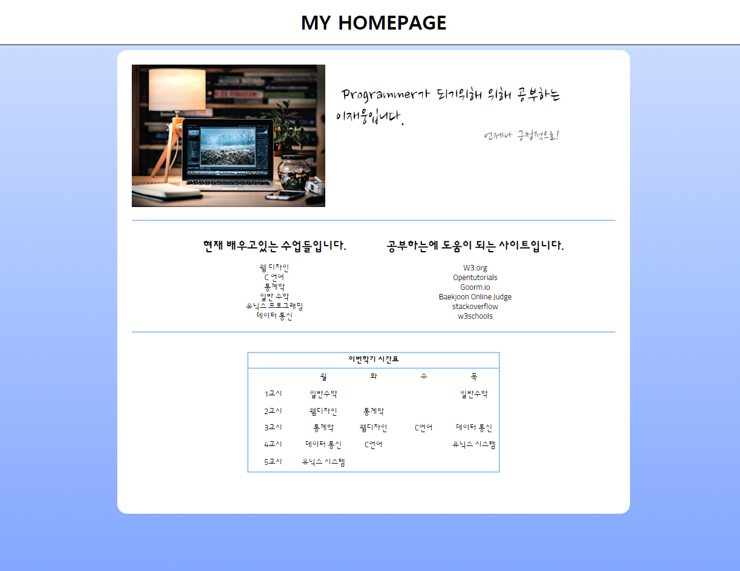

**css_num1을 적용한 홈페이지 입니다.**

**<!—첫번째 html파일-->**

<!DOCTYPE html>

<html>

<head>

<title>My HomePage</title>

<link rel="stylesheet" href="css_num1.css">

<link href="https://fonts.googleapis.com/css?family=Nanum+Brush+Script|Sunflower:300" rel="stylesheet">

</head>

<body>

<h1>MY HOMEPAGE</h1>

<div class="container">

<div class="img">

<img src="pic.jpg" width="400px">

<p><span>&nbsp;&nbsp;&nbsp;Programmer가 되기위해 위해 공부하는<br>&nbsp;&nbsp;이재웅입니다.</span><br><span id="sub">언제나 긍정적으로!</span></p>

</div>

<div class="container2">

<ul>

<h2>현재 배우고있는 수업들입니다.</h2>

<li>웹 디자인</li>

<li>C 언어</li>

<li>통계학</li>

<li>일반 수학</li>

<li>유닉스 프로그래밍</li>

<li>데이터 통신</li>

</ul>

<ul>

<h2>공부하는에 도움이 되는 사이트입니다.</h2>

<li><a href="https://www.w3.org">W3.org</a></li>

<li><a href="https://opentutorials.org/course/1">Opentutorials</a></li>

<li><a href="https://ide.goorm.io/">Goorm.io</a></li>

<li><a href="https://www.acmicpc.net/">Baekjoon Online Judge</a></li>

<li><a href="https://stackoverflow.com/">stackoverflow</a></li>

<li><a href="https://www.w3schools.com/">w3schools</a></li>

</ul>

</div>

<br><br>

<table border="1">

<tr>

<th colspan="5">이번학기 시간표</th>

</tr>

<tr>

<td>&nbsp;</td>

<td>월</td>

<td>화</td>

<td>수</td>

<td>목</td>

</tr>

<tr>

<td>1교시</td>

<td>일반수학</td>

<td>&nbsp;</td>

<td>&nbsp;</td>

<td>일반수학</td>

</tr>

<tr>

<td>2교시</td>

<td>웹디자인</td>

<td>통계학</td>

<td>&nbsp;</td>

<td>&nbsp;</td>

</tr>

<tr>

<td>3교시</td>

<td>통계학</td>

<td>웹디자인</td>

<td>C언어</td>

<td>데이터 통신</td>

</tr>

<tr>

<td>4교시</td>

<td>데이터 통신</td>

<td>C언어</td>

<td>&nbsp;</td>

<td>유닉스 시스템</td>

</tr>

<tr>

<td>5교시</td>

<td>유닉스 시스템</td>

<td>&nbsp;</td>

<td>&nbsp;</td>

<td>&nbsp;</td>

</tr>

</table>

</div>

</body>

</html>

**<!—첫번째 css파일(css_num1) -->**

body {

margin: 0px;

background: rgb(133, 175, 255);

background: linear-gradient(0deg, rgba(133, 175, 255, 1) 0%, rgba(210, 228, 255, 1) 100%);

height: 1200px;

}

p {

font-family: 'Nanum Brush Script', cursive;

font-size: 40px;

float: right;

}

h1 {

text-align: center;

border-bottom: 2px solid gray;

padding: 20px 0px 20px 0px;

background-color: white;

margin: 0px;

font-size: 40px;

}

ul {

display: inline-block;

list-style: none;

margin: 20px;

}

table {

text-align: center;

}

.img {

float: left;

margin-bottom: 20px;

}

.container {

font-family: 'Sunflower', sans-serif;

background-color: white;

width: 1000px;

height: 900px;

margin: auto;

padding: 30px;

margin-top: 10px;

border-radius: 20px;

}

.text1 {

font-size: 30px;

font-family: 'Black Han Sans', sans-serif;

}

.container2 {

text-align: center;

clear: both;

border-top: 2px solid #99ccff;

border-bottom: 2px solid #99ccff;

}

a {

text-decoration: none;

color: black;

}

table {

margin: auto;

height: 250px;

border: 2px solid #99ccff;

}

td {

width: 100px;

border: 0px;

}

th {

border: 0px;

border-bottom: 3px solid #99ccff;

}

#sub {

font-size: 30px;

color: gray;

float: right;

}

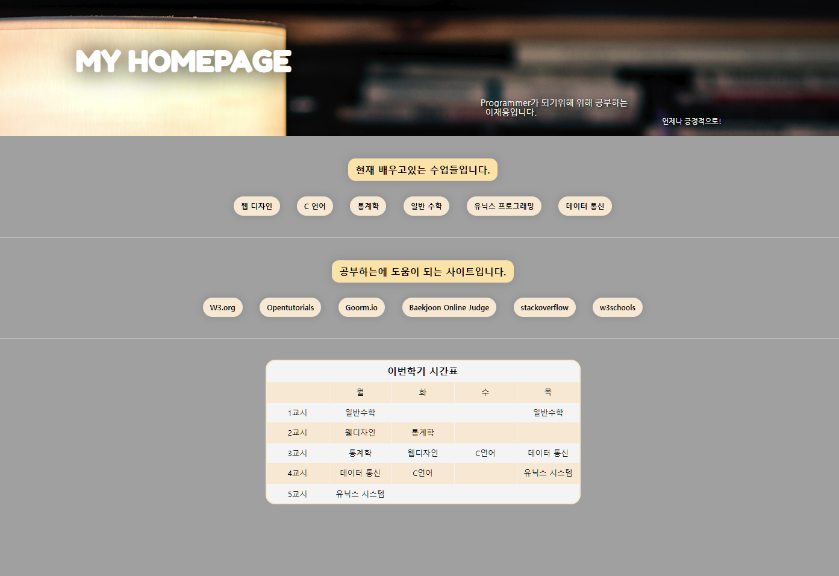**.**

**css_num2를 적용한 홈페이지입니다**

**<!—두번째 html파일 -->**

<!DOCTYPE html>

<html>

<head>

<title>My HomePage</title>

<link rel="stylesheet" href="css_num2.css">

<link href="https://fonts.googleapis.com/css?family=Fredoka+One|Nanum+Gothic" rel="stylesheet">

</head>

<body>

<div class="main">

<h1>MY HOMEPAGE</h1>

<p><span>Programmer가 되기위해 위해 공부하는<br>&nbsp;&nbsp;이재웅입니다.</span><br>

<span id="sub">언제나 긍정적으로!</span></p>

</div>

<ul>

<h2>현재 배우고있는 수업들입니다.</h2><br>

<li>웹 디자인</li>

<li>C 언어</li>

<li>통계학</li>

<li>일반 수학</li>

<li>유닉스 프로그래밍</li>

<li>데이터 통신</li>

</ul>

<ul>

<h2>공부하는에 도움이 되는 사이트입니다.</h2><br>

<li><a href="https://www.w3.org">W3.org</a></li>

<li><a href="https://opentutorials.org/course/1">Opentutorials</a></li>

<li><a href="https://ide.goorm.io/">Goorm.io</a></li>

<li><a href="https://www.acmicpc.net/">Baekjoon Online Judge</a></li>

<li><a href="https://stackoverflow.com/">stackoverflow</a></li>

<li><a href="https://www.w3schools.com/">w3schools</a></li>

</ul>

<br><br>

<table border="1">

<tr>

<th colspan="5">이번학기 시간표</th>

</tr>

<tr id="color">

<td>&nbsp;</td>

<td>월</td>

<td>화</td>

<td>수</td>

<td>목</td>

</tr>

<tr>

<td>1교시</td>

<td>일반수학</td>

<td>&nbsp;</td>

<td>&nbsp;</td>

<td>일반수학</td>

</tr>

<tr id="color">

<td>2교시</td>

<td>웹디자인</td>

<td>통계학</td>

<td>&nbsp;</td>

<td>&nbsp;</td>

</tr>

<tr>

<td>3교시</td>

<td>통계학</td>

<td>웹디자인</td>

<td>C언어</td>

<td>데이터 통신</td>

</tr>

<tr id="color">

<td>4교시</td>

<td>데이터 통신</td>

<td>C언어</td>

<td>&nbsp;</td>

<td>유닉스 시스템</td>

</tr>

<tr>

<td>5교시</td>

<td>유닉스 시스템</td>

<td>&nbsp;</td>

<td>&nbsp;</td>

<td>&nbsp;</td>

</tr>

</table>

</body>

</html>

**<!—en번째 css파일(css_num2) -->**

body {

border: 0px;

margin: 0px;

background-color: darkgray;

}

.main {

background-image: url("pic.jpg");

background-size: cover;

}

h1 {

padding: 100px 0 0px 20%;

font-size: 60px;

margin: 0px;

color: white;

text-shadow: 3px 3px 50px #000000;

font-family: 'Fredoka One', cursive;

}

p {

padding: 40px 0px 40px 55%;

font-size: 18px;

margin: 0px;

color: white;

text-shadow: 3px 3px 5px #000000;

font-family: 'Nanum Gothic', sans-serif;

width: 500px;

}

#sub {

font-size: 15px;

float: right;

}

ul {

display: block;

margin: auto;

padding: 30px 60px;

width: 70%;

border-bottom: 1px solid antiquewhite;

text-align: center;

}

h2 {

display: inline-block;

background-color: #FfE5Af;

padding: 10px 15px;

border-radius: 15px;

box-shadow: 0px 0px 20px 3px rgba(0, 0, 0, 0.1);

font-size: 20px;

}

li {

padding: 10px 15px;

margin: 15px;

display: inline-block;

font-size: 15px;

border-radius: 20px;

box-shadow: 0px 0px 15px 3px rgba(0, 0, 0, 0.1);

background-color: antiquewhite;

font-weight: bold;

}

a {

text-decoration: none;

color: black;

}

table {

margin: auto;

height: 300px;

border: 2px solid antiquewhite;

text-align: center;

margin-bottom: 150px;

background-color: whitesmoke;

border-radius: 20px;

}

td {

width: 120px;

border: 0px;

}

th {

border: 0px;

font-size: 20px;

}

#color {

background-color: antiquewhite;

}

#color > td {

border: 3px solid antiquewhite;

}