

**AMITY INSTITUTE OF ENGINEERING**

**AND TECHNOLOGY**

Course Code: CSE2015

**“SOURCE CODE MANAGEMENT”**

**LABORARTORY RECORD**

**Winter 2nd Semester**

**2024 – 25**

**SUBMITTED BY:**

Chandana BR

Btech (CSE)

A86605224237

**LAB EXERCISE:**

The “**PRO GIT**” book provides clear and helpful information about Git.

GIT INSTALLATION:

Download git for Windows from the official site :

<https://git-scm.com/download/win>

After opening Git Bash

#command

$git --version

git version 2.47.1.windows.1

Git Configuration:

#command

$git config user.name “985chandana”

$git config user.email “chandana.r1@s.amity.edu”

$git config user.name



$config user.email



$git config --list

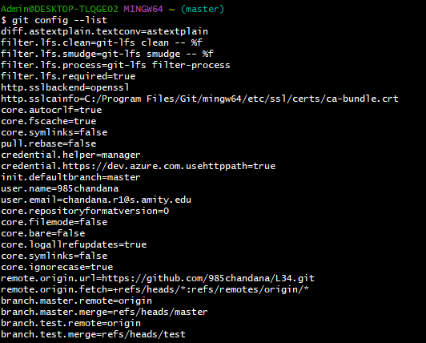

**Managing Files and Directories in git**

#commands

$mkdir 124046

$cd 124046

$vi hello.cpp

$cat hello.cpp

$git init

$git status

$git add hello.cpp

$git status

$git commit -m “It is c++ code on hello world”

$git log

$git log --oneline

#output

$mkdir 124046

$cd 124046

$vi hello.cpp(//After this command we should press I to type anything into the file.To come out of the file we should press Esc and :wq to exit )

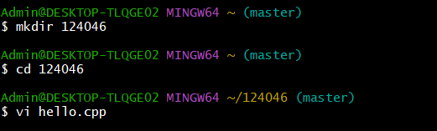

$cat hello.cpp(//It will print or show what ever written in that file)

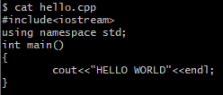

$git init



$ls(It shows the the files)



$git status(It shows the files is tracked or untracked but at present it is untracked)

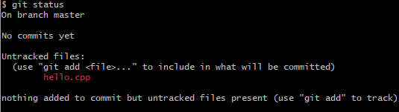

$git add hello.cpp



$git status(Now it is tracked)

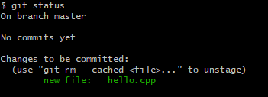

$git commit -m “code on hello world”



$git log(It shows in long format with authour ,date ,time,email)

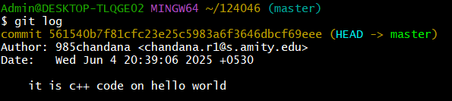

$git log --oneline(It display in short format)

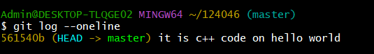

**Creating a branch**

#commands

$git branch

$git branch test

$git checkout test

$vi simple.html

$cat simple.html

$git init

$git status

$git add simple.html

$git status

$git commit -m “simple code in html”

$git log --oneline

#output

$git branch(it shows branch, now we have only one branch master)



$git branch test(It creats one more branch test)

$git branch



$git checkout test (It changes from master to test)

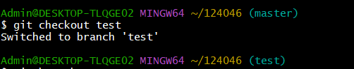

$vi simple.html

$cat simple.html

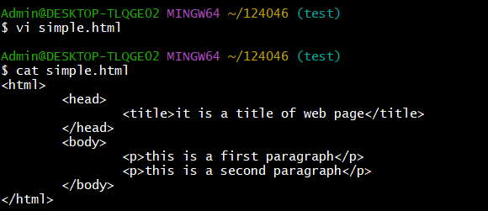

$git init



$git status

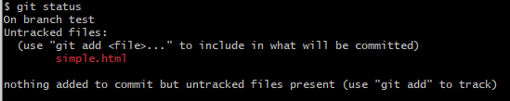

$git add simple.html



$git status

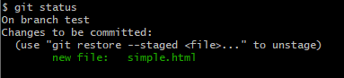

$git commit -m “simple code in html”



$git log --oneline

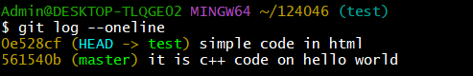

Creating one more file in test branch by using the same commands the output will be:

$vi sum.cpp

$cat sum.cpp

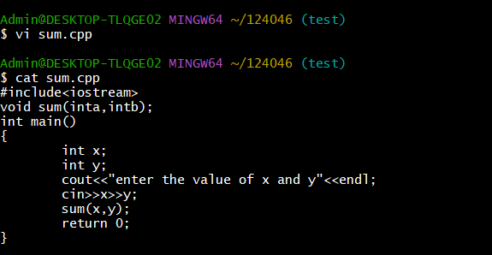

$git add sum.cpp

$git status

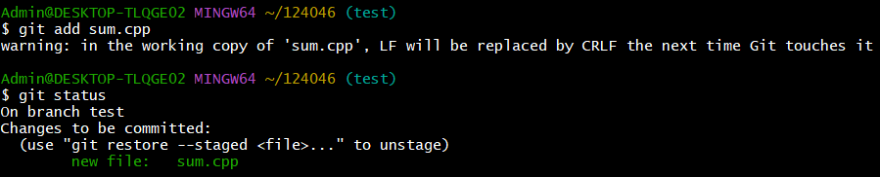

$git commit -m “code on sum of two number”

$git log --oneline

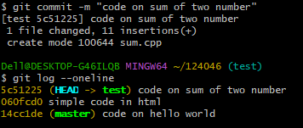

Creating a new repository

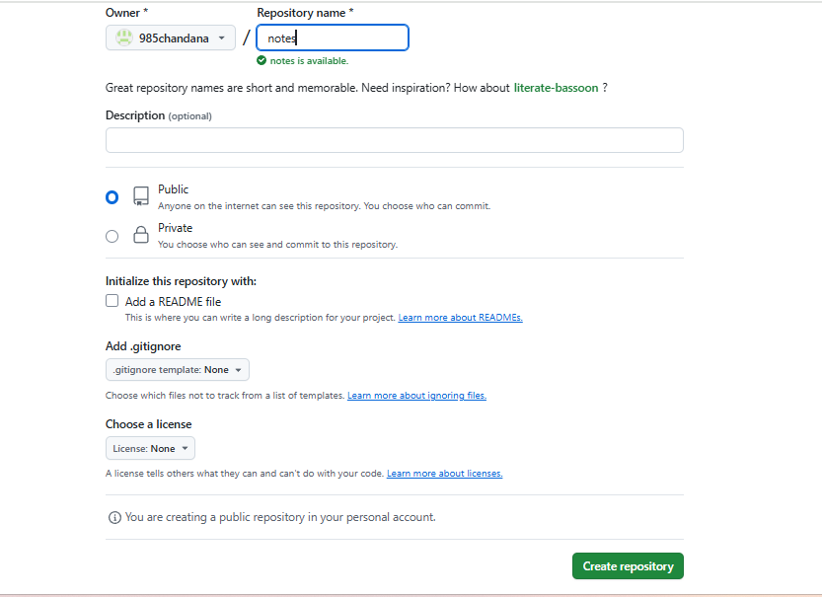

Pushing the files which are in the master and test

#commands

$git remote add origin <https://github.com/985chandana/notes.git>

$git push -u origin master(This is from master)

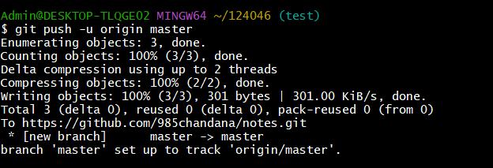

$git push -u origin test

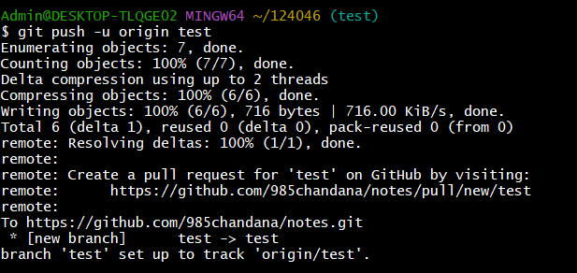

Now the files in master and test will appear on git hub repo in notes after the command git push -u origin test and git push -u origin master

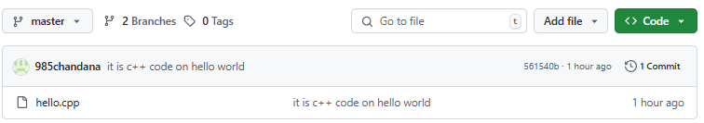

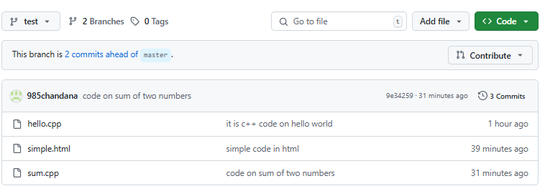

Pull Request:

$git pull https://github.com/985chandana/notes.git

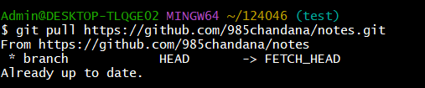

Git diff

It compare the commits or files

$git diff 5c51225 146908c

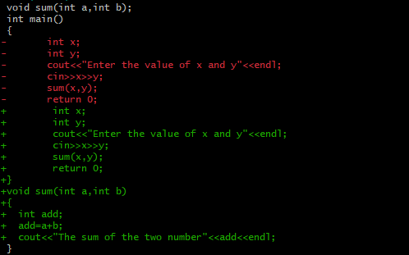

MERGE THE FILES

$git merge

$git conflict master /test

$git mergetool

$git commit -m “merge the file”(After merging the file from two different branch)

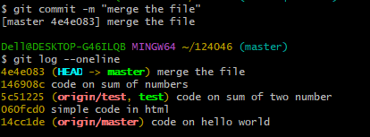

This the file which is merged together

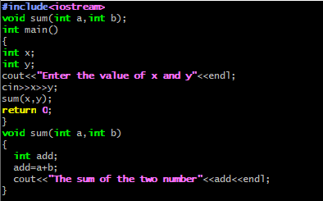

Fork and cloning of the repository

In git hub we should search the repo which should to be fork and cloned

After opening the repo we will get the fork option



We cannot fork our own repository

**CLONE:**

#Commands

$mkdir cloned

$cd cloned

$git clone https://github.com/bhavana428/L34.git

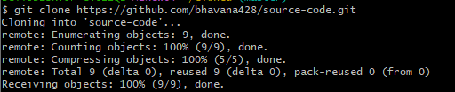

Creating a pull request in git hub:

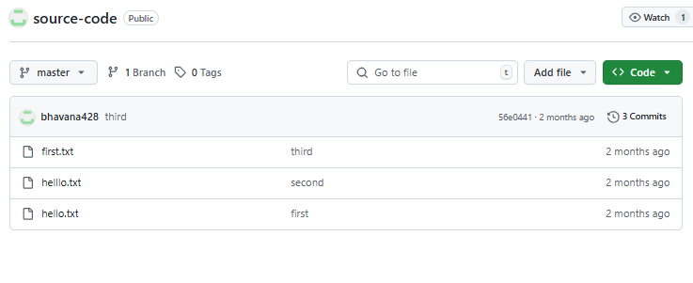

Add file (adding the file name as demo.html we get)

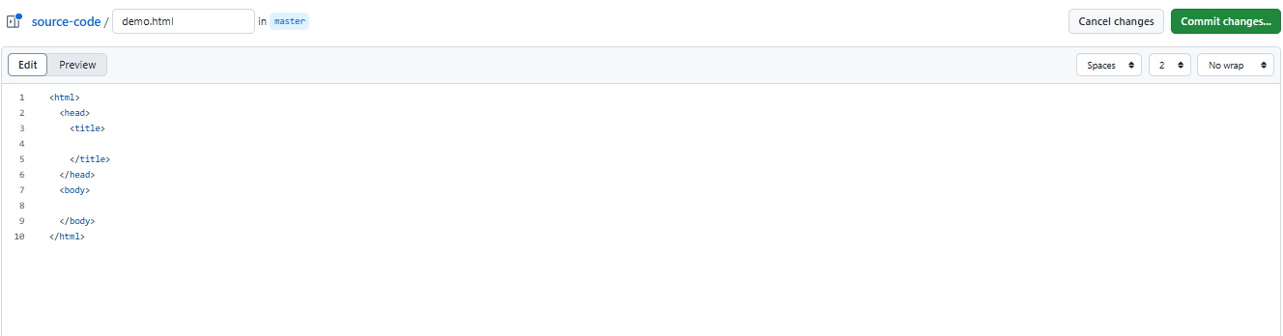

After typing we should commit changes

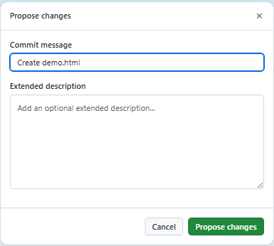

After propose changes we will get option of create pull request

