# Implementatie

Sedric Yaovi Lodonou

Opgesteld op 26/4/2020

Versie 1

Door de … zijn de verschillende oplossingen niet geïmplementeerd,

**Oplossing 1 Bittorent - Implementatie**

### Een ACL list die niks binnen laat via de poorten van bittorent.

# Ip access-list 101 deny tcp ip 10.20.0.0 0.0.255.255 eq 6881-6889

Op de inerface die naar Telenet als belgacon gaat

#conf t

# inter gig 0/2

#Ip access-group 101 in

### Bittorrent blokeren met Nbar

ip cef

  class-map match-any LIMIT-TOR

  match protocol bittorrent

  exit

  policy-map QOS-LIMIT-TOR-POLICY

  class LIMIT-TOR

  police cir 2000000

  confirm-action drop

  exceed-action drop

  exit

  exit

  exit

  int gig 0/1

  ip nbar protocol-discovery

  service-policy input QOS-LIMIT-TOR-POLICY

  service-policy output QOS-LIMIT-TOR-POLICY

### MQC Low Latency (QOS)

Conf t

Class-map Bittorrent

Match protocol bittorent of **match access-group 101** (die vorige access list die we gecreëerd hebben)

Exit

^z

Conf t

Policy-map LLQ_Bittorent

Class Bittorent

Priority percent 1%

Exit

Conf t

Int gig 0/2 (interface naar internet)

Service-output output LLQ_Bittorent

^z

Show policy-map interface gig 0/2

**Oplossing 2 Telephonie / VOIP - Implementatie**

access-list 102 permit udp any any range 16384 32776

class-map match-any LLQ_voip

match access-group 102

match precedence critical

Exit

^z

Conf t

Policy-map LLQ_voip

Class LLQ_voip

bandwidth 3500

priority 3500

set precedence critical

exit

^z

Conf t

Int gig 0/2 (interface naar internet)

Service-output output LLQ_voip

^z

Show policy-map interface gig 0/2

**Oplossing 3 Wachtwoorden- Implementatie**

### Enforce password history

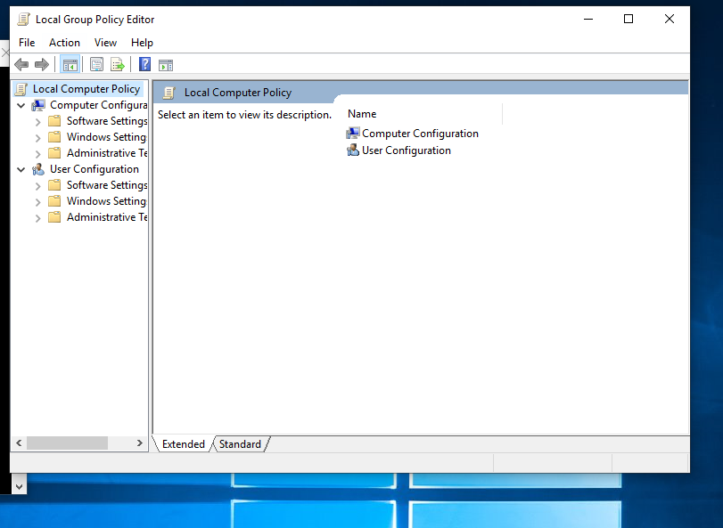

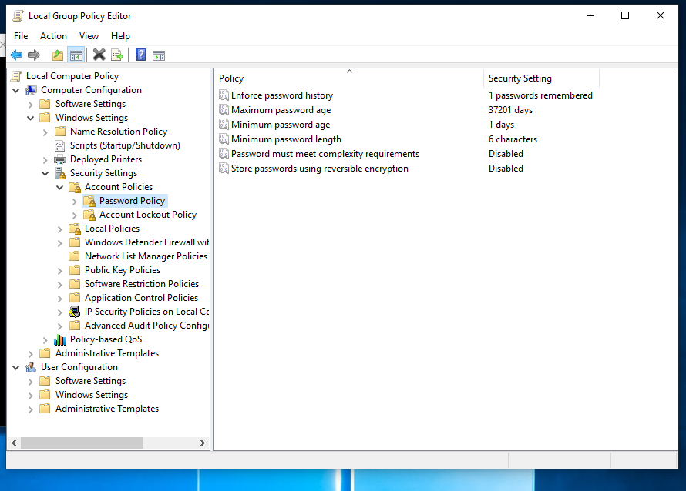

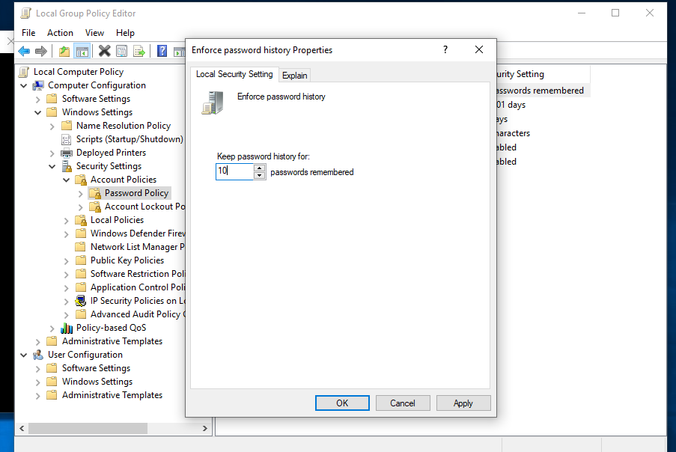

### “Max Password age”

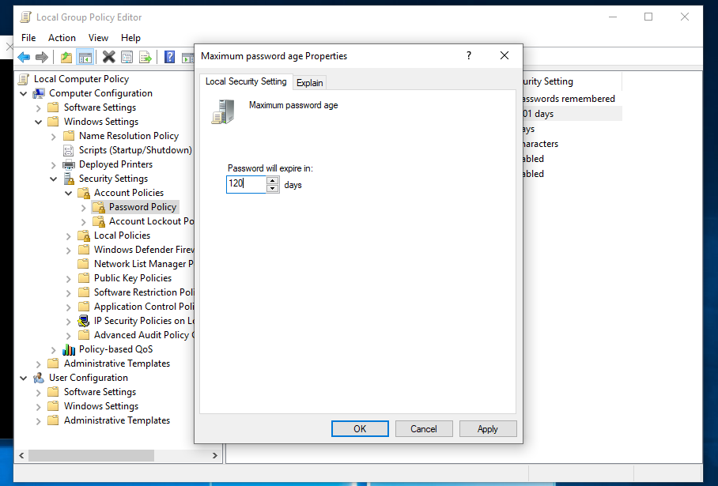

### Min Passwoord age

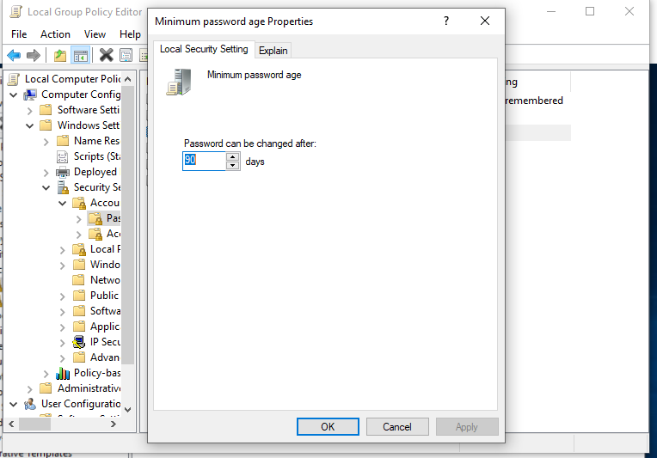

### Min Passwoord Length

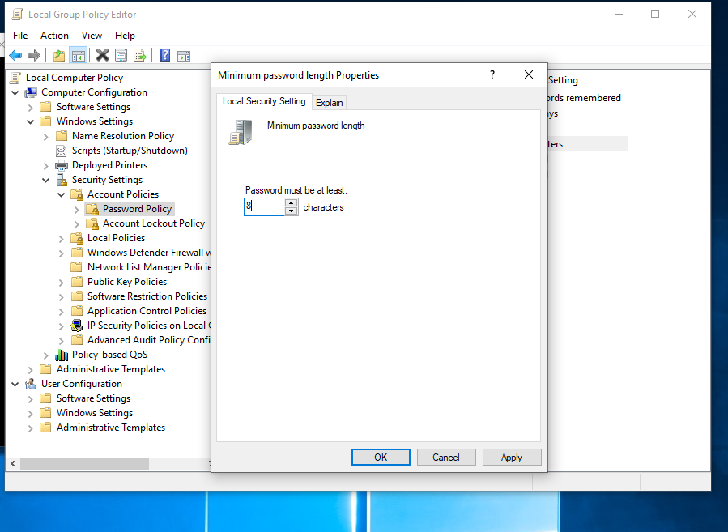

### Password complexity requirement

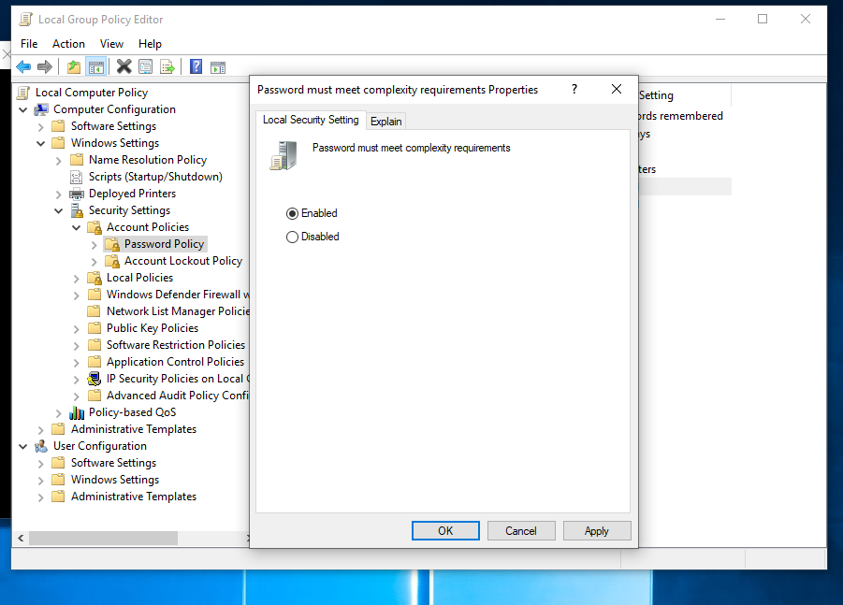

### Account Lockout Threshold

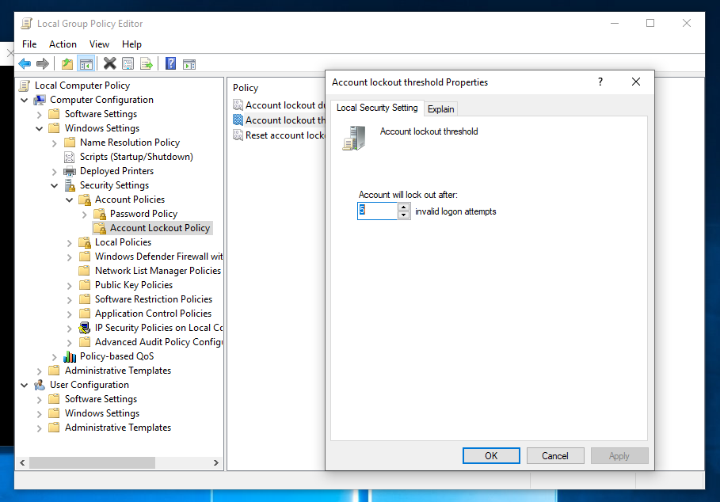

### Account Lockdown Duration

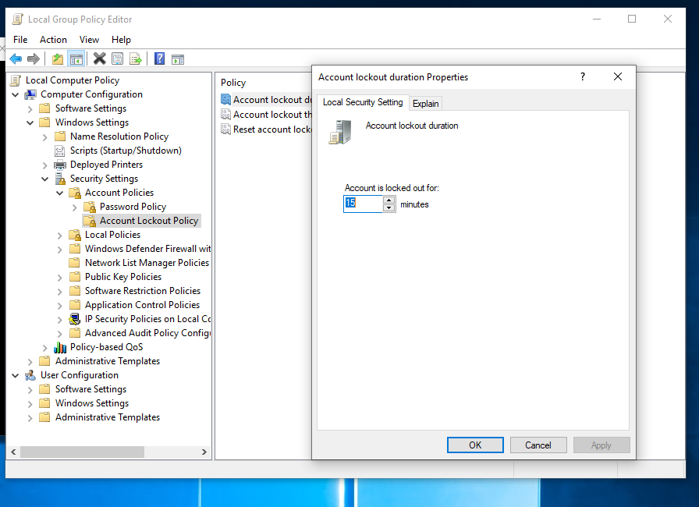

### Reset Lockdown counter

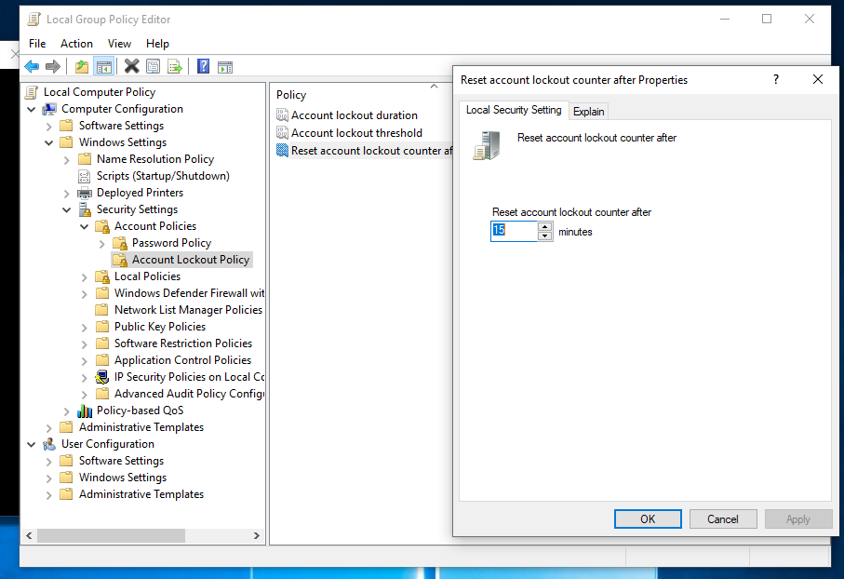

**Oplossing 4.1 Per-Vlan Rapid Spaning Tree(PVST+)- Implementatie**

**LGL-FL1CR-Core-C3560v2-24p-Poe**

*>eneable*

*LGL-FL1CR-Core-C3560v2-24p-Poe#config t*

*LGL-FL1CR-Core-C3560v2-24p-Poe(Config)#spanning-tree mode rapid-pvst*

*LGL-FL1CR-Core-C3560v2-24p-Poe(Config)#spanning-tree vlan 2,10,20,30,40,50,60,70,80,90,99,100,120*

*LGL-FL1CR-Core-C3560v2-24p-Poe(Config)#spanning-tree vlan 20,30,40,50,60,70,100,120 root primary diameter 4*

*LGL-FL1CR-Core-C3560v2-24p-Poe(Config)#spanning-tree vlan 1,2,10,90,99 secondary primary diameter 4*

*LGL-FL1CR-Core-C3560v2-24p-Poe(Config)#end*

**LGL-FL2-A213-Dist-C3560v2-24p-Poe**

*>enable*

*LGL-FL2-A213-Dist-C3560v2-24p-Poe#config t*

*LGL-FL2-A213-Dist-C3560v2-24p-Poe(config)#spanning-tree mode rapid-pvst*

*LGL-FL2-A213-Dist-C3560v2-24p-Poe(Config)#spanning-tree vlan 2,10,20,30,40,50,60,70,80,90,99,100,120*

*LGL-FL2-A213-Dist-C3560v2-24p-Poe(Config)#spanning-tree vlan 20,30,40,50,60,70,100,120 root secondary diameter 4*

*LGL-FL2-A213-Dist-C3560v2-24p-Poe(Config)#spanning-tree vlan 1,2,10,90,99 root primary diameter 4*

*LGL-FL2-A213-Dist-C3560v2-24p-Poe(Config)#end*

**LGL-FL2-A201-C2860-24p**

*>enable*

*LGL-FL2-A201-C2860-24p#Conf t*

*LGL-FL2-A201-C2860-24p(config)#spanning-tree mode rapid-pvst*

*LGL-FL2-A201-C2860-24p(config)#spanning-tree vlan 2,10,20,30,40,50,60,70,80,90,99,100,120*

*LGL-FL2-A201-C2860-24p(config)#end*

**LGL-FL4-FR-SF300-...#**

*LGL-FL4-FR-SF300-...>enable*

*LGL-FL4-FR-SF300-...>Conf t*

*LGL-FL4-FR-SF300-...(config)#spanning-tree mode rapid-pvst*

*LGL-FL4-FR-SF300-...(config)#spanning-tree vlan 2,10,20,30,40,50,60,70,80,90,99,100,120*

*LGL-FL4-FR-SF300-...(config)#end*

**Oplossing 5 Backup- Implementatie**

### Configuratie tftpd

Current Directory 🡪 Locatie waar backup opgelagen moet worden.

Server Interface 🡪 de Interface die geconnecteerd met de router .

### Back-Up via command-line

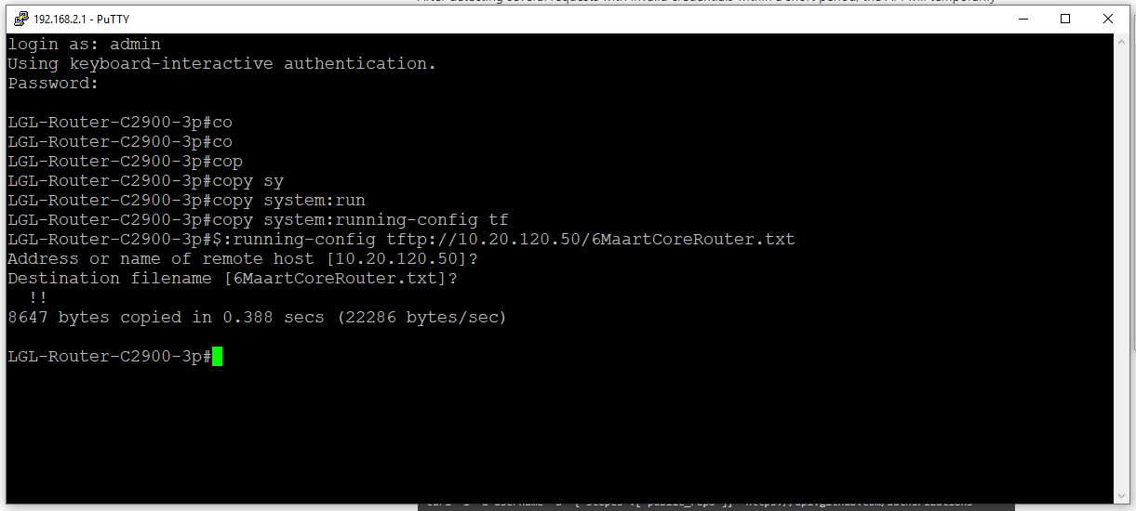

# copy system:running-config tftp://[*Server Interface Address*]/DocumentNaam.txt

Op 2000 series switches is het mogelijk dat de commando hiervoor anders is.

#copy image tftp:// ://[*Server Interface Address*]/DocumentNaam.txt