**Documentation**

There are some steps and methods that must be taken before using the program to its full extent. I will cover everything in the Installation part below.

**Installation**

1. 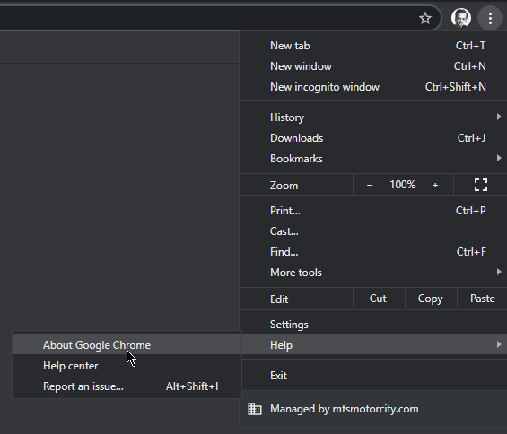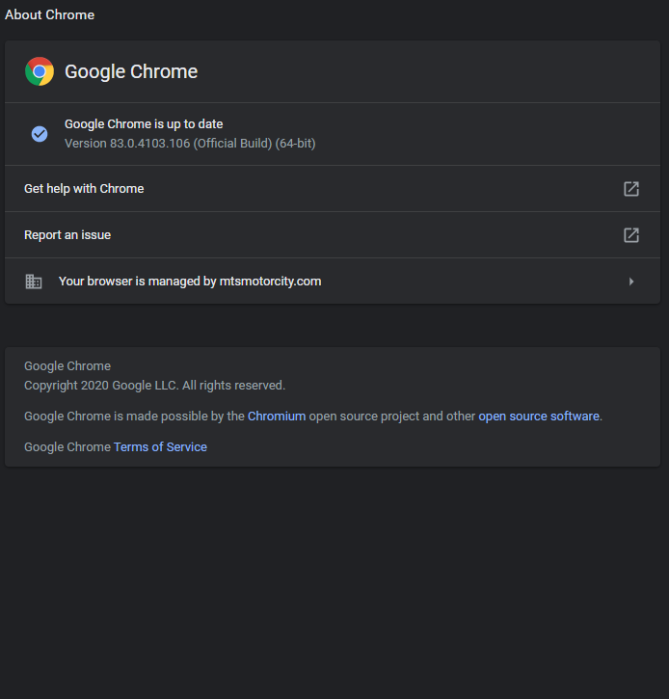Acquire information about your browser, in the demo, I will be using **83.0.4103.106 (Official Build) (64-bit)**. In Chrome, we can navigate to “About Google Chrome” through **Three Dots > Help > About Google Chrome.**
2. Download the drivers based on the version of your browser. Browsers can be found in the links provided below.

**Firefox:** <https://firefox-source-docs.mozilla.org/testing/geckodriver/Support.html>

**Internet Explorer:** <https://github.com/SeleniumHQ/selenium/wiki/InternetExplorerDriver#required-configuration>

**Safari:** <https://developer.apple.com/documentation/webkit/about_webdriver_for_safari>

**Chrome (Recommended):** <https://sites.google.com/a/chromium.org/chromedriver/>

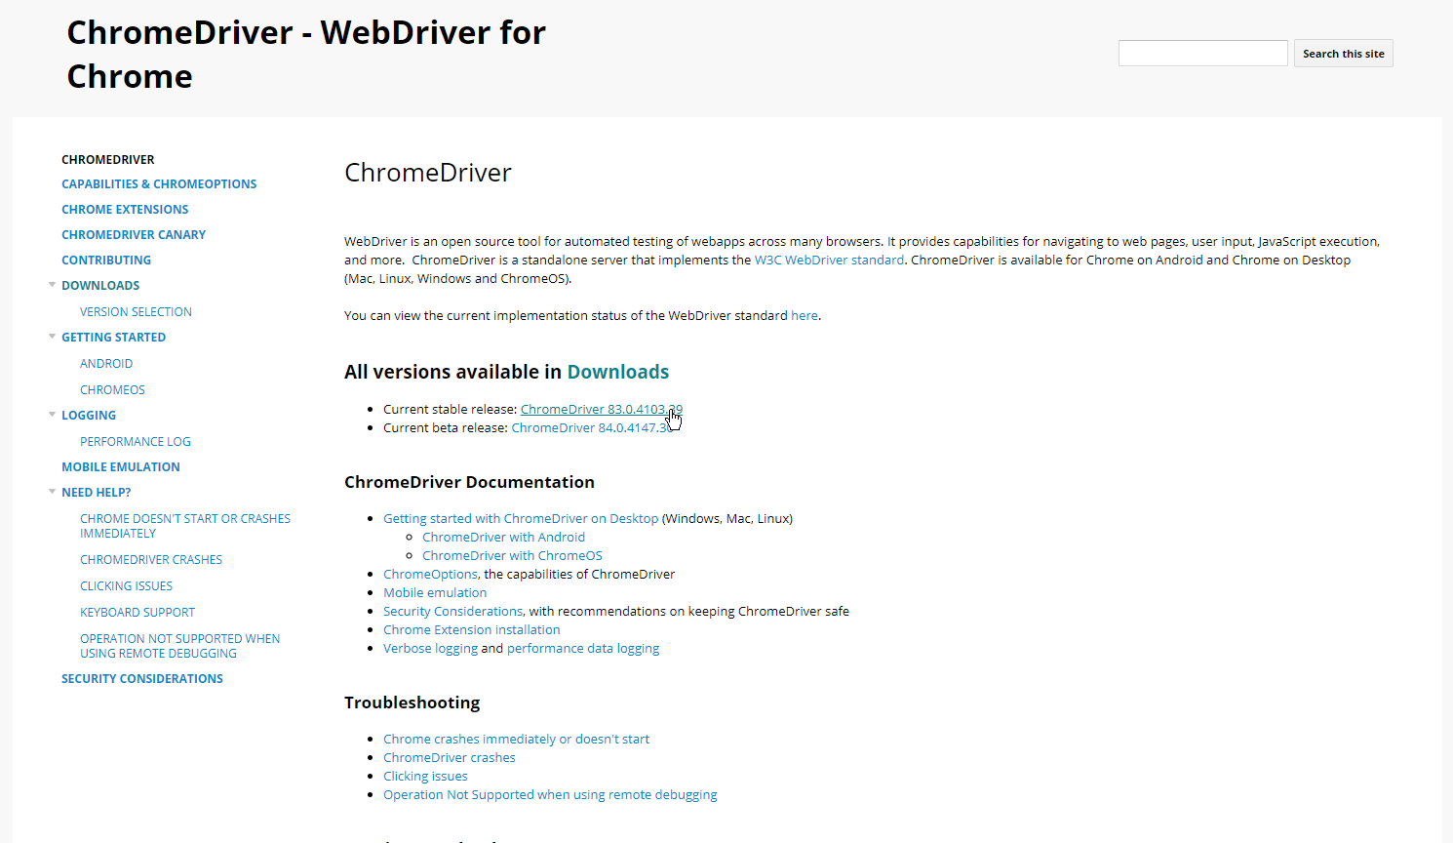

1. Go to DrFrostMaths.com, and login with your credentials. After that, navigate to your dashboard. Follow the instructions on the pictures:

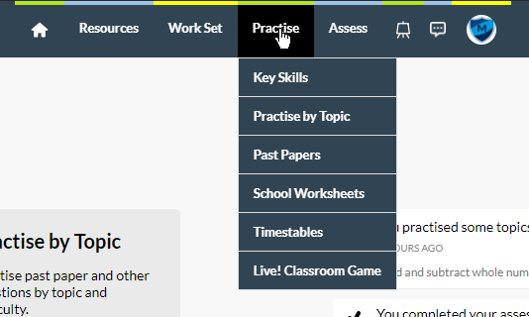

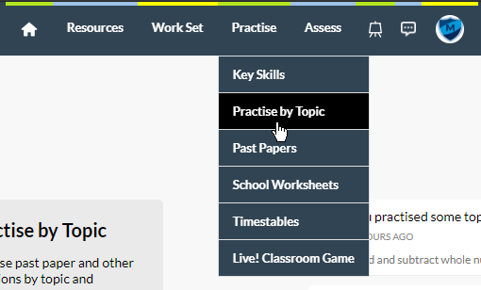

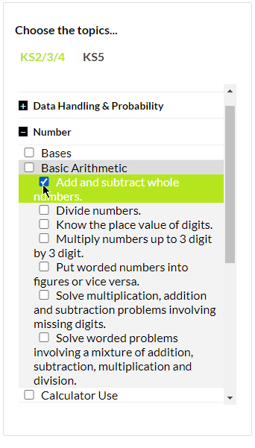 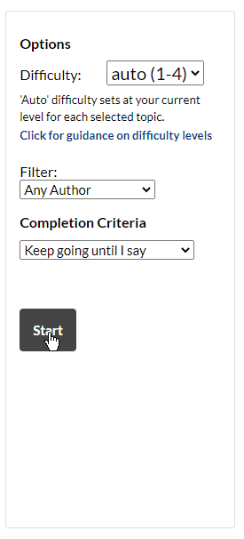

Then, when you are navigated to the exercise, keep doing the exercises till you see one of these questions. Note them down in the order you saw them appear in:

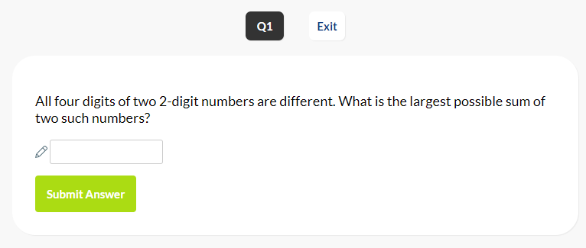

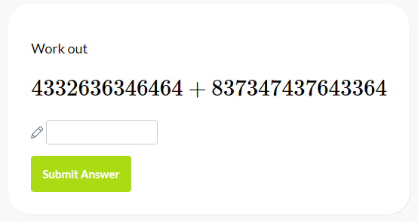

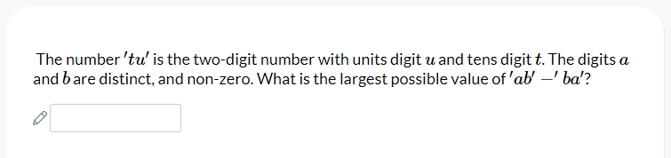

Finish each question **ONCE,** then copy the URL but delete the stuff at the end of the exercise and finish the activity by clicking the Finish button.



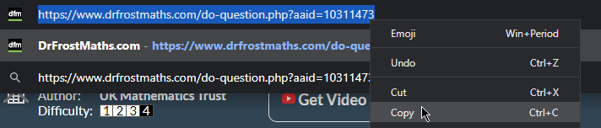

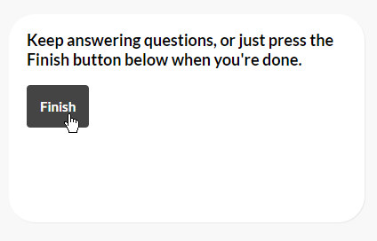

1. Open the python program provided in the Github repository, and edit the following this that I do.

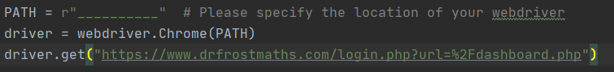

Specify the path of your webdriver, please place the webdriver in the same place as the python file is.



Enter the credentials for DrFrostMaths in order to successfully log in to your account.



Paste the URL of the exercise in the speech-marks.



Enter the answer for the first question you saw (44332…. = 841680073989828, All four….. = 183, ‘ab’ – ‘ba’ = 72) for these as well:

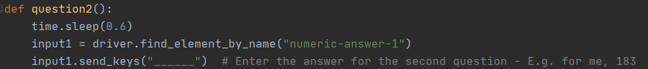

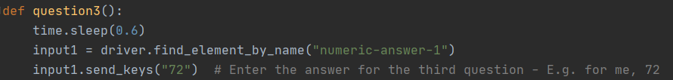

Then finally, so that you will be able to use this exploit without memorizing each question, enter the things that are asked in each question right here:

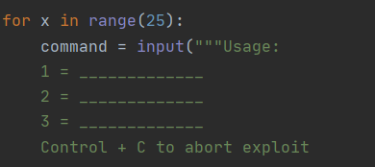

For example, this is how mine would look like:

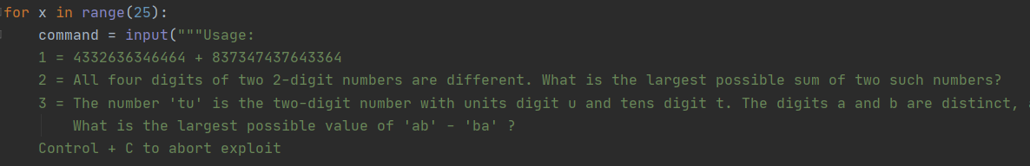

**Usage**

You can run the program through the terminal or an IDE that you use. This is how it would work:

1. Start the “DFM Script.py”

 or 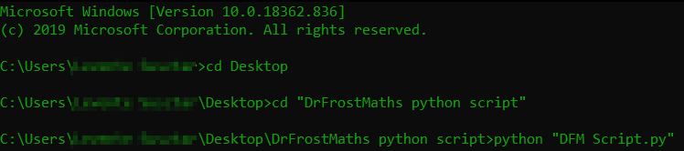

1. A Chrome or other Browser window will pop-up and all you have to do is fill in the inputs:

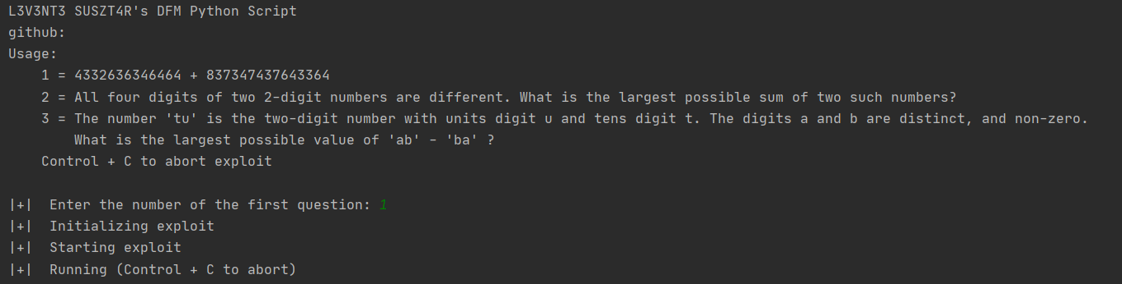

1. You are done! Sit back and relax!

Thank you for downloading my script!

L3V3NT3