
Національний технічний університет України
«Київський політехнічний інститут ім. Ігоря Сікорського»
Факультет Інформатики та Обчислювальної техніки
Кафедра Технічної Кібернетики

Лабораторна робота №5
з курсу «Основи front-end технологій»
Тема: «Верстка сайту за допомогою HTML-5 і CSS-3 за зразком»

Перевірив
Голубєв Л. П.

Виконав
Студент гр. ІК-71:
Саченко О. О.

КИЇВ 2020
Лабораторна робота №5
Завдання
Зробити верстку сайту відповідно за своїм варіантом. (Зберегти макет дизайн сайту, текст та малюнки можуть відрізнятися від оригіналу).
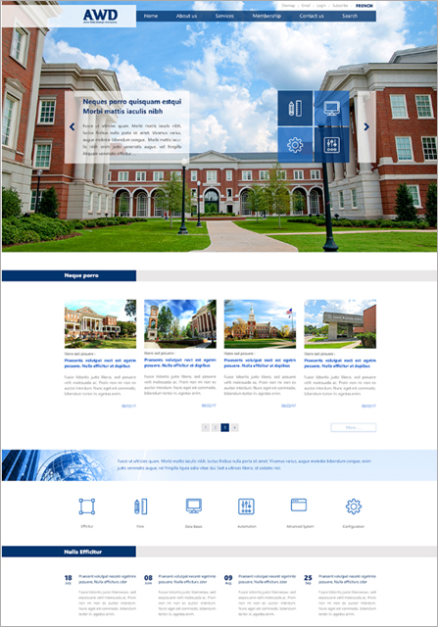
Варіант №19
Хід роботи
- HTML

<!DOCTYPE html>
<html lang="en">

<head>
<meta charset="UTF-8">
<meta name="keywords" content="HTML, CSS, front-end, лабораторна">
<meta name="description" content="Лабораторна робота 5 з курсу Основи front-end технологій">
<link rel="stylesheet" href="lab_5_style.css">
<title>Саченко О. О. IK-71</title>
</head>

<body>
<div class="wrapper">
<div class="top">
<div class="top__name">
<h1>AWD</h1>
<p>Lorem ipsum dolor</p>
</div>
<nav class="top__mini_menu">
<a href="">Lorem</a>
<a href="">Ipsum</a>
<a href="">Dolor</a>
<a href="">Sit</a>
<a href="">Amet</a>
</nav>
<nav class="top__menu">
<a href="">Home</a>
<a href="">About us</a>
<a href="">Services</a>
<a href="">Membership</a>
<a href="">Contact us</a>
<a href="">Search</a>
</nav>
<div class="top__content">
<div class="top__content_description">
<div class="top__content_description_button">
<button></button>
</div>
<div class="top__content_description_text">
<h1>Lorem ipsum dolor sit amet, consectetur adipiscing elit, sed do eiusmod tempor incididunt ut labore et
dolore magna.</h1>
<p>
Lorem ipsum dolor sit amet, consectetur adipiscing elit, sed do eiusmod tempor incididunt ut labore et
dolore magna aliqua.
Ut enim ad minim veniam, quis nostrud exercitation ullamco laboris nisi ut aliquip ex ea commodo
consequat.
Duis aute irure dolor in reprehenderit in voluptate velit esse cillum dolore eu fugiat nulla pariatur.
Excepteur sint occaecat cupidatat non proident, sunt in culpa qui officia deserunt mollit anim id est
laborum.
</p>
</div>
</div>
<div class="top__content_icons">
<div class="top__content_icons_icons">
<button class="icon"></button>
<button class="icon"></button>
<button class="icon"></button>
<button class="icon"></button>
</div>
<div class="top__content_icons_button">
<button></button>
</div>
</div>
</div>
</div>

<div class="middle">
<div class="middle__header_line">
<div class="middle__header_line_blue">
<p>Lorem ipsum</p>
</div>
</div>
<div class="middle__universities_container">
<div class="university">
<img src="lab_5_pictures/gallery_pic_1.jpg" alt="university">
<p>Lorem ipsum dolor</p>
<a href="">Lorem ipsum dolor sit amet, consectetur adipiscing elit</a>
<p>
Lorem ipsum dolor sit amet, consectetur adipiscing elit, sed do eiusmod tempor incididunt ut labore et
dolore magna aliqua.
Ut enim ad minim veniam, quis nostrud exercitation ullamco laboris nisi ut aliquip ex ea commodo consequat.
</p>
<button>Lorem</button>
</div>
<div class="university">
<img src="lab_5_pictures/gallery_pic_2.jpg" alt="university">
<p>Lorem ipsum dolor</p>
<a href="">Lorem ipsum dolor sit amet, consectetur adipiscing elit</a>
<p>
Lorem ipsum dolor sit amet, consectetur adipiscing elit, sed do eiusmod tempor incididunt ut labore et
dolore magna aliqua.
Ut enim ad minim veniam, quis nostrud exercitation ullamco laboris nisi ut aliquip ex ea commodo consequat.
</p>
<button>Lorem</button>
</div>
<div class="university">
<img src="lab_5_pictures/gallery_pic_3.jpg" alt="university">
<p>Lorem ipsum dolor</p>
<a href="">Lorem ipsum dolor sit amet, consectetur adipiscing elit</a>
<p>
Lorem ipsum dolor sit amet, consectetur adipiscing elit, sed do eiusmod tempor incididunt ut labore et
dolore magna aliqua.
Ut enim ad minim veniam, quis nostrud exercitation ullamco laboris nisi ut aliquip ex ea commodo consequat.
</p>
<button>Lorem</button>
</div>
<div class="university">
<img src="lab_5_pictures/gallery_pic_4.jpg" alt="university">
<p>Lorem ipsum dolor</p>
<a href="">Lorem ipsum dolor sit amet, consectetur adipiscing elit</a>
<p>
Lorem ipsum dolor sit amet, consectetur adipiscing elit, sed do eiusmod tempor incididunt ut labore et
dolore magna aliqua.
Ut enim ad minim veniam, quis nostrud exercitation ullamco laboris nisi ut aliquip ex ea commodo consequat.
</p>
<button>Lorem</button>
</div>
</div>
<div class="middle__buttons">
<div></div>
<div class="pages">
<button>1</button>
<button>2</button>
<button>3</button>
<button>4</button>
</div>
<button class="single_button">Lorem</button>
</div>
<div class="middle__globe_line">
<img src="lab_5_pictures/globe.png" alt="globe">
<p>
Lorem ipsum dolor sit amet, consectetur adipiscing elit, sed do eiusmod tempor incididunt ut labore et
dolore magna aliqua.
Ut enim ad minim veniam, quis nostrud exercitation ullamco laboris nisi ut aliquip ex ea commodo consequat.
</p>
</div>
<div class="middle_icons">
<div class="icon">
<button></button>
<p>Lorem</p>
</div>
<div class="icon">
<button></button>
<p>Ipsum</p>
</div>
<div class="icon">
<button></button>
<p>Dolor sit</p>
</div>
<div class="icon">
<button></button>
<p>Amet</p>
</div>
<div class="icon">
<button></button>
<p>Elit sed</p>
</div>
<div class="icon">
<button></button>
<p>Adipiscing</p>
</div>
</div>
</div>

<div class="bottom">
<div class="bottom__header_line">
<div class="bottom__header_line_blue">
<p>Lorem ipsum</p>
</div>
</div>
<div class="bottom__advert">
<div class="post">
<div class="date">
<div class="day">18</div>
<div class="month">July</div>
</div>
<a href="">Lorem ipsum dolor sit amet, consectetur</a>
<p>
Lorem ipsum dolor sit amet, consectetur adipiscing elit, sed do eiusmod tempor incididunt ut labore et
dolore magna aliqua.
Ut enim ad minim veniam, quis nostrud exercitation ullamco laboris nisi ut aliquip ex ea commodo consequat.
</p>
</div>
<div class="post">
<div class="date">
<div class="day">08</div>
<div class="month">June</div>
</div>
<a href="">Lorem ipsum dolor sit amet, consectetur</a>
<p>
Lorem ipsum dolor sit amet, consectetur adipiscing elit, sed do eiusmod tempor incididunt ut labore et
dolore magna aliqua.
Ut enim ad minim veniam, quis nostrud exercitation ullamco laboris nisi ut aliquip ex ea commodo consequat.
</p>
</div>
<div class="post">
<div class="date">
<div class="day">09</div>
<div class="month">Aug</div>
</div>
<a href="">Lorem ipsum dolor sit amet, consectetur</a>
<p>
Lorem ipsum dolor sit amet, consectetur adipiscing elit, sed do eiusmod tempor incididunt ut labore et
dolore magna aliqua.
Ut enim ad minim veniam, quis nostrud exercitation ullamco laboris nisi ut aliquip ex ea commodo consequat.
</p>
</div>
<div class="post">
<div class="date">
<div class="day">25</div>
<div class="month">Aug</div>
</div>
<a href="">Lorem ipsum dolor sit amet, consectetur</a>
<p>
Lorem ipsum dolor sit amet, consectetur adipiscing elit, sed do eiusmod tempor incididunt ut labore et
dolore magna aliqua.
Ut enim ad minim veniam, quis nostrud exercitation ullamco laboris nisi ut aliquip ex ea commodo consequat.
</p>
</div>
</div>
</div>
</div>
</body>

</html>

- CSS

*{padding:0;margin:0;border:0;}
*,*:before,*:after{-moz-box-sizing:border-box;-webkit-box-sizing:border-box;box-sizing:border-box;}
:focus,:active{outline:none;}
a:focus,a:active{outline:none;}
nav,footer,header,aside{display:block;}
html,body{height:100%;width:100%;font-size:100%;line-height:1;font-size:14px;-ms-text-size-adjust:100%;-moz-text-size-adjust:100%;-webkit-text-size-adjust:100%;}
input,button,textarea{font-family:inherit;}
input::-ms-clear{display:none;}
button{cursor:pointer;}
button::-moz-focus-inner{padding:0;border:0;}
a,a:visited{text-decoration:none;}
a:hover{text-decoration:none;}
ul li{list-style:none;}
img{vertical-align:top;}
h1,h2,h3,h4,h5,h6{font-size:inherit;font-weight:inherit;}

body{
font-family: 'Merriweather', serif;
}

.wrapper {
min-height: 100%;
overflow: hidden;
display: flex;
flex-direction: column;
}

.top {
background: url('lab_5_pictures/main_pic.jpg')no-repeat;
background-size: 100%;
height: 765px;
}

.top__name {
display: flex;
flex-direction: column;
align-items: center;
width: 400px;
height: 90px;
margin-top: 20px;
background-color: rgba(255, 255, 255, 0.7);
color: rgb(35, 73, 131);
user-select: none;
float: left;
}

.top__name h1 {
font-size: 60px;
font-weight: bold;
margin-left: 175px;
margin-top: 5px;
}

.top__name p {
font-size: 12px;
margin-left: 175px;
}

.top__menu {
display: flex;
justify-content: space-around;
align-items: center;
width: 700px;
height: 40px;
background-color: rgb(35, 73, 131);
}

.top__menu a {
color: white;
font-size: 18px;
}

.top__menu a:hover {
filter: drop-shadow(0 0 10px white);
}

.top__mini_menu {
display: flex;
justify-content: space-around;
align-items: center;
width: 300px;
height: 40px;
margin-left: 810px;
}

.top__mini_menu a {
color: rgb(94, 94, 94);
font-size: 18px;
}

.top__mini_menu a:last-child {
color: rgb(35, 73, 131);
font-weight: bold;
}

.top__content {
display: flex;
justify-content: space-around;
margin: 200px auto;
}

.top__content_description,
.top__content_icons {
display: flex;
justify-content: space-around;
width: 500px;
height: 300px;
}

.top__content_icons {
width: 400px;
}

.top__content_description_text {
width: 450px;
height: 300px;
background-color: rgba(255, 255, 255, 0.7);
}

.top__content_description_text h1 {
font-size: 24px;
font-weight: 550;
color: rgb(35, 73, 131);
margin: 20px 10px;
}

.top__content_description_text p {
margin: 20px 20px 20px 10px;
font-size: 18px;
}

.top__content_icons_icons {
display: grid;
grid-template-columns: 145px 145px;
grid-template-rows: 145px 145px;
gap: 10px;
}

.top__content_icons_icons .icon:nth-child(1) {
background: url('lab_5_pictures/mini_pic_1_1.png') no-repeat;
background-size: 90%;
background-position: center;
background-color: rgba(35, 73, 131, 0.8);
}

.top__content_icons_icons .icon:nth-child(2) {
background: url('lab_5_pictures/mini_pic_1_2.png') no-repeat;
background-size: 70%;
background-position: center;
background-color: rgba(104, 165, 255, 0.7);
}

.top__content_icons_icons .icon:nth-child(3) {
background: url('lab_5_pictures/mini_pic_1_3.png') no-repeat;
background-size: 70%;
background-position: center;
background-color: rgba(104, 165, 255, 0.7);
}

.top__content_icons_icons .icon:nth-child(4) {
background: url('lab_5_pictures/mini_pic_1_4.png') no-repeat;
background-size: 70%;
background-position: center;
background-color: rgba(35, 73, 131, 0.8);
}

.top__content_icons_icons .icon:hover {
transform: scale(1.1);
}

.top__content_description_button button {
background: url('lab_5_pictures/arrow_left.png') no-repeat;
}

.top__content_icons_button button {
background: url('lab_5_pictures/arrow_right.png') no-repeat;
}

.top__content_description_button button,
.top__content_icons_button button {
background-size: 50%;
background-position: center;
width: 50px;
height: 300px;
background-color: rgba(255, 255, 255, 0.7);
}

.top__content_description_button button:hover,
.top__content_icons_button button:hover {
background-color: rgba(255, 255, 255, 0.8);
}

.middle__header_line {
display: grid;
grid-template-columns: 400px auto;
height: 50px;
margin: 75px 0;
background-color: rgba(235, 235, 235, 0.7);
}

.middle__header_line_blue {
background-color: rgb(35, 73, 131);
}

.middle__header_line_blue p{
color: white;
font-size: 24px;
font-weight: 550;
margin: 10px 0 0 50%;
}

.middle__universities_container {
display: flex;
width: 80%;
margin: 0 auto 50px;
justify-content: space-between;
}

.university {
display: flex;
flex-direction: column;
width: 23%;
}

.university img {
width: 100%;
}

.university p {
margin-top: 15px;
font-size: 18px;
text-align: justify;
}

.university a {
margin: 10px 0;
font-size: 24px;
color: rgb(104, 165, 255);
}

.university button {
align-self: flex-end;
margin-top: 15px;
font-size: 18px;
color: rgb(104, 165, 255);
background-color: white;
}

.middle__buttons {
display: grid;
width: 80%;
grid-template-columns: 150px auto 150px;
margin: 50px auto 75px;
}

.middle__buttons .pages {
display: flex;
justify-content: space-between;
width: 16%;
margin: 0 auto;
float: left;
}

.middle__buttons .pages button {
display: block;
width: 30px;
height: 30px;
font-size: 18px;
color: rgb(35, 73, 131);
background-color:rgba(235, 235, 235, 0.7);
box-shadow: 0 0 3px rgb(185, 185, 185);
}

.middle__buttons .pages button:hover {
background-color: rgb(35, 73, 131);
color: rgba(235, 235, 235, 0.7);
}

.middle__buttons .single_button {
display: block;
align-self: flex-end;
width: 150px;
height: 30px;
font-size: 18px;
background-color:white;
color: rgb(104, 165, 255);
border: 1px solid rgba(104, 165, 255, 0.5);
box-shadow: 0 0 3px rgb(185, 185, 185);
}

.middle__buttons .single_button:hover {
transform: scale(1.05);
}

.middle__globe_line {
display: grid;
grid-template-columns: 400px auto;
grid-template-rows: 100px;
margin-bottom: 50px;
}

.middle__globe_line img {
object-fit: none;
width: 100%;
height: 100%;
filter: contrast(1.3);
}

.middle__globe_line p {
display: block;
font-size: 20px;
color: rgb(35, 73, 131);
padding: 30px 130px 0 0;
background-image: linear-gradient(90deg, rgba(136, 194, 221, 0.1), rgba(136, 194, 221, 0.3), rgba(136, 194, 221, 0.5));
filter: contrast(1.3);
}

.middle_icons {
display: flex;
width: 80%;
height: 100px;
margin: 0 auto 30px;
justify-content: space-around;
}

.middle_icons .icon {
display: grid;
grid-template-columns: 100px;
grid-template-rows: 100px 20px;
}

.middle_icons .icon:nth-child(1) button {
background: url('lab_5_pictures/mini_pic_1_1_blue.png') no-repeat;
background-size: 100%;
background-position: center;
}

.middle_icons .icon:nth-child(2) button {
background: url('lab_5_pictures/mini_pic_1_2_blue.png') no-repeat;
background-size: 80%;
background-position: center;
}

.middle_icons .icon:nth-child(3) button {
background: url('lab_5_pictures/mini_pic_1_3_blue.png') no-repeat;
background-size: 80%;
background-position: center;
}

.middle_icons .icon:nth-child(4) button {
background: url('lab_5_pictures/mini_pic_1_4_blue.png') no-repeat;
background-size: 80%;
background-position: center;
}

.middle_icons .icon:nth-child(5) button {
background: url('lab_5_pictures/mini_pic_1_5_blue.png') no-repeat;
background-size: 75%;
background-position: center;
}

.middle_icons .icon:nth-child(6) button {
background: url('lab_5_pictures/mini_pic_1_6_blue.png') no-repeat;
background-size: 80%;
background-position: center;
}

.middle_icons .icon button:hover {
transform: scale(1.1);
}

.middle_icons .icon p {
font-size: 18px;
font-weight: 550;
margin-top: 10px;
text-align: center;
}

.bottom__header_line {
display: grid;
grid-template-columns: 400px auto;
height: 50px;
margin: 75px 0;
background-color: rgba(235, 235, 235, 0.7);
}

.bottom__header_line_blue {
background-color: rgb(35, 73, 131);
}

.bottom__header_line_blue p{
color: white;
font-size: 24px;
margin: 10px 0 0 50%;
}

.bottom__advert {
display: flex;
justify-content: space-between;
width: 80%;
margin: 0 auto 40px;
}

.bottom__advert .post {
display: grid;
grid-template-columns: 30px 210px;
grid-template-rows: 45px auto;
gap: 15px;
font-size: 18px;
}

.bottom__advert .post .date {
text-align: center;
color: rgb(35, 73, 131);
grid-column: 1/2;
grid-row: 1/2;
}

.bottom__advert .post .date .day {
font-size: 32px;
font-weight: bold;
}

.bottom__advert .post .date .month {
font-size: 14px;
}

.bottom__advert .post a {
font-size: 24px;
font-weight: 550;
color: rgb(35, 73, 131);
grid-column: 2/3;
grid-row: 1/2;
}

.bottom__advert .post p {
text-align: justify;
grid-column: 2/3;
grid-row: 2/3;
}

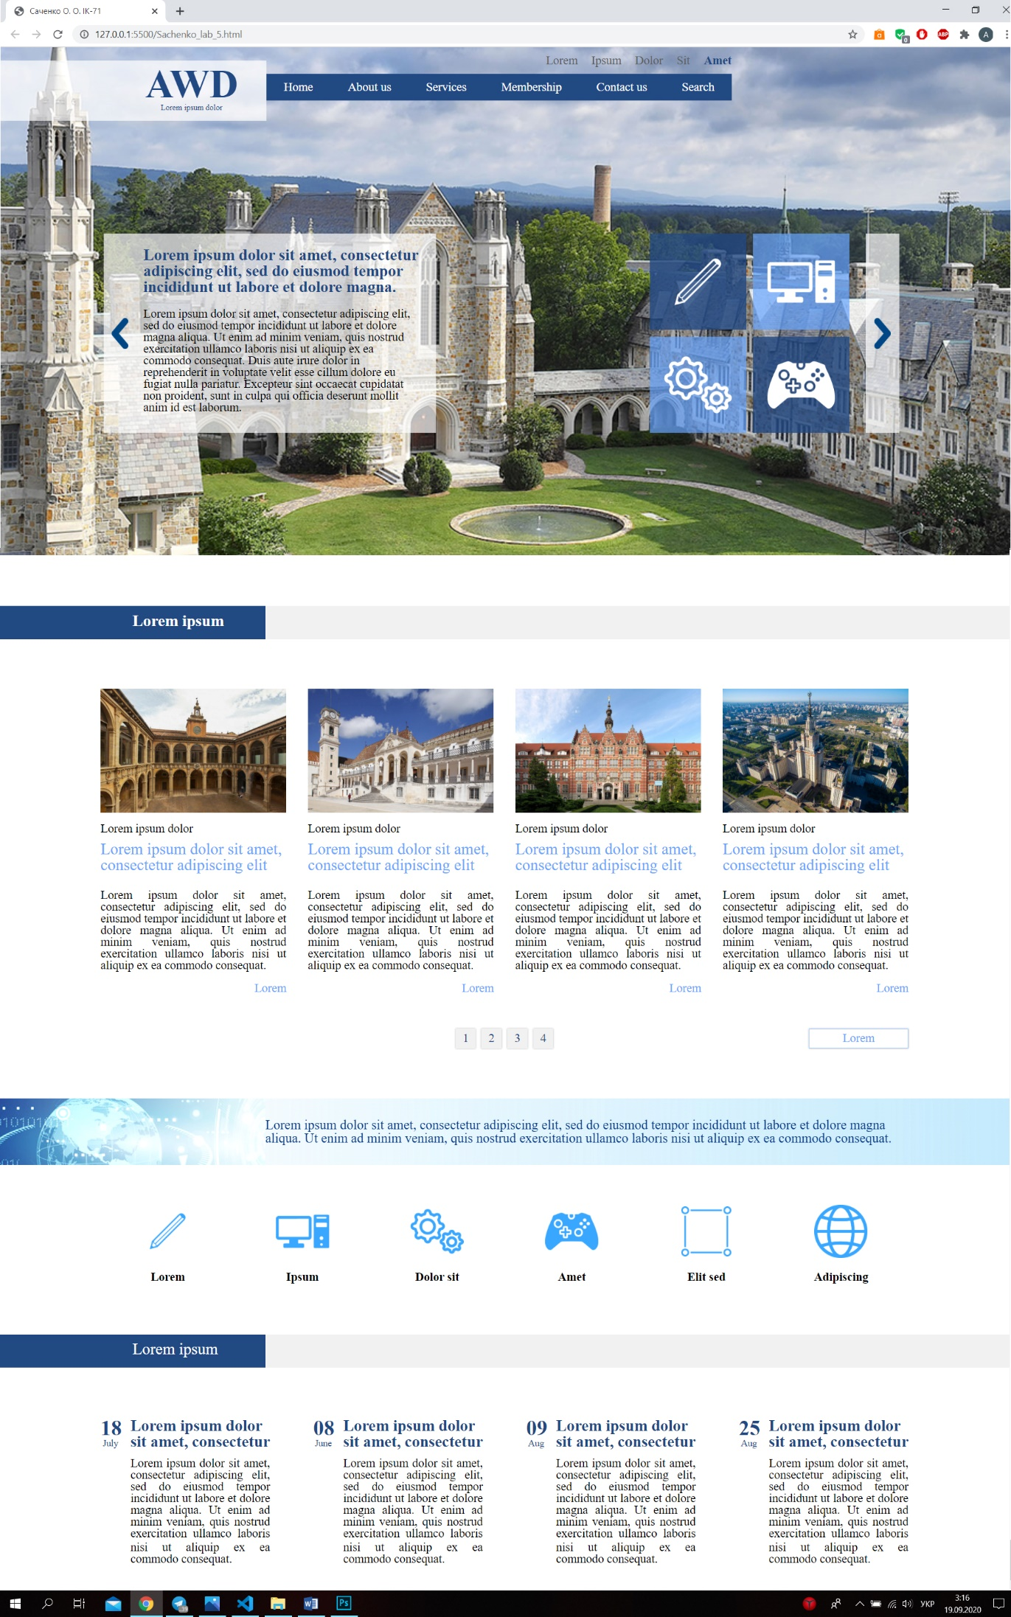
Отримані результати

