IMAGE-PUZZLE : 3 X 3 square

**Needs :**

* A grid board 3 X 3
  + 50px for each grid
  + Width : 50px X 3 = 150px
  + Height : 50px X 3 = 150px
  + One empty grid.
* An image :
  + Piece of 50px image per grid
  + 8 pieces of image (one empty grid)
* Empty grid:
  + For allowing movement of a puzzle piece.

**Algorithm**

* Move a piece at a time until all the pieces are at the right position for winning.

**How to move a puzzle piece?**

* Detect the puzzle pieces available around the empty grid
* Move one of the available puzzle piece toward the empty grid

(Note: one is allowed to move at a time)

* Loop

**How to know that all the puzzle pieces match in other to stop and display win?**

* Detect the correct position of each puzzle pieces, if all positions correct then win

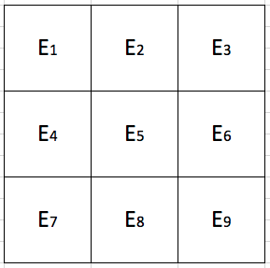

**Detect the available puzzle pieces around the empty grid**

* Find the position of the empty grid
  + Check the cells with background-image
  + If cell background-image = none
    - Then return it coordinates (a x b)
      * a is the row number
      * b is the col number
* if (a x b) of empty grid returned
  + then available puzzle pieces are at the coordinates:
    - if empty grid is at the middle of the grid:
      * (a-1) x b; a x (b-1); a x (b+1); (a+1) x b
    - If empty grid is at the top left edge E1
      * a x (b+1); (a+1) x b
    - if empty grid is at the top right edge E3
      * a x (b-1); (a+1) x b
    - if empty grid is at the bottom left edge E7
      * (a-1) x b; a x (b+1)
    - If empty grid is at bottom right edge E9
      * a x (b-1); (a-1) x b
    - if empty grid is at the top middle horizontal row E2
      * a x (b-1); a x (b+1); (a+1) x b
    - if empty grid is at the bottom middle horizontal row E8
      * a x (b-1); a x (b+1); (a-1) x b
    - if empty grid is at the left middle vertical column E4
      * (a-1) x b; (a+1) x b; a x (b+1)
    - If empty grid is at the right middle vertical column E6
      * (a-1) x b; (a+1) x b; a x (b-1)

Note: a and b are the row, column number of the empty grid respectively

**Move available puzzle piece toward the empty grid**

* a cell is clicked.
  + It returns its coordinates (a x b)
* If the return cell coordinates (a x b) are not in the return available puzzle piece.
  + then these cells are not clickable.

Note: Only the cell coordinates present in the list are clickable.

Note: a and b are the row and column number of the clicked cell respectively.

**Challenges:**

Is it possible to make a table cell clickable like a button in other to react to certain events?