# GYVTC CNET Program Review

## Students

### Number of students in each program year

(See table in next section)

### Number of anticipated students to begin prep year in 2017

|  |  |
| --- | --- |
| **Class** | **Number** |
| *Class 2017 (Prep Year) | 20 |
| Class 2016 (2nd Year) | 20 |
| Class 2015 (3rd Year) | 79 |

### Changes and updates to student recruitment for the Program

We’re enhancing our recruitment effort by hiring a dedicated recruiting team from “Chongqing Direct Info Tech Ltd.”. According to their solid work this year a constant recruitment number of student could be expected.

### Methods or measures being used to assist students with their english proficiency, self-motivation and study skills.

We’re benefiting from government level cooperation projects with the U.N, which send native speakers to help us enhancing our English teaching quality on a regular base, including:

* 10hrs/week in first two semesters
* Off-class talking opportunities provided to all students such as “English-corner”

### Courses students find most challenging

**CNET-1021 Cisco CCNA Routing and Switching Essentials**

* Most of the students had no experience in operating in a command line editing environment
* Most of the students found it hard to understand abstract concepts in networking, especially in English

### Courses students find most easiest

**CMPS-1000 A+ Software**

* Most of the students were familiar with Windows operating system and using Windows utilities to manage their daily use of Windows
* Most students found contents in this course relate closely to their daily use of computers, thus interested them most

### What are attrition numbers for students

**Reasons for attrition：**

1. limited family incomes and educational budget

2. disadvantage in high school education

3. interest ( some of the students are forced to school by their parents, and they show no interest in pursuing a diploma in CNT )

### Results from students’ evaluation of program

Below table is exported from our CRP system ( SAM equivalent), represents the overall satisfaction level of CNT courses that have been delivered in year 2016.

|  |  |  |  |  |  |  |  |  |  |
| --- | --- | --- | --- | --- | --- | --- | --- | --- | --- |
| **Year** | **Month** | **Name** | **Course Title** | **Excellent** | **%** | **Good** | **%** | **Poor** | **%** |
| 2016 | 12 | 刘艺 | Routing & Switching Essentials：路由器和交换原理 | 5 | 100% | 0 | 0% | 0 | 0% |
| 2016 | 12 | 刘艺 | Routing & Switching Lab: 交换机、路由器配置实训 | 5 | 100% | 0 | 0% | 0 | 0% |
| 2016 | 12 | 郑江玥 | Windows Server Administrator：服务器管理 | 5 | 100% | 0 | 0% | 0 | 0% |
| 2016 | 12 | 刘艺 | Computer Essentials：计算机网络基础 | 80 | 97% | 2 | 2% | 0 | 0% |
| 2016 | 12 | Craig Nash | Windows Server Administrator：服务器管理 | 69 | 95% | 3 | 4% | 0 | 0% |
| 2016 | 12 | Spencer MacPhee | Routing & Switching Essentials：路由器和交换原理 | 69 | 95% | 3 | 4% | 0 | 0% |
| 2016 | 12 | 蒙晓暄 | Routing & Switching Lab:交换机、路由器配置实训 | 32 | 94% | 2 | 5% | 0 | 0% |
| 2016 | 12 | 蒙晓暄 | CiscoCCNA I:Introduction to Networks:网络基础 | 32 | 94% | 2 | 5% | 0 | 0% |
| 2016 | 12 | 刘颖 | Technical Conmmunications:技术交流 | 32 | 94% | 2 | 5% | 0 | 0% |
| 2016 | 12 | ABEDEL | Practical English: 实用英语(中加) | 14 | 93% | 1 | 6% | 0 | 0% |
| 2016 | 12 | 宋波 | Routing & Switching Lab: 交换机、路由器配置实训 | 34 | 89% | 4 | 10% | 0 | 0% |
| 2016 | 12 | 蒙晓暄 | Windows Server Administrator：服务器管理 | 64 | 88% | 8 | 11% | 0 | 0% |
| 2016 | 12 | 蒙晓暄 | A+ Hardware:硬件基础 | 64 | 88% | 8 | 11% | 0 | 0% |
| 2016 | 12 | 蒙晓暄 | Routing & Switching Essentials：路由器和交换原理 | 63 | 87% | 9 | 12% | 0 | 0% |
| 2016 | 12 | 宋波 | CiscoCCNA I:Introduction to Networks:网络基础 | 33 | 86% | 5 | 13% | 0 | 0% |
| 2016 | 12 | 刘海波 | A+Software:软件基础 | 66 | 85% | 11 | 14% | 0 | 0% |
| 2016 | 12 | 艾容 | Practical English: 实用英语(中加) | 12 | 80% | 3 | 20% | 0 | 0% |
| 2016 | 12 | 王梅 | Technical Conmmunications:技术交流 | 29 | 76% | 9 | 23% | 0 | 0% |
| 2016 | 12 | 刘正艳 | A+ Hardware:硬件基础 | 8 | 53% | 7 | 46% | 0 | 0% |

## Teaching/Instructors

### New staff delivering EJV courses

(See below table)

|  |  |  |  |  |  |
| --- | --- | --- | --- | --- | --- |
| Name of Instructor | EJV Course being taught | Educational Credentials | Number of Years of Teaching in the College/ University | Had been trained at Holland College （PEI) (If yes, please state which year?) | Had been participated in the EJV Best Practice Symposium held in China (If yes, please state which year?) |
| Song Bo | 1. CNET-1050 Network and Information Security2. CNET-1010 CCNA-I | Master | 18 | NO | NO |
| Xie Hong | 1. CPRG-1000 Basics of Programming2. CNET-2030 Web Technologies | Master | 19 | YES. 2015 Fall | NO |
| Liu Haibo | 1. CMPS-1000 A+ Software2. CNET-1100 Linux Administration | Master | 3 | YES. 2015 Fall | NO |
| Liu Yi | 1. CNET-1021 CCNA-II2. CNET-2201 Network Analyze and Design | Master | 12 | NO | NO |
| Wu Yan | COMM-1000 Techincal Communication | Bachelor | 12 | NO | NO |
| Tan Lijun | Object-Oriented Programming | Master | 20 | NO | NO |
| Zhong Zhengyong | CNET-2040 Voice and Video over Internet | Bachelor | 2 | NO | NO |
| Abedel (Eng) | English | Bachelor | 1 | NO | NO |
| Stephen (US) | English | Bachelor | 1 | NO | NO |

### Teaching methods and strategies used in the program – elaborate on creative interactive students activities, projects

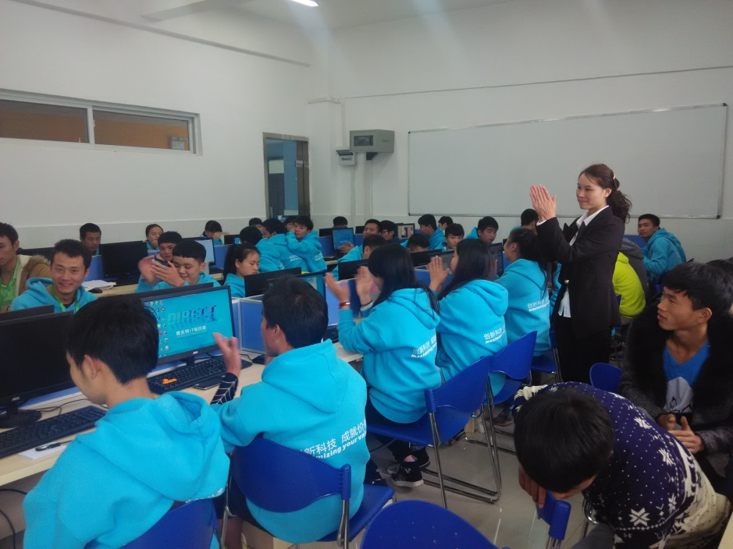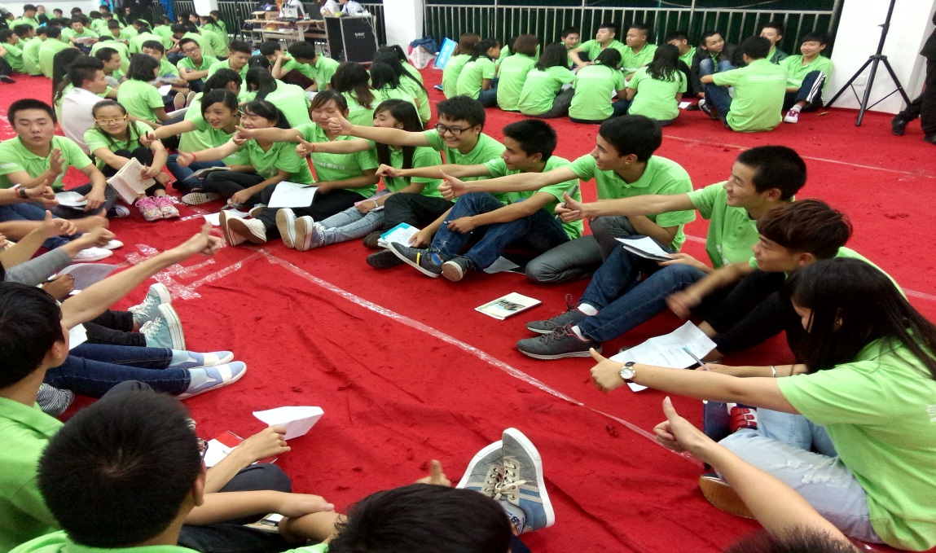

Photo Group activities developing teamwork spirit and collaborative skills

### What instructors find most challenging in delivering their course(s)

To make a difference in every aspect that the students feel they’re participating an EJV program rather than simply replacing course materials and schedules

### What can we as (EJV partners) jointly work on for solutions to these challenges

Identify key elements that distinguish CBE from Chinese traditional educational methods and design a QA procedure to ensure we’re making progress in introducing CBE in our daily educational activities.

### Professional development opportunities for EJV instructors

* Instructors are assigned to companies and corporations for professional skills uplifting on a regular basis
* Instructors are receiving trainings from government invited experts and researchers on a regular basis

### Feedback on what instructors learned that changed them as an instructor (if instructors recently visited Holland College for training)

How to construct the relationship with students in a CBE preferred way. The traditional relationship between instructors and students in Chinese education system is instructor-centralized, which emphasizes the importance of obedience and depresses the creativity of students. However in HC, we observed a very different scenario where instructors and students worked together to solve problems as if they were colleagues. This requires a "chemical reaction" of lots of educational elements.

### Feedback on what instructors benefited from at EJV Best Practice Symposium 2015 in Hainan.

No attendance.

### What kind of training you would like to see at the upcoming EJV Best Practice Symposium 2017 in Guiyang.

* Skills training on innovative and elaborative course content design
* Teaching methods and strategies best practice training
* Course developing techniques

### Discuss collaboration between EJV instructors

During the last year all EJV instructors collaborate intensively to deliver CNT program courses:

* We had meetings on how to remap CNT courses from 2yrs basis to 3yrs basis, which could comply with Chinese local policies and regulations.
* We discussed how to design teaching plans and evaluation matrix of CNT program courses using materials and tools we learned from workshop held in HC in 2015 fall semester.
* We work closely with Craig Nash and Spencer MacPhee to deliver Windows Server Administration and Routers and Switchers Essentials to students, assisted them on translation, lab running and individual evaluation. The feedback is positive.

### Opportunities for China faculty to visit Holland College

### Discuss Holland College instructors who may have delivered EJV program courses at yours institution *What was learned from this experience by both students and faculty?

* Professionalism and integrity
* Skills to get students involved
* One on one evaluation of students’ performance
* A practical and effective evaluation system
* How to find highlight from every student even if their performance didn't meet course criteria and use it as a positive stimulation to encourage students to go on their studying

## Curriculum

|  |  |
| --- | --- |
| 2014 class (to be graduated in June 2017)Holland College Year 1 Courses1st Semester (Code and Course Title) | 2014 class (to be graduated in June 2017)Holland College Year 1 Courses2ndst Semester (Code and Course Title) |
| Practical English | Practical English |
| CMPH-1000 A+ Hardware | CNET-1010 Cisco CCNA I Introduction to Networks |
| COMP-1000 Computer Essentials |  |
| PROF-2000 Ethics and Professional Practices |  |
| 2014 class (to be graduated in June 2017)Holland College Year 2 Courses1st Semester (Code and Course Title) | 2014 class (to be graduated in June 2017)Holland College Year 2 Courses2nd Semester (Code and Course Title) |
| CNET-1021 Cisco CCNA II Routing and Switching Essentials | CPRG-1000 Basics of Programming |
| CMPS-1000 A+ Software | CNET-1100 Linux Administration |
| CNET-1110 Windows Server Administration | CNET-1050 Network and Information Security |
| COMM-1000 Technical Communications | CNET-2040 Voice and Video Over Internet |

### Provide a sample of instructor’s lesson plan and assessments from one of the program courses

(See attachment list)

### Discuss and provide comments on the delivery of course curriculum over the last year

* Professionalism
* Teaching Skills
* Students Participation
* Evaluation

## Facilities/Resources/Equipment Updates

### Availability of books and resources

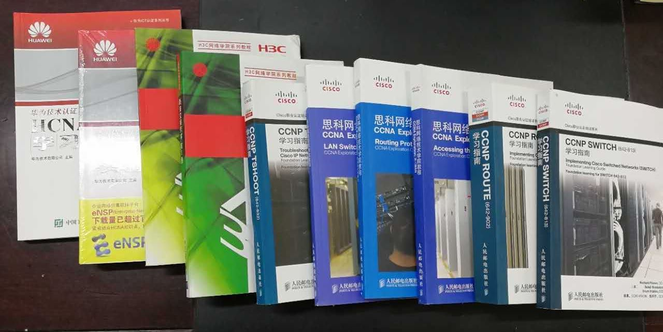

Photo Text books used in CNT program

### Usage of SAM Resources

Use SAM to:

* Receiving news feeds
* Accessing CNT program documents
* Library resources
* Staff Email Service

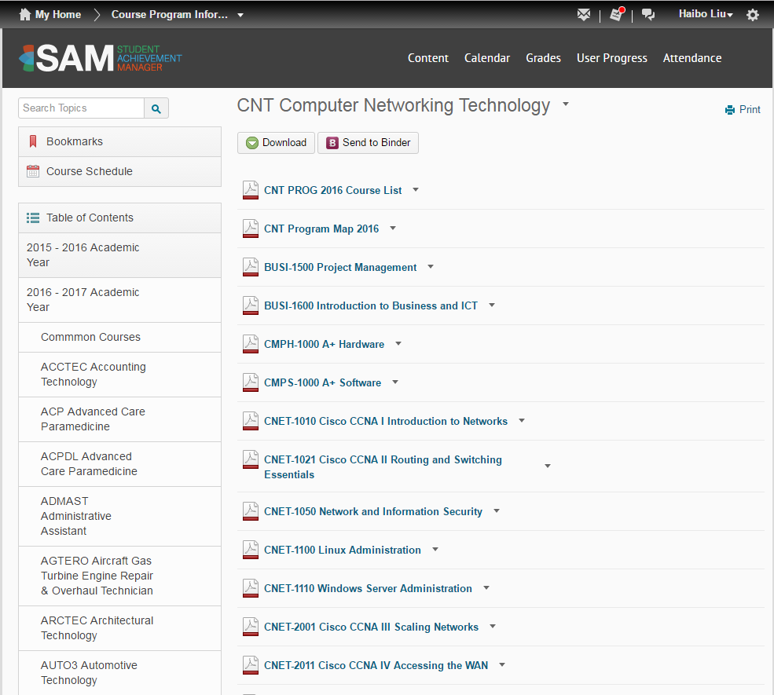

Photo Accessing course documents in new version of SAM

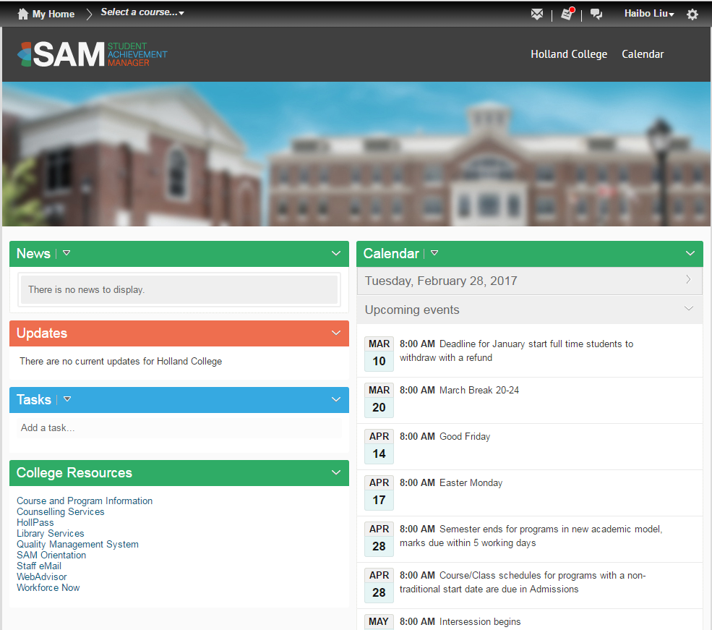

Photo Home page of new SAM

### Equipment and Facilities

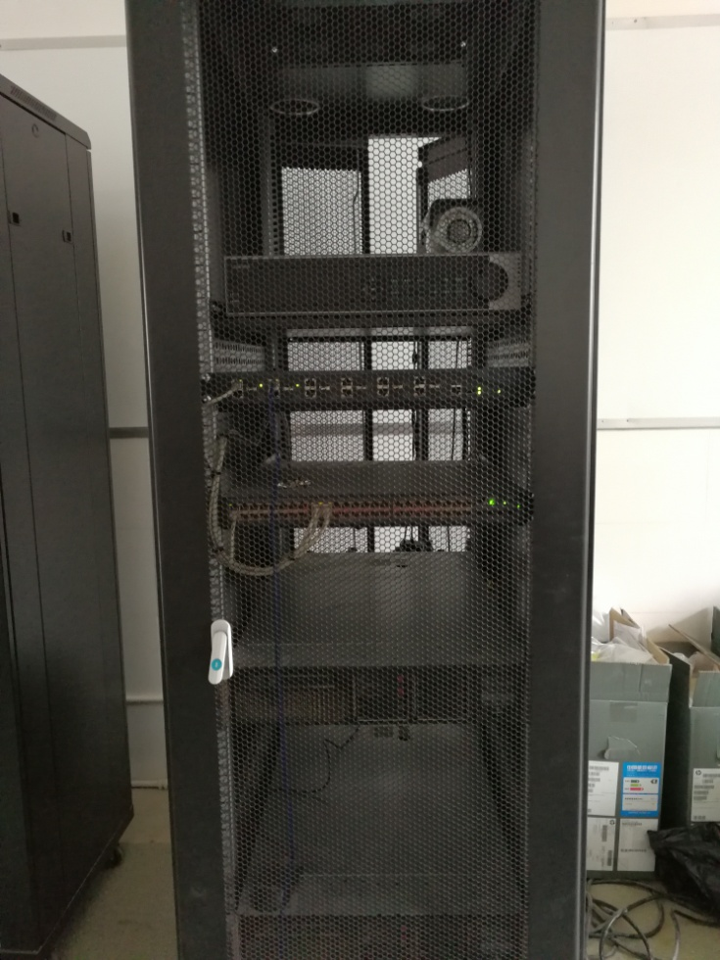

Photo CCTV and Virtualization Server

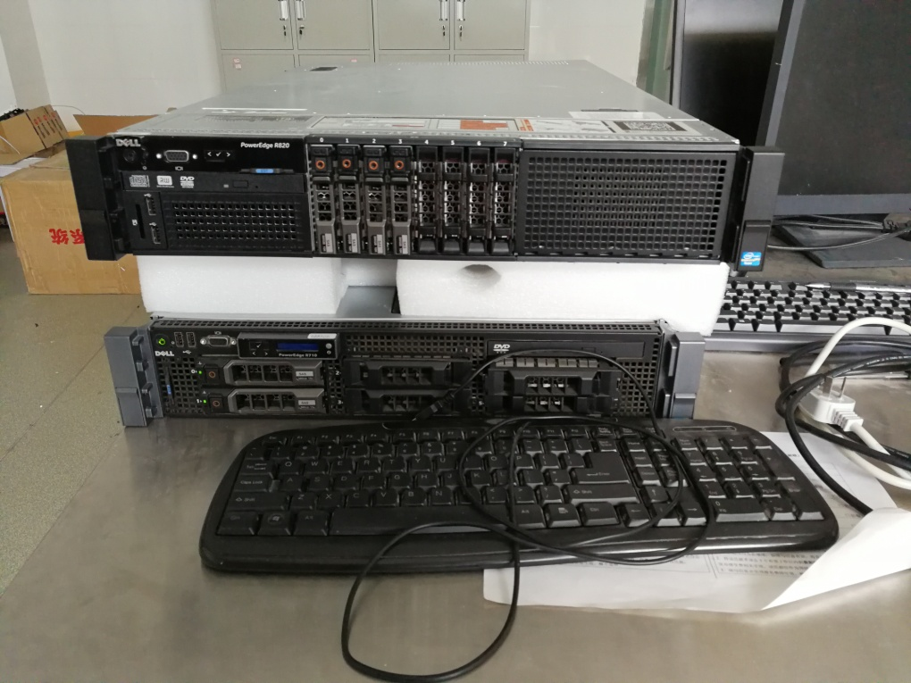

Photo Windows Servers

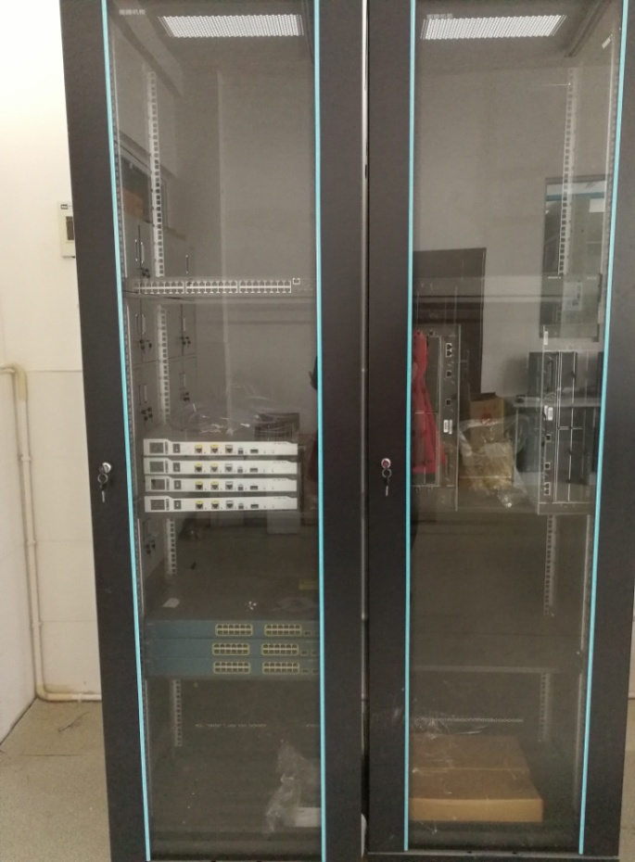

Photo Routers and Switchers

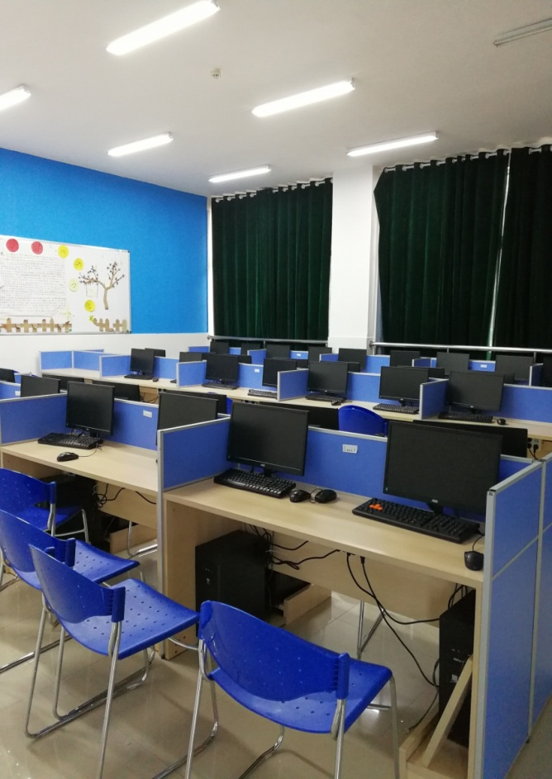

Photo Classroom for Lab

## Employment/OJT

### Employment information of students

No graduates yet.

### Any updates on status of industry and OJT partners?

We have several educational partners providing training opportunities and course contents to help students developing technical advantages and preparing examination for certificates

|  |  |  |  |
| --- | --- | --- | --- |
| **Name of Company** | **Contact Person** | **Tel** | **Address** |
| Jiaxin Educational Tech Ltd. | Pan Ritao | 13208028486 | Jinyang Technology Industry Campus B401, Guiyang High Tech Zone |
| Micro Study Educational Tech Ltd. (Microsoft partner) | Huang Jianguo | 13628569326 | Huangguoshu Plaza A13-3, Zhonghua North Rd. 126, Guiyang |
| Chongqing Direct Info Tech Ltd. | Zhou Jisong | 18523417007 | Micro-electronics Industry Campus, Shapingba District, Chongqing |

## Others

### Strengths of our EJV

* Mutual beneficial
* The very few EJV program approved by Department of Education of China among all vocational schools in Guizhou
* Very experienced instructors and project management team from both sides

### Challenges of our EJV

* Language barrier
* Professionalism and language skills of Chinese instructors
* How to guarantee the quality procedure been executed with the absence of
  + a mechanism designed to ensure the procedure
  + key participants
* Culture and environment limitations

### Additional comments

No comments yet

## Recommendation Updates

Since in China networking and communication equipments market is dominated by Huawei, we are now using text books and teaching materials which are matched up with lab equipments provided by Huawei and subsidiary companies such as H3C. We recommend CNT program running in China reflects the marketing needs of technicians familiar with technologies and equipments from local suppliers.