🟢 Verbs Starter:  - rise  - fall  - freeze  - melt  - float  - rotate | 🟠 Intermediate:  - occur  - expand  - contain  - react  - support

PRESENT SIMPLE – SPECIAL CLASS
Student: ……………………………………………. Date: …… /…… /……..

WE USE THE PRESENT SIMPLE FOR:
🔹 1 – Facts & Things That Always Happen
📝Examples:
Water boils at 100°C.
Earthquakes occur around fault lines.

🔹 2 – Routines & Habits
🟢 Verbs Starter:  - wake up  - brush  - eat  - drink  - go  - sleep | 🟠 Verbos Intermediários:  - commute  - manage  - prepare  - exercise  - avoid

📝 Examples:
I wake up at 7.
She commutes to work by bus.

🔹 3 – Timetabled Events
🟢 Verbos Básicos:  - start  - finish  - leave  - arrive  - open  - close | 🟠 Verbos Intermediários:  - depart  - resume  - broadcast  - operate  - land

📝 Examples:
The train leaves at 8.
The show resumes after the break.

🔹 4 – Plots (Stories, Films, Plays)
🟢 Verbs Starter:  - live  - find  - travel  - meet  - help  - run  - fall | 🟠 Intermediate:  - struggle  - betray  - reveal  - transform  - explore

📝 Examples:
A girl finds a magical door.
He struggles to survive on the island.

🔹 EXTRA FREE TIME & WORK ACTIVITIES
GO | out/ for a walk/ clubbing / running / shopping
GO TO | the beach/cinema /concerts / the gym
GET | dressed/ready
PUT sth ON | Makeup / clothes / shoes
PLAY | Sports / video games / board games with friends/family
DO | exercise/ laundry / groceries
HAVE | a lie in / a night in / some friends over
MEET UP | with friends
VISIT | VISIT relatives
WATCH | Movies / netflix / tiktok/youtube
READ | Books / the news / articles
EAT | Out / in
LISTEN TO | music / a podcast / an interview
ORDER | in / ifood
HAVE/ ATTEND | a meeting
CHECK / REPLY/ WRITE | emails
DRIVE/ COMMUTE | To work
LEAVE | to work/ home
ARRIVE | From work / at home
CLOCK | in / out
RUN | errands
MEET | a deadline
CALL | in sick
DO | overtime

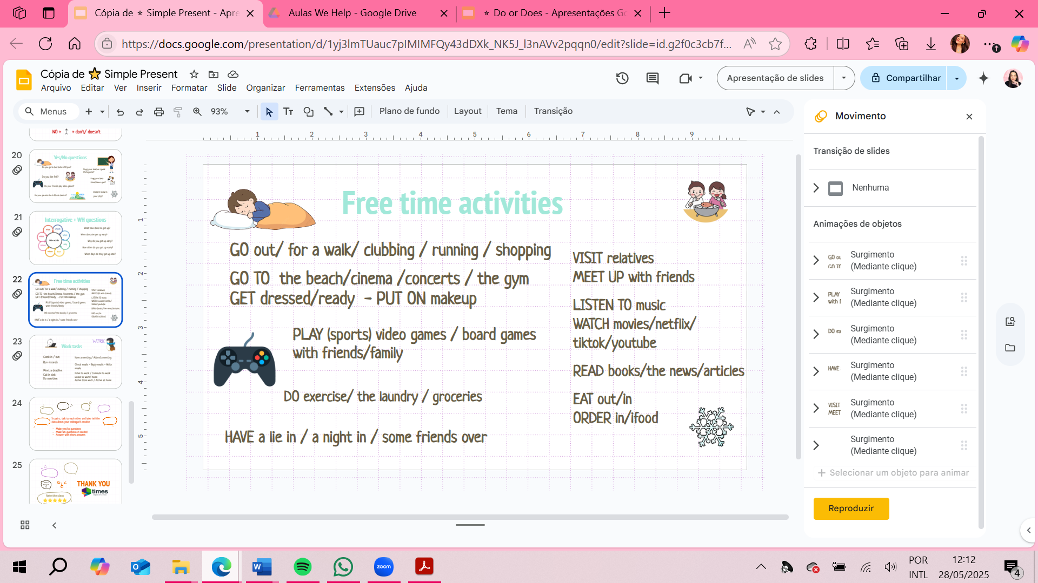

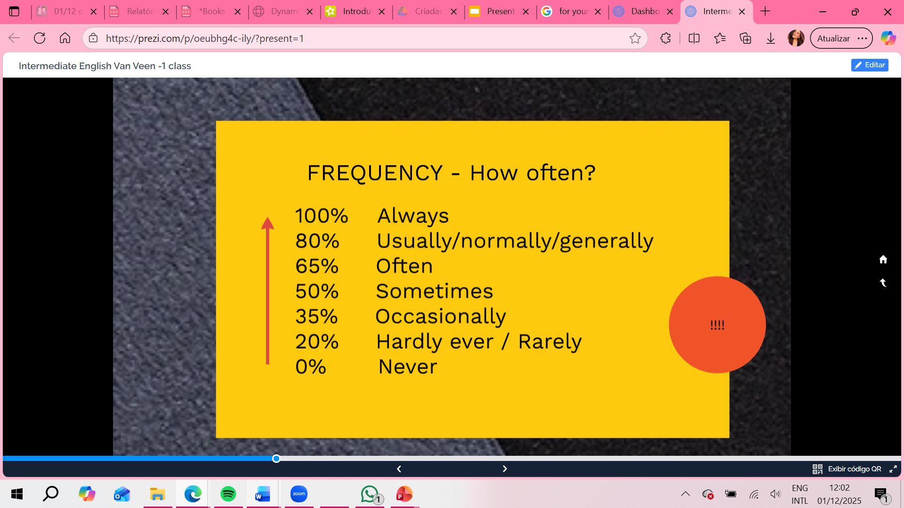
SUBJECT + FREQUENCY ADVERB + VERB = I OCCASIONALLY EAT BURGUERS
I USUALLY GO FOR A RUN IN THE MORNING

