Scanned Document
March 04, 2026 21:07
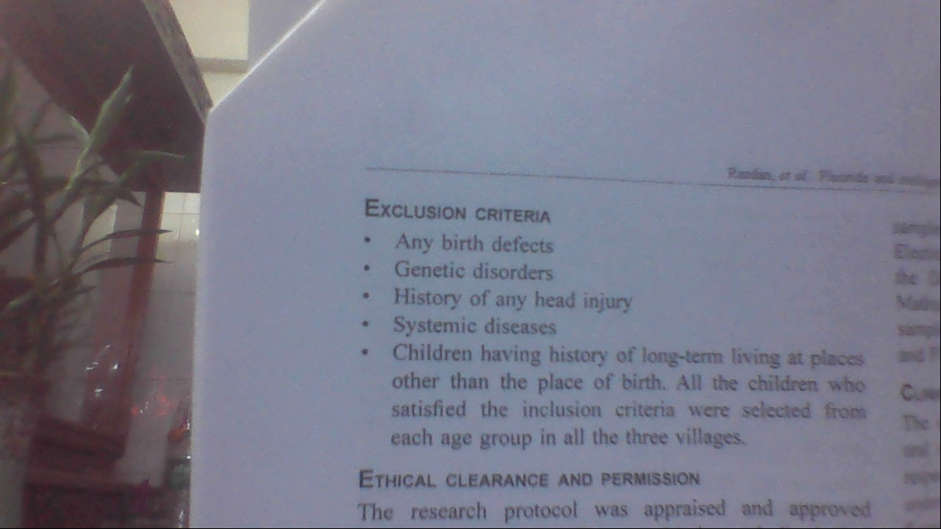
Extracted Text
\y Y
\ AON;
N\ , c\.
oo LVL! | | EXCLUSION CRITERIA a:
J tale - Any birth defects Es:
0 gE * Genetic disorders Ast
aa 7 * History of any head injury Ne.
- * Systemic diseases ST
noe * Children having history of long-term living at pisces 55?
eM other than the place of birth. All the children who q.-
or satisfied the inclusion criteria were setected from ms
re i ¢ : ench nage group in all the three villages. _
aa” ETHICAL CLEARANCE ANO PERNISSION ; ae
¥ The research protocol was appraised and appmvad -

