Project: PAGE

Team members:

Kaspar Kesli

Joosep Heinmets

Rainer Keerdo

Page prototype layout:

When the user first logs in, this page is shown. Main elements

* Logo/banner (on the top)
* Quick links, may include quick searches (one, two, three)
* Login button
* Search box:
  + Text search for names
  + Drop-down menus for locations
  + Slider for price indication
  + Service selection checkboxes
  + Search button
* Content box (contains text)

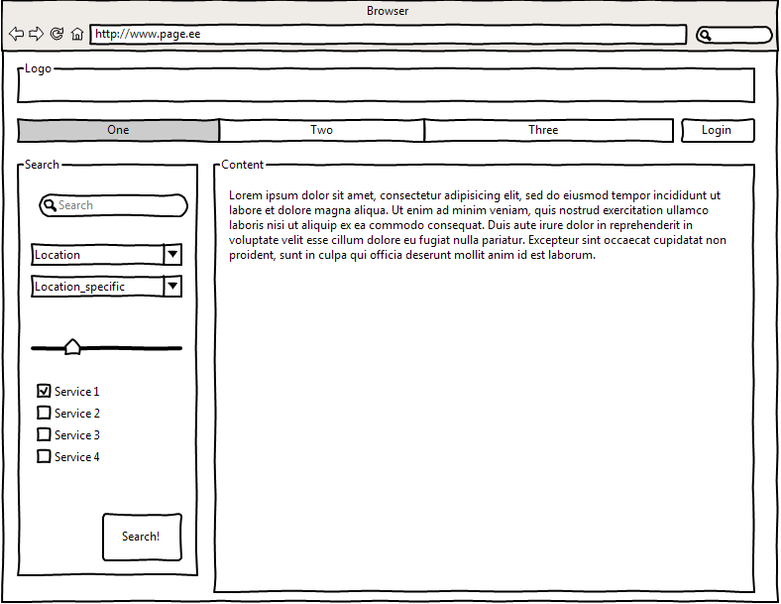

When a search is conducted, the following results page is shown (replaces the previous contents). The box will be scrollable, if there are enough search results.

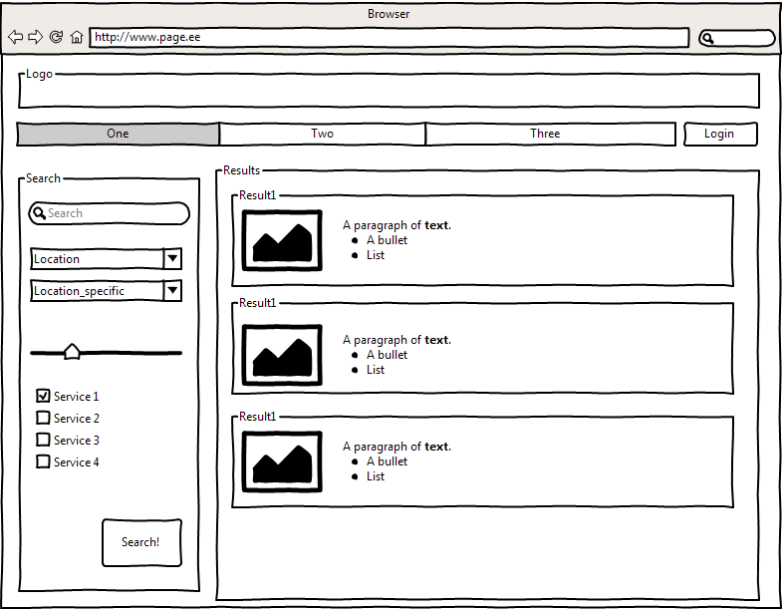

When a search result is selected, the following detailed result page is shown.

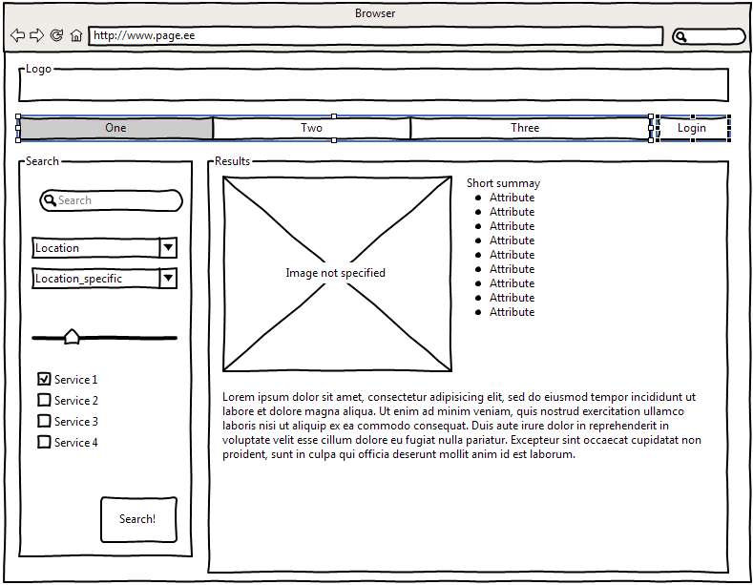

When the login button is pressed, a login screen appears.

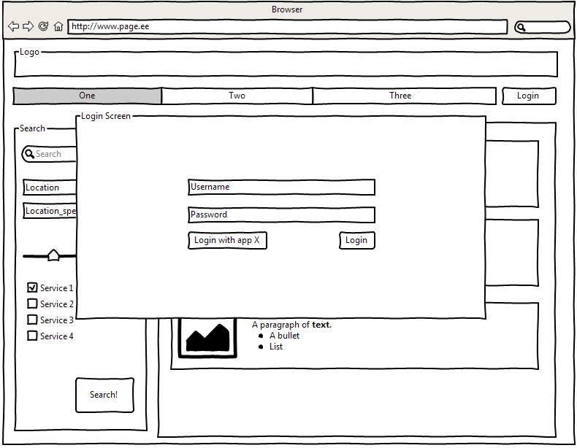

If the user is successfully logged in, the login button is replaced with „Logged in as x“.

