四 川 大 学 计 算 机 学 院、软 件 学 院
实 验 报 告
学号： 2022141460180 姓名： 封欢欢 专业：计算机科学与技术 班级： 行政4班 第 14-15 周
课程名称 | 操作系统课程设计 | 实验课时 | 4小时
实验项目 | 奖励实验 | 实验时间 | 第14周到第15周
实验目的 | 运用操作系统的相关知识(作业调度、互斥访问等)解决一个现实使用场景的问题；
实验环境 | HUAWEI电脑 Clion2024.1.1
实验内容（算法、程序、步骤和方法） | 实验内容：  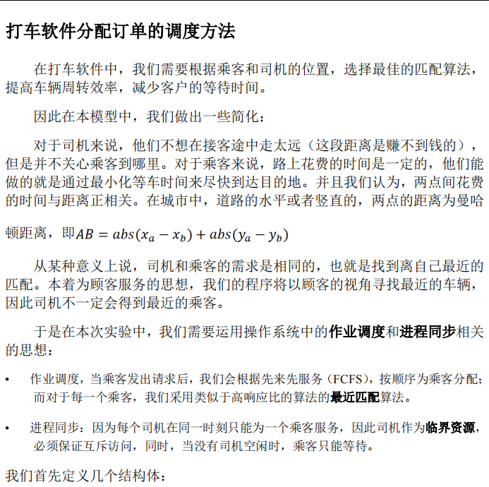  程序：  #include <iostream>  #include <Windows.h>  #include <conio.h>  #include <fstream>  #include <queue>  #include <vector>  #include <cmath>  #include <utility>  using namespace std;  #define sleep(n) Sleep(n*1000)  struct ThreadInfo {  int tid; // 线程ID  char role; // 扮演角色 P or C  double delay; // 线程延迟  double persist; // 线程读写操作持续时间  int x, y; // 乘客或司机的位置  };  HANDLE mutex;  HANDLE driverAvailable;  HANDLE passengerWaiting;  queue<ThreadInfo*> passengerQueue;  priority_queue<pair<int, ThreadInfo*>, vector<pair<int, ThreadInfo*>>, greater<pair<int, ThreadInfo*>>> driverQueue;  int calculateDistance(ThreadInfo* passenger, ThreadInfo* driver) {  return abs(passenger->x - driver->x) + abs(passenger->y - driver->y);  }  void DriversThread(LPVOID lpParam) {  ThreadInfo* info = (ThreadInfo*)lpParam;  sleep(info->delay); // 模拟延时时间  printf("Driver thread %d is ready to take a ride request.\n", info->tid);  WaitForSingleObject(mutex, INFINITE);  driverQueue.push({info->tid, info});  ReleaseSemaphore(driverAvailable, 1, NULL);  ReleaseMutex(mutex);  // 等待乘客匹配  WaitForSingleObject(passengerWaiting, INFINITE);  WaitForSingleObject(mutex, INFINITE);  // 匹配乘客  if (!passengerQueue.empty()) {  ThreadInfo* passenger = passengerQueue.front();  passengerQueue.pop();  ReleaseMutex(mutex);  printf("Driver thread %d is picking up passenger %d.\n", info->tid, passenger->tid);  sleep(info->persist); // 模拟持续时间  printf("Driver thread %d finished the ride.\n", info->tid);  } else {  ReleaseMutex(mutex);  }  }  void PassengersThread(LPVOID lpParam) {  ThreadInfo* info = (ThreadInfo*)lpParam;  sleep(info->delay); // 模拟延时时间  printf("Passenger thread %d requests a ride.\n", info->tid);  WaitForSingleObject(mutex, INFINITE);  passengerQueue.push(info);  ReleaseSemaphore(passengerWaiting, 1, NULL);  ReleaseMutex(mutex);  // 等待司机匹配  WaitForSingleObject(driverAvailable, INFINITE);  WaitForSingleObject(mutex, INFINITE);  // 匹配司机  if (!driverQueue.empty()) {  auto driverPair = driverQueue.top();  driverQueue.pop();  ReleaseMutex(mutex);  printf("Passenger thread %d is being served by driver %d.\n", info->tid, driverPair.second->tid);  sleep(info->persist); // 模拟持续时间  printf("Passenger thread %d finished the ride.\n", info->tid);  } else {  ReleaseMutex(mutex);  }  }  int main() {  DWORD n_thread = 0; // 线程数目  DWORD thread_ID; // 线程ID  // 线程对象数组  HANDLE h_thread[20];  ThreadInfo thread_info[20];  // 创建信号量和互斥量  driverAvailable = CreateSemaphore(NULL, 0, 10, NULL);  passengerWaiting = CreateSemaphore(NULL, 0, 10, NULL);  mutex = CreateMutex(NULL, FALSE, NULL);  // 读取输入文件  cout << "Drivers and Passengers simulation:" << endl;  cout << endl;  ifstream inFile;  inFile.open("../data2.txt");  if (!inFile) {  printf("Error opening file!\n");  return -1;  }  string s;  getline(inFile,s);  while (inFile >> thread_info[n_thread].tid) {  inFile >> thread_info[n_thread].role;  inFile >> thread_info[n_thread].delay;  inFile >> thread_info[n_thread].persist;  inFile >> thread_info[n_thread].x;  inFile >> thread_info[n_thread].y;  n_thread++;  }  inFile.close();  // 创建线程  for (int i = 0; i < n_thread; i++) {  if (thread_info[i].role == 'P' || thread_info[i].role == 'p') {  h_thread[i] = CreateThread(NULL, 0, (LPTHREAD_START_ROUTINE)(PassengersThread), &thread_info[i], 0, &thread_ID);  } else if (thread_info[i].role == 'D' || thread_info[i].role == 'd') {  h_thread[i] = CreateThread(NULL, 0, (LPTHREAD_START_ROUTINE)(DriversThread), &thread_info[i], 0, &thread_ID);  }  }  // 等待所有线程结束  WaitForMultipleObjects(n_thread, h_thread, TRUE, INFINITE);  cout << endl;  printf("All drivers and passengers have finished their operations!\n");  _getch();  return 0;  }
数据记录  和计算 | 其中data2.txt内容如下：  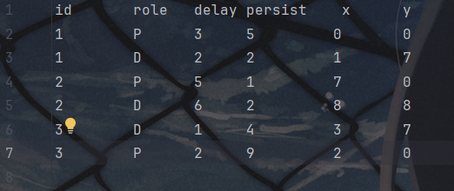
结 论  （结 果） | 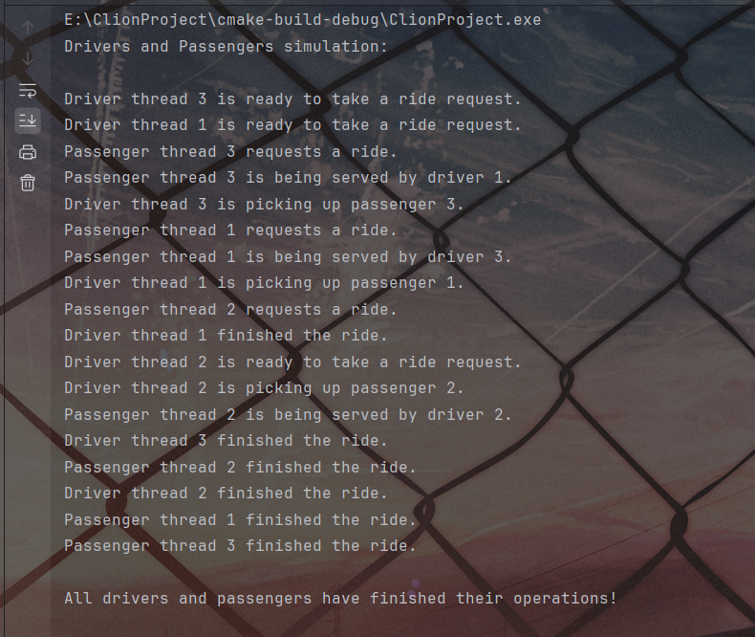  发现输出结果和理论结果一直，实验成功。
小 结 | 通过此次实验，加深了我对作业调度、互斥访问的理解，并且发现操作系统的相关知识的思想在现实使用场景中的应用也屡见不鲜；
指导老师评议 | 成绩评定： 指导教师签名：

