https://la-miller.github.io/less-project/

https://github.com/LA-Miller/less-project

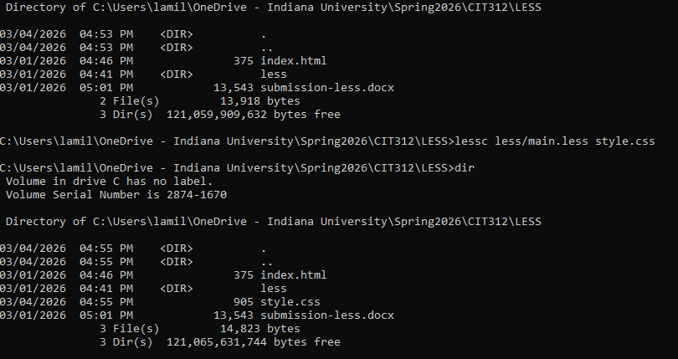
I used the LESS CSS preprocessor for this project.
All styles were written in the /less directory and then the style.css file was generated using:
lessc less/main.less style.css

