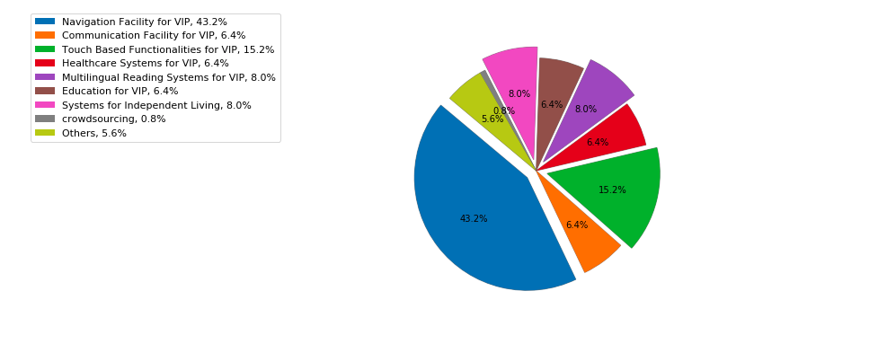

Work done in different areas for VIP in past 20 years

On the basis of the analysis performed for the various assistive technologies and publications to facilitate the lives of Visually Impaired People (VIP), it was found that the maximum work has been done for facilitating navigation or creating walking assistants for the VIP that includes obstacle detection and avoidance features, pathway finding in schools, colleges, etc. Also, some of the proposed work and technologies included various other systems for independent living such as semi-autonomous vehicles, easy shopping, etc. But, it is evident from the results that there is less work done for the education of these people or to facilitate communnication. Thus, there is a need of technology in the education sector so that these people can read, learn and study just like other people.

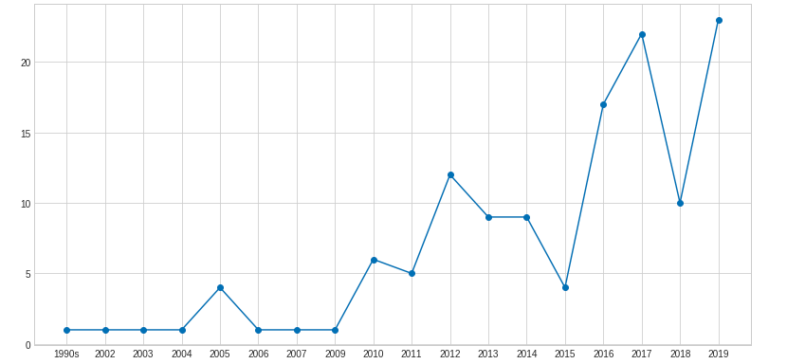No. of publications for each year

Research Status (Indian and International)

**Walking Assistant and Navigation Facilities**

The development of walking assistants for visually impaired people has become a prominent research area in India due to the rapid growth of these individuals in recent decades and difficulties they face.[2] This functionality is based on various field including sensors, computer vision, and smartphone-based walking assistants.[8] The main idea has been to enhance the utility of traditional navigational aids to produce solutions that are more reliable. The proposed designs involves Electronic Travel Aids (ETAs), Electronic Orientation Aids (EOAs), and Position Locator Devices (PLDs). [105]

There has been a constant development of systems to facilitate real-time obstacle detection and avoidance application for visually impaired people(VIP) individuals to assist them in navigating independently in indoors environments. Some researches also proposed a new multiobject recognition framework. It consists of coarsely checking the presence of multiple objects in a portable camera-grabbed image at a considered indoor site. [89]

**Use of Assistive Technology for Teaching-Learning and Administrative Processes for the Visually Impaired People** Some new features are proposed to facilitate easy communication for VIP with each other and also with other people. Along with that, advanced assistive technology is developed to help a person improve his administrative capabilities. These devices can help the administrator with augmentive communication when his spoken communication is not sufficient.[40]

The explosive growth of visual data both online and offline in private and public repositories has led to urgent requirements for better ways to index, search, retrieve, process and manage visual content. Automatic methods for generating image descriptions can help with all these tasks, and also play an important role in assistive technology for the visually impaired.

**A comprehensive digital environment for visually impaired students**

The study developed an information system DigitVaran to assist visually impaired undergraduate students in India. The system will help them to access the study materials and make aware of various extracurricular activities of the institutions. An increasing amount of information content used in school, work, and everyday living is presented in graphical form. [52]