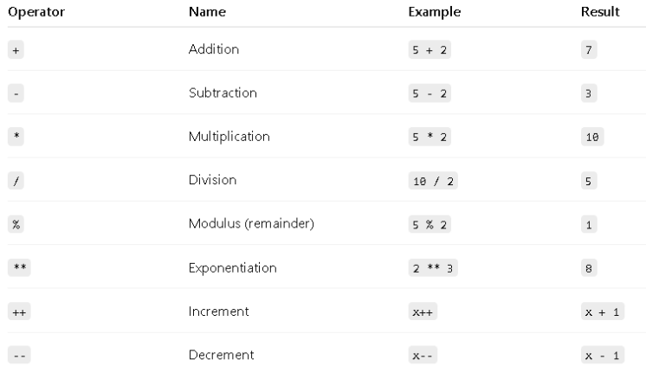In JavaScript, variables are containers for storing data values. You can think of them as labels for data that your program uses.

**Declaring Variables**

There are three main ways to declare a variable in JavaScript:

1. var – (old, mostly avoided now)
2. let – block-scoped, can be updated
3. const – block-scoped, cannot be reassigned

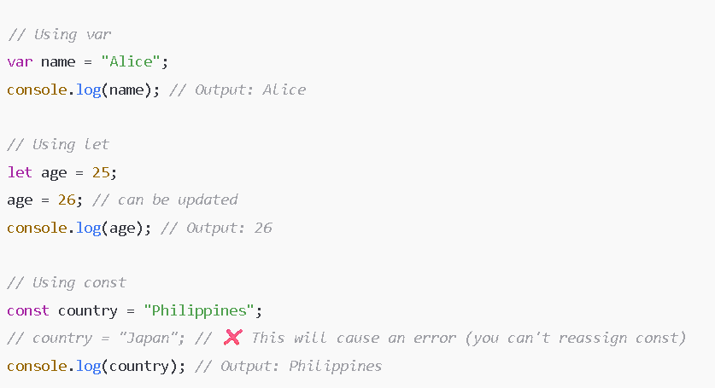Data types:  
Primitive data types

* are the basic building blocks of data in JavaScript. They represent single, simple values, and do not have properties or methods (unlike objects).

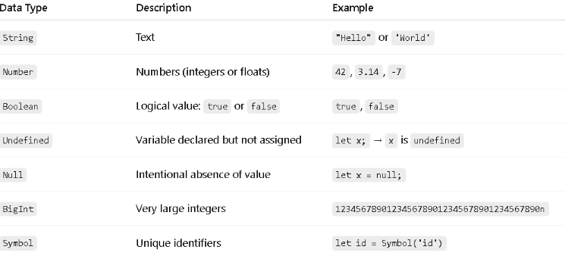Non-Primitive data type

* also known as reference types, are data types that can store multiple values or more complex data. Instead of holding the actual value, a variable holds a reference (memory address) to the data.

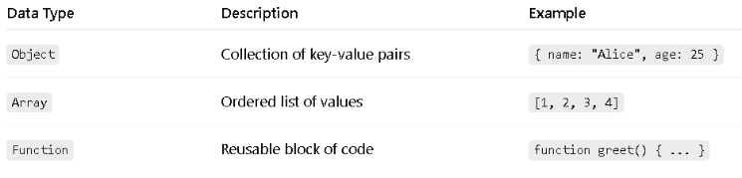Operators - are symbols used to perform operations on values (variables and data). They are essential for calculations, comparisons, logic, and more.

Arithmetic Operators - Used to perform basic math.

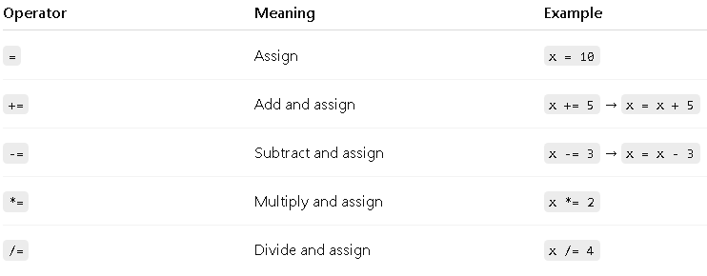Assignment Operators - Used to assign values to variables.

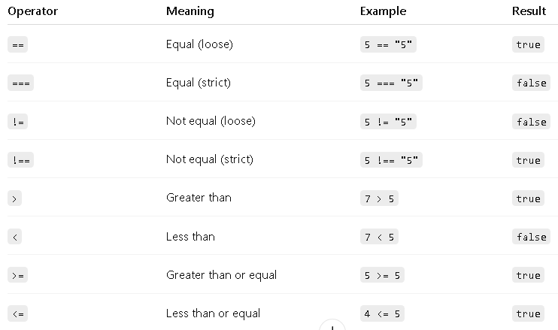Comparison Operators - Used to compare values.

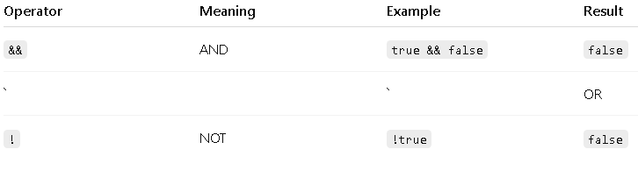Logical Operators - Used for logic conditions (often in if statements).

What is conditional - are used to make decisions in your code. They allow your program to execute certain blocks of code only when specific conditions are true.

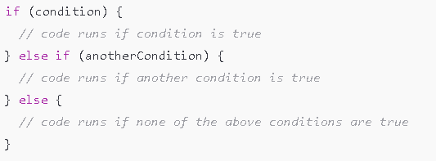if Statement - Used to run a block of code if a condition is true.

switch Statement - Used when you want to test many conditions based on the same value (more readable than many if-else if statements).

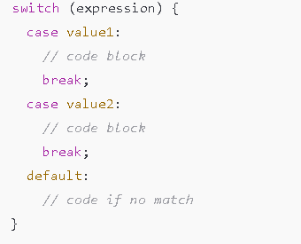JavaScript Loop - are used to repeatedly execute a block of code as long as a condition is true. There are several types of loops, and the most common ones are:

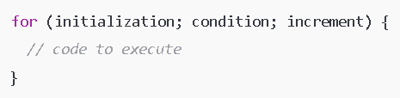for Loop - Used when you know how many times you want to loop.

forEach() - A method used on arrays to run a function once for each element.

for...in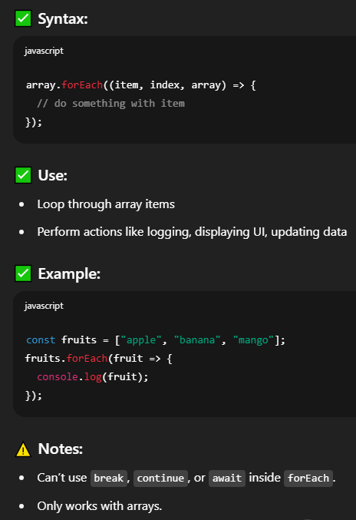 - A loop used to go through object keys (property names).

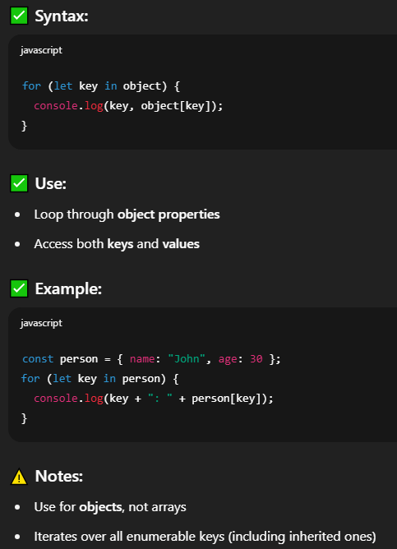

for...of - A loop used to go through values of iterable objects like arrays, strings, sets, etc.

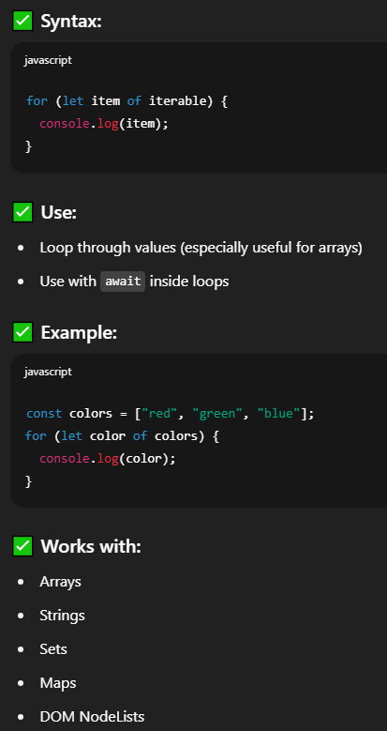

while Loop - Used when you don't know in advance how many times you want to loop, but you know the condition.

do...while Loop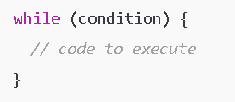 - Similar to while, but guarantees the code runs at least once, even if the condition is false initially.

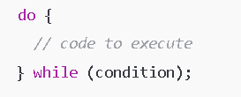Loops Summary:

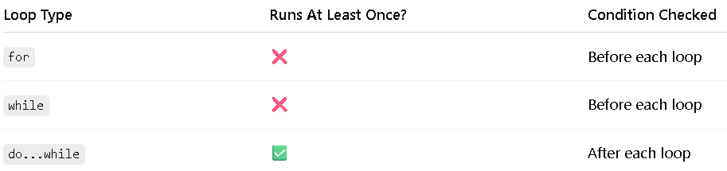JavaScript – Function

are blocks of reusable code that perform a specific task. They are fundamental to structuring programs and are used for:

* Code reuse (you write once, use many times)
* Modular programming (breaking code into smaller parts)
* Abstraction (hiding implementation details)

1. 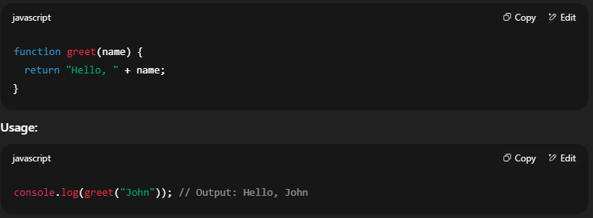Normal (Traditional) Function
2. Arrow Function (ES6)

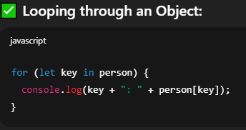JavaScript, Arrays and Objects are data structures used to store and organize values. They are essential building blocks for managing and manipulating data in your code.

1. Arrays - is an ordered list of values (called elements), indexed by numbers starting from 0.

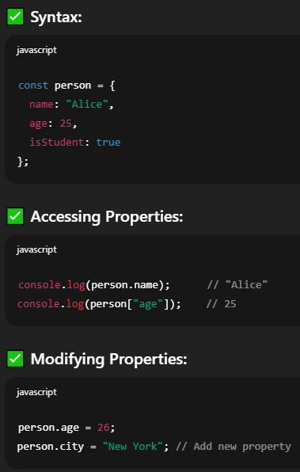2. Objects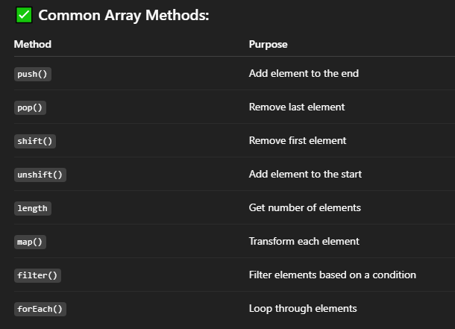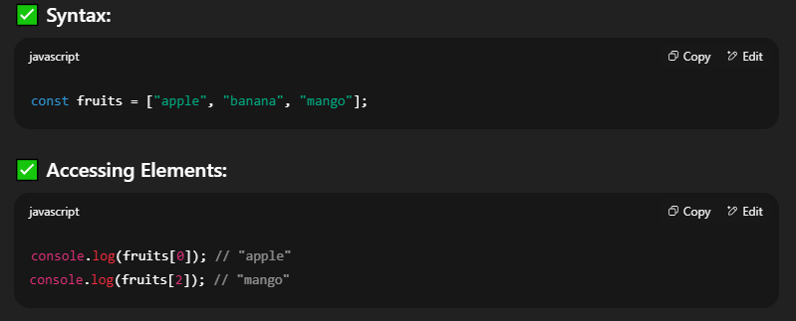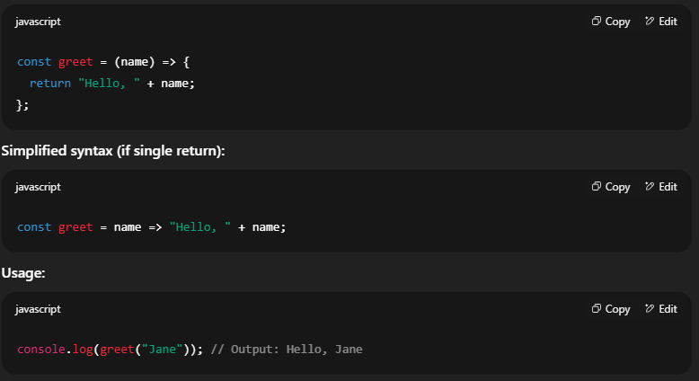 - is a collection of key-value pairs, where each key is a string (or symbol), and each value can be any data type.