**GEO115 PROGRAMMING IN GIS**

**Topic: Week 3**

**Submitted to: Alireza Ghaffari**

**Submitted by: Chetan Chavan**

**Student Number: A00148718**

TASK 1

TASK 2

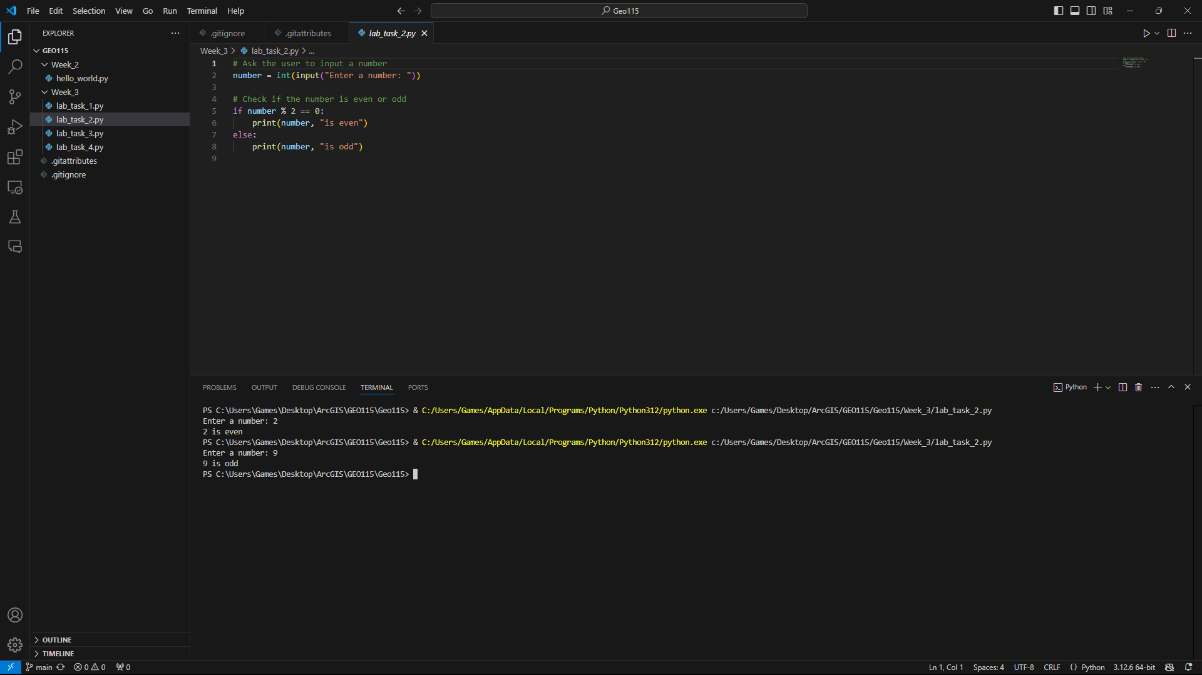

TASK 3



TASK 4

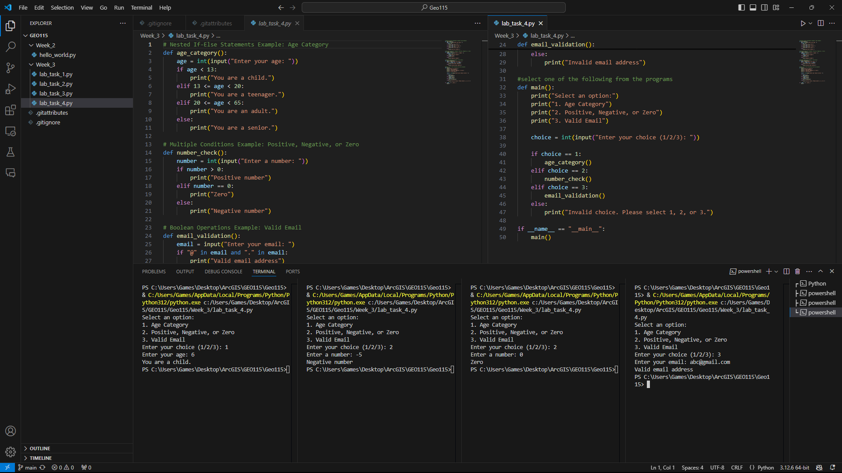

GitHub Push

