**L**atin **A**merican and **C**aribbean **C**onsortium of **E**ngineering **I**nstitutions

**The OAS Summit of Engineering for the Americas**

**22nd LACCEI International Multi-Conference for Engineering, Education and Technology**

*“Sustainable Engineering for a Diverse, Equitable, and Inclusive Future at the Service*

*of Education, Research, and Industry for a Society 5.0.”*

{{description}}

{{authors}}

______________________________________

Libis Valdez, PhD.

LACCEI President

______________________________________

María M. Larrondo Petrie, PhD.

LACCEI Executive Director

**Virtual Edition**

**Dec. 2 - 4, 2024**

**{{title}}**

**{{paperID}}**

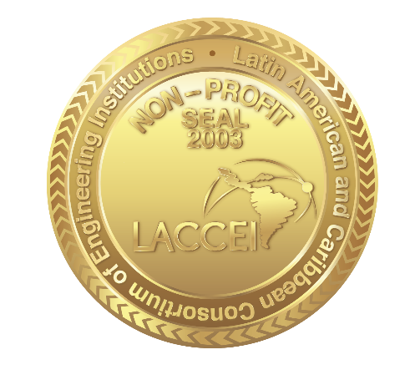

**Date received:** {{paper_submitted}}

**Date of acceptance:** {{acceptance_date}}