- Provide a detailed explanation of regression in coding, its uses, and provide an example.
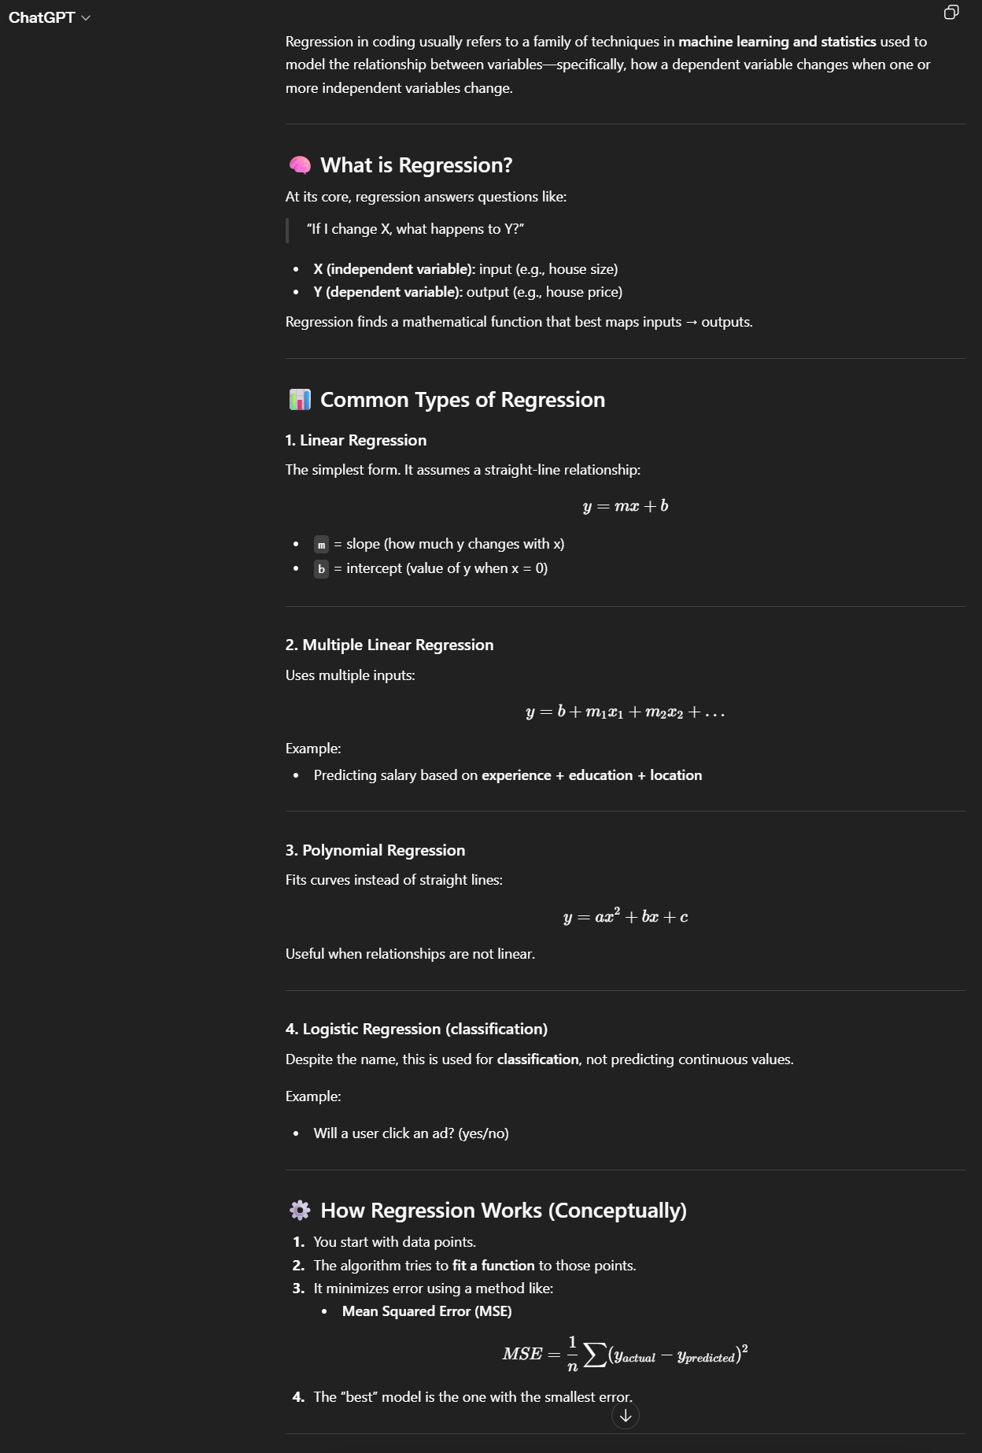
- Explain what SQL is, what it is used for, and why it is preferred over other databases (it’s benefits)
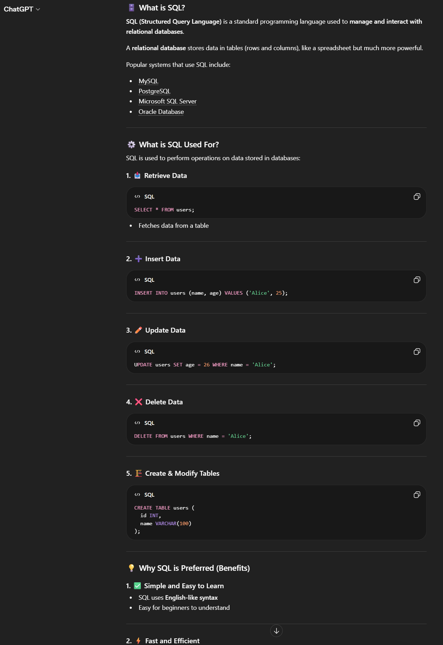
- In the effort of learning SQL and Excel, create a slightly complex dataset with multiple factors to work with
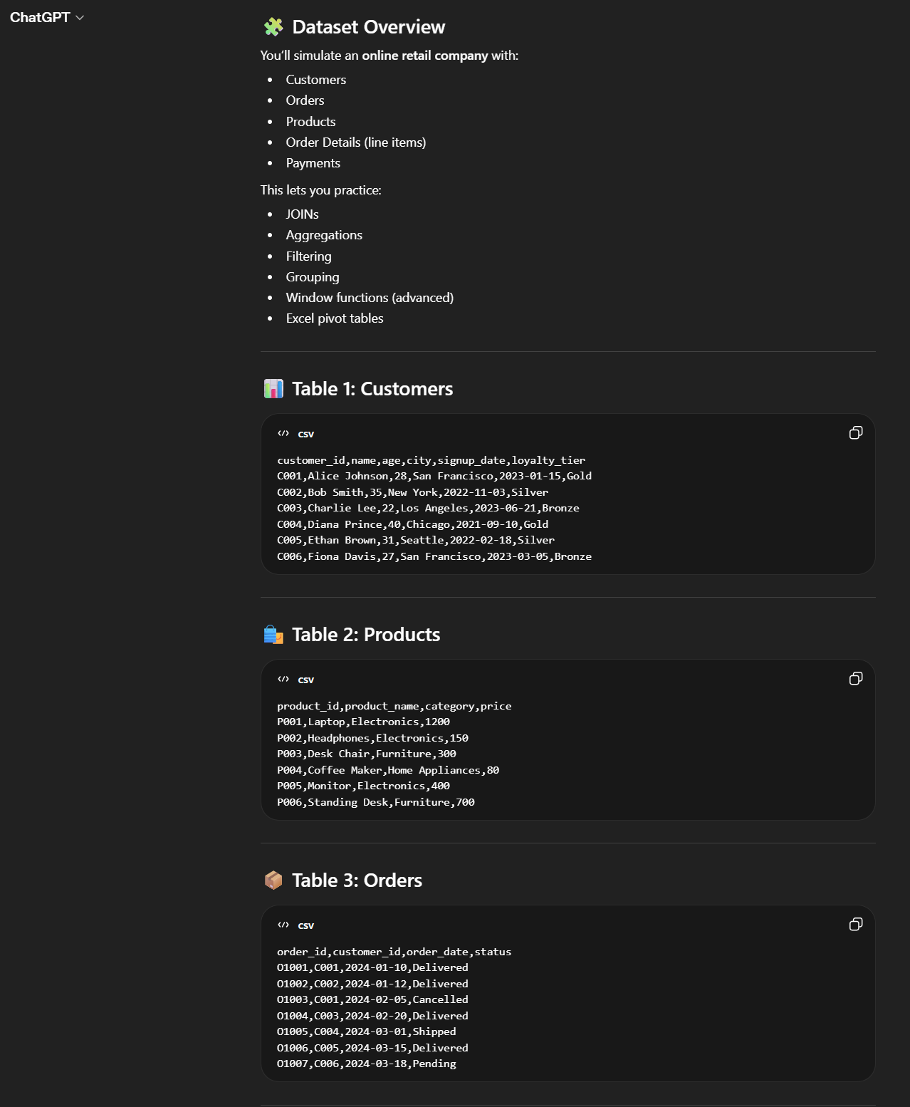
My revised prompts are stronger because they ask for detailed explanations, use cases, examples, and provides context when necessary.

