BATTLETECH: Strike Brigades
By Herbert Elwood Gilliland III, CDT Agent Level 2

See Quick Start Guide at the end of this document for a step-by-step, but please read on to understand more:

CONTEXT: “Strike Brigades” lets you create and deploy novice-to-legendary mechwarriors to pilot a variety of combat assets and be supported by battlefield support, and is tailored to a mixed structure of games that involve both the rules of Total Warfare, and the rules of Alpha Strike.

An ongoing campaign model for BATTLETECH, “Strike Brigades” attempts to inject some roleplaying and war chest campaign management options into regular recurring games, with some flexibility not present in current campaigns and it derives some of its mechanisms from various Catalyst rulebook assets, specifically Mercenaries, Aces, Campaign Operations and other adventure modules.

This document describes a campaign that eliminates a lot of the corner cases and keeps the rules as streamlined as possible, yet as flexible as possible.

Books used: CORE, Mercenaries, Campaign Operations

The Metrics of Points and Their Equivalents

This “War Chest” campaign system (Strike Brigades) are based on various campaign rulesets from Catalyst. The War Chest is filled with Warchest Points (WP). WP are equivalent to Support Points (SP).

1 WP = 10 SP (or 100,000 CB)
1 SP = 10,000 CB (base, or use Scaling Formula)

(The Scaling Formula: For larger-scale forces (like a Battalion or Regiment, not applicable to a lance), the system introduces a Base Force Size Modifier (BFSM) and Tech Ratings to prevent the economy from breaking. ergo Depending on how large your mercenary group is, 1 WP can yield anywhere from 10,000 CB to 15,000+ CB)

1 PV is 1/50th BV
For Light ‘Mechs, though, 1 PV is 1/30th BV (1/29th actually)
Medium / Heavy ‘Mechs, 1 PV is 1/39th BV
Each Player Runs a Brigade

You establish your suite of 8 pilots in a brigade, then spend your BV to assemble a weapons cache. You draw from your cache to deploy in a mission. A mission is generated from a contract offered by the GM, and augmented at time of battle by the appropriate campaign augmentation tables. A contract can augment a deployment with additional forces that work for or against a given side. Contracts can have up to any number of sides, though in a 1v1 game it is 2 sides, in 1v1v1 it is 3 sides, etc, to satisfy the needs of the game day.

The choice between Alpha Strike and Total Warfare rules must be decided prior to the acceptance of the contracts, or announced as an upcoming store event. For example, in our local store, we are using TW alternating with AS every other session. Our recurrence is once a month but could happen more frequently.

Regardless of the cache a player has, a contract (provided by GM) limits the amount of BV or PV spent on a single contract. GM is a facilitator of creating a balanced experience (or unbalanced for narrative purposes). It’s a good idea for GMs to come with one or more follow ups on a particular day, or use tables to modify the scenario.

Onboarding a Player’s Team (Generation once per player entering campaign)

A player is given a number of points to spend on a set amount of Pilot Personalities. The player may randomly select or author the backstory of pilots. To do this, players are given Pilot Personality Points. These points are spent by subtracting from PS and GS numbers. These pilots represent the primary commanding officers as part of a “special team force” that aligns with one of the following:

- Inner Sphere Faction “Great House”
- Splinter Faction
- Clan / ilClan
- Elite Mercenary Group
- Realm Force (Periphery)
- Other Force (LosTech hunters, Dispossessed, Rogue faction)

See “Powers Breakdown” section later in this document.

Choose a backstory and name your team:

- Debt to the faction house for all squad pilots
- Feudal blood oath by Brigade leader
- Career Opportunity, simply “Doing it for glory”
- Other (write-in) / use Force Background table

To determine your force bravado:

In our test run, the campaign allows each player to have a bank of 8 Brigade Mech Pilots.
The total number of points to distribute is equal to the number of pilots times 3 (24 for 8).

Steps to make the Brigade Pilots Table:
- Write the name of each pilot on a single line in a spreadsheet or notebook page. The columns should be similar to this sheet: Pilot Sheet - BattleTech War Chest Campaigns: Strike Brigades
- Assume the day they left the academy or were given the keys to their first mech they had 6 Piloting and 6 Gunnery as a passing score.
- Using points from the assignment pool, subtract from Piloting and Gunnery to create variation among the pilots. Individual pilots cannot subtract more than 3 Gunnery and 4 Piloting, meaning the most legendary starter you can make a starting pilot is 2 3, balanced by another pilot or pilots sacrificing improvements. Each point subtraction is the equivalent of a completed and survived mission, ultimately adding to the experience of a given pilot. (GMs: You may set a campaign-wide subtraction if you want more extreme combat, for example saying “all pilots start with 4 5 or 3 4 or 4 4”)
- Accumulating confidence: All pilots start with 0 modified gunnery skill and 0 modified piloting skill.

Gaining and spending mission confidence for veteran pilots during an encounter

- Each time a mechwarrior successfully hits its target, add 1 gunnery tick. After the accumulation of 10 ticks, a mechwarrior gains 1 in modified gunnery skill.
- Each time a mechwarrior successfully completes a PSR, add 1 piloting tick. After the accumulation of 10 ticks, a mechwarrior gains 1 in modified piloting skill.
- Mechwarriors may spend their modified skill to modify rolls during future turns. Modified skill points are spent 1 time and subtracted from the pilot’s modified skill. For example if a player opts for a pilot skill roll to pass but requires spending 2 of their 3 modified skill, they can modify the roll but are left only with 1 modified skill.
- If the pilot ejects all modified confidence points are set to 0 for both gunnery and piloting.

Starting Capital

Each Brigade, whether it works for Word of Blake, Scorpion Empire, Wolf Clan or House Kurito (Draconis Combine), is allocated an initial spend from their treasury. Even though in name a brigade may not be mercenarial, budgets are budgets and there are bottom lines, so all brigades will share the same. See the sample test run.

Game Phases

- Announced Mission Parameters: Ruleset, GM-decided parameters, Contract Pool
- Day-of Pre-Mission Briefing: Dice-determined Parameters, Deployment
- Mission
- Post-Mission Cleanup and Outcome

Between mission structure:

- Post-Mission Cleanup (generally done at end of previous) and Payout
- New Contract Bidding
- Purchasing Phase
- Refit / Repair Phase
- Squad Setup for Mission

Additional Mission ROE:

- Inner Sphere pilots piloting pure-IS tech lose 1, and 1 for Gunnery respectively for the mission only (while piloting the pure-IS tech)
- Death of pilot and pilot switching: Pilots that role a critical (snake eyes) when doing a PSR directly related to damage (20+ points per round, being shot in head) are “cockpit sniped” ... during battle a player may take over the mech of another side by sacrificing one combat turn if the player has moved within 1 hex. In doing so, the player can lock down their previous mech, but it remains stationary on the battlefield and cannot be remote controlled. Locked down mechs cannot be taken over, but they can be fired on and eventually destroyed.

Post-Mission Cleanup and Outcome

If a pilot dies, it is replaced by a clone with 1 higher Piloting and 1 higher Gunnery numbers with a # after its name. For each death, 1 and 1 are increased up to a maximum of 8 8, when the clone degrades to the point where the pilot is dead. This costs 10000 CB.

When a mission ends, the contract pays out based on each goal met. There may be a completion bonus for sides that dominate. Then, repair is calculated, and items can be ordered on the open market but are delayed by at least 1 contract before delivery. Deliveries and orders should be tracked on the sheet.

To make things work smoothly, here are the test run parameters:

Era: 3050-3067 (Clan Invasion)
(but we might allow other eras and tech levels as long as we can discuss it first, specifically for loadouts we like)

We gift each player a standard drop ship and long-term storage facility that can store up to 16 ‘mechs and land 4 (one lance) in the field (squeeze up to 6 if light mechs)
Each player controls 1 lance, we consider roll 6 to be the standard starting scenario

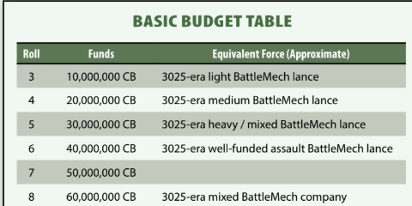
Source: Campaign Operations 4th Printing

Budget multiplier based on era: 

Initial Setup and Purchasing

- Player trains the 8 pilots (see above)
- Player christens the drop ship, name their force, and roll their background (see below)
- Player spends CB on BV/PV to purchase mechs and loadouts, getting GM approval for price and configuration, by submitting a “initial purchase order”
- Player adds ‘mech sheets to their sheet stack for tracking damage
- Players are assigned a contract and they can bid on blind goals

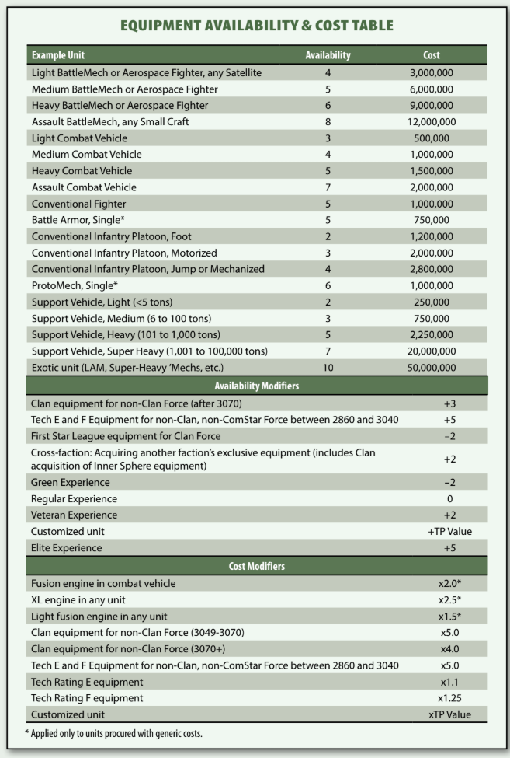
Operating Expenses (to be paid after battle)
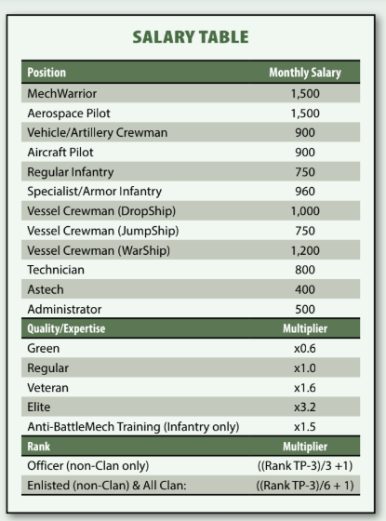

In our case, there are 8 pilots (starting) paid 1500 CB (total:12000 CB) each mission whether they spent the time in DropShip or on deployment, with expertise factored in in later scenarios.
Ship crew adds 20000 CB / month, assuming 10 crew (10000 CB and fuel costs)
At long-term storage facility 10000 CB for guards and rent per ‘Mech slot in blocks of 4 (so 40000 CB as the DropShip can only carry 4-5 to deployments ), thus:
20000 CB + 40000 CB + 12000 CB = 72000 CB initial monthly upkeep during first run to be paid after the mission, along with any repair or refit fees.

Force background bonus

This rule helps differentiate each force. Only 1 roll is made. 3D6, one time, write on Pilots sheet. Player can opt out of this random rule by making up a background that receives no bonus or penalty, or choosing the default background: A new strike brigade has been formed and funded by the <clan or IS faction>

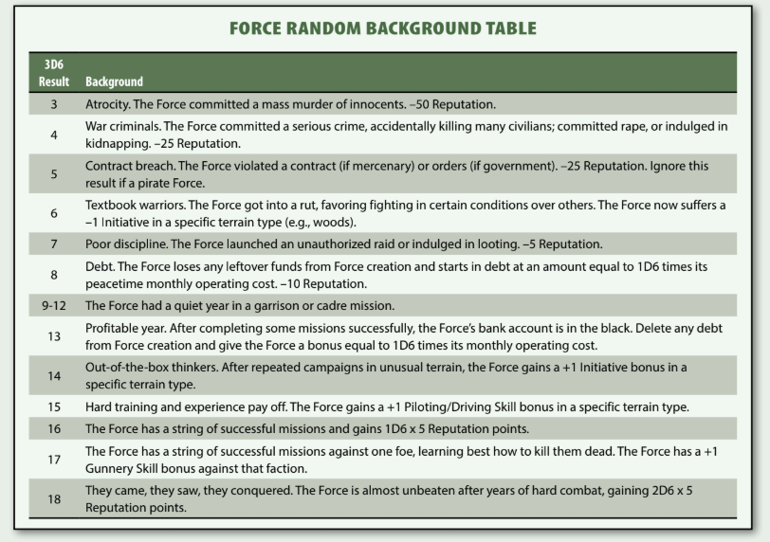

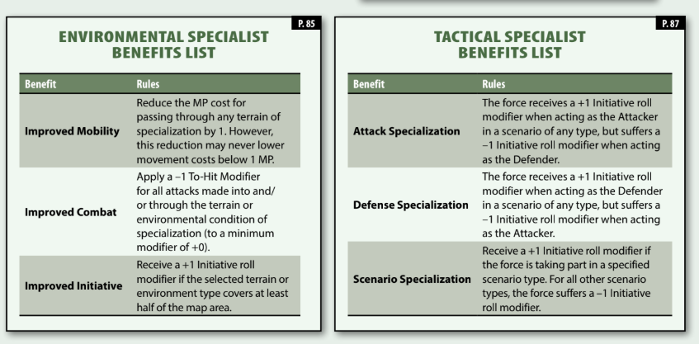

Powers breakdown: In the IlClan period the following are considered Major Powers.
- Capellan Confederation [CC]
- Draconis Combine [DC]
- Lyran Commonwealth [LC]
- Federated Suns [FS]
- Free Worlds League [FWL]
- Outworlds Alliance (Clan) [OWA]
- Rasalhague Dominion (Clan) [RD]
- Wolf Empire (Clan) [WE]
- Clan Hells Horses (Clan) [CHH]
Due to the Fortress Wall – Terra ( and the Star League) are inaccessible. Clan major powers do not normally hire mercenaries nor do they allow mercenary halls. Backstory for clans is that they are offering mission choices to a Strike Brigade within their clan. The Fortress Wall falls in 3149.
Minor Powers
- Alyina Mercantile League [AML]
- Arc Royal Liberty Coalition [ARLC]
- Clan Jade Falcon Remnant [CJFR]
- Clan Sea Fox Protectorate [CSFP]
- Clan Protectorate [CP]
- Duchy of Andurien [DOA]
- Malthus Confederation [MC]
- Rim Territories [RT]
- Tamar Pact [TP]
- Timbuktu Collective [TCO]
- Vesper Marches [VM]
Major Periphery Powers
- Magistracy of Canopus [MOC]
- Taurian Concordat [TC]
- Marian Hegemony [MH]
Minor Periphery Powers
- Fronc Reaches [FR]
- Filtvelt Coalition [FCO]
- Calderon Protectorate [CP]
- Oberon Confederation [OC]
- Tortura Dominions [TD]

Contracts

Contract have: Location (Map), Military Purpose (Type), then specific goals: Goal 1, (Goal 2, Goal 3), for each side. We use the term loosely as Contract is really meaning Mission in this campaign.

GM may specify if Goal 2 or Goal 3 is optional. Goal 1 is always required.

Contracts are agreed to before the battle begins. Contracts must involve one player v GM controlled forces, or one player versus another player, with optional GM controlled forces, scalable upward to as many players as needed, but all with conflicting goals.

Sharing Salvage: You can agree to a sliding scale with an ally on the same contract. For allies, 50/50 is the standard rule or an equal equivalent split, like 33/33/33 or 25/25/25/25 ... if this is to be adjusted, use abacus rules if agreed to by all neighbors, and write them down along with the contract payout information when agreed upon. In allied scenarios, all teams on one side share a goal.

Salvage Rights: Salvage rights are a percentage (0-100%) requested by the contractee. In exchange, it decreases payout by a logarithmic decrease. Any ‘Mech or equipment lost by a contractor who finishes a mission’s required goals will receive 100% of their own salvage. Otherwise the salvage goes to the general pool. The general pool is drawn from for the salvage rights.
See this table:

Salvage Claim | Payout Multiplier
10% | 0.9
20% | 0.78
30% | 0.65
40% | 0.5
50% | 0.4
60% | 0.35
70% | 0.25
80% | 0.1
90% | 0.05
100% | None

As the battle begins, modifications are made based on table rolling. Then, the players blind goals are revealed.

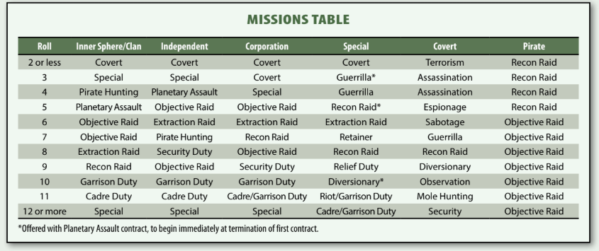

Loan systems can be entered into if the player wishes and GM allows. GM may reject loans if underwriters believe they will not be paid back before the end of the campaign series.

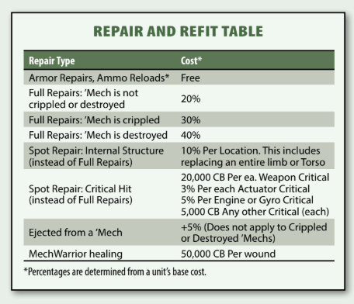
GM Section

Adjusting Opfor (Mission Multiplier)

Base OpFor Strength (The Mission Multiplier)
The fundamental modifier to an OpFor's size is determined by the Mission Type Table during contract generation. Different assignments alter the overall firepower the employer expects you to face: [1]
- Low-Intensity (e.g., Garrison Duty, Riot Duty): The OpFor is typically modified downwards. They might only field a force equal to 75% to 90% of your unit's Battle Value (BV), often heavily skewed toward conventional infantry or light vehicles.
- Standard (e.g., Raid, Planetary Assault): The baseline OpFor is usually configured at 100% to 115% of your force's total deployed BV.
- High-Risk (e.g., Breakthrough, Spearhead): The OpFor is modified upwards, granting the enemy 125% to 150%+ of your BV. Furthermore, if the OpFor's final calculated BV is more than double your force's BV, the GM designates it as a High-Risk Mission, altering your contract's operational tempo multiplier. [1]

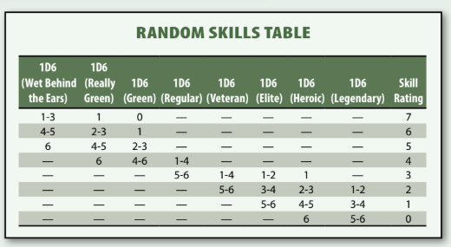
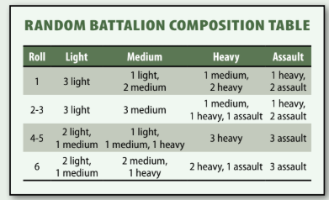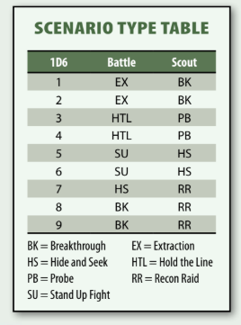

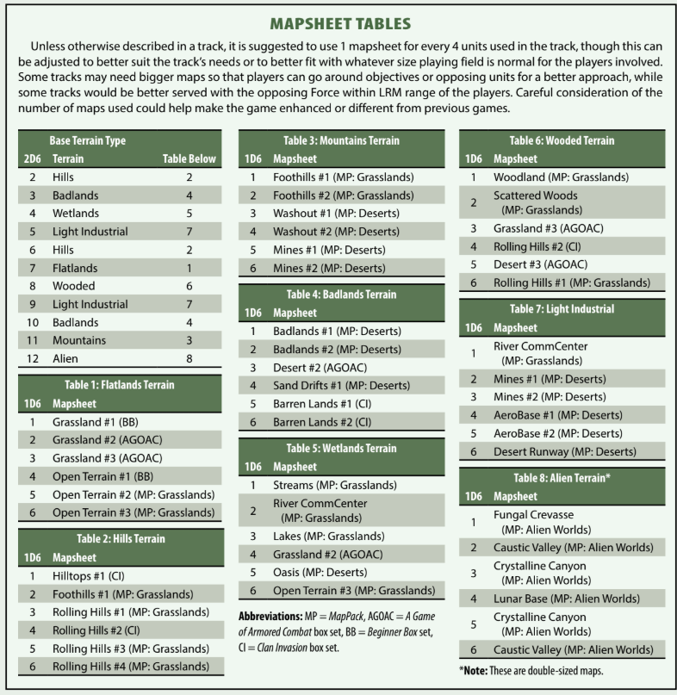
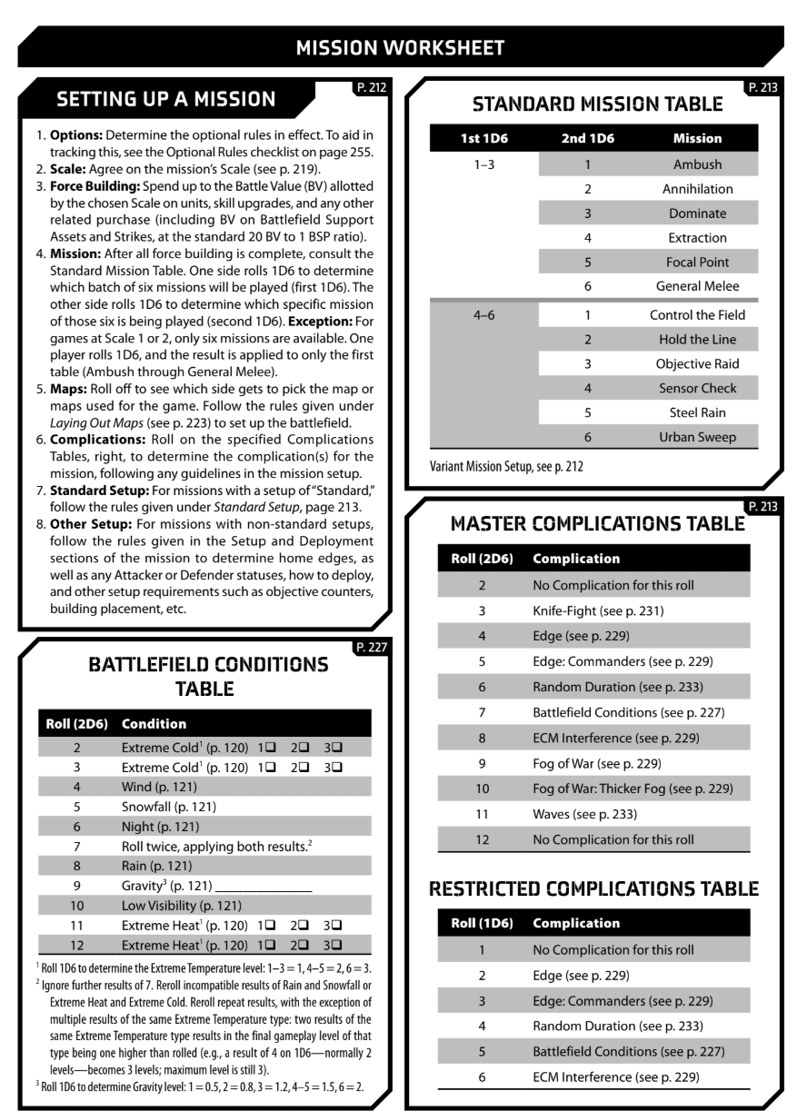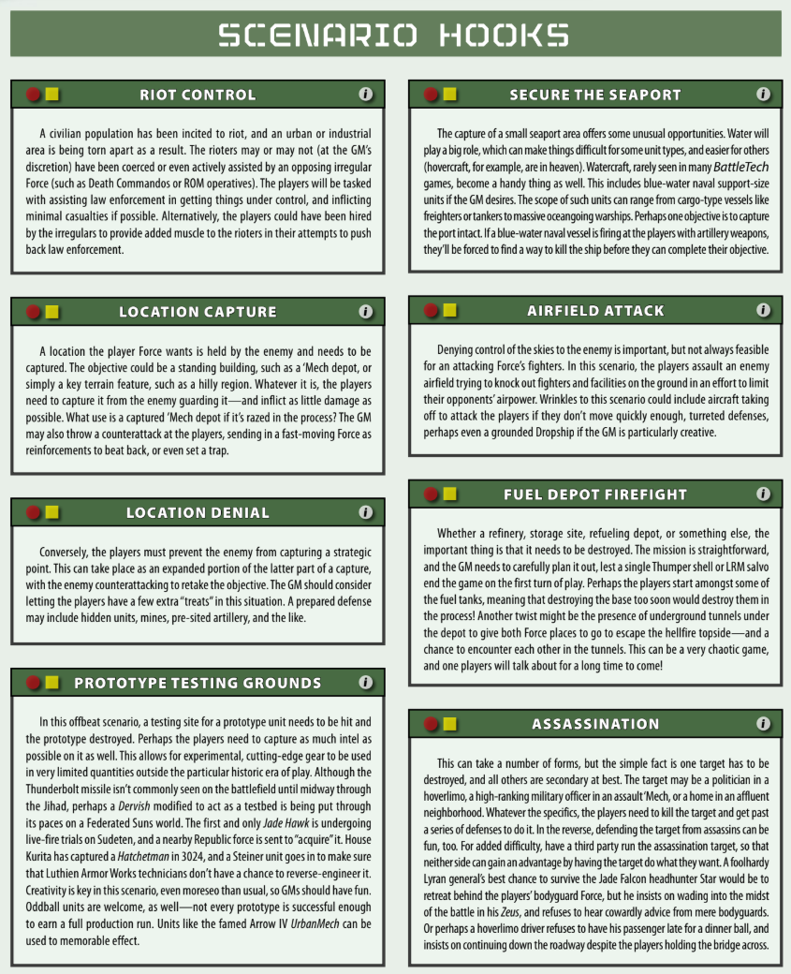
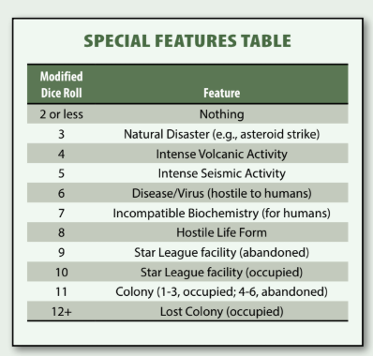
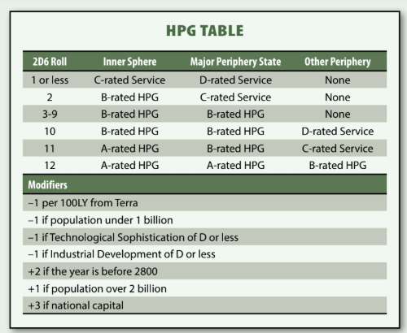
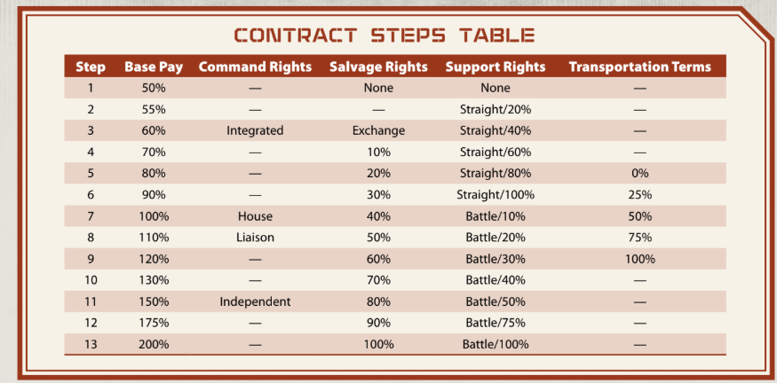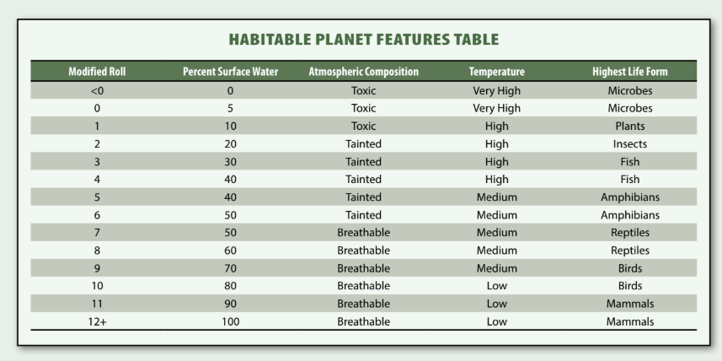

Objective Title | 2d10,  17D6 | WP Reward (approx.) | Details
Advance Attack | 1, 98 | 300 | Destroy/Cripple at least half of the opposing Force.
Annihilate | 2, 99 | 500 | Cripple/destroy all of the opposing Force.
Asset Denial | 3, 17 | 200 | Retain control of a designated unit, building, person, or other asset at the end of the track.
Being Difficult | 4, 18 | 400 | At least two-thirds of the player’s Force must be operational at the end of the track.
Blitzkrieg! | 5, 19 | 250 | Destroy/Cripple a certain number of opposing units (half or more) by a defined time limit.
Boom! | 6, 20 | 500 | Force the enemy to withdraw completely.
Boxed In | 7, 21 | 400 | Allow no more than half of the enemy Force to exit off their home edge. (Best when used with the setup of the Force in question on the opposite side from their home edge.)
Breakthrough | 8, 22 | 200 | The players exit at least 25% of their Force through the opponent’s home edge.
Bring the Pain | 9, 23 | 600 | Destroy/Cripple at least 75% of the enemy Force.
Bullet Time | 10, 24 | 100 | The players must complete the track without a friendly pilot death caused by any means. For example: A cockpit critical hit, MechWarrior damage through failed Piloting Skill Rolls, ammo explosions, falling, and so forth.
Burn the Flag | 11, 25 | 500 | Locate and destroy the enemy Force’s headquarters unit/building/location.
Cherry Picker | 12, 26 | 400 | Pre-select no less than 30% of the opposing Force’s units before setup. Cripple or Destroy all of these units. These units do not have to be revealed to the opposing player.
Clean House | 13, 27 | 500 | Destroy all of the enemy Force’s specific unit types (BattleMechs, vehicles, battle armor, etc.) and hold a specific building/location at the end of the track.
Clear the Zone | 14, 28 | 100 | Destroy all the buildings on the battlefield.
Close the Door | 15, 29 | 300 | Destroy, Cripple, or Force Withdrawal at least 75% of the enemy Force.
Command and Conquer | 16, 30 | 100 | Destroy the opposing command post and retain a friendly command post by the end of the track.
Containment | 17, 31 | * | Stop as many vehicles as possible from exiting the battlefield. Points are given on a per-unit basis, often +10, +25, or +50 depending on the track’s overall story goal.
Cover Me! | 18, 32 | 200 | The players must not have any units destroyed through attacks into the unit’s rear arc. In other words, do not die from getting shot in the back!
Cut Off the Head | 19, 33 | 100 | Destroy/Cripple the enemy commander.
Dead...with Prejudice | 20, 34 | 1000 | Destroy/Cripple all of the enemy Force before a specified time limit.
Delaying Tactics | 21, 35 | 500 | Destroy/Cripple two or more commanders or officers, as designated by the GM, before a specified time limit.
Denial | 22, 36 | 400 | Keep the enemy Force from destroying a set number of buildings or CF before a set time limit or the end of the track.
Discourage Pursuit | 23, 37 | * | Destroy/Cripple the opposing Force’s fastest units; one unit per four fielded is an average number. WP awarded per unit, often +50, +75, or +100.
Drive the Nail | 24, 38 | 300 | Destroy/Cripple at least half of the enemy Force.
End the Rivalry | 25, 39 | 200 | The players’ commander defeats the enemy Force commander; typically, by either landing the killing blow or through single combat.
Escape | 26, 40 | 200 | At least one-third of the players must survive and withdraw from the battlefield after a specific time limit has expired.
Even the Odds | 27, 41 | * | Award a number of WP for each enemy Force’s unit destroyed. Awards can be +50, +100, or even designated per unit type.
Fast Recon | 28, 42 | 150 | Exit one of the players’ units off the enemy Force’s home edge; a higher award can be given if a specified time limit is indicated.
Ferocity | 29, 43 | 300 | The players must destroy 50% of the enemy Force with less than 50% losses.
Fight Another Day | 30, 44 | 300 | The players suffer less than 50% losses.
Fight On | 31, 45 | 1000 | More than half of the players must survive by the end of the track, or by a specified time limit. Units exiting the home edge under Forced Withdrawal count towards this objective.
Forced March | 32, 46 | 200 | The players’ commander exits through the enemy Force’s home or starting edge.
Frugal is the Word | 33, 47 | 300 | The players limit their destroyed units to 10% or less.
Gauntlet | 34, 48 | 400 | Exit at least half of the players’ Force through the enemy’s home edge.
Get Physical | 35, 49 | * | The player must perform a set number of successful charges, pushes, or Death from Above attacks by the end of the track. WP awards can also be given for each instance, rather than a complete total.
Get the Intel | 36, 50 | 300 | The players must scan a set number (or designated) of buildings, objective hexes, or specific unit types; scanning rules should be detailed in the Special Rules section.
Hammer | 37, 51 | 400 | Destroy/Cripple at least two-thirds of the opposing Force.
Headhunter | 38, 52 | 500 | Destroy the enemy Force’s commander (not Cripple).
Hearts and Minds | 39, 53 | 600 | The players must not destroy or damage any buildings (or designated buildings) during the course of the track.
Hit and Run | 40, 54 | 150 | One of the players’ units enters (or moves adjacent) to a designated hex, and then exits from its home edge.
Hold | 41, 55 | 200 | Retain control of a designated battlefield edge, with no more than one functional enemy unit within two hexes of that edge during the End Phase (or other designated time).
Hold the Line | 42, 56 | 300 | Destroy/Cripple at least half of all designated unit types on the opposing Force.
Honorable Combat | 43, 57 | 500 | Cripple (do not destroy) at least half of the enemy’s Force.
I Like These Odds | 44, 58 | * | A set number of WP is awarded for every enemy unit destroyed without losing a friendly unit.
I Spy... | 45, 59 | 100 | Move at least one unit to within a specified number of hexes from the enemy’s home edge to verify there are no hostile reinforcements coming.
Identify and Destroy | 46, 60 | 100 | Locate (using Scanning, which should be detailed in Special Rules) and destroy a headquarters, an enemy commander, specific unit types, buildings, or other objective. Multiple WP can be awarded if multiple targets are in play during the track.
Identify the Opposition | 47, 61 | 200 | Successfully scan at least half of the enemy Force. Scanning rules should be defined in the Special Rules section. Higher WP can be awarded if the percentage of enemy Forces to be identified is increased (i.e. two-thirds, 75%, etc.).
Information | 48, 62 | 250 | Capture or Cripple a GM-designated unit among the enemy Force.
Interception | 49, 63 | 700 | A third-party unit makes it across the players’ home or starting edge before or after a specified time.
Interdiction | 50, 64 | 500 | Destroy a third-party unit before it crosses the enemy’s home or starting edge before or after a specified time.
Justice | 51, 65 | * | Destroy/Cripple secretly designated units or unit types; WP can be awarded as a blanket total, or per unit. The units or unit types can be revealed through scanning, intelligence, or GM-designated turns or other trigger events during the track.
Last Man Standing | 52, 66 | 100 | At the end of a designated time, the players have more tonnage (or other predetermined value) than the enemy on the battlefield. This should only include units in functioning order and not under Forced Withdrawal or Crippled status.
Leave No Man Behind | 53, 67 | 700 | At least two-thirds of the players’ Force survives the track or is able to exit their home edge after a certain time limit.
Live to Kill Later | 54, 68 | * | WP awarded per player unit that exits a designated battlefield edge, often before or after a time limit, and not under Forced Withdrawal or Crippled status.
Master the Bid | 55, 69 | * | WP awarded per unit that does not fire any weapon during the course of the track.
New Toys | 56, 70 | 50 | Capture a designated unit by Crippling (and not Destroying) it.
No Witnesses | 57, 71 | 400 | Destroy (not Cripple) all of the enemy’s Force.
Pick Up | 58, 72 | 300 | Capture a designated amount of cargo tonnage, typically within a building or cargo carrier. Rules for capturing should be detailed in the Special Rules section.
POW | 59, 73 | 100 | Capture (not Destroy) the enemy commander by Crippling the unit and having a unit within two hexes of it at the end of the track.
Pre-emptive Strike | 60, 74 | 100 | Destroy/Cripple at least 25% of the enemy Force by a predetermined time limit, often close to the start of the battle.
Preserve Your Force | 61, 75 | 350 | Destroy/Cripple at least 50% of the enemy’s Force without losing more than 25% of the player’s Force.
Professionals | 62, 76 | 200 | Destroy/Cripple more than 75% of the enemy’s Force before reinforcements arrive at a designated time.
Reduce Effectiveness | 63, 77 | 150 | Damage at least 75% of the enemy’s Force before a specified time limit.
Research Junkies | 64, 78 | 150 | Cripple a GM-designated unit and keep it from exiting the battlefield so it can be salvaged.
Run Them Down | 65, 79 | * | Award WP for every enemy unit Destroyed. A higher WP can be given if a designated time limit is also imposed.
Secure the Zone | 66, 80 | 500 | Occupy at least 3 GM-designated locations by a designated time limit.
Selective Destruction | 67, 81 | * | Before the start of the track, the enemy must secretly write down which of the player’s units they must destroy. The enemy must declare at least half of the player's Force (rounded down). For each unit destroyed, the player loses a number of WP from their total. WP can also be awarded for each of the listed targets survive the track.
Shatter | 68, 82 | 800 | Destroy/Cripple at least 80% of the enemy’s Force.
Shatter Their Will | 69, 83 | 400 | Destroy a building/object secretly designated by the opponent. Building/object is selected before the start of the game and is revealed at the end of the track.
Stand Your Ground | 70, 84 | 250 | At least half of the player’s Force survives the end of the track.
Stop Them Cold | 71, 85 | * | WP are lost for every enemy unit that exits via their home edge that are not under Forced Withdrawal rules.
Superior Firepower | 72, 86 | 200 | Destroy/Cripple the units of the two best enemy pilots or crews as determined by skill. If there are more than two, the enemy may select which two pilots for the objective.
Sustainability | 73, 87 | 100 | At least 25% of a third party Force assisting the players survives the track.
Symbolic Victory | 74, 88 | 200 | At least one player unit occupies a GM designated hex at the end of the track or by a certain time limit.
Take the Hill! | 75, 89 | 350 | The player must seize an enemy-designated objective hex and occupy it for a set number of Turns (can be consecutive or non-sequential and be the same unit or a combination of units, as determined by the GM according to those that best fit the track story). Multiple objectives can be awarded WP per completion, or a minimum number of objectives set before a blanket award is given.
Target Acquired | 76, 90 | 100 | Destroy a set number of buildings/locations by a set time limit.
The Road to Paradise | 77, 91 | 500 | Destroy, drive off, or capture a set percentage of the opposing Force by a set time limit.
Total Victory | 78, 92 | 200 | Complete all other Objectives. Add +100 if done while a track Option is in effect.
Training Day | 79, 93 | 300 | At least one third-party Force that is allied with the player must suffer no more than 25% casualties.
Turkey Shoot | 80, 94 | * | Destroy as much of the enemy Force as possible. WP offered per unit Destroyed, typically +50, +100, +200 depending on needs of the campaign.
Undercut | 81, 95 | 300 | Destroy/Cripple 100% of all third party Forces allied with the opponent.
Vengeance | 82, 96 | 500 | Destroy/Cripple 100% of the enemy Force while taking less than a certain percentage of damage, often 25% or 50%.
World of Hurt | 83, 97 | 500 | Destroy/Cripple at least two-thirds of the enemy Force.

Contract Types (Descriptions)
Assassination
Assassination is simply put the act of ending a targets life. Assassination contracts can be legally sanctioned or illegal. A legally sanctioned assassination is targeting an individual who has incurred a “death warrant” from a particular state. Commonly such a parent is issued to murders, pirates, deserters, intelligence agents, war criminals but also the occasional dissident. Note that while an a death warrant may have been legally issued by a state, the state the target is currently in may not recognise this warrant, and if a Mercenary Company takes on this warrant they will be treated as criminals and not protected by the Mercenary Charter. Targets for Assassination may be in buildings or may have their own unit (BattleMech, Combat Vehicle etc).
Common Objectives: Locate Target, Scan Target, Defeat/Destroy Opposing Forces (bodyguards), Kill Target.
Cadre Duty
Cadre Duty involves training another force. That force might be a house force, planetary militia, mercenaries, corporate security or even rebels. Cadre duty involves being deployed on one world, and may involve ‘war games’ where forces fight each other with dummy paint rounds and electronic tracking. In this case, run a track as normal except all damage bar physical attacks is not real, but simulated.
If a unit on Cadre Duty is present on world during an enemy attack a “Garrison” clause may be activated where they are expected to participate in defence. Mercenary units do not have to agree to such a clause, but if they do it will pay out bonus rates.
One common Cadre duty is to pair a seasoned MechWarrior as Lance Leader and lead a lance of cadets in a simulated mission.
Common Objectives: Defeat/Destroy Opposing Forces, Preserve Friendly Forces.
Diversionary Raid
This track is the same as the Raid contract – but the employer goal is to draw the enemy forces away from the real target for a second mission. The mercenary command may or may not be aware of this – although it is considered bad form for employers to commit mercenaries to a diversion without informing them
Common Objectives: As any raid
Espionage
Espionage contracts may include many activities including – insertion and extraction of assets, kidnapping, data theft, equipment theft, observation etc. Espionage contracts last at least 12 months and the employer is usually a local intelligence organisation.
Common Objectives: Insert Friendly Asset, Pickup Friendly Asset, Acquire Enemy Asset, Scan, Identify.
Extraction Raid
Extraction is the act of acquiring a human asset from the field. The target of an extraction mission may be willing (e.g. an intelligence operative) or may be unwilling. Unwilling targets could be Scientists, Technicians etc or could be targets that have an arrest warrant (Bounty Hunting). Extraction of non-combat non-specialist personnel for slavery or random is considered a war crime under the Mercenary Charter.
Clan’s may issue a Batchall for a Trial of Possession when performing Extraction Raids.
Common Objectives: Acquire Enemy Assets, Scan, Defeat/Destroy Enemy Forces
Garrison
The Mercenary Force is contracted to guard either a specific asset on a planet e.g. factory, or may be placed on a rapid response (with a DropShip) to respond to raids anywhere on the planet. In some cases Garrison duty may involve standing ready on a “Tripwire” JumpShip that will Jump into a system as soon as news arrives that the system is under attack.
Garrison Duty tends to be slow paced and so Intensity Checks are made only once a month. In Campaign Operation rules – maintenance checks while on Garrison Duty or Cadre Duty are only made once per month rather than once per week.
Common Objectives: Protect Allied Assets, Defeat Enemy Forces, Preserve forces
Guerrilla
One of the toughest contracts, in a Guerrilla operation the Mercenary Company is Dropped on a target world with no further support. The Company only have access to what they either carry or what they can scavenge. There are often limits to what repair facilities are available. Guerrilla activity is considered dishonourable under the Clan rules of warfare – a Clan is expected to openly attack a world in a trail and give the planet up when they lose – although there have been many examples of guerrilla actions by Clanners e.g. Clan Smoke Jaguar on Huntress after the 2nd Star Leagues Planetary Invasion..
Common Objectives: Destroy Enemy Assets, Destroy Enemy Forces, Acquire Enemy Resources
Mole Hunting
A very specific form on counter intelligence, mole hunting usually involved the Mercenary Company working together with state intelligence assets to identify a mole (enemy spy) and then move in to capture that mole or prevent that mole from being extracted.
Common Objectives: Destroy Enemy Forces, Prevent Enemy Acquisition of Target, Capture Enemy Asset (Mole).
Objective Raid
One of the most common Mercenary missions, the Mercenary Force are to attack an enemy position to either destroy enemy assets (facilities or forces) or capture enemy resources. The key part of an Objective Raid is, get in, get the loot and get out before the reinforcements arrive.
Common Objectives: Destroy Enemy Forces, Destroy Enemy Assets, Capture Enemy Assets, Scan.
Observation
A special type of espionage, observation (often called shadowing) involved monitoring the target and reporting on anything the target does. The target may be an enemy formation, an enemy facility, or an enemy asset. The key to observation is not to engage the force. Some observation is covert (don’t let the enemy know your there) or over (the enemy knows your watching).
Common Objectives: Scan, Avoid Enemy, Identify
Pirate Hunting
Similar to Objective Raid, Private Hunting involves the destruction or capture of pirate assets, facilities or forces. A Pirate is defined broadly as an force undergoing military operations without the backing/sanction for a state (although many pirates actually receive covert backing from a state and in some cases the state doesn’t even try to be covert in their hiring of pirates). The Mercenary Charter does not protect pirates. Often pirate hunting can provide a good opportunity for salvage. Most Pirate Hunting contracts involve targeting worlds in the periphery or even deep periphery. Rarely pirates may operate from uninhabited systems within the InnerSphere. Pirates may also be DarkCaste Clanners.
Common Objectives: Destroy/Capture Enemy Forces, Destroy/Capture Enemy Assets, Destroy/Capture Enemy Facilities, Scan.
Planetary Assault
The Planetary Assault contract is one of the most major actions a Mercenary Force can undertake. Planetary Assaults usually only occur when two forces are actively Hostile or Enemies, and is an Act of War. It involved landing in a hostile system, neutralising the garrison forces, deposing the local government, and protecting the world against guerrilla actions and reinforcements. Planetary Assaults may go very bad, and require the Mercenary Force to retreat under fire.
Clans may issue Batchall for a Trial of Possession for a planet.
Common Objectives: Destroy/Capture Enemy Forces, Destroy/Capture Enemy Assets, Destroy/Capture Enemy Facilities, Scan.
Recon Raid
Similar to Observation, although more direct, in a Recon Raid, the Mercenary Force is expected to land on a world, identify enemy forces or scan enemy facilities, then retreat to get that information to their employer.
Common Objectives: Preserve Force, Identify, Scan.
Relief Duty
Relief duty is about supporting civilians and infrastructure either after enemy action or natural disasters. It can include actives such as protecting food and medical supplies, to clearing areas of debris on mines.
Common Objectives: Preserve Force, Defend Allied Force, Clear Mines, Scan.
Retainer
A retainer is a special mission where a Mercenary Force is hired for a contract in the future. It often occurs when a state wants to gather forces before a big operation such as a Planetary Invasion, or to keep forces in had for several smaller operations such as Objective Raids. Retainers may include a defence clause that expects the Mercenary Force to defend the location where they are stationed, or may include Cadre Duty.. At the end of each month on retainer roll 2d6 with a target number of 12+ for a new contract that starts on the next month. Reduce this target number by 1 each month of the retainer. [Campaign Operations] While on retainer maintenance checks are only once per month.
Common Objectives: None. (Sitting back, sipping cocktails on the beach)
Riot Duty
One of the most disliked and dangerous contracts for a Mercenary Force to undertake. The Mercenary Force are expected to provide security against a civillian population that are in active revolt, ranging from peaceful protest to full blown Terrorism. Many Mercenaries dislike this type of contract as it may involve firing on civilians (under the orders of the state)
Common Objectives: Riot Control, Defend Allied Facilities, Defeat Enemy Forces.
Sabotage
Whereas an Objective Raid is an obvious attack on an enemy force or facility, sabotage involves inserting forces covertly to destroy enemy forces or facilities without engaging in conflict (unless it goes wrong). Examples could include bombing facilities and infrastructure e.g. bridges. The targets are not civillian – this is covered under terrorism. Although sabotage is considered underhand – it is legal under the articles of war and forces are protected by the Mercenary Charter (As long as no civilians are directly targeted).
Common Objectives: Insert Forces, Extract Forces, Destroy Enemy Facilities, Destroy Enemy Forces.
Security Duty
Often referred to as “Body Guarding”, Security Duty involves the protection of a human asset (as opposed to Garrison Dirty which defends a physical location). Security Duty may involve defending a residence e.g. a Nobles Manor House, a key corporate meeting and guarding assets when they are on the move. Security Duty could involve protecting the asset in a mission to another world e.g. Diplomatic Protection.
Common Objectives: Defeat Enemy, Protect Allied Asset, Protect Allied Structure, Transport Allied Asset
Terrorism
Similar to the Sabotage contract, Terrorism however involves targeting civilian buildings and even people to create… terror! Terrorism is a War Crime and Mercenary Forces on a Terrorism Contract will not be protected by the Mercenary Charter.
Common Objectives: Destroy Civillian Structures, Destroy Civillian Assets, Destroy Civillian Personnel.

Objectives
Each track requires objectives for completion. Tracks should be structured so objectives can be partially completed, fully completed and include a bonus objective. Each objective can include a % e.g. Defeat 50% of the enemy. This % can either refer to the number of units, tonnage of units or BV of units as the GM decides is appropriate.
Contract Objectives | Base Pay
Not Completed | 25% (-3 Reputation for withdrawing)
Partially Completed | 50%
Completed | 100%
Bonus Objective Completed | 150%
Objective Types/Key Terms
Allied – Forces controlled by the employer (GM) but not directly by the Mercenary Force player.
Asset – Any mission critical equipment, unit, structure or personnel. e.g Ammo Crates, Mobile HQ, Special Ops Infantry Team, Scientist.
Enemy – All opposing military forces.
Civillian – Non combat forces, structures, assets or personnel that do not have a strategic value. e.g. a hospital is a civillian structure, but a power plant can be designate a military target. Targeting Civillian Forces is a War Crime
Pirate – Any force conducting military activity without a Mercenary Charter.
War Crime – Conducting any activity that is not covered as legitimate under the Mercenary Charter
Defeat – Cripple enemy forces (place them in forced withdrawal). You do not need to destroy the enemy to defeat them.
Damage – Reduce an enemy structure to half construction factor.
Destroy – Destroy or Truly Destroy enemy units (this does not involve killing the Crews/MechWarriors). Destroy Enemy Structure
Kill/Assassinate – Kill the crews or MechWarriors in enemy units. (This is often considered a War Crime against the Mercenary Charter, unless there is a valid death warrant).
Capture – Capture an enemy structure. This may involve using Conventional Infantry/Battle Armor to secure the building.
Preserve – Prevent the destruction of your own Mercenary units.
Defend – Prevent the damage or restructure of allied forces or structures.
Insert – Transport allied units or assets (e.g. Infantry, Special Forces, Sappers etc) to a specific location on the battlefield.
Extract – Pick up and transport off the battlefield allied units or assets (e.g. Infantry, Special Forces, Sappers etc) to a specific location on the battlefield.
Control – Have more units than the enemy in an area around a waypoint. This can be measured by number, tonnage of BattleMechs or BV or forces. Crippled, Immobile and KO’d forces can’t control points.
Acquire – Capture enemy assets. Steal equipment (Standard 10 ton containers), capture personnel, capture military equipment. BattleMech with hand actuators are good for this.
Commandeer – When Infantry Special Forces are able to take control of an enemy unit (Conventional Vehicle or BattleMech).
Identify – Be within line of sight of the target the end of the movement phase to positively image them and identify them. Maximum range 30 hexes Conventional Infantry/BattleArmour/Vehicles, 60 hexes for BattleMechs. 120 Hexes for VTOL’s
Scan – Any unit (except infantry) in a force may attempt a detailed scan on any turn that it ends its Movement phase within 3 hexes of an opposing unit or building (5 if the Attacker unit is equipped with any equipment with “probe” in the title or equipment description). Scanning is successful if the unit spends two complete turns within range of the target. The unit attempting the action may not fire any weapons or make physical attacks during the time it takes to complete a scan; units equipped with a probe ignore this limitation. Line of sight is not required.
Clear Mines – Remove a minefield from a hex e.g. using Mine clearing infantry, an LRM20.
Riot Control – Using non-lethal weapons to subdue/pacify civilians.
Avoid – Prevent the enemy from identifying or scanner your unit.
Breaking Through – Exit the map from the opposite edge to which you deployed.
Sabotage – Insert infantry units into a facility to sabotage key infrastructure or units e.g. to plant explosives.
Prevent – An objective to stop any of the above objectives occurring. e.g. Prevent 50% of the Enemy from Breaking Through.

- Quick Start Guide for New Players
- How to Make a Brigade for Strike Brigades Campaign

- Step 1: Your Brigade
- Pick a major faction, clan or group from Sarna.net like Inner Sphere or Clans or other, then name your brigade team (pg 2 of Strike Brigades), and choose the backstory (pg 2), or "opt in" to 4, where you roll 3D6 "on the day" to find out your team's backstory.

- Step 2: Your Mechwarrior Roster
- Fill out your Pilot Sheet (linked on pg 2 of doc). Give each pilot a name and 6 Piloting 6 Gunnery. From a pool of 24 points, subtract from the pilots to "increase" skill. For each subtraction, decrease pool by 1 point. (pg 2) Submit the sheet to me for approval.

- Step 3: Spending Your Investment C-Bills
- From an initial starting resource of 40,000,000 CB, spend 30,000,000 up to 38,000,000 CB on at least 4 'Mechs to build your starting lance. Costs are in adjusted dollars from the 3050-3067 era of BattleTech. You can take a look at 'Mechs on MekBay (which is probably the best place tbh) or at https://sheets.flechs.net/ or at MUL (Master Unit List) either by looking into individual 'Mechs or using the Force Builder.

- You do not need to own the 'Mech mini in question to buy the 'Mech, as any mini can be used as proxy.

- What to buy? Generally you will want to allocate funds to 4 ‘Mechs.

- Advice online suggests multiple things in the combined range of 3000-9000 BV, but I suggest hitting the middle of that range around 6000 BV. The complication is that CB ($) (a value in dollars) is not congruent to BV, which is a combination of 'Mech force and Pilot/Gunnery skill of the Mechwarrior. Be aware that there is an older style of BV in BattleTech Classic, but most on MUL should be "latest" and not resemble Classic. If you were to, say, read an old book and want to buy a 'Mech from it, it might be, though. Day-of Balancing will solve "BV hackers", so don't worry too much about it. BV will adjust on the day by the GM giving out temporary per-Pilot bonuses or handicaps, and based on the scenario, other adjustments occur based on Attacker/Defender. We'll get to the contract in a bit, for now it's team making time.

- How to use MUL: You can see C-Bill costs for many units directly on the Official Master Unit List (MUL), though availability varies depending on the specific unit type.
- • Unit Pricing: The MUL lists C-Bill values for many standard 'Mechs and vehicles (such as a baseline Locust LCT-1V priced around 1,512,400 C-Bills).
- • Missing or Omitted Costs: C-Bill values are not universally displayed for every single asset in the database; specialized units, certain equipment variants, or WarShips may not show C-Bill costs on their MUL profile.
- • Alternative Metrics: The MUL primarily tracks Battle Value (BV) and Alpha Strike Point Value (PV) for game balancing rather than C-Bills, which are mainly used for campaign and mercenary-management rules (such as those found in Campaign Operations).

- Also, Gemini can find out a fairly accurate C-Bill number (CB) if you ask it like this: "How many C-Bills for a Locust LCT-1V"

- One source for C-Bill values of units (other than MekBay or Gemini) It does appear these values are not 100% accurate on the BV and PV side though, sadly.
- 24_BattleValueTables-3_0.pdf

- I'm uploading a video will link it showing how to use Mekbay and Master Unit List
- Mekbay.com seems to be the best place to get all of the information, but the video will give you an overview of the various online resources, along with a brief intro to the Total Warfare Mech Sheet
- https://youtu.be/MDqOg59NAxw - Initial Spend / How to Find and Buy Mechs

