Said LAHARRAF  laharrafsaid@gmail.com | (+212) 7 77 60 35 26 | Casablanca-Settat, Morocco  LinkedIn, Portfolio | 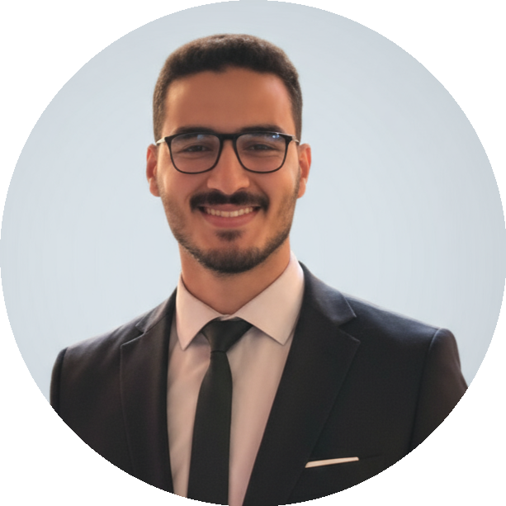

Professional Experience
Al Akhawayn University (AUI)
Data Engineer : Database Designer – Final Year Project | Ifrane, November - June 2025
- Design and implementation of a student-athlete tracking platform from scratch.
- Process analysis and modeling (BPMN) to represent the current state.
- UML modeling (use case and class diagrams).
- Design, development, and management of SQL databases for performance storage and analysis.
- ETL pipeline implementation for data integration and tracking.
- Collaboration with stakeholders for requirements gathering and documentation.
- Implementation of a scalable architecture on GCP to host the platform and deploy ML models.
- Technos : MySQL, SQL, UML, GCP, BPMN, phpMyAdmin, Lucidchart.
Freelance
Full-Stack Web & Mobile Developer | Remote, 2024 – Present
- Design application architectures across web, mobile, and desktop environments, driving projects from concept to production.
- Dental Clinic Platform : Developed, managed, and deployed a comprehensive management system to optimize medical records and patient scheduling.
- Tire Shop & E-Commerce : Created a full-process inventory and sales system managing product visualization, online ordering, and validation.
- Relational database schema design (SQL) and system administration including deployment on production hosting environments via cPanel.
- Technos : PHP, Laravel, Python, MySQL, HTML, CSS, JavaScript, cPanel.
Arteka :
Data Analyst – Summer Internship | France (remote), August – October 2024
- Extraction and preparation of sports datasets (CSV/JSON, online APIs).
- Data preprocessing and structuring for ML model training.
- Creation of interactive dashboards for football and tennis match analysis.
- Benchmarking of sports analytics platforms.
- Technos : Python (pandas, matplotlib, mplsoccer, NumPy), LabelMe.
Physicare :
Mobile Developer – Graduation Project | France (remote), April – June 2023
- Design of mobile application for diabetes tracking and sports prescription.
- UI mockup creation and development of main features.
- Technos : Flutter, Firebase, Adobe XD.
Raznet :
Full-Stack Developer – Summer Internship | Casablanca, August - October 2022
- Functional architecture and database schema design for dental clinic management web application.
- Front-end and back-end development with data security and smooth UX.
- Technos : PHP, MySQL, XAMPP, HTML, CSS, JS.
Radeec :
Full-Stack Developer – Graduation Project | Settat, May - June 2022
- Architecture and data model design for beneficiary management web application.
- User interface development and management features (creation, tracking, reporting).
- Technos : PHP, XAMPP, phpMyAdmin, MySQL.

Academic Projects (Data & AI)
- Big Data on the Premier League (Hadoop, Hive, Spark, Python) : Data collection, analysis and visualization. | 2024 – 2025
- Physical Activity Statistical Study (SPSS, PCA, XLSTAT) : Correlation between body parameters and sports performance. | 2023 – 2024
- Sprint Performance Analysis (Python, scikit-learn, NumPy) : Quantitative study of speed and muscular strength indicators. | 2023 – 2024
- Player & Ball Detection (YOLOv5, Python, LabelMe) : Custom dataset creation and YOLOv5 model training for sports analytics. | 2024 – 2025
- Personalized Sports Tracking System (PHP, MySQL, Bootstrap) : Training recommendations based on physical fitness tests. | 2023 – 2024

Education
Hassan First University - ISSS – Settat | Settat, 2025 – Present
- PhD Candidate in Artificial Intelligence & Digital Health.
- Teaching Assistant : Biomedical Informatics.
Hassan First University - I2S – Settat | Settat, 2022 – 2025
- Master's in Digital Transformation and Sports Technologies.
- Professional Bachelor's in Sport and Technology.
BTS Center | Settat, 2020 – 2022
- Higher Technician Certificate (BTS) in Information Systems Development.
Technical Qualifying High School | Settat, 2019 – 2020
- Baccalaureate in Electrical Sciences and Technologies (STE).

Skills & Interests
- Data Engineering : SQL, MySQL, Hadoop, Hive, Spark, Data Modeling, ETL (Airflow), data warehouse (Snowflake) | Methodology : Agile, Scrum, Kanban
- Software Development : PHP, LARAVEL, HTML, CSS, JavaScript, Flutter, C, JAVA
- Data Analytics & ML : Python (pandas, NumPy, scikit-learn, matplotlib, YOLO), SPSS, XLSTAT, Power BI, Tableau, Excel
- Modeling & Tools : UML, BPMN, Merise, Git, VSCode, LabelMe, Firebase | Cloud : GCP, AWS
- Interests : Running, Swimming, Hiking | Languages : Arabic (native), French (fluent), English (fluent)

Certifications
DataCamp :  - Data Engineer Associate  - Understanding Artificial Intelligence  - AWS Cloud Practitioner (CLF-C02) | Oracle :  - Oracle Cloud Infrastructure AI Foundations Associate (2025)  - Oracle Cloud Infrastructure AI Foundations Associate (2023)  - Oracle MySQL Implementation Associate

Extracurricular Activities
- Participation in the 14th edition of the UM6P Entrepreneur Generation Bootcamp | UM6P Benguerir, June 2024
- Presentation at the International Congress on Physical Activity Sciences and Emerging Technologies (ICPASET'24) | UH1 Settat, May 2024
- Participation in the Smart Cities International Hackathon | ENS Martil, May 2024
- Participation in the ONCF-UM6P High-Speed Mobility Hackathon | UM6P Benguerir, March 2024
- Participation in the NEXT-GEN Hackathon | GDSC EMSI Rabat, August 2023
- Participation in the RACATHON 3.0 at El Jadida | ENSA El Jadida, May 2023

