Students choose one of the following two exercises to implement:
- Use the linked list to build the program of storing grades for all students in a university for a certain semester. A brief description of the program is follow:
  - Assume that there are 8000 students and 300 classes.
  - Grades are between 1 and 10.
  - The program has functions such as:
    - Add a new student to a class. Information of student includes ID (1 to 8000) and class number (1 to 300).
    - Update grade of student through ID and class number.
    - Remove a student from a class through ID and class number.
    - List all classes and grades which a student joined and got.
    - List all students and their grade of a certain class.
Data structure can be organized as the below picture:
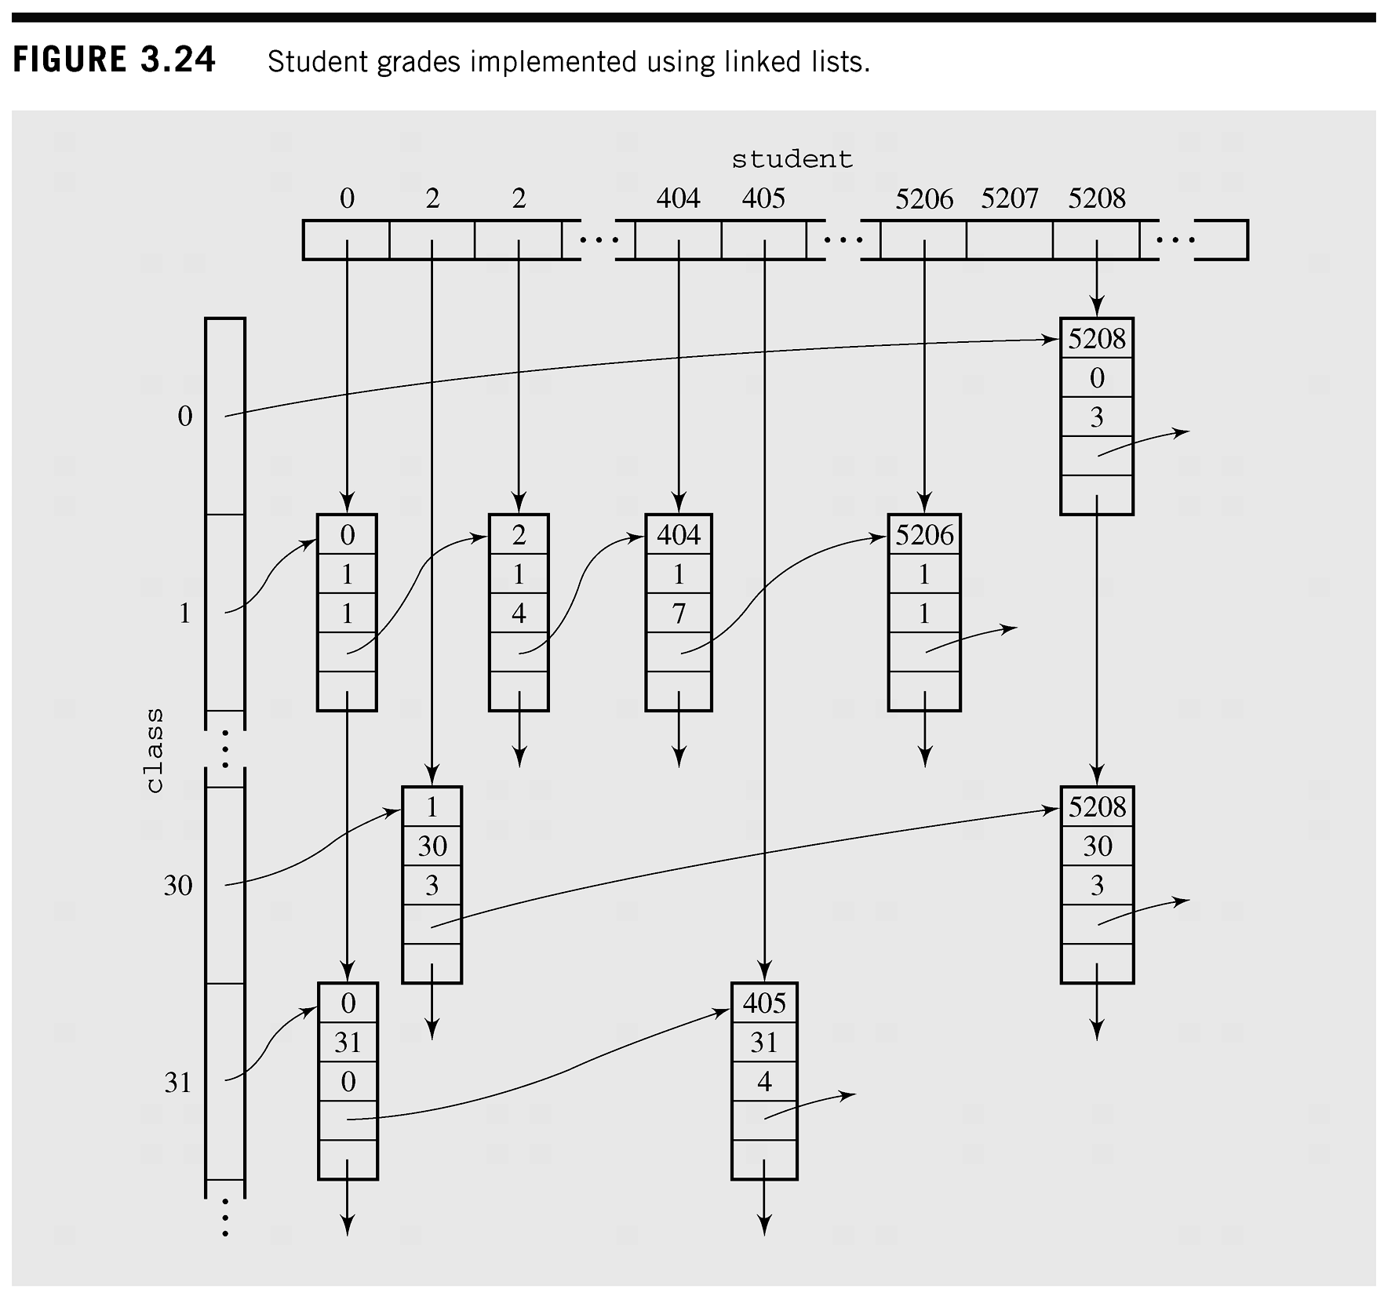

- Write a program to perform the four basic arithmetic operations +, –, * and / on very large positive integers.
Hints: Use the algorithm addingLargeNumbers() from section 4.1, page 142.

Submission Requirements
Each exercise should be contained in one .java file. All files must be packaged in .zip or .rar. At the beginning of your program, include comments with the following information formatted neatly, and reflecting accurate information for you.
/* Assignment 1 */
/* Course: Fall 2009 - SE.4xx */
/* Family Name: Student */
/* Given Name: John */
/* Student Number: 123-456-789 */
/* Login name: jstudent */
/* Professor: Mr..... */
/* Due Date: July 02, 2009 */
/* */
/* I declare that the attached assignment is my own work in accordance with */
/* FPT UniversityPolicy. No part of this assignment has been copied manually */
/* or electronically from any other source (including web sites) or distributed */
/* to other students*/

