Name: T H LAKSHANA
USN:1NT19IS174
DATE: 26/05/22
Aggregate functions and Pipelines

db.lakshana.find().pretty()
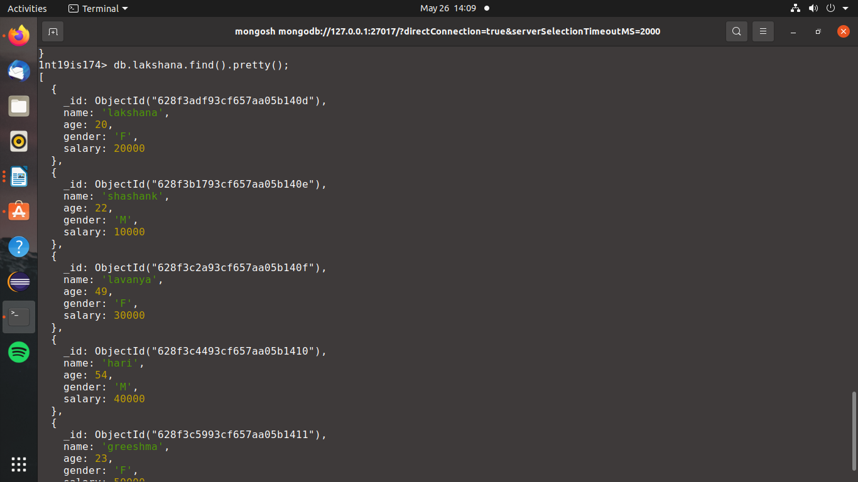

1)Count
To count no. Of people with age 20

db.lakshana.aggregate([{$match:{'age':20}},{$count:"Number of people with age 20"}]);

ddf

2) Sum

i)To find sum of salary of all the female employees

db.lakshana.aggregate([{$match:{"gender":'F'}},{$group:{_id:null,sum:{$sum:"$salary"}}}]);

ii)To find sum of the salary of all male employees
db.lakshana.aggregate([{$match:{"gender":'M'}},{$group:{_id:null,sum:{$sum:"$salary"}}}]);

iii) To find sum of salary of all employee
db.lakshana.aggregate([{$match:{}},{$group:{_id:null,sum:{$sum:"$salary"}}}]);

3)Average salary of all employee
db.lakshana.aggregate([{$match:{}},{$group:{_id:null,Average:{$avg:"$salary"}}}]);

4)Maximum and minimum
i) To find max salary among all the employees

db.lakshana.aggregate([{$match:{}},{$group:{_id:null,Maximum:{$max:"$salary"}}}]);

ii)To find minimu salary amaong all the employees
db.lakshana.aggregate([{$match:{}},{$group:{_id:null,Minimum:{$min:"$salary"}}}]);

5)First and Last

i)To find first name in database

db.lakshana.aggregate([{$match:{}},{$group:{_id:null,First_name_in_database:{$first:"$name"}}}]);

ii)To find last name in database

db.lakshana.aggregate([{$match:{}},{$group:{_id:null,Last_name_in_database:{$last:"$name"}}}]);

Map and Reduce
Collection

db.orders.insertMany([
{ _id: 1, cust_id: "Ant O. Knee", ord_date: new Date("2020-03-01"), price: 25, items: [ { sku: "oranges", qty: 5, price: 2.5 }, { sku: "apples", qty: 5, price: 2.5 } ], status: "A" },
{ _id: 2, cust_id: "Ant O. Knee", ord_date: new Date("2020-03-08"), price: 70, items: [ { sku: "oranges", qty: 8, price: 2.5 }, { sku: "chocolates", qty: 5, price: 10 } ], status: "A" },
{ _id: 3, cust_id: "Busby Bee", ord_date: new Date("2020-03-08"), price: 50, items: [ { sku: "oranges", qty: 10, price: 2.5 }, { sku: "pears", qty: 10, price: 2.5 } ], status: "A" },
{ _id: 4, cust_id: "Busby Bee", ord_date: new Date("2020-03-18"), price: 25, items: [ { sku: "oranges", qty: 10, price: 2.5 } ], status: "A" },
{ _id: 5, cust_id: "Busby Bee", ord_date: new Date("2020-03-19"), price: 50, items: [ { sku: "chocolates", qty: 5, price: 10 } ], status: "A"},
{ _id: 6, cust_id: "Cam Elot", ord_date: new Date("2020-03-19"), price: 35, items: [ { sku: "carrots", qty: 10, price: 1.0 }, { sku: "apples", qty: 10, price: 2.5 } ], status: "A" },
{ _id: 7, cust_id: "Cam Elot", ord_date: new Date("2020-03-20"), price: 25, items: [ { sku: "oranges", qty: 10, price: 2.5 } ], status: "A" },
{ _id: 8, cust_id: "Don Quis", ord_date: new Date("2020-03-20"), price: 75, items: [ { sku: "chocolates", qty: 5, price: 10 }, { sku: "apples", qty: 10, price: 2.5 } ], status: "A" },
{ _id: 9, cust_id: "Don Quis", ord_date: new Date("2020-03-20"), price: 55, items: [ { sku: "carrots", qty: 5, price: 1.0 }, { sku: "apples", qty: 10, price: 2.5 }, { sku: "oranges", qty: 10, price: 2.5 } ], status: "A" },
{ _id: 10, cust_id: "Don Quis", ord_date: new Date("2020-03-23"), price: 25, items: [ { sku: "oranges", qty: 10, price: 2.5 } ], status: "A" }
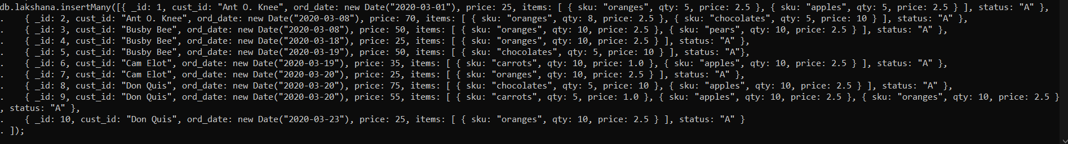
])
1)

var mapFunction1 = function() {
emit(this.cust_id, this.price);
};
var reduceFunction1 = function(keyCustId, valuesPrices) {
return Array.sum(valuesPrices);
};
db.lakshana.mapReduce(
mapFunction1,
reduceFunction1,
{ out: "map_reduce_example" }
)

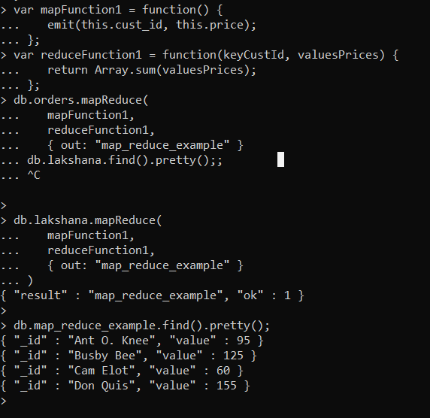

Hadoop

Hadoop version

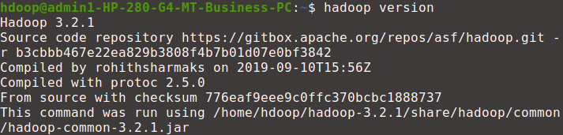
start -dfs.sh
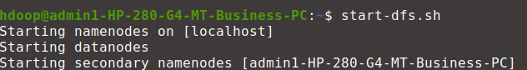
f

1)Create a directory named by your name
>hadoop fs -mkdir /lakshana
>hadoop fs -ls /

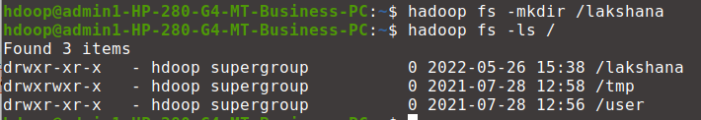
hj

2)Add two empty files into it

>hadoop fs -touchz /lakshana/one.txt
>hadoop fs -touchz /lakshana/two.txt

3) List all the files in the directory that you have created
>hadoop fs -ls /lakshana
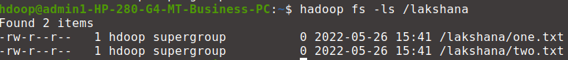

4) Create one more directory by your usn and put that inside the directory of your name
>hadoop fs -mkdir /lakshana/1NT19IS174
>hadoop fs -ls /lakshana
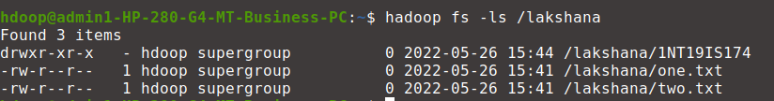

5)Create a file in your local system by the name_usn.txt and add the contents as "Syntax to list Is command is hadoop fs -Is "
>cat > lakshana_1NT19IS147.txt
>"Syntax to list ls command is hadoop fs -ls"
