1. create table my_employee(

ID number(4) primary key,

last_name varchar2(25),

first_name varchar2(25),

userid varchar2(25),

salary number(9,2)

);

1. insert into my_employee values(1,'Patel','Ralph','rpatel',895);

insert into my_employee values(2,'Dancs','Betty','bdancs',860);

1. select * from my_employee;

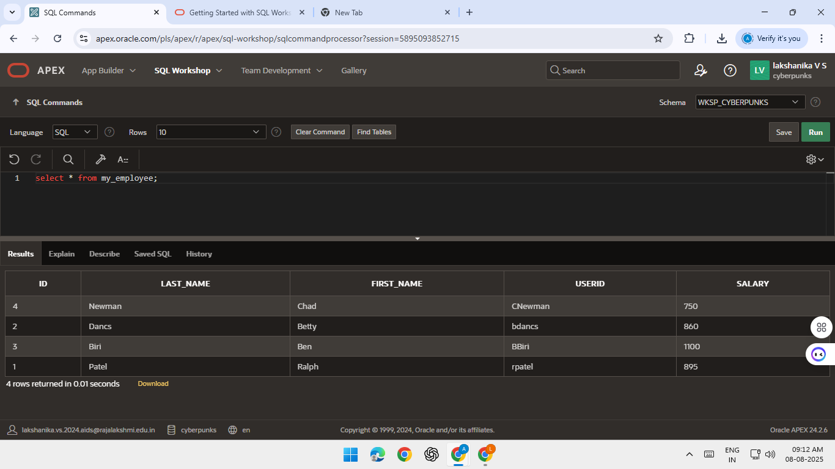

1. insert into my_employee values(3,'Biri','Ben',substr('Ben',1,1)||substr('Biri',1,7),1100);

insert into my_employee values(4,'Newman','Chad',substr('Chad',1,1)||substr('Newman',1,7),750);



1. commit;
2. update my_employee set last_name='Dreler' where ID=3;

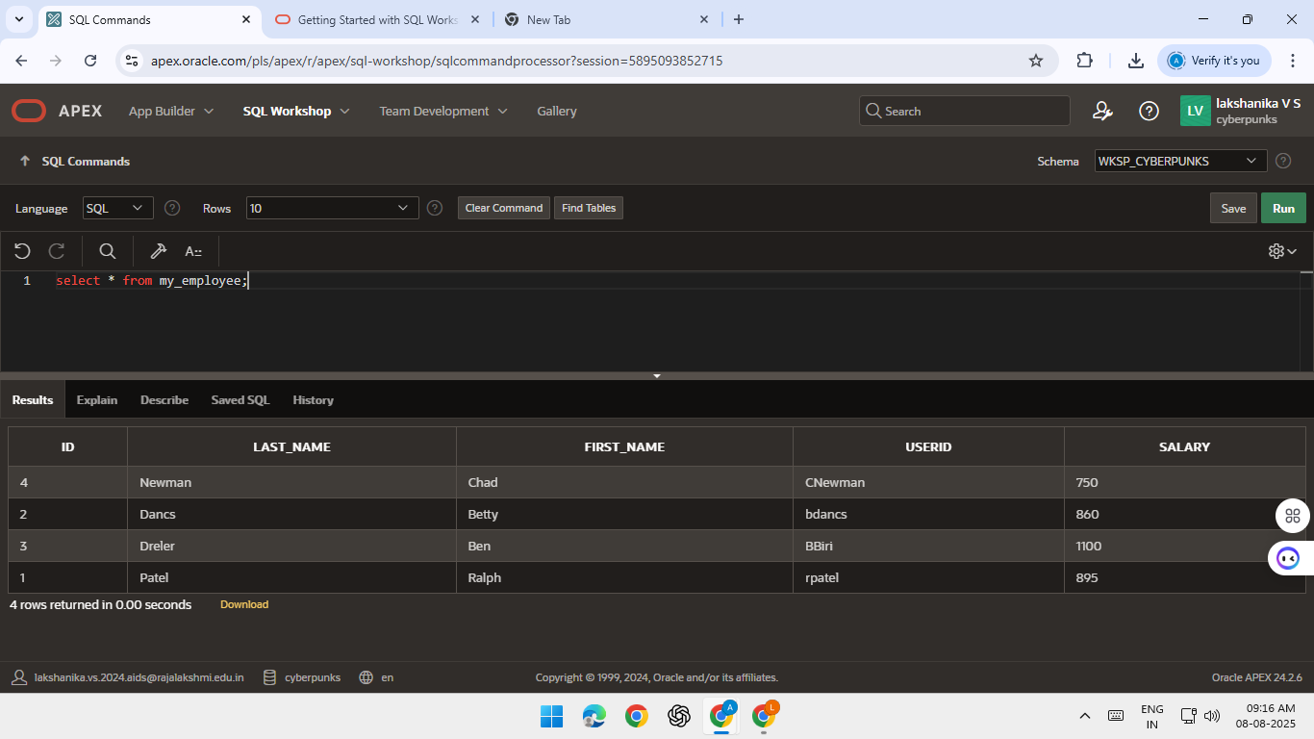

1. update my_employee set salary=1000 where salary<900;

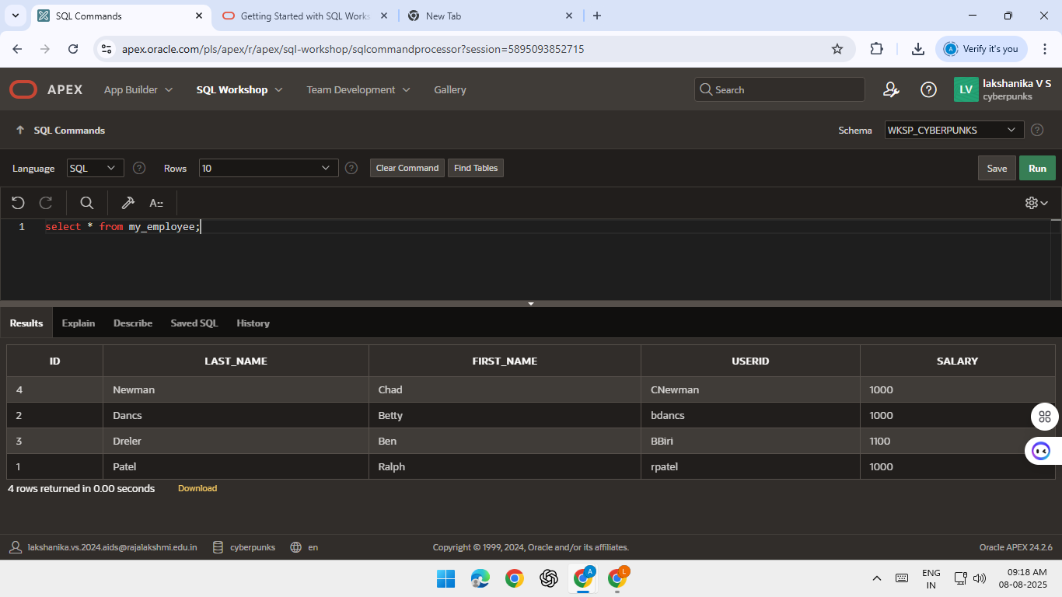

1. delete from my_employee where first_name='Betty';

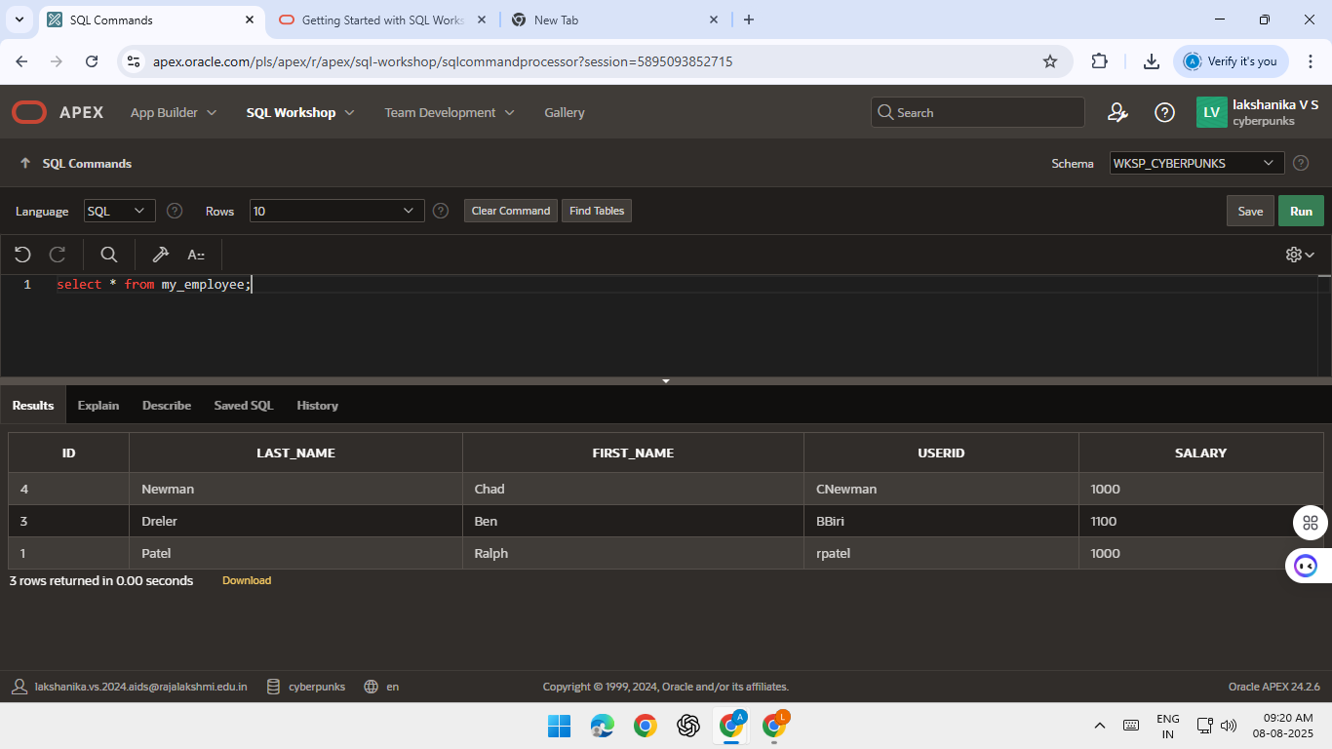

1. update my_employee set last_name=null,first_name=null,userid=null,salary=null where ID=4;

