Lab Exercise 5
Cloud Object Storage Manager Using Python & MinIO

Aim
To develop a Python-based application that interacts with a local MinIO server (an S3-compatible cloud storage emulator) to understand object storage concepts such as buckets, unique object keys, and metadata tracking.

Problem Statement
Develop a Python application that mimics cloud object storage behavior using an open-source MinIO server running locally inside a VirtualBox VM, communicating via the official MinIO Python API. The application must implement:
- Create Bucket – initialize a flat container on the MinIO server.
- Upload Object – upload a local file into a bucket with a unique key.
- Download Object – retrieve an object using its unique key.
- List Bucket Contents – display objects with metadata (size, last modified).
- Delete Object – remove an object using its unique key.

Architecture
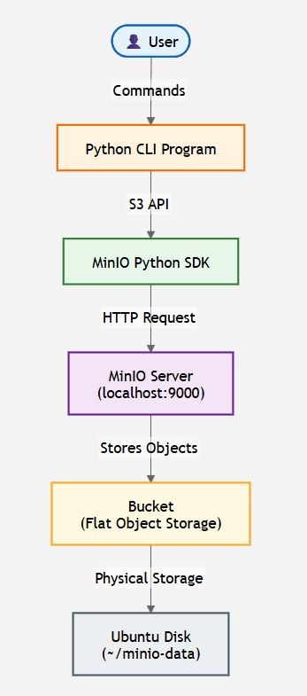

Procedure

Step 1-2: Update Ubuntu & Install Python
sudo apt upgrade -y
sudo apt install python3 python3-pip -y
python3 --version
pip3 --version

Step 3: Install MinIO Server
mkdir ~/minio && cd ~/minio
wget https://dl.min.io/server/minio/release/linux-amd64/minio
chmod +x minio
sudo mv minio /usr/local/bin/
minio --version

Step 4-5: Create Storage Folder & Start Server
mkdir ~/minio-data
export MINIO_ROOT_USER=minioadmin
export MINIO_ROOT_PASSWORD=minioadmin
minio server ~/minio-data --console-address ":9001"
API: http://127.0.0.1:9000 | Console: http://127.0.0.1:9001 | Login: minioadmin / minioadmin

Step 6: Open MinIO Console
Visit http://localhost:9001 and log in. Initially there are no buckets.

Step 7-8: Create Project & Virtual Environment
mkdir ObjectStorageSimulator && cd ObjectStorageSimulator
python3 -m venv venv
source venv/bin/activate
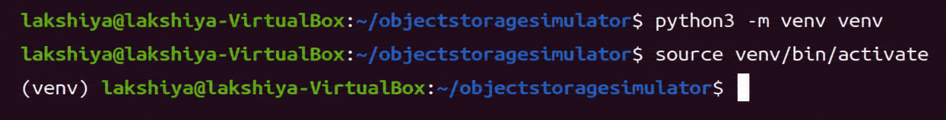

Step 9: Install MinIO Python SDK
pip install minio
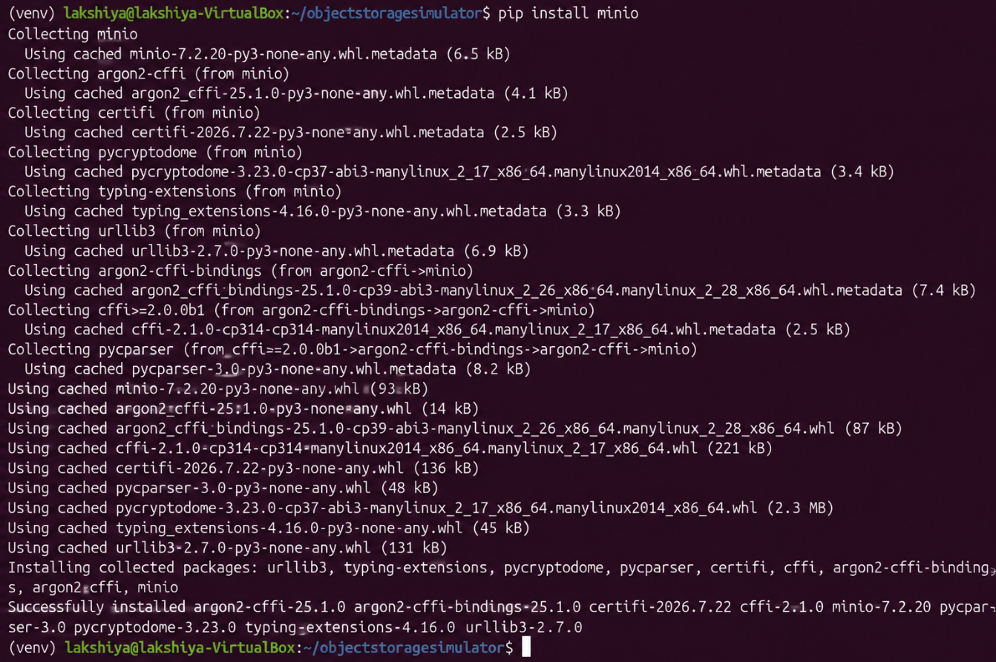

Verify installation:
pip show minio
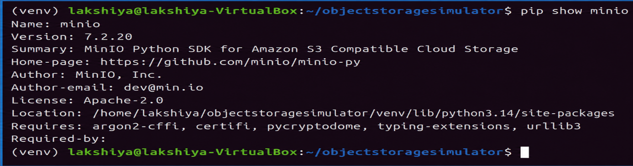

Step 10: Create Sample File & Bucket
echo "Hello this is sample minio project" > sample.txt
Create main.py with the bucket-creation code below and run it:
from minio import Minio
client = Minio("localhost:9000", access_key="minioadmin",
secret_key="minioadmin", secure=False)
bucket_name = "studentbucket"
if not client.bucket_exists(bucket_name):
client.make_bucket(bucket_name)
print("Bucket Created")
else:
print("Bucket Already Exists")
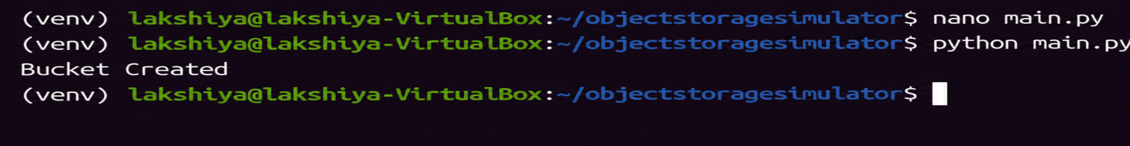
Verify in the MinIO console — the new bucket appears with no objects yet:
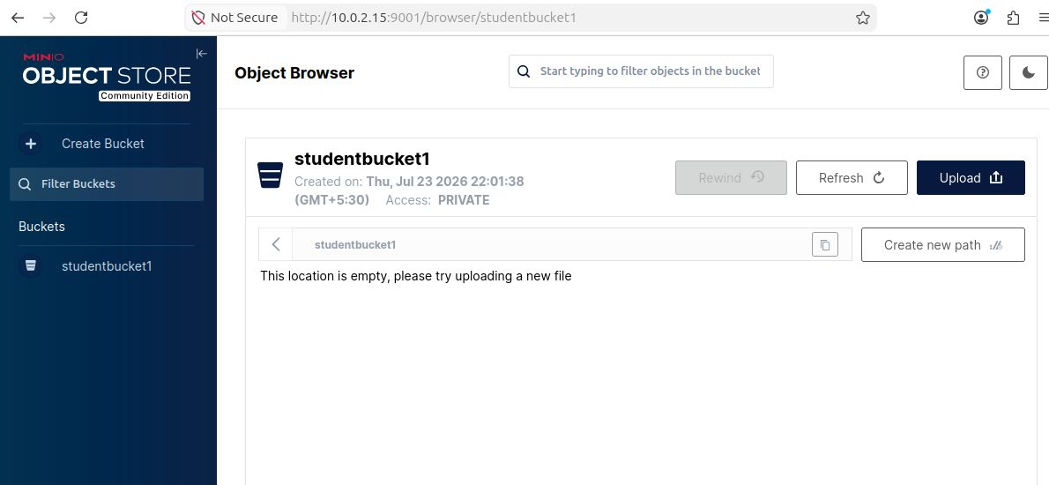

Step 11: Upload an Object
client.fput_object("studentbucket", "notes.txt", "sample.txt")
print("Upload Successful")
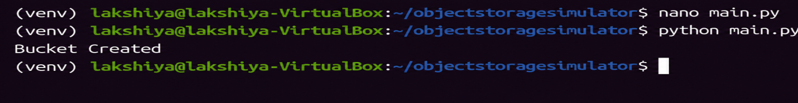
Verify in the console — notes.txt now appears inside the bucket:
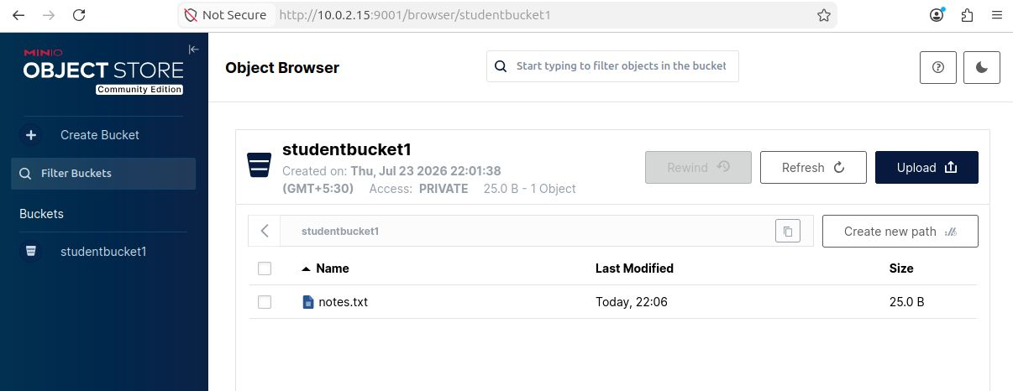

Step 12: Download an Object
Modify main.py to replace the upload code with:
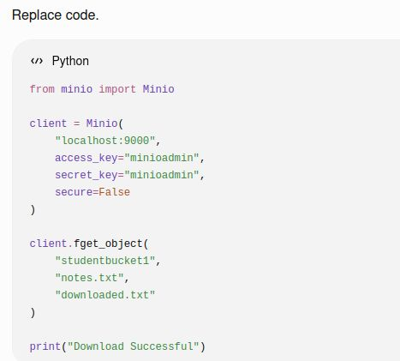

Result
Thus, a Python application was developed to perform bucket creation, object upload, and object download using the MinIO S3-compatible local object storage server.

