**AI HEALTHCARE CHATBOT WEBSITE USING DJANGO**

**Abstract:**

With the increasing population of India and a rise in birth rates coupled with advancements in the medical field leading to a decrease in death rates, there is a concerning shortage of doctors to adequately serve the growing population. This issue becomes apparent when visiting government hospitals in cities, where the limited availability of doctors is a major cause of inadequate treatment and, in some cases, even resulting in patient deaths. Furthermore, doctors, being human, are prone to making mistakes in providing accurate treatments, which can also lead to patient fatalities. To address such situations, the development of an intelligent and smart chat bot that can offer advice to both doctors and patients becomes crucial, potentially saving the lives of hundreds of people. Virtual assistants, including chat bots, have the potential to assist patients and healthcare providers with various medical-related tasks. Chat bots are computer programs designed to engage in conversations with individuals, offering assistance through text messages, applications, or instant messaging. These bots can identify symptoms and provide diagnoses based on specific symptoms, as well as recommend appropriate doctors for prompt responses. While chat bots are already extensively employed in other industries such as retail to enhance processes, their integration into healthcare services can prove invaluable.

**Keywords:** Intelligent chat bot, Virtual assistants, medical-related tasks, Diagnosis, health service.

**PROJECT OBJECTIVE:**

The objective of developing a Health-Care Chat Bot using Support Vector Machines (SVM) and Decision Tree algorithms is to provide an intelligent and interactive conversational system that can assist users in addressing their health-related queries and concerns. The chat bot will leverage the capabilities of both SVM and Decision Tree algorithms to enhance its performance and accuracy in understanding user inputs and providing relevant and reliable responses.

**PROBLEM STATEMENT:**

Develop an AI-powered healthcare chat bot website using Django to enhance patient engagement and streamline healthcare inquiries. The chat bot will provide users with personalized health information, appointment scheduling assistance, and general medical advice. By leveraging natural language processing, the chatbot aims to improve user experience, facilitate health-related conversations, and contribute to efficient healthcare communication. This project addresses the need for accessible, intelligent healthcare support, fostering a more responsive and patient-centric approach in the digital landscape.

**WHY THIS TOPIC CHOSSEN?**

The AI Healthcare Chatbot website using Django was chosen to revolutionize healthcare interactions. By integrating artificial intelligence, the chatbot offers instant, personalized medical guidance, enhancing patient engagement and accessibility. This innovative solution aims to streamline communication, provide timely health advice, and facilitate appointment scheduling. The project aligns with the growing demand for efficient, patient-centric healthcare services, leveraging technology to bridge gaps, improve healthcare accessibility, and offer a user-friendly interface for seamless interaction between patients and medical resources.

**EXISTING METHOD**

The existing system for a healthcare chatbot incorporates blockchain technology and data analysis. This system aims to enhance the security, privacy, and integrity of healthcare data, while also leveraging data analysis techniques to provide valuable insights and improve the overall patient experience. This is more costly to use and time taking process. It can use by multiple authorizations.

**DISADVANTAGES**

* Complex user interface. Making user difficult to recognize the operations
* Late response to user due to highly dumped data set
* More processing time to process huge data

**PROPOSED SYSTEM**

The proposed system for a healthcare chatbot integrates Natural Language Processing (NLP) techniques, Decision Trees, and Support Vector Machines (SVM) to create an advanced and intelligent healthcare chatbot solution.

The chatbot utilizes NLP algorithms to understand and interpret user queries or messages in a natural language format. NLP allows the chat bot to extract relevant information, such as symptoms, medical history, or specific concerns from the user's input. By applying NLP techniques, the chatbot can comprehend and respond effectively to a wide range of user queries, facilitating a more interactive and personalized conversation.

**ADVANTAGES**

* More visually pleasing
* Less response time to user
* Simple data set
* Less processing times.

**PROJECT FLOW**

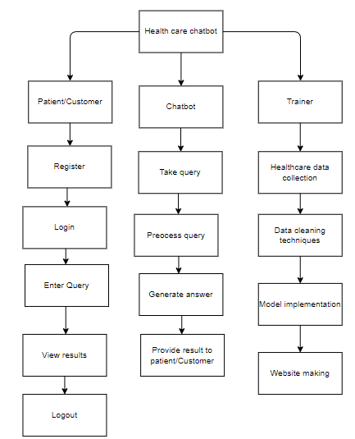

**HARDWARE & SOFTWARE REQUIREMENTS**

**SOFTWARE REQUIREMENS**

Operating System : Windows 7/8/10

Server side Script : HTML, CSS, Bootstrap & JS

Programming Language : Python

Libraries : Flask, Pandas, Mysql.connector, Os, Smtplib, Numpy

IDE/Workbench : PyCharm

**SOFTWARE REQUIREMENS**

Technology : Python 3.6+

Server Deployment : Xampp Server

Database : MySQL

**HARDWARE REQUIREMENTS**

Processor - I3/Intel Processor

RAM - 8GB (min)

Hard Disk - 128 GB

Key Board - Standard Windows Keyboard

Mouse - Two or Three Button Mouse

Monitor - Any

**MODULES:**

**1. System**

**1.1 Take Data:** System will receive data from the user.

**1.2 Pre-processing:** The system will undergo for pre-processing.

**1.3 Training:** The System will be trained.

**1.4 Model:** The system will work based on model.

**1.5 Results:**The system will deliver the output to the user.

**2. User**

**2.1 Send Query:** User will send Query to the system.

**2.2 View Query Result:** User will view his query result.