OOPS CONCEPTS ASSIGNMNET

1. Employee salary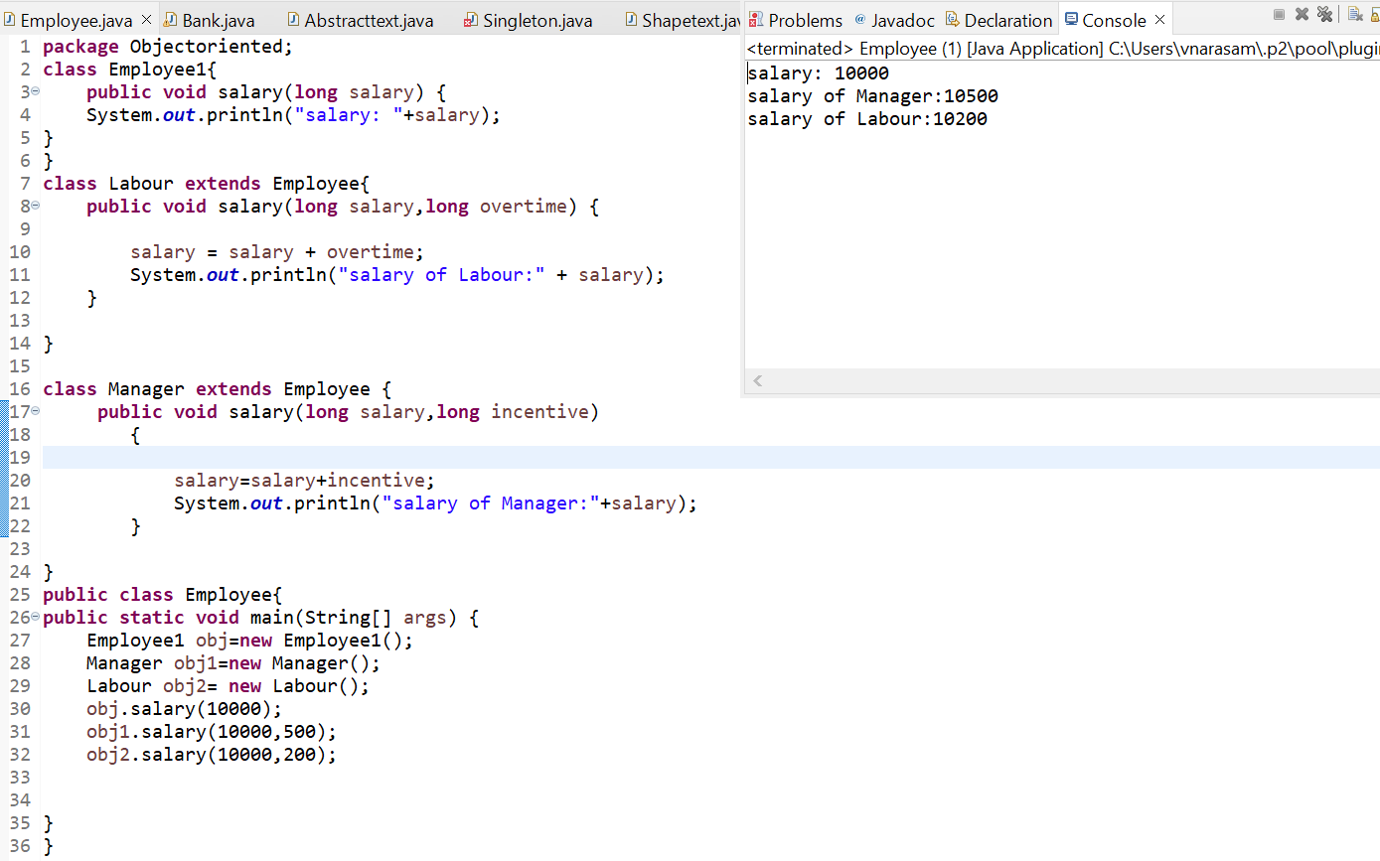
2. Bank deposite or credit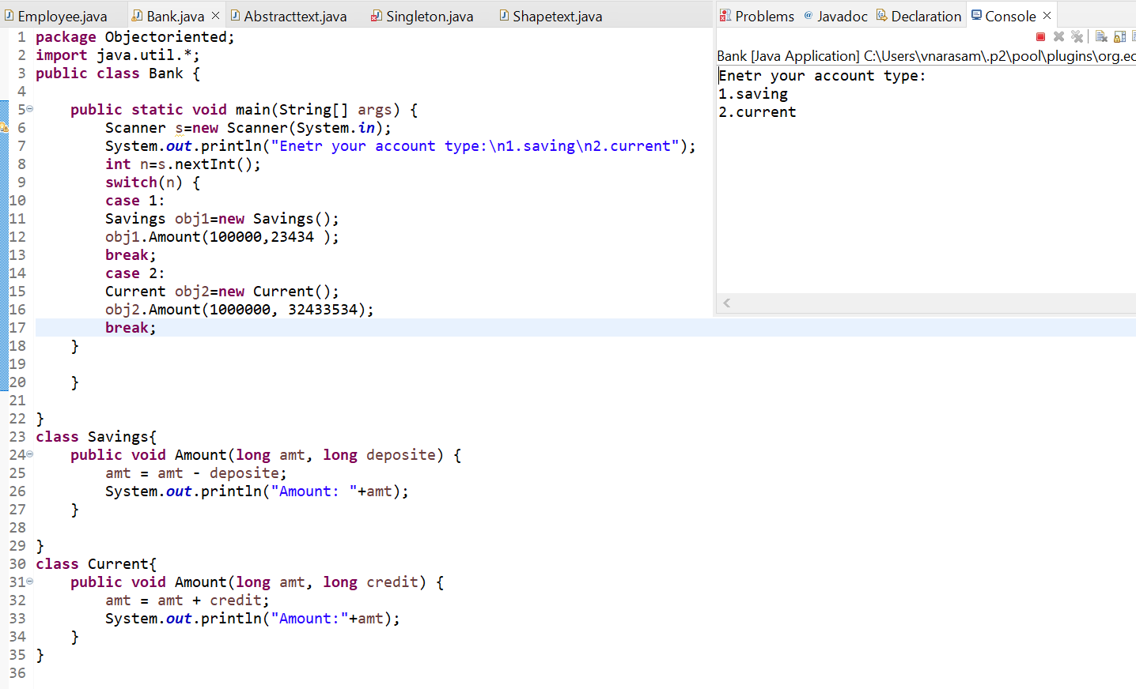
3. Abstraction

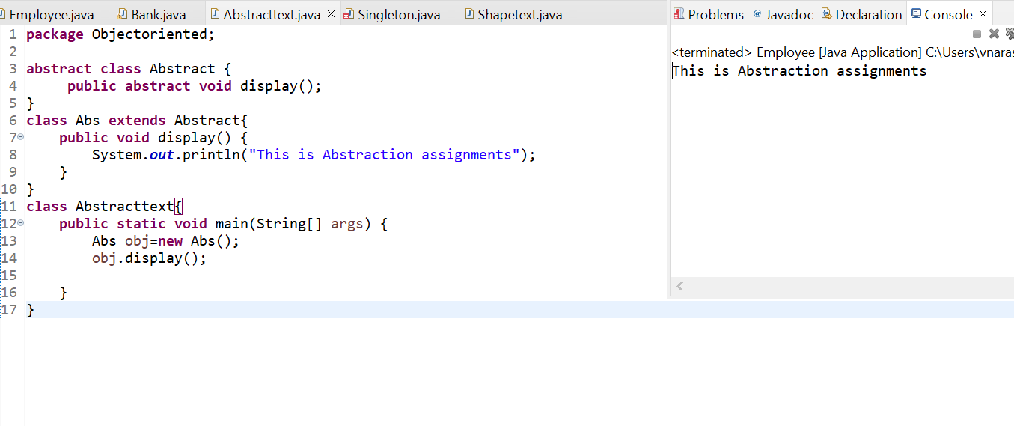

1. Singleton class

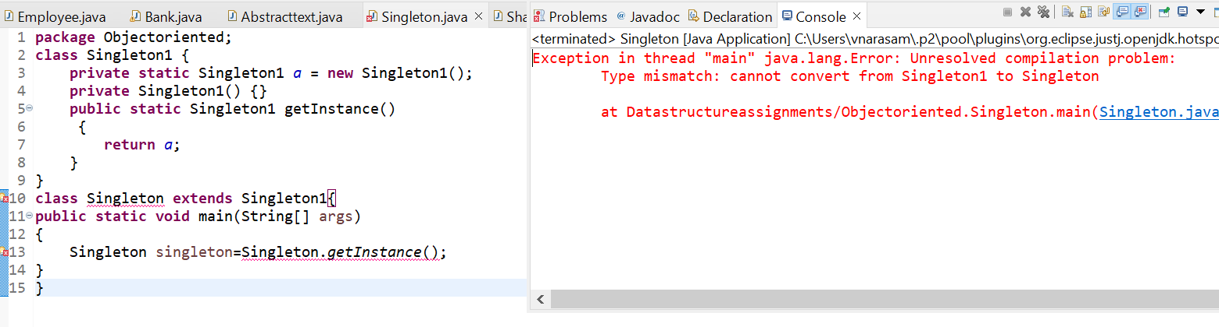

1. Shapes