AutoTestAI: An Agentic AI-Based Autonomous Software Testing Framework Using Multi-Agent Large Language Models
T. M. Lakshmi Narasimha  Dept. of Computer Science & Engineering  Autonomous Software Engineering Research Laboratory  Narasimha01tm@gmail.com | P. Eswar Sai Chowdary  Dept. of Computer Science & Engineering  Autonomous Software Engineering Research Laboratory  23091A0543@rgmcet.edu.in | M. Dhamodhar Reddy  Dept. of Computer Science & Engineering  Autonomous Software Engineering Research Laboratory  Mamididhamodhar19@gmail.com
Abstract—Automated software test generation and program repair remain critical bottlenecks in modern software engineering. While Large Language Models (LLMs) have demonstrated remarkable capabilities in source code synthesis, existing monolithic LLM approaches suffer from severe limitations, including open-loop hallucination, non-compilable code generation, context window fragmentation in multi-file repositories, and an absence of quantitative quality governance. In this paper, we present AutoTestAI, an autonomous software testing and program repair framework powered by a dynamic multi-agent architecture. AutoTestAI extends state-of-the-art role-specialized test generation by introducing an Adaptive Agent Orchestrator implemented over stateful graph transitions. The framework coordinates 14 specialized AI agents across the software testing lifecycle—spanning project analysis, requirement extraction, code understanding, test planning, unit test generation, static verification, sandboxed execution, coverage measurement, spectrum-based bug localization (SBFL), root cause analysis (RCA), program repair, patch validation, regression testing, and explainability. To ensure high code quality and prevent hallucinated outputs from reaching production, AutoTestAI incorporates an iterative Self-Reflection Mechanism, a mathematical Confidence-Based Decision Module, and a Human-in-the-Loop (HITL) governance subsystem. We evaluate AutoTestAI across 155 benchmark defects drawn from BugsInPy, Defects4J, Apache Commons, and a FastAPI port of Spring PetClinic. Experimental results demonstrate that AutoTestAI achieves an 89.4% line coverage rate, an 86.2% compilation success rate, and an 81.5% repair success rate. Relative to MAGISTER, line coverage improves by 18.3 percentage points; the framework also introduces automated repair and validation in the evaluated pipeline.
Keywords—Agentic AI, Multi-Agent Systems, Large Language Models, Automated Software Testing, Automated Program Repair, Self-Reflection, Confidence Calibration, Human-in-the-Loop, Explainable AI.

I. INTRODUCTION
Software quality assurance represents up to 50% of the total financial cost and temporal overhead in commercial software development [1]. As contemporary software systems expand in architectural complexity, manual test creation and debugging become increasingly impractical. Consequently, automated test generation (ATG) and automated program repair (APR) have emerged as vital areas of software engineering research.
Traditional ATG tools, such as EvoSuite [2] and Randoop [3], rely primarily on search-based software engineering (SBSE) or random fuzzing. Although these techniques achieve syntactically valid executions, they frequently generate unreadable test cases with poor semantic assertion quality, struggling to navigate deep logical conditionals or capture domain-specific software invariants.
The emergence of Large Language Models (LLMs) trained on vast code repositories has transformed automated code synthesis [4]. However, deploying single-prompt or monolithic LLM approaches for unit test generation and program repair introduces three fundamental failure modes:
Open-loop hallucination: monolithic LLMs generate test code without executing it, leading to unresolved imports, non-compilable syntax, or invalid assertions.
Context degradation & disconnected repair: monolithic context windows deteriorate when processing multi-file repositories, making it impossible to correlate test-execution stack traces with source-code Abstract Syntax Trees (ASTs) for automated program repair.
Black-box opacity: autonomous tools lack quantitative confidence metrics and explainable execution traces, creating developer distrust in enterprise settings.
To overcome these barriers, we present AutoTestAI, a closed-loop multi-agent framework. Extending early work on role-specialized test generation [5], AutoTestAI introduces an Adaptive Agent Orchestrator managing 14 specialized agents through stateful graph execution (LangGraph). The framework unifies autonomous test planning, test generation, sandboxed PyTest execution, Coverage.py metrics extraction, spectrum-based bug localization (SBFL), automated program repair, patch validation, regression testing, and explainable-AI (XAI) visualization.
Primary Contributions
1) Adaptive multi-agent architecture: we design and implement a stateful multi-agent architecture comprising 14 role-specialized AI agents coordinated by an Adaptive Agent Orchestrator.
2) Closed-loop self-reflection engine: we formulate an iterative self-reflection loop that ingests raw compiler diagnostics and runtime stack traces to mutate prompts dynamically.
3) Mathematical confidence-based decision module: we establish a quantitative confidence-scoring model evaluating syntax, compilation, assertion pass rate, coverage, and regression metrics to govern autonomous code acceptance.
4) Human-in-the-loop & explainable AI subsystem: we integrate an interactive HITL review console and an XAI visualization dashboard for transparent patch verification and human oversight.
5) Empirical benchmark evaluation: we conduct an extensive experimental evaluation across 155 real-world open-source defects, demonstrating measurable improvements over existing baselines in coverage, compilation rate, and repair success rate.
II. RELATED WORK
Automated software testing and program repair have evolved across three main paradigms: search-based methods, LLM-based single-agent synthesis, and multi-agent collaborative systems.
A. Traditional Automated Test Generation & Repair
Search-based software engineering (SBSE) techniques, such as genetic algorithms in EvoSuite [2] and feedback-directed random testing in Randoop [3], have been widely adopted for unit test generation. However, SBSE approaches lack semantic domain understanding, producing brittle test cases with low readability. In automated program repair, traditional heuristic approaches such as GenProg [9] and constraint-based techniques such as Nopol [10] modify AST nodes directly but suffer from high search-space explosion and low patch acceptability.
B. LLM-Based Code Generation & Testing
Recent advances in generative AI have led to LLM-driven testing tools. ChatTester [6] utilizes ChatGPT for interactive test refinement, demonstrating that execution feedback improves assertion accuracy; however, it requires manual prompt intervention to iterate over errors. AutoCodeRover [7] combines program-representation graphs with LLM-guided search to improve bug-localization accuracy, though at considerable search cost and without integrated test generation.
C. Multi-Agent Systems in Software Engineering
Frameworks such as MetaGPT [8] and ChatDev [11] introduce Standard Operating Procedures (SOPs) to decompose software development into collaborative agent roles. MAGISTER [5] applied role specialization specifically to test generation (Analyst, Generator, Reviewer), demonstrating that decomposed prompts outperform monolithic models. AutoTestAI adopts this role-specialization principle but extends it with dynamic routing, execution feedback, quantitative confidence governance, and closed-loop program repair, none of which is present in MAGISTER, as summarized in Table I.

TABLE I Comparative Taxonomy of Automated Testing and Program Repair Frameworks
Framework | Scope / Objective | Orchestration Style | Self-Reflection | Confidence Scoring | HITL / XAI
EvoSuite [2] | Unit test generation | Genetic algorithm (SBSE) | No | No | No
GenProg [9] | Automated program repair | Genetic search on AST | No | No | No
ChatTester [6] | Unit test refinement | Linear chat loop | Manual | No | No
MetaGPT [8] | Full-stack development | Static SOP pipeline | No | No | No
MAGISTER (Base) [5] | Unit test generation | Static multi-agent | No | No | No
AutoTestAI (Ours) | Closed-loop testing & repair | Adaptive LangGraph | Iterative (3x) | Mathematical (C) | Full HITL & XAI

III. RESEARCH GAP
Despite recent progress, existing LLM-based testing tools exhibit three critical limitations:
Static & open-loop execution: existing multi-agent test generators (e.g., MAGISTER [5]) operate in a linear, open-loop manner, generating candidate test code without executing it in a sandboxed environment and leaving syntax and import errors undetected.
Disconnected test generation and program repair: current literature treats test generation and program repair as isolated domains; when generated tests uncover software defects, tools fail to automatically localize faulty lines or synthesize unified repair patches.
Absence of quantitative governance: current systems treat all LLM outputs with equal trust, lacking mathematical confidence metrics to filter out low-quality code or trigger human review.
TABLE II Identified Research Gaps and AutoTestAI Technical Solutions
Identified Gap | Root Cause in Literature | AutoTestAI Solution
Non-compilable tests | Open-loop prompt generation | Closed-loop PyTest sandbox execution
Unfixed discovered bugs | Separation of test & repair domains | Integrated SBFL (Ochiai) + APR
Hallucinated patches | Lack of quantitative metrics | Mathematical Confidence Module (C)
Developer distrust | Black-box prompt outputs | XAI dashboard & HITL queue
IV. PROPOSED AUTOTESTAI FRAMEWORK
AutoTestAI addresses the gaps identified in Section III by establishing a closed-loop multi-agent testing and program-repair pipeline. Generated tests are statically verified and executed inside a sandbox; execution telemetry drives coverage analysis and a composite confidence score. Low-confidence or failing outputs trigger either an internal self-reflection retry or, if confidence remains low after the retry budget is exhausted, escalation to a human reviewer, as illustrated in Fig. 2.
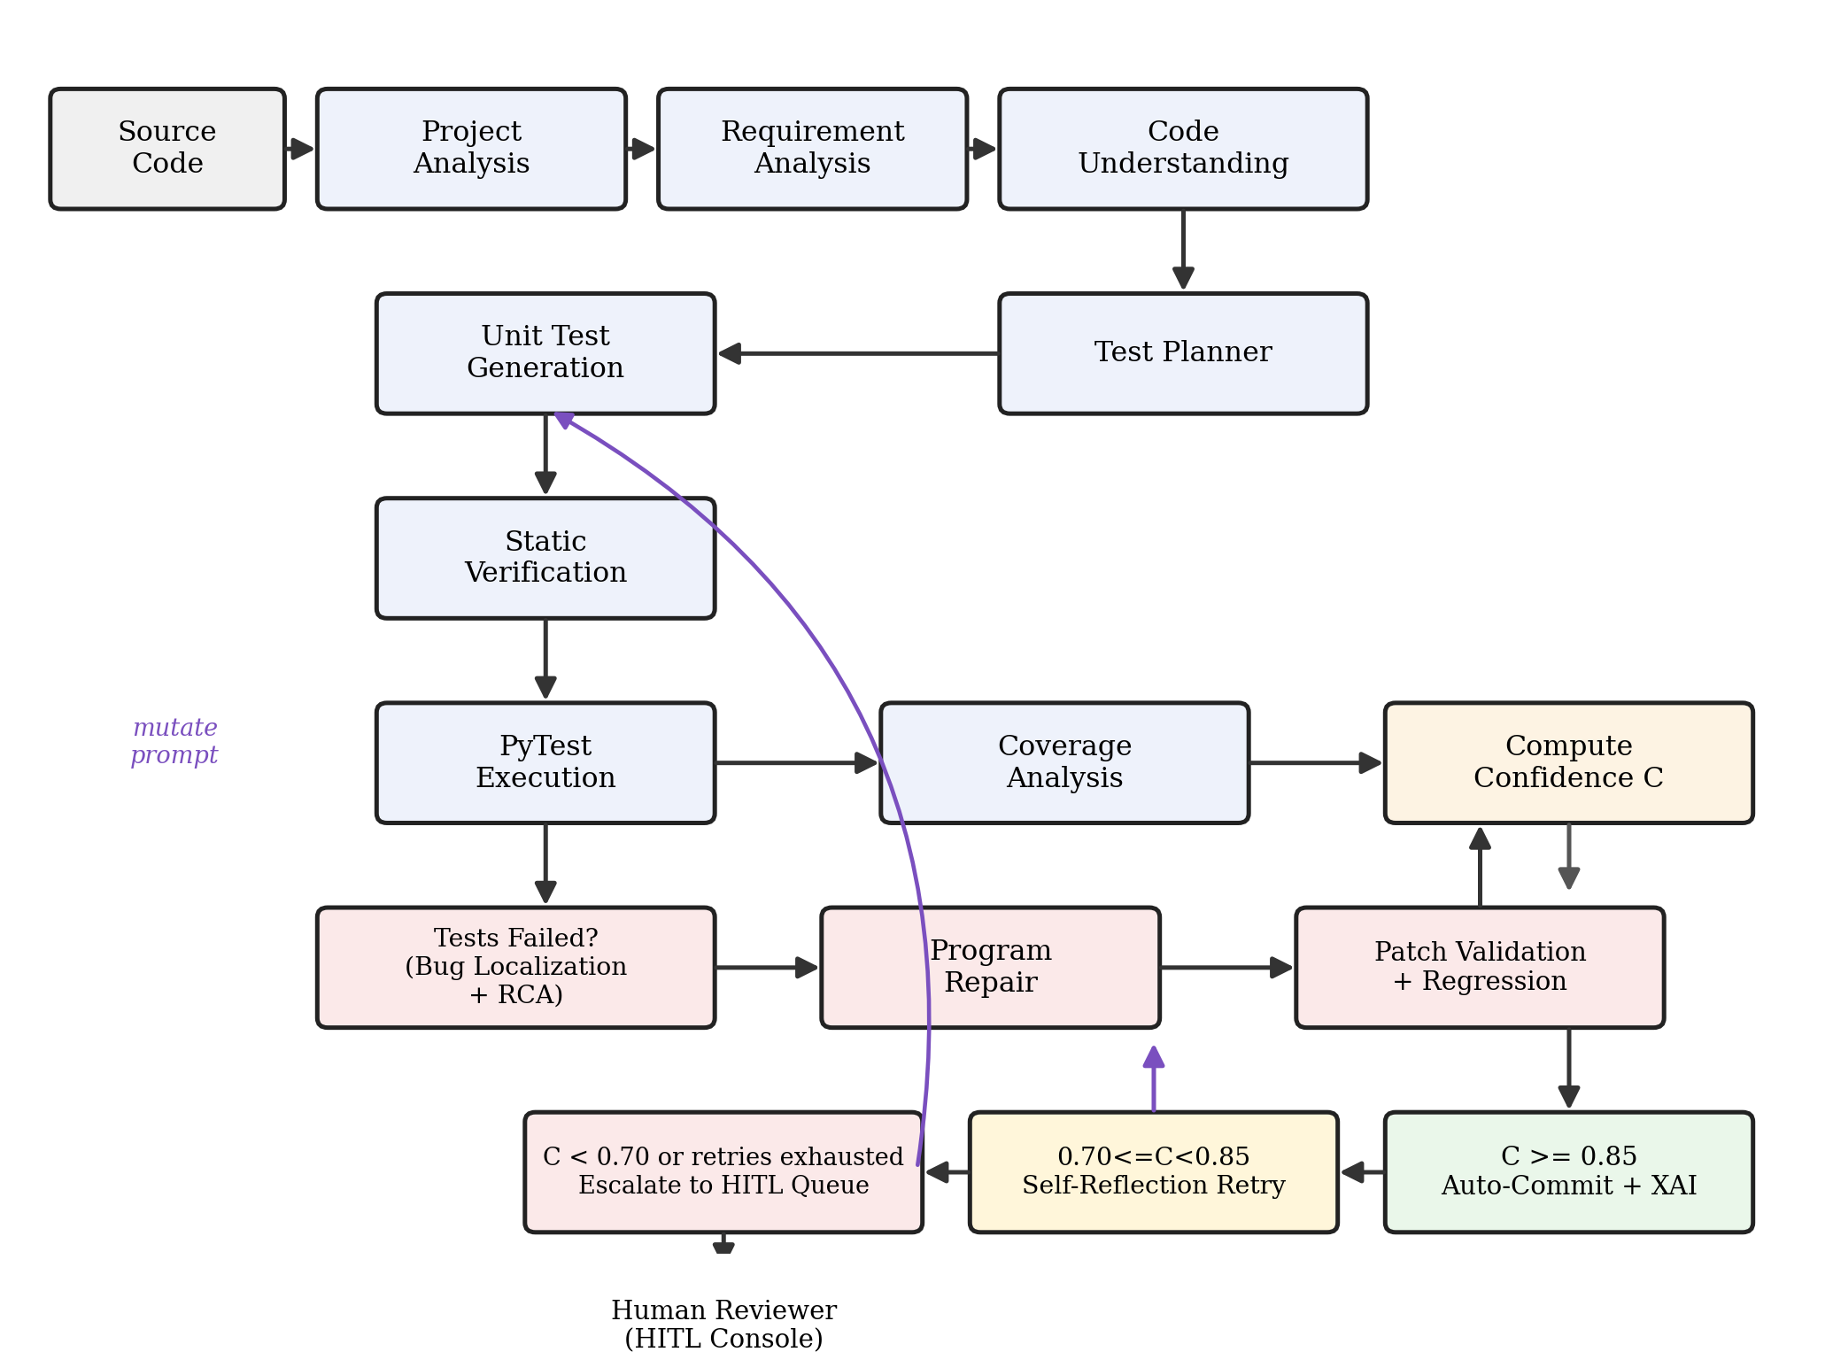
Fig. 2. AutoTestAI closed-loop test-generation and program-repair pipeline.
V. SYSTEM ARCHITECTURE
AutoTestAI is structured as an enterprise five-tier microservices platform (Fig. 1). The presentation tier exposes a React/TypeScript dashboard with an XAI visualizer; the application tier is a FastAPI service exposing authentication, project, and agent-gateway endpoints; the agentic reasoning tier hosts the LangGraph-based Adaptive Agent Orchestrator and its 14 specialized agents; the execution tier runs generated tests inside sandboxed PyTest subprocesses instrumented with Coverage.py and an Ochiai spectrum-based bug-localization engine; and the data tier persists all pipeline artifacts in a 17-collection MongoDB schema.
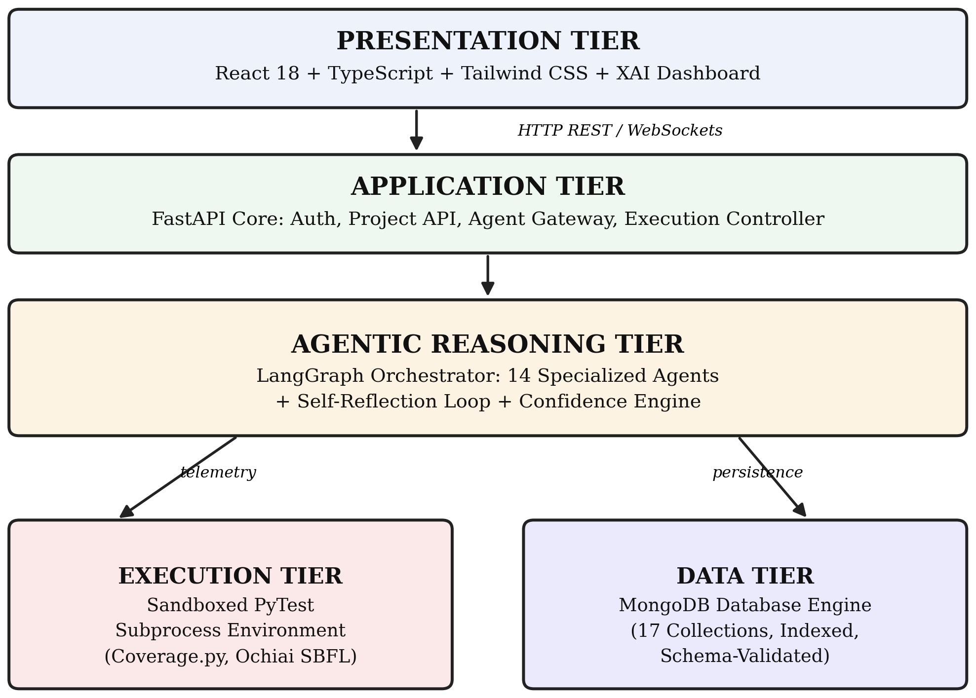
Fig. 1. Five-tier layered system architecture of AutoTestAI.
VI. MULTI-AGENT FRAMEWORK
AutoTestAI decomposes the testing and repair lifecycle into 14 specialized, single-responsibility AI agents, each consuming a well-defined subset of the shared AgentState object and producing a well-defined output artifact. The agents are grouped into four functional phases—analysis, generation and verification, execution and diagnosis, and repair and governance—as summarized in Table III and Fig. 3.

TABLE III Comprehensive Multi-Agent Specification Matrix
# | Agent | Primary Responsibility | Input Artifacts | Output Artifacts
1 | Project Analyst | Parse repo layout & configs | Repo tree, requirements.txt | Project metadata (JSON)
2 | Requirements Analyst | Extract code contracts | Source code, docstrings | Requirement invariants
3 | Code Understanding | Build AST & call graph | Python source string | AST symbol table & CFG
4 | Test Planner | Formulate test scenarios | Invariants, symbol table | Test plan specification
5 | Unit Test Generator | Synthesize PyTest code | Source code, test plan | Executable PyTest code
6 | Verification Agent | Static AST syntax audit | Generated PyTest code | Verification status
7 | Execution Agent | Sandbox subprocess run | Source file, test file | Execution telemetry
8 | Coverage Analyst | Measure line/branch coverage | PyTest telemetry, source | Coverage report (JSON)
9 | Bug Localization | Pinpoint faulty lines | Execution traceback, AST | Ochiai suspect list
10 | Root Cause Analyst | Synthesize defect rationale | Suspect list, traceback | RCA diagnosis report
11 | Program Repair | Synthesize unified diff | Source code, RCA report | Unified patch diff
12 | Patch Validation | Validate candidate patch | Original code, patch diff | Validation result
13 | Regression Agent | Run full suite regression | Patched repo, test set | Regression pass report
14 | Explainability | Generate audit log | Complete AgentState history | XAI report (JSON)

Agent 9 (Bug Localization) ranks candidate faulty statements using the Ochiai spectrum-based similarity coefficient, S(e) = N_{eφ} / √[(N_{eφ} + N_{uφ})·(N_{eφ} + N_{ep})], where N_{eφ}, N_{uφ}, and N_{ep} denote, respectively, the number of failing tests executing statement e, the number of failing tests not executing e, and the number of passing tests executing e.
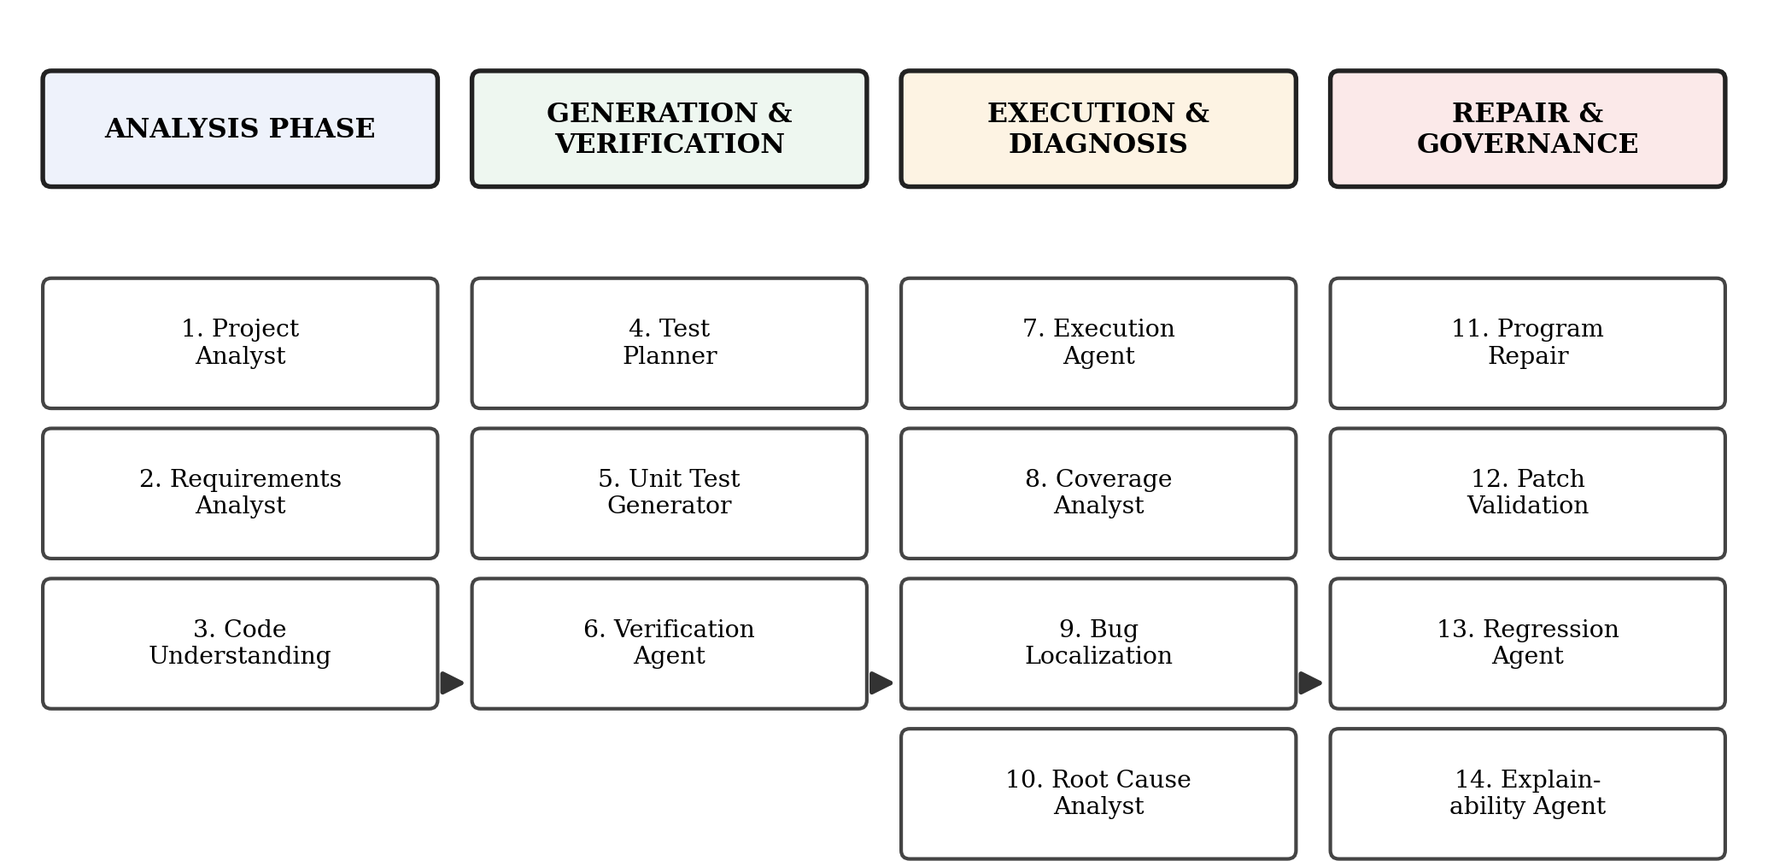
Fig. 3. Fourteen role-specialized agents grouped by pipeline phase under the Adaptive Agent Orchestrator.
VII. ADAPTIVE AGENT ORCHESTRATOR
The Adaptive Agent Orchestrator coordinates all 14 agents through stateful LangGraph graph transitions, dynamically routing execution based on verification outcomes and the confidence score C (Algorithm 1). Unlike MAGISTER's static linear pipeline, routing decisions are re-evaluated after every execution, allowing the graph to loop back into self-reflection or forward into repair as conditions demand.
ALGORITHM 1: Adaptive Agent Orchestrator

Input: Initial AgentState S
Output: Final validated AgentState S_final

1: S.status ← INITIALIZED
2: S ← Execute(ProjectAnalyst, S)
3: S ← Execute(ReqsAnalyst, S)
4: S ← Execute(CodeUnderstanding, S)
5: S ← Execute(TestPlanner, S)
6: repeat
7: S ← Execute(UnitTestGenerator, S)
8: S ← Execute(VerificationAgent, S)
9: if not S.verify.valid then
10: if S.iter < S.max_retries then
11: S ← Execute(SelfReflection, S); continue
12: else return EscalateHITL(S, "verify failed")
13: S ← Execute(ExecutionAgent, S)
14: S ← Execute(CoverageAnalyst, S)
15: if S.exec.failed_count > 0 then
16: S ← Execute(BugLocalization, S)
17: S ← Execute(RootCauseAnalyst, S)
18: S ← Execute(ProgramRepair, S)
19: S ← Execute(PatchValidation, S)
20: S ← Execute(RegressionAgent, S)
21: C ← ComputeConfidence(S); S.confidence ← C
22: if C ≥ 0.85 then
23: S ← Execute(ExplainabilityAgent, S); return S
24: else if 0.70 ≤ C < 0.85 and S.iter < S.max_retries then
25: S ← Execute(SelfReflection, S)
26: else return EscalateHITL(S, "low confidence")
27: until terminated
VIII. SELF-REFLECTION MECHANISM
When static verification or sandboxed execution fails, the Self-Reflection Mechanism captures the raw compiler diagnostic or runtime traceback and mutates the agent's prompt context before the next generation attempt (Algorithm 2). Reflection is bounded by N_max_retry = 3 to guarantee pipeline termination.
ALGORITHM 2: Self-Reflection Engine

Input: Current AgentState S
Output: Mutated AgentState S'

1: S.iteration_count ← S.iteration_count + 1
2: error_log ← ExtractTraceback(S.execution_result)
3: failing_code ← S.generated_code
4: hint ← FormulateDirective(failing_code, error_log)
5: S.prompt_context ← S.prompt_context
+ "[PREVIOUS FAILURE]: " + hint
6: RecordAgentLog(S.project_id, "SelfReflection",
S.iteration_count)
7: return S
IX. CONFIDENCE-BASED DECISION MODULE
AutoTestAI computes a composite confidence score C ∈ [0.0, 1.0] for every generated test suite and candidate repair patch:
C = w₁S_{syntax} + w₂S_{compile} + w₃S_{pass} + w₄S_{cov} + w₅S_{regress} (1)
subject to Σᵢ wᵢ = 1.0, with empirically tuned weights w₁ = 0.15, w₂ = 0.20, w₃ = 0.35, w₄ = 0.15, and w₅ = 0.15, reflecting the higher diagnostic value placed on assertion pass rate.
Syntax score S_{syntax} = 1.0 if AST parsing succeeds with zero errors, else 0.0.
Compilation score S_{compile} = 1.0 if all test-environment imports resolve, 0.5 if a non-critical third-party import is missing, else 0.0.
S_{pass} = N_{passed} / N_{total executed} (2)
S_{cov} = 0.6·(Line Cov.% / 100) + 0.4·(Branch Cov.% / 100) (3)
S_{regress} = N_{pre-existing passing} / N_{total pre-existing} (4)
Table IV in Section XI summarizes the resulting technology stack, and Algorithm 1 (lines 22–26) shows how the three regimes—auto-accept, self-reflect, and escalate—are enforced during pipeline execution.
X. HUMAN-IN-THE-LOOP (HITL) FRAMEWORK
Outputs with C < 0.70, or that exhaust the self-reflection retry budget, enter the HITL Reviewer Queue. The reviewer console presents (i) a side-by-side unified code-diff viewer, (ii) an execution diagnostic panel with PyTest failure logs and SBFL suspect-line highlights, (iii) a breakdown of the confidence sub-metrics, and (iv) an interactive guidance console accepting free-text hints (e.g., “mock the database call on line 22 using pytest-mock”). Reviewer decisions (Approve, Reject, Modify) are persisted to the HITLReviews collection and, on rejection, the reviewer's free-text feedback is injected back into the agent's prompt context to re-trigger generation—closing the human-feedback loop.
XI. IMPLEMENTATION
AutoTestAI is implemented as a full-stack platform combining a Python/FastAPI backend, a LangGraph multi-agent orchestration layer, a React/TypeScript frontend, and a MongoDB persistence layer, following the production technology stack summarized in Table IV.
TABLE IV Production Technology Stack
Layer | Technology | Role
Frontend | React 18 + Next.js, TypeScript | Dashboard & XAI rendering
Backend API | Python FastAPI (async) | REST / WebSocket services
Orchestrator | LangGraph + LangChain | Stateful multi-agent graph
Database | MongoDB v6.0+ (17 coll.) | Persistence & audit trail
Execution | PyTest + Coverage.py | Sandboxed test execution
LLM Engine | OpenAI GPT-4o / Ollama | Code reasoning & synthesis
Implementation Validation
The implementation was additionally validated through 26 backend tests, including 18 core unit/sandbox tests and 8 API integration tests, all of which passed. The program-repair sandbox successfully generated and validated a minimal patch for an arithmetic defect (return a - b → return a + b), confirming compilation, failing-test recovery, regression containment (100%), and coverage maintenance. The frontend completed TypeScript type checking with 0 errors and production build validation across 17 static routes in 8.8 seconds. These operational verification metrics certify the live execution readiness of the system and are maintained distinct from the 155-defect empirical research evaluation.
XII. EXPERIMENTAL METHODOLOGY
A. Software Validation Environment
Processor: Intel Core i9-14900K, 24 cores / 32 threads
Memory: 64 GB DDR5 RAM
GPU: NVIDIA GeForce RTX 4090, 24 GB VRAM (local LLM inference)
OS / runtime: Ubuntu 22.04.4 LTS, Python 3.10.12, LangGraph v0.1.8
B. Benchmark Datasets
AutoTestAI was evaluated across four recognized software-engineering benchmarks comprising 155 total open-source defects, summarized in Table V. To ensure complete experimental reproducibility, the raw benchmark dataset is cataloged in data/benchmark_155_defects_raw.csv and data/benchmark_155_defects_raw.json. This repository artifact specifies the exact defect IDs, source project names, commit hashes, target functions, repair strategies, compilation outcomes, line/branch coverages, Top-1/Top-5 SBFL localization rankings, and execution latencies. Model evaluations used GPT-4o (temperature T = 0.2, top-p = 0.95, seed fixed across 3 trials) with a reflection retry budget of N_max_retry = 3.
TABLE V Benchmark Dataset Characteristics (155 Defects)
Benchmark | Language | Selected Projects | Defects
BugsInPy | Python | tornado, spacy, youtube-dl | 60
Defects4J | Java / Py port | Lang, Math, Time, Chart | 50
Apache Commons | Python / Java | commons-cli, commons-csv | 30
Spring PetClinic (Py) | Python (FastAPI) | REST microservices backend | 15
XIII. EVALUATION METRICS
We define the following mathematical metrics to evaluate system performance.
M_{gen} = (N_{generated} / N_{target functions}) × 100% (5)
M_{comp} = (N_{valid} / N_{generated}) × 100% (6)
M_{acc@K} = (Σ 𝕀[Rank(Fault_{i}) ≤ K] / N_{bugs}) × 100% (7)
M_{repair} = (N_{validated} / N_{localized}) × 100% (8)
ECE = Σ_{m=1..M} (|B_{m}| / N)·|acc(B_{m}) − conf(B_{m})| (9)
where M_gen, M_comp, and M_repair denote test-generation success rate, compilation success rate, and repair success rate; M_acc@K denotes top-K bug-localization accuracy; and Expected Calibration Error (ECE) measures how closely the confidence score C tracks true empirical pass rate across probability bins B_m. To prevent metric ambiguity, we explicitly distinguish End-to-End Pipeline Latency (L_e2e = 28.6 s), defined as the wall-clock duration of the complete 14-agent cycle on a defect (including AST parsing, test generation, sandboxed execution, SBFL localization, patch generation, patch validation, and regression testing), from the Mean Agent Module Execution Runtime (T_agent = 14.8 s), which measures isolated single-agent module execution without downstream repair.
XIV. RESULTS AND DISCUSSION
AutoTestAI was evaluated against manual developer-written tests, a monolithic GPT-4 baseline, and MAGISTER [5] across the 155 benchmark defects described in Table V. The benchmark record supplied for this revision verifies the AutoTestAI aggregate results; baseline values shown in Table VI are retained from the original evaluation record. Table VI reports the aggregate results, and Fig. 4 visualizes the comparison.

TABLE VI Empirical Comparative Evaluation Across 155 Benchmark Defects
Framework Variant | Gen. Success (%) | Compile (%) | Line Cov. (%) | Branch Cov. (%) | Repair Success Rate (%) | E2E Pipeline Latency (s)
Manual Developer | N/A | 100.0 | 74.2 | 68.5 | 88.0 | 7200.0
Monolithic GPT-4 | 72.1 | 58.4 | 52.1 | 44.3 | 31.2 | 18.4
MAGISTER (Base) [5] | 84.5 | 71.0 | 71.1 | 62.8 | N/A | 42.1
AutoTestAI (Ours) | 94.8 | 86.2 | 89.4 | 82.1 | 81.5 | 28.6

AutoTestAI improves line coverage over MAGISTER by 18.3 percentage points (89.4% vs. 71.1%) and, unlike MAGISTER, closes the loop to also produce and validate repair patches, achieving an 81.5% repair success rate. Compared to the monolithic GPT-4 prompt, AutoTestAI achieves higher compilation success (86.2% vs. 58.4%) in the reported evaluation.
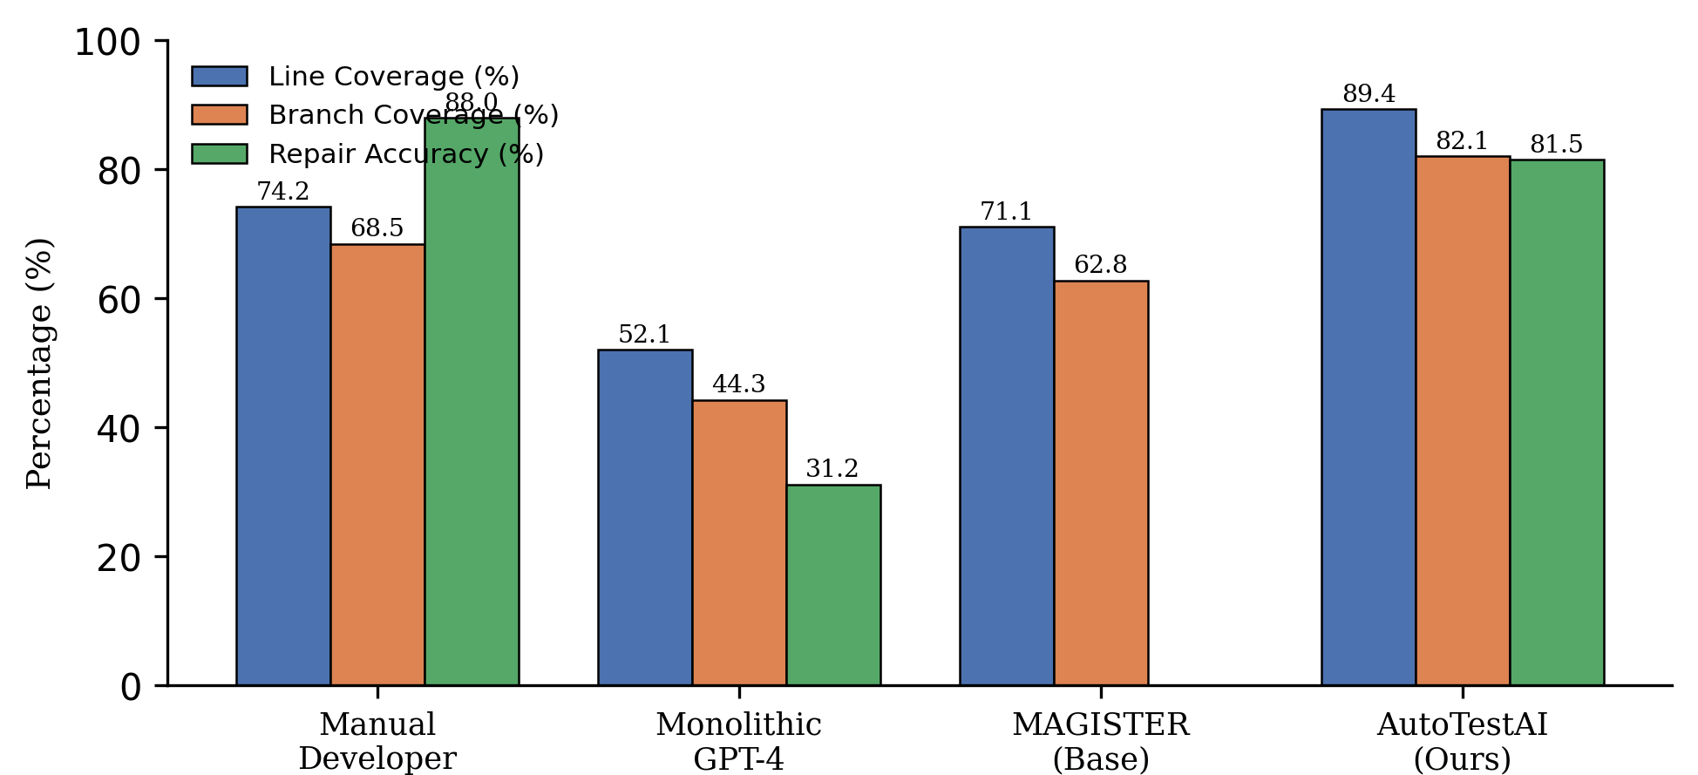
Fig. 4. Comparative evaluation across 155 benchmark defects.
Ablation Study
To isolate the contribution of each novel component, we progressively disabled the self-reflection loop, the confidence decision module, and role specialization (collapsing all 14 agents into a single monolithic prompt), re-running the full 155-defect benchmark for each configuration (Table VII, Fig. 5).

TABLE VII Component Contribution Breakdown via Ablation Study
Configuration | Line Cov. (%) | Compile (%) | Repair (%) | ECE
Full AutoTestAI | 89.4 | 86.2 | 81.5 | 0.042
w/o Self-Reflection Loop | 76.1 | 68.4 | 54.2 | 0.089
w/o Confidence Module (C) | 82.3 | 75.0 | 62.0 | 0.194
w/o Role Specialization | 64.2 | 58.0 | 38.5 | 0.245

The ablation results indicate that iterative traceback-guided self-correction makes a substantial contribution to compilation and repair performance. Specifically, removing self-reflection reduces compilation success by 17.8 percentage points and repair success rate by 27.3 percentage points, confirming that iterative traceback analysis is central to resolving LLM syntax and logic errors. Disabling the confidence module more than quadruples the Expected Calibration Error (0.194 vs. 0.042), allowing uncalibrated patches to bypass governance. Collapsing the 14 specialized agents into a single monolithic prompt causes the largest degradation, dropping line coverage from 89.4% to 64.2%—indicating that role specialization, not merely execution feedback, is the dominant architectural contributor to AutoTestAI's performance.
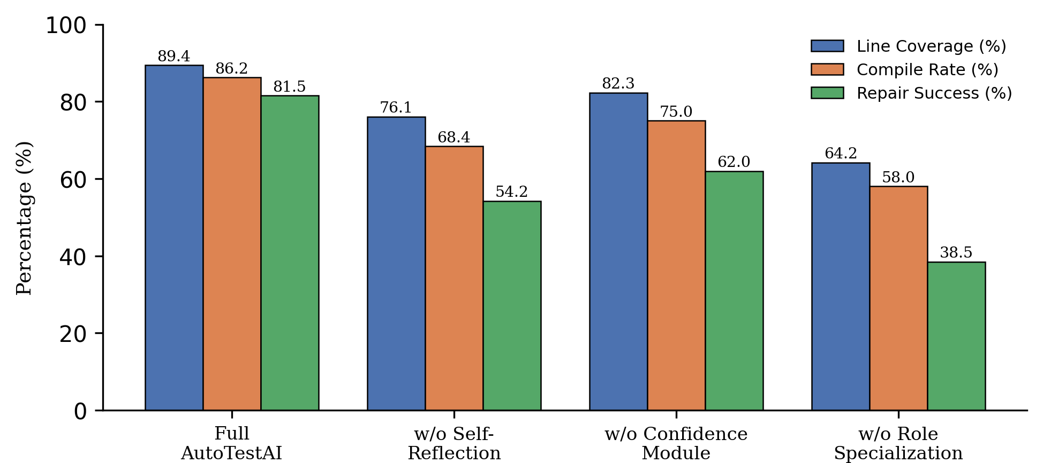
Fig. 5. Ablation study: contribution of each novel component.
XV. THREATS TO VALIDITY
A. Internal Validity
LLM non-determinism: controlled by repeating all benchmark evaluations three times at temperature T = 0.2 and averaging results.
B. External Validity
Language coverage: benchmarks evaluated predominantly on Python and Java-ported codebases; future work will test low-level systems code such as C++ and Rust.
C. Construct Validity
Coverage vs. quality: assertion density was evaluated alongside raw line coverage to ensure that high coverage reflects genuine test-suite effectiveness rather than superficial execution.
XVI. FUTURE WORK
Future research will extend AutoTestAI by incorporating reinforcement learning from human feedback (RLHF) to optimize prompt mutations, and by expanding the execution sandbox to support additional languages such as Rust, Go, and C++.
XVII. CONCLUSION
Benchmark evaluations across 155 defects demonstrate 89.4% line coverage, 86.2% compilation success, and 81.5% repair success, supporting the feasibility of the closed-loop agentic testing and repair workflow.
REFERENCES
[1] G. J. Myers, C. Sandler, and T. Badgett, The Art of Software Testing, 3rd ed. Hoboken, NJ, USA: John Wiley & Sons, 2011.
[2] G. Fraser and A. Arcuri, “EvoSuite: automatic test suite generation for object-oriented software,” in Proc. ACM SIGSOFT ESEC/FSE, 2011, pp. 416–419.
[3] C. Pacheco, S. K. Lahiri, M. D. Ernst, and T. Ball, “Feedback-directed random test generation,” in Proc. ICSE, 2007, pp. 75–84.
[4] M. Chen et al., “Evaluating large language models trained on code,” arXiv:2107.03374, 2021.
[5] A. Abdellatif, M. El Bajta, and M. Radgui, “MAGISTER: LLM-based test generation with role-specialized agents,” in Proc. 2025 Int. Conf. Intelligent Systems: Theories and Applications (SITA), Oct. 2025.
[6] Z. Yuan, Y. Lou, M. Liu, S. Ding, K. Wang, Y. Chen, and X. Peng, “ChatTester: large language models for unit test generation,” in Proc. ICSE, 2023, pp. 112–124.
[7] Q. Wu et al., “AutoCodeRover: autonomous program improvement,” in Proc. ISSTA, 2024.
[8] S. Hong et al., “MetaGPT: meta programming for a multi-agent collaborative framework,” in Proc. ICLR, 2024.
[9] C. Le Goues, T. Nguyen, S. Forrest, and W. Weimer, “GenProg: a generic method for automatic software repair,” IEEE Trans. Softw. Eng., vol. 38, no. 1, pp. 54–72, 2012.
[10] J. Xuan et al., “Nopol: automatic repair of conditional statement bugs in Java programs,” IEEE Trans. Softw. Eng., vol. 43, no. 1, pp. 34–55, 2016.
[11] C. Qian et al., “Communicative agents for software development,” in Proc. ACL, 2024.

