Level1-Task1(Top cuisines)-----Dataset used is Datasetcleaned.csv-----

Determine the top three most common cuisines in the dataset.

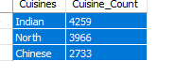

Calculate the percentage of restaurants that serve each of the top cuisines.

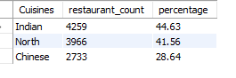

Task2----

Identify the city with the highest number of restaurants in the dataset.

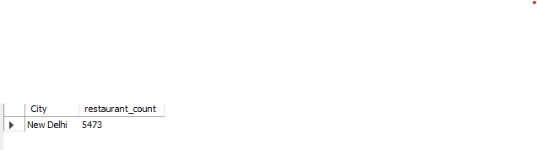

Calculate the average rating for restaurants in each city.

|  |  |  |  |  |  |  |  |  |  |
| --- | --- | --- | --- | --- | --- | --- | --- | --- | --- |
| City average_rating   |  | | --- | | Inner City | | Quezon City |  |  |  | | --- | --- | |  |  | |  |  | | |  | | --- | | 4.900000 | | 4.800000 | |
| Makati City | 4.650000 |
| Pasig City | 4.633333 |
| Mandaluyong City | 4.625000 |
| Beechworth | 4.600000 |
| London | 4.535000 |
| Taguig City | 4.525000 |
| Tagaytay City | 4.500000 |
| Lincoln | 4.500000 |
| Secunderabad | 4.500000 |
| Rio De Janeiro | 4.489474 |
| Orlando | 4.478947 |
| Tampa Bay | 4.410000 |
| Palm Cove | 4.400000 |
| Tanunda | 4.400000 |
| Rest Of Hawaii | 4.394737 |
| Bangalore | 4.375000 |
| Dubai | 4.370000 |
| Pasay City | 4.366667 |
| Jakarta | 4.356250 |
| Hyderabad | 4.344444 |
| Chennai | 4.315000 |
| Ankara | 4.305000 |
| Clatskanie | 4.300000 |
| Vernonia | 4.300000 |
| Vineland Station | 4.300000 |
| Abu Dhabi | 4.300000 |
| Mohali | 4.300000 |
| Tangerang | 4.300000 |
| Randburg | 4.300000 |
| Sandton | 4.300000 |
| Stanbul | 4.292857 |
| Auckland | 4.275000 |
| Boise | 4.260000 |
| Kolkata | 4.255000 |
| San Juan City | 4.250000 |
| Wellington City | 4.250000 |
| Goa | 4.245000 |
| Des Moines | 4.235000 |
| Pune | 4.220000 |
| Athens | 4.200000 |
| Pensacola | 4.200000 |
| Panchkula | 4.200000 |
| Bandung | 4.200000 |
| Johannesburg | 4.200000 |
| Lucknow | 4.195238 |
| Guwahati | 4.190476 |
| Pretoria | 4.190000 |
| Savannah | 4.168421 |
| Cedar RapidsIowa City | 4.165000 |
| Ahmedabad | 4.161905 |
| SO Paulo | 4.152941 |
| Coimbatore | 4.135000 |
| Macon | 4.131579 |
| Augusta | 4.130000 |
| Jaipur | 4.130000 |
| Davenport | 4.127778 |
| Dalton | 4.110000 |
| Cape Town | 4.110000 |
| East Ballina | 4.100000 |
| Huskisson | 4.100000 |
| Trentham East | 4.100000 |
| Edinburgh | 4.090000 |
| Mumbai | 4.085000 |
| Kochi | 4.080000 |
| Doha | 4.060000 |
| Chandigarh | 4.050000 |
| Dehradun | 4.050000 |
| Manchester | 4.045000 |
| Gainesville | 4.042105 |
| Columbus | 4.030000 |
| Sharjah | 4.030000 |
| Vadodara | 4.025000 |
| Vizag | 4.005000 |
| Princeton | 4.000000 |
| Bhubaneshwar | 3.980952 |
| Ludhiana | 3.980000 |
| Indore | 3.970000 |
| Agra | 3.965000 |
| Nagpur | 3.965000 |
| Bhopal | 3.950000 |
| Surat | 3.935000 |
| Weirton | 3.900000 |
| Birmingham | 3.873684 |
| Colombo | 3.870000 |
| Bogor | 3.850000 |
| Kanpur | 3.815000 |
| Santa Rosa | 3.800000 |
| Hepburn Springs | 3.800000 |
| Lakes Entrance | 3.800000 |
| Middleton Beach | 3.800000 |
| Sioux City | 3.765000 |
| Mangalore | 3.745000 |
| Puducherry | 3.730000 |
| Valdosta | 3.715000 |
| ChathamKent | 3.700000 |
| Fernley | 3.700000 |
| Forrest | 3.700000 |
| Inverloch | 3.700000 |
| Phillip Island | 3.700000 |
| Mysore | 3.695000 |
| Amritsar | 3.685714 |
| BrasLia | 3.678947 |
| Pocatello | 3.668421 |
| Waterloo | 3.650000 |
| Dicky Beach | 3.600000 |
| Lakeview | 3.600000 |
| Lorn | 3.600000 |
| Monroe | 3.600000 |
| Ojo Caliente | 3.600000 |
| Victor Harbor | 3.600000 |
| Singapore | 3.575000 |
| Albany | 3.552941 |
| Dubuque | 3.535000 |
| Nashik | 3.520000 |
| Varanasi | 3.510000 |
| Armidale | 3.500000 |
| Flaxton | 3.500000 |
| Macedon | 3.500000 |
| Patna | 3.455000 |
| Ranchi | 3.455000 |
| Penola | 3.400000 |
| Allahabad | 3.395000 |
| Aurangabad | 3.375000 |
| Gurgaon | 3.330674 |
| Potrero | 3.300000 |
| Yorkton | 3.300000 |
| New Delhi | 3.297381 |
| Balingup | 3.200000 |
| Winchester Bay | 3.200000 |
| Noida | 3.159626 |
| Faridabad | 3.103311 |
| Cochrane | 3.100000 |
| Ghaziabad | 3.100000 |
| Consort | 3.000000 |
| Mayfield | 2.900000 |
| Paynesville | 2.600000 |
| Mc Millan | 2.400000 |
| Montville | 2.400000 |

Determine the city with the highest average rating.



Task 3

Create a histogram or bar chart to visualize the distribution of price ranges

among the restaurants.

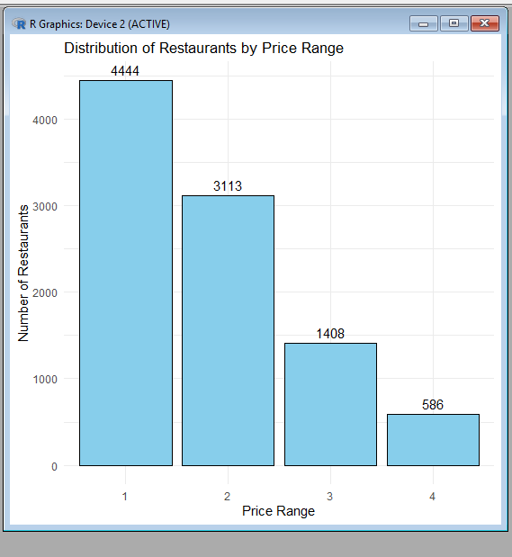

Calculate the percentage of restaurants in each price range category.

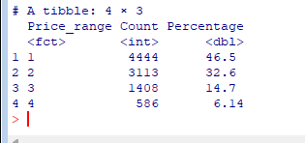

Task4-----

Determine the percentage of restaurants that offer online delivery. Compare the average ratings of restaurants with and without online delivery.

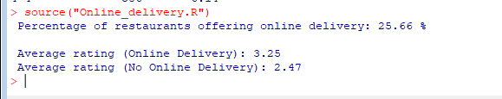

Level2-Task1------

Analyze the distribution of aggregate ratings and determine the most common

rating range. Calculate the average number of votes received by restaurants.

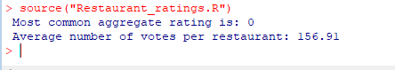

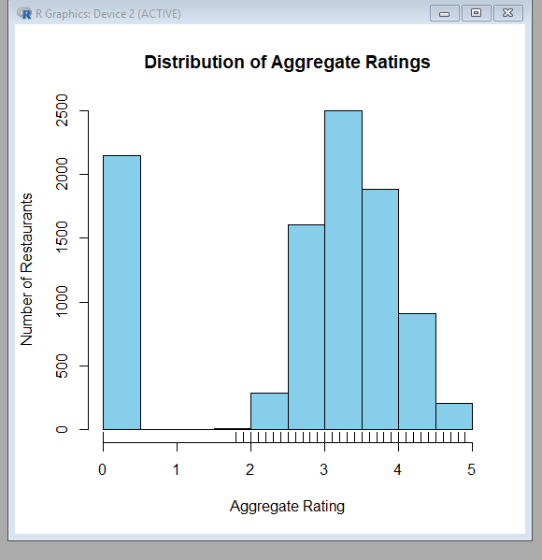

Task2----

Identify the most common combinations of cuisines in the dataset.

Determine if certain cuisine combinations tend to have higher ratings.

