# EDUCATION

## B. Tech.

### SANGAM UNIVERSITY

*10/2018 - Pre*, *BHILWARA RAJASTHAN INDIA - 311001*

*Computer Science*

7th Semester

# SKILLS

ADVANCE JAVA-SCRIPT INCLUDING ES-12

HTML5

CSS3

REACT

NODE

**PERSONAL PROJECTS**

MONGO-DB

EXPRESS

REST-API

PROJECT-STRUCTURING

JSON

GIT

#### BOOT WALE - A Shopping Site (01/2021 - 02/2021)

it’s a single-category product shopping [site](https://bootwale.herokuapp.com/) for different categories of shoes. with all functionalities using REACT, EXPRESS, MongoDB, NODE. visit here for more details [PRESENTATION](https://docs.google.com/presentation/d/1U84iSYgicTp3THil9EZcsGV6060xPfEhKykjnk5cMvM/edit?usp=sharing)

#### Restaurant management application (0000 - 00/0000)

[it's a single page application for restaurant management using MERN, visit here](https://awesomerestaurant.herokuapp.com/)

# ORGANIZATIONS

#### RUN SANGUM - (University Event) (03/2019 - 03/2019)

*I coordinate the event, it's a technical event (Robo Race) - it was* an awesome experience.

# WORK EXPERIENCE

## WEB DEVELOPMENT

### Edureka

*09/2020 - 03/2021*,

*It's 6 months virtual internship, I learn a lot of things like project structuring,* JWT APIs CRUD operations, login sign-up functionality with all modern javascript concepts.

## HTML, CSS, Java-Script

### As Student

*08/2018 - Pre*,

*After three years, now I can design awesome responsive websites using html5,* css3, java-script with ES2021 also including bootstrap.

## React & Node

### As Student

*06/2019 - Pre*,

*I have also two years experience of in Node and React, I can build* ***SINGLE- PAGE-APPLICATION*** *with advanced features.*

# CERTIFICATES

#### Full Stack Web Developer (09/2020 - 03/2021)

*This is a "Full Stack Web Developer" course from edureka and I got the* [Super Intern certificate.](https://www.linkedin.com/posts/lal-chand-teli-758961170_superintern-activity-6782520871350353920-hNUn)

#### React Training (07/2021 - 08/2021)

*It's six weeks online training on React from Internshala*

#### MERN STACK MASTER (08/2021 - 09/2021)

*this is a MERN STACK MASTER course from GREAT LEARNING -* using this course I can build my own INSTAGRAM-CLONE

# LANGUAGES

##### English

*Elementary Proficiency*

##### Hindi

*Professional Working Proficiency*

**MORE-THINGS**

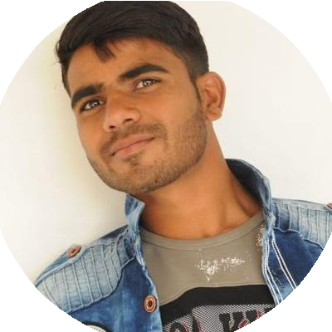

[linkedin.com/in/lal-chand-teli-758961170](https://www.linkedin.com/in/lal-chand-teli-758961170/)

BHILWARA, INDIA - 311024

8769280061

[lalchandteli13@gmail.com](mailto:lalchandteli13@gmail.com)

LAL CHAND TELI

MERN Stack Developer

SOFTWARE ENGINEER - JAVA-SCRIPT WEB DEVELOPER

Self-Motivated

Creative-Coder

Problem-Solver

Quick-Learner