Name: Lamisa Aziz NSID: zlq765 Student ID: 1138653
Course: CMPT 353
Assignment: 2 - Client-Server Posting System
Assignment -02 [REPORT]

Testing Approach
I tested the front end using manual interaction in the browser and verified all network requests using the Brave+ Edge DevTools Network tab. This allowed me to confirm that the page correctly sent asynchronous fetch requests to the backend and handled responses without requiring a page reload.

Test Case A2 - Page loads successfully
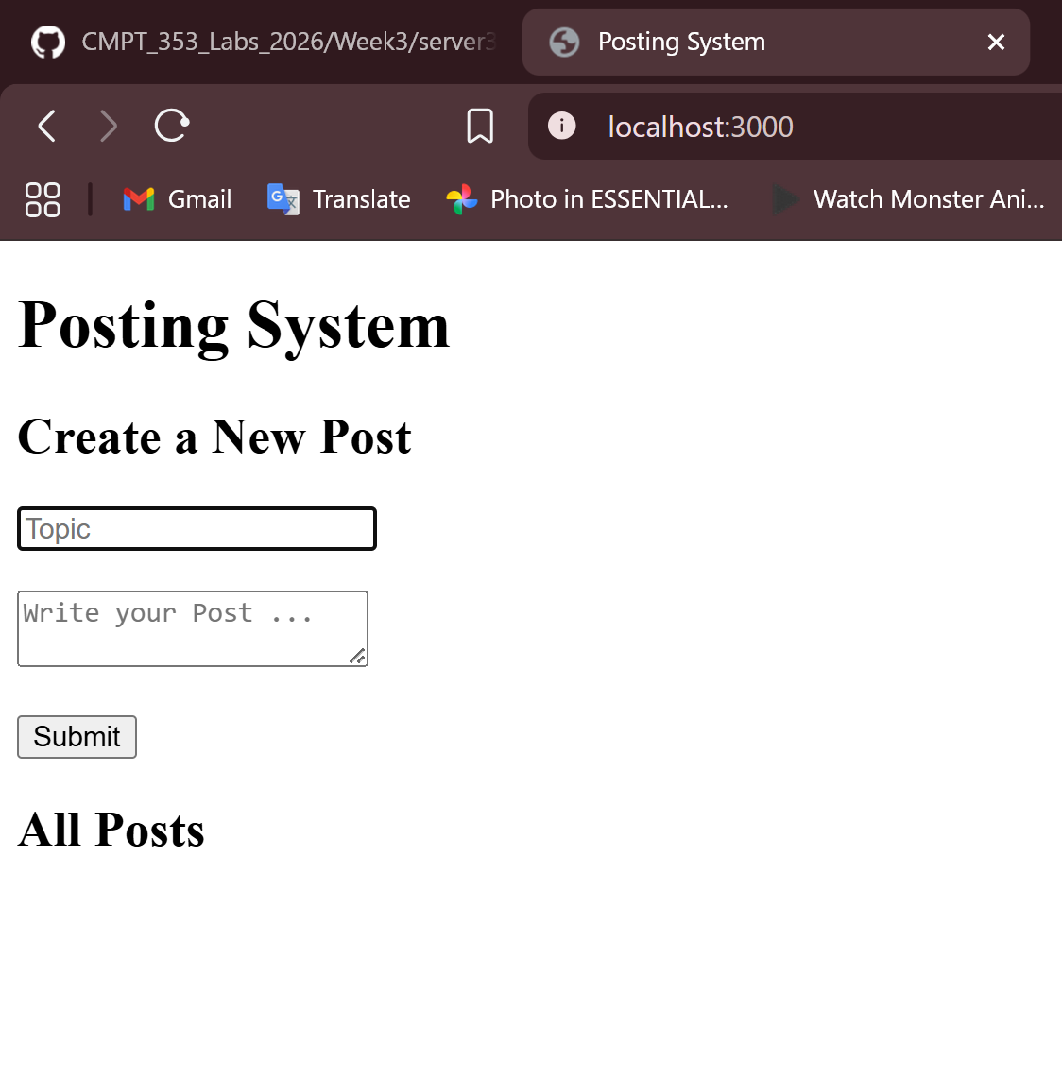

Test Case A2 - Valid POST request
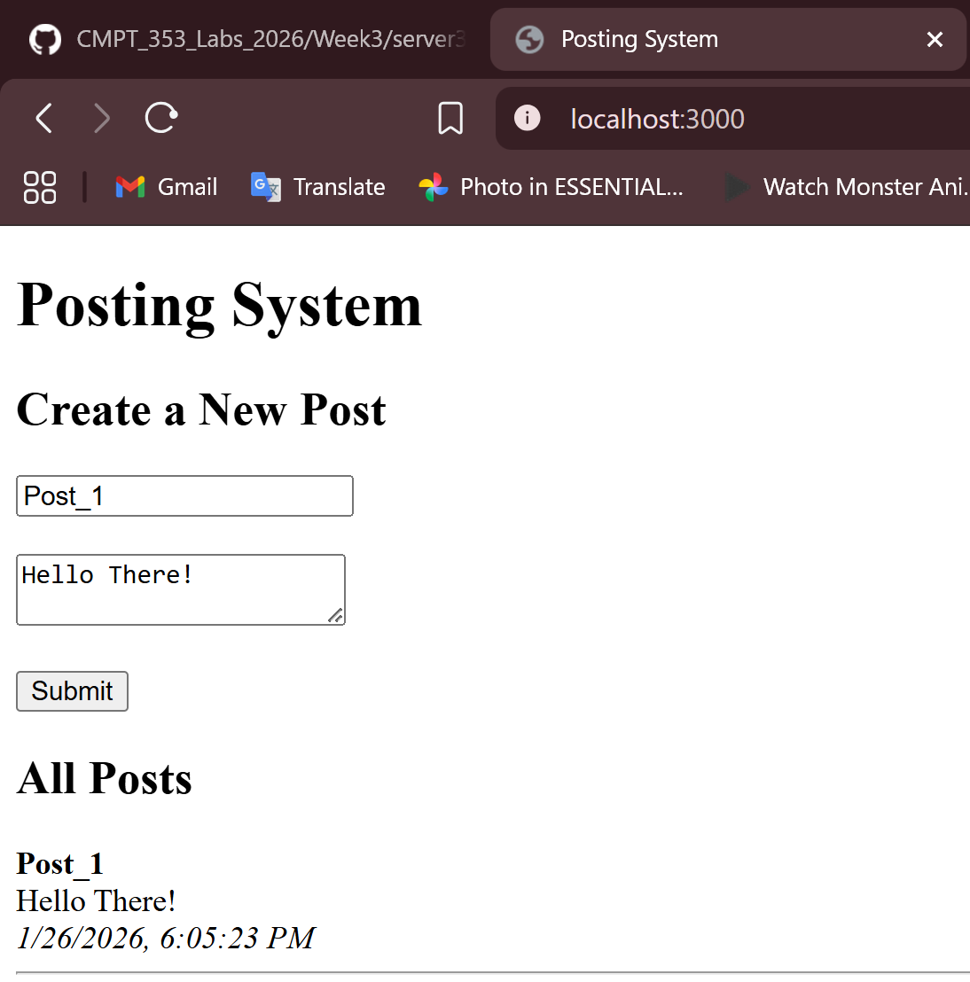

Test Case A2 — AFTER refreash
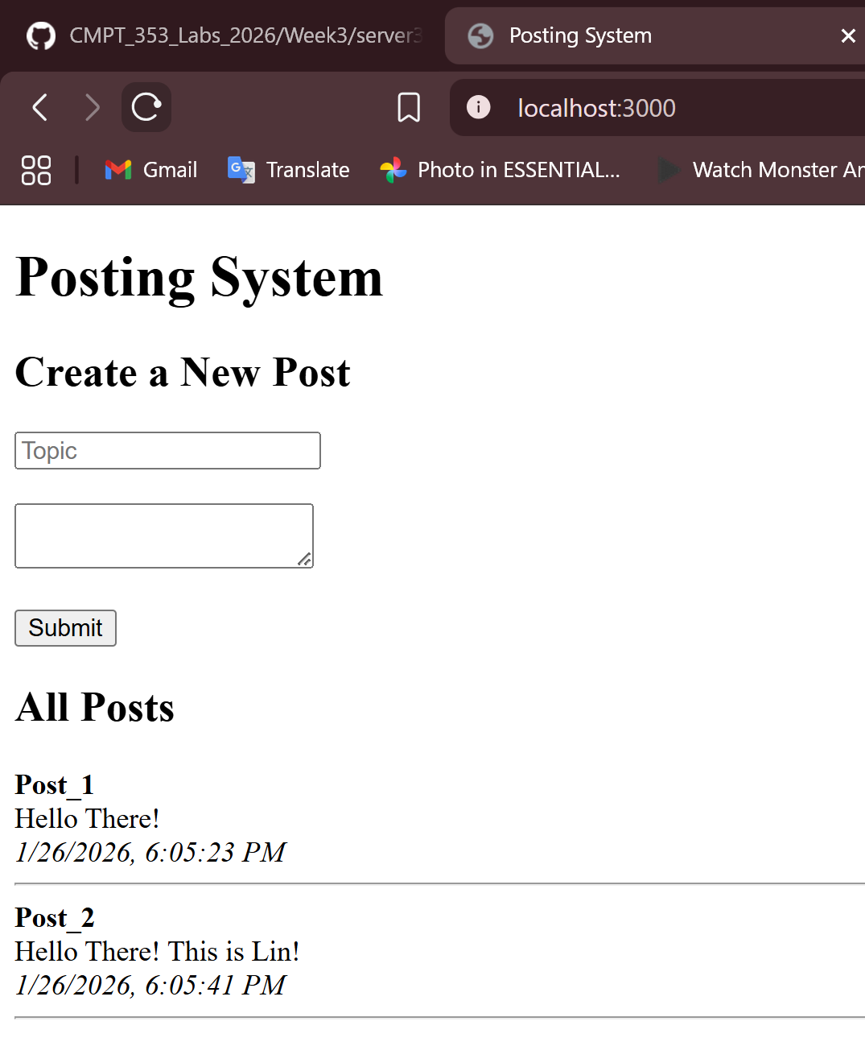

Test Case A2 - Missing Topic
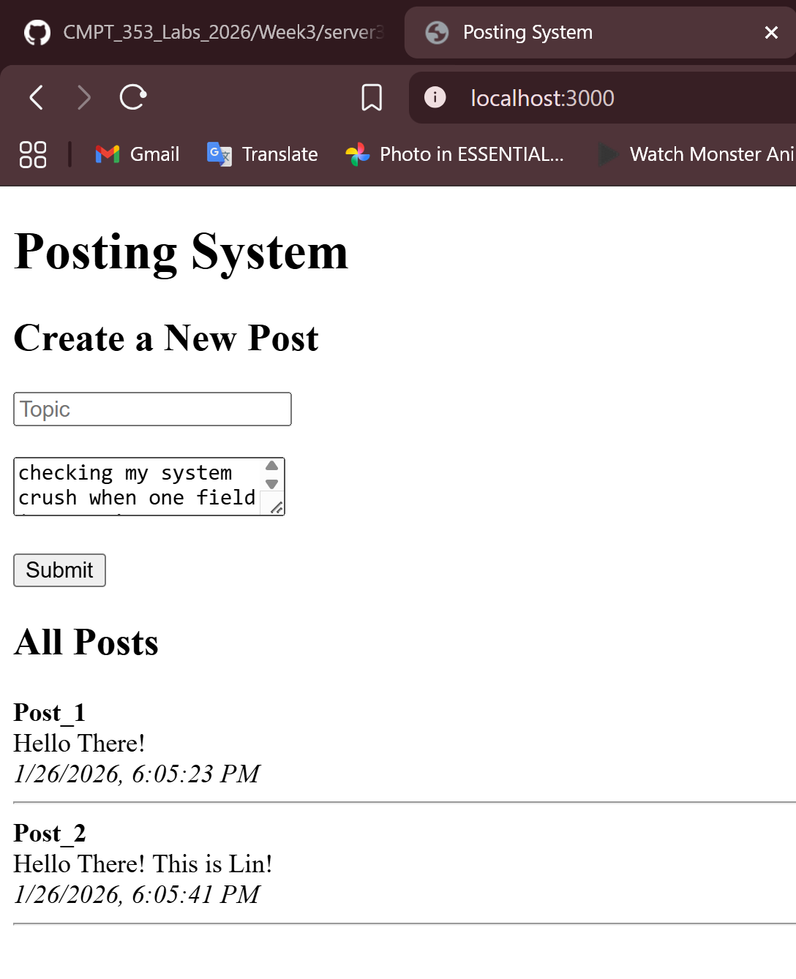

Test Case A2 - Missing Data
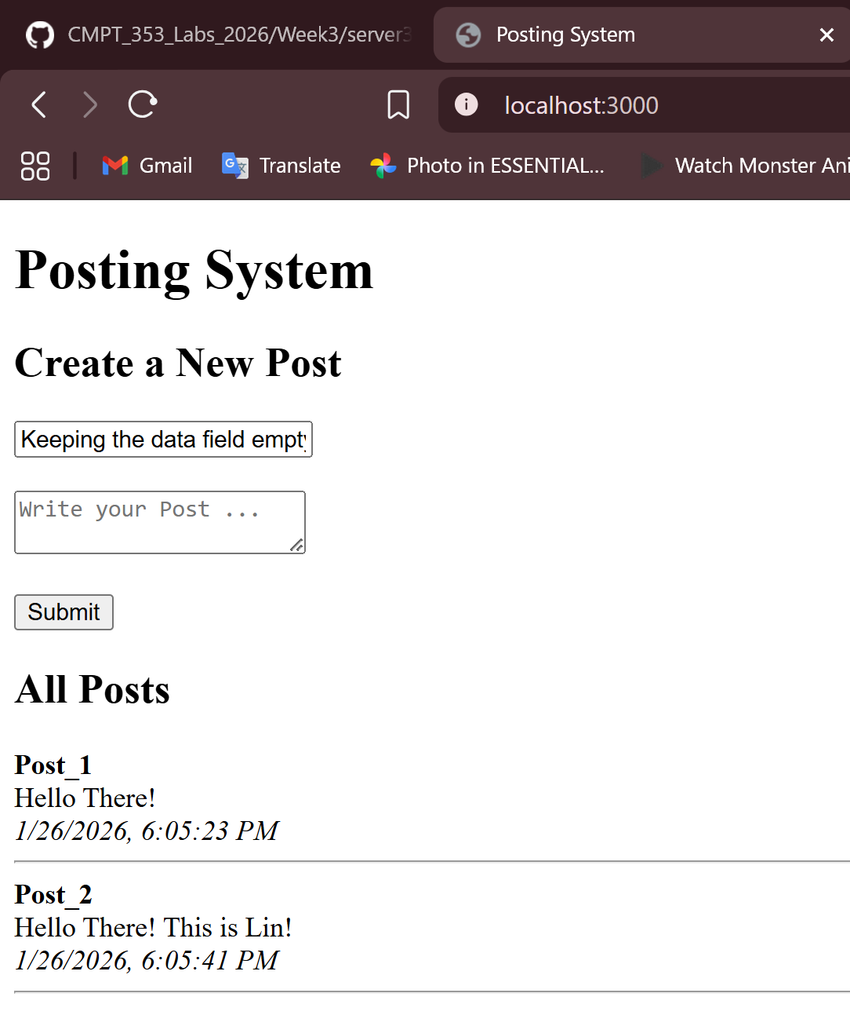

Test Case A2 - Server restart resets posts
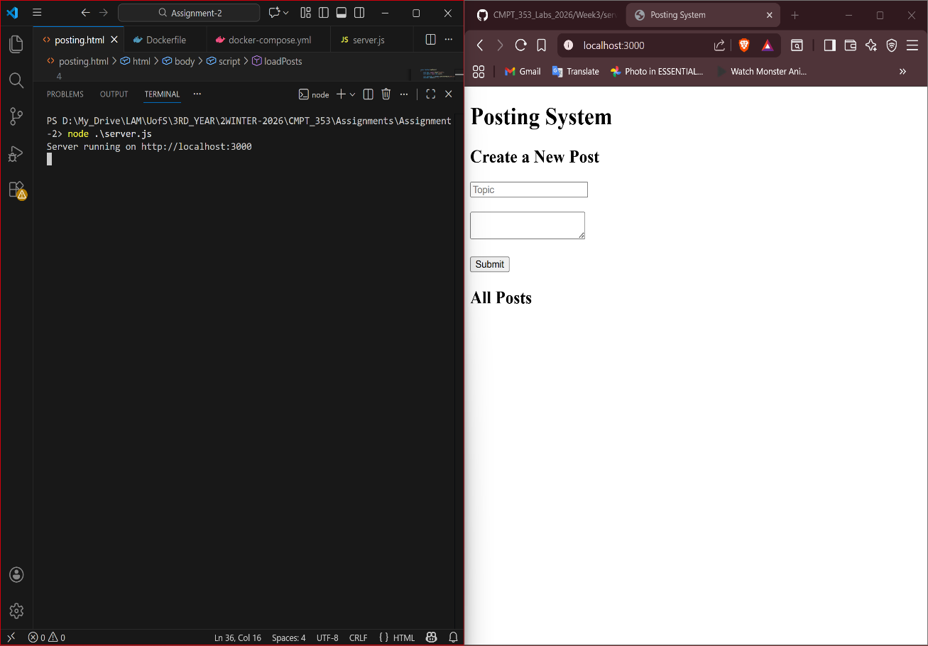

Test Case A2 - Create a new post
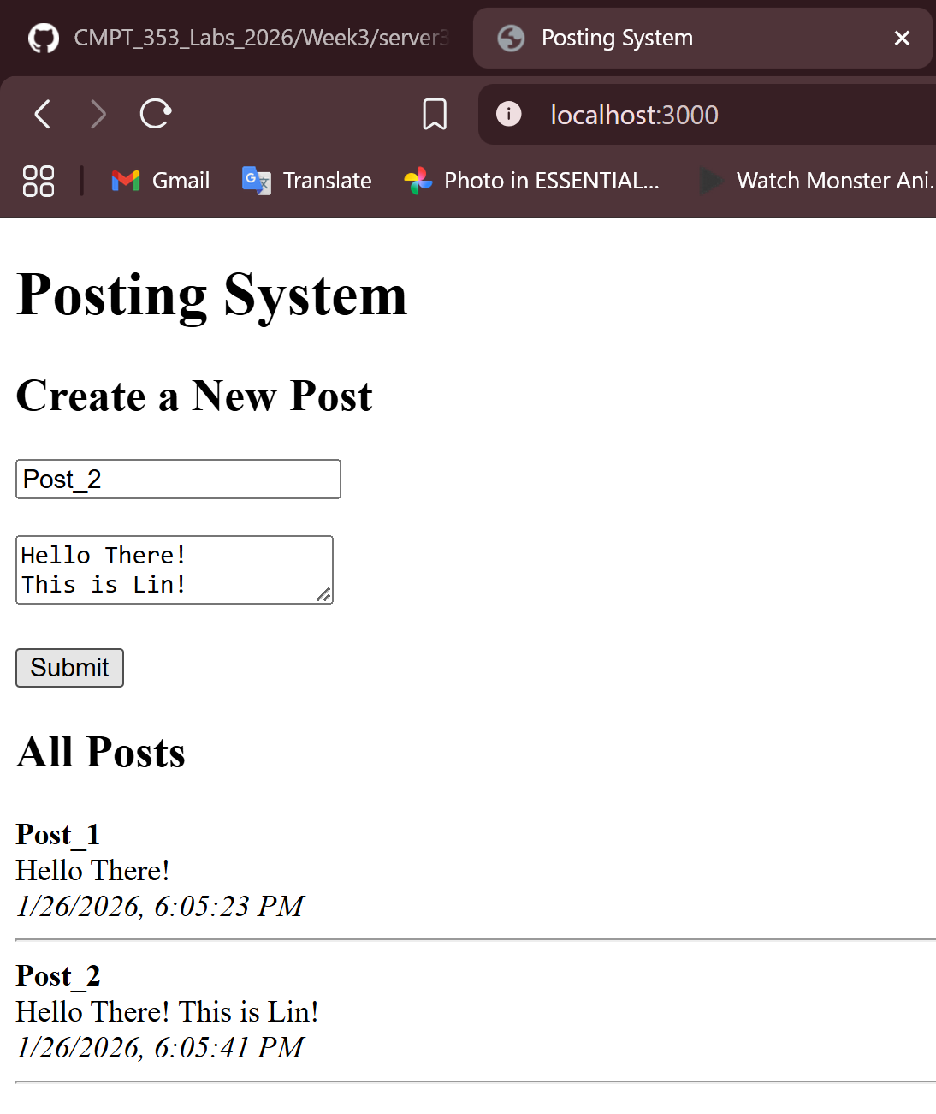

Test Case A2 - Real-time update
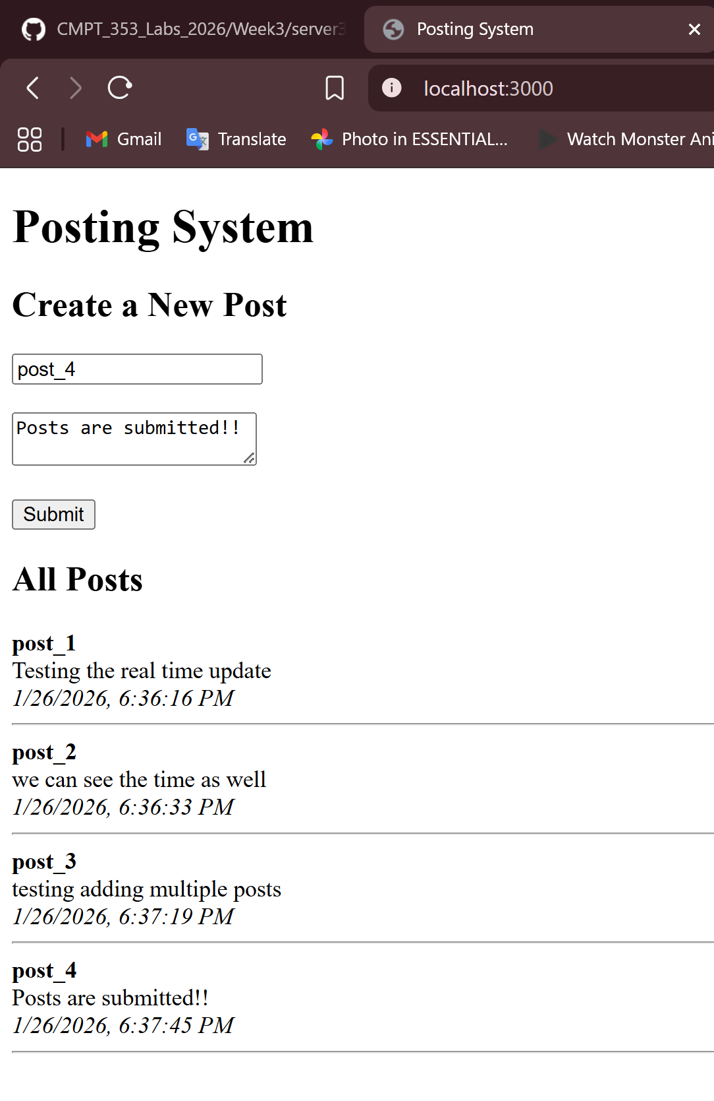

Challenges:
Challenge 1 — “Cannot GET /”
Cause: No route for /.
Solution:
app.get("/", (req, res) => {
res.sendFile(__dirname + "/posting.html");
});

Challenge 2 — Serving static files
Solution:
app.use(express.static(__dirname));

Testing HTTP status codes
