Discussion:

2.2 how the sigma value affects the final edge detection results.

The sigma value affects the sharpness of the “Gradient” image and shows a different in the magnitude of pixels after no-max suppression.

When the sigma is high, the Gradient magnitude is spread wider to nearby pixel and lead to a dim result in no-max suppression. After that, both two thresholds need to be set at very low values to get pixels. As a result, some thin objects in the original image will be neglected as the high sigma Gaussian filter, such as the lamp post.

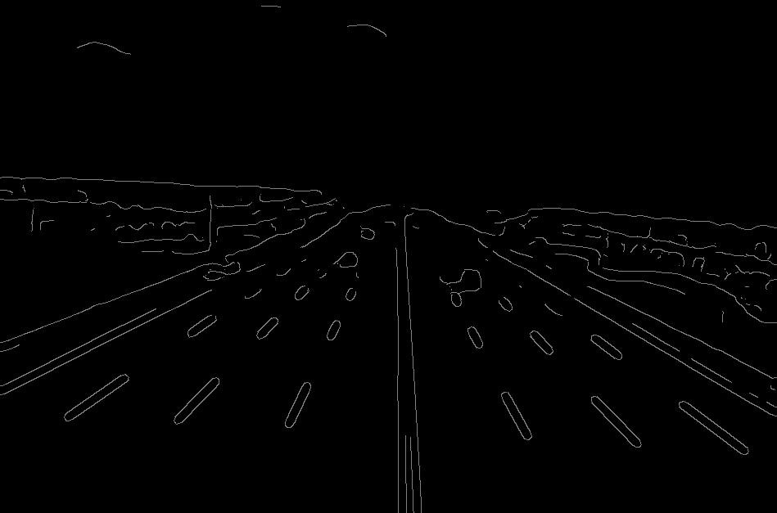

Figure sigma=5; low_thr=20; high_thr=30;

If the sigma is low, it means that more noises in the original image are kept. These noises will reduce the weight of the actual edges. Also, the gradient magnitude will be very large, the thresholds need to be set at a very high value.

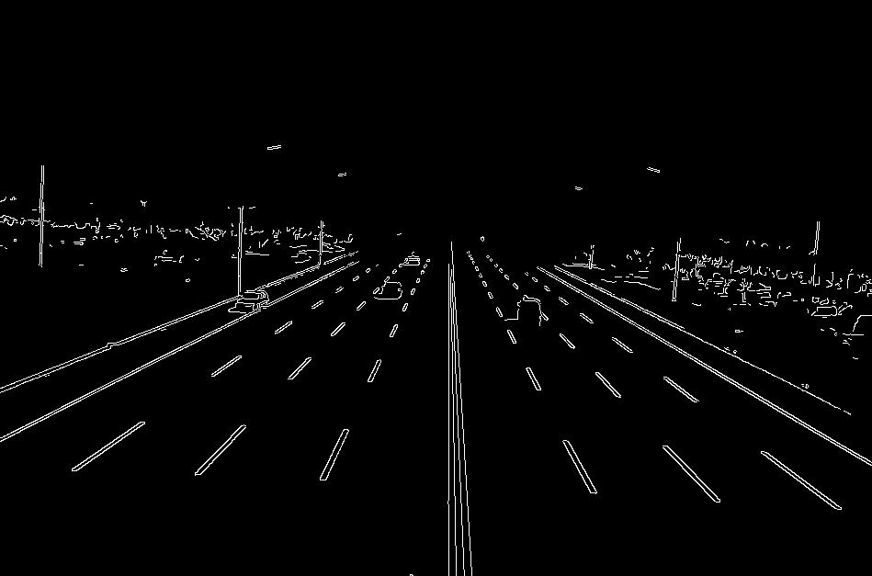

Figure sigma = 0.1; low_thr = 200; high_thr = 270

2.5 how different thresholds affect the final edgemap.

As said before, sigma will affect threshold selections. In this discussion, statements such as “too high” or “too low” are compared to the suitable threshold range.

Both are too high: all-black.

Both are too low: the edgemap keeps too much information, not only edges.

Two thresholds are close to each other: the high_thr is not working actually.

Too far away from each other: keep very strong magnitudes only