* 1. **L’intégration de SmartACCESS dans le réseau de la banque**

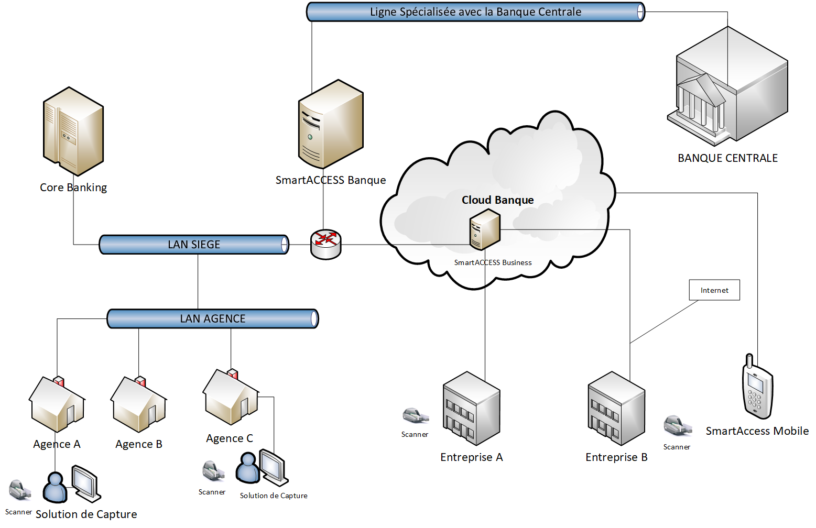

* 1. **Matrice des flux**

|  |  |  |  |
| --- | --- | --- | --- |
| Source | Destination | Protocole | PORT |
| SmartAccess Banque | Core Banking | SFTP,HTTP | SFTP 22 |
| Core Banking | SmartAccess | SFTP,HTTP | TBD |
| SmartAccess Banque | Banque Centrale | CFT |  |
| SmartAccess Banque | SmartAccess Business | http,ICS(Windows Share) | https 8081  https 5480 |
| PCs client de la banque | SmartAccess Banque | http | TBD |
| PCs sur Internet | SmartAccess Business | https | 443 |