**👽👽👽**

**v**



**Aliens Vs Predator**

**<Dongers Inc.>**

Robot Butlers

* Goal of Movie
  + Sell new range of robot butlers
* Tools and Methods
  + Source Film Maker
  + Comedic effect
  + Commercial/ Infomercial cliché or making-fun-of-cliché cliché.
  + Just before I, Robot era. Middle class and up
* Ideas
  + Show a range of households (I.e. family and individuals)
  + Robots needing upgrades (e.g. throwing hot soup at owner)
  + New company of robot makers which is better than old company (think Apple vs Android)
  + Fat person unable to pick something off the floor (black and white with competitors to colour with our company). Ours can also lift spoon of ice cream to mouth
  + Old company robots pass the Turing test and hates serving people, occasionally runs away. New robots don’t
  + Butlers don’t suck your ass. Abrasive
  + Plugins: personal trainer. Halves all your food portions. Strict? “You can’t handle the truth!”
  + Range of robots and plugins. Modular behaviours like in Interstellar

**To do before Christmas**

* Drop Out
* Proposed Idea for ident
  + Company ‘style’ ideas
    - High class provider of bespoke robot butlers
    - ?
  + Company Name ideas
    - B.U.T.L.E.R
      * (Bespoke Utility, Training and Liaison Estate Robots.)
    - ?
  + Mood of Ident ideas
    - High quality, high status, bespoke robot provider
    - ?
* Proposed Idea for trailer
  + Design work
    - World fiction
    - Product
    - How to product fits into the world fiction
      * Examples of reference materials.
    - Comedic style.
  + Production planning
    - Script
    - Type of filming
      * Assets
        + Where are they coming from?

What are we making?

What did we have to do to make it work?

What are we stealing?

How can they be used?

How can they not be used?

* + - * + Examples of what we need
        + Animation requirements/capabilities
    - Gantt chart (production plan and times)
      * Plan where each production element is going to be worked on
        + Pre-production

Decide on product

Decide on world fiction

Interaction with product

Concept art

Rip Reel

Examples

Mood Board

Overall mood of movie

Story Draft

Scenes

Moods

Intentions

Example shots

Draft Idents

Audio planning

Source content examples

* + - * + Production

Story board (throughout)

Script

Asset modelling, rigging, texturing

Animation

Lighting

Camera Calibration

Audio production (foley?/ soundtrack/ ambience)

* + - * + Post-production

Testing

Editing

Clean up

Compositing

Visual effects

Mood correction (colours, shot focus, etc.)

* + - Storyboard (overkill) / mood board / rip reel
      * Camera movement/shots
    - Audio mood board just to add lube to the wanking dave off module

**Presentation ideas**

* GIFs
* Try and use a range of media (e.g. videos, images, audio, non-digital?) Lil Davey-poos will love that probably
* Storyboard / mood board / rip reel

**SCHEDULE - ah i was wondering wtf was going on**

|  |  |
| --- | --- |
| Week commencing | Tasks (person) |
| 6/11 | * Mood board and clips * Find reference materials and note the mood you feel from it * Contemplate ideas for ident * Example Gantt chart (Luke, so yall don’t need to do mood board) |
| 13/11 | * Storyboard |
| 20/11 |  |
| 27/11 |  |
| PRESENTATION | * Drop Out |
|  |  |

World ideas

* 50’s vision of 2030?
* Realistic 2030’s?
* Slick future
* Shity-ish future with robots (Chappie)

Scene Ideas:

* Opening Scene:
  + Slow motion scene with a customer and a rival robot butler
  + Rival robot butler attacks customer in silly ways.
  + Sentimental music
  + Big robot comes and then destroys rival robot.
* Robot reveal
  + Overly dramatic lighting, low angles, Latin chant music plays
  + New and old robot duel. Western style. Old robot gets first shot, new robot doesn’t even care- face lasers the old robot

Gantt Chart

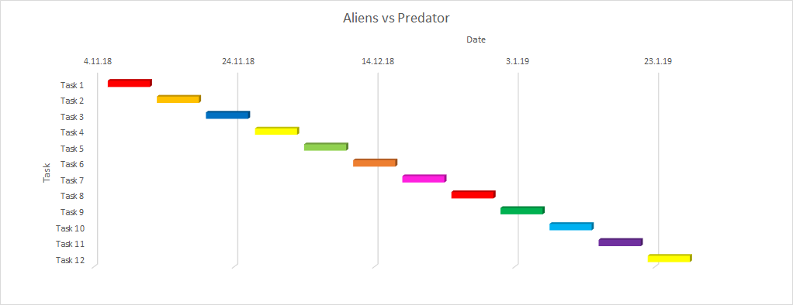

Random ass ‘robot’ idea mood board idk

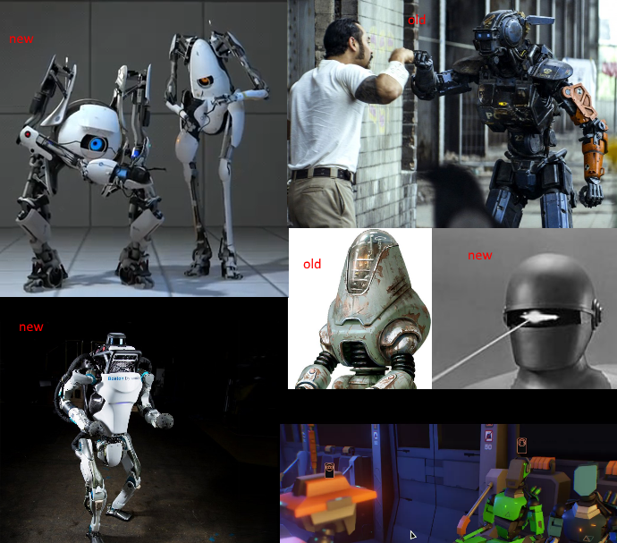

*i want to die. Life is irrational - Joseph Kony*