Attachment B

Treasure Street ADL 403433 Mr. Ames’ Parcel
Elliot Hwy Proposed Easement
ADL 403433
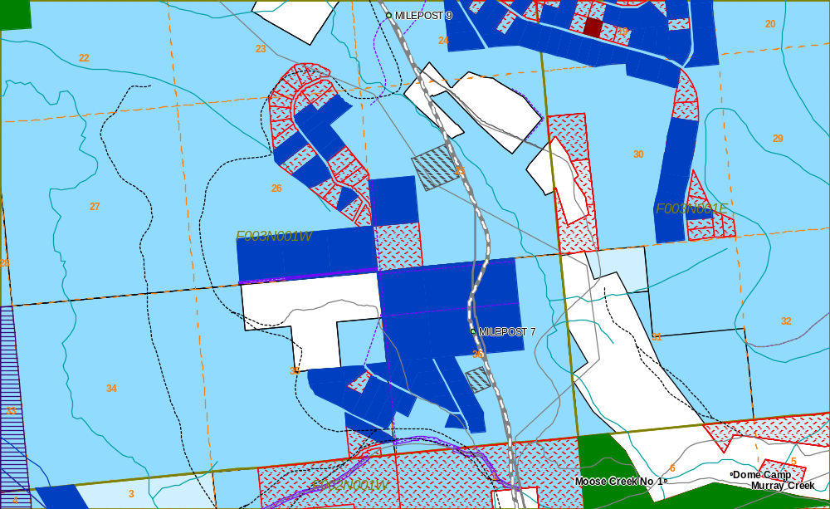

Treasure Street (not used) Access Currently Used

End of Constructed Access at Section Corner

Red Lots are MHTLO Parcels

Blue Lots are State Parcels

