Ecoregion map used for testing
(for all tests, 1 pixel = 100 m)
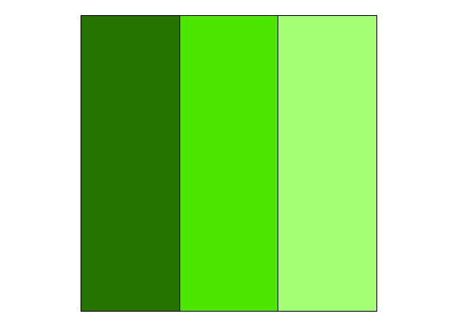
Site Resource Dominance: Left = 1.0 Center = .66 Right = .44
Outbreak Probability: Left = .66 Center = .44 Right = .29

Test 1 – Epicenter # equals 10
(red = outbreak zone)
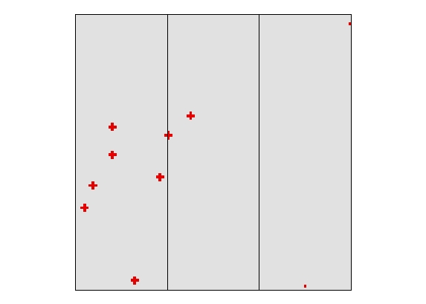
Result: test worked – 10 outbreaks occurred
Test 2 – Epicenter # equals 1
(red = outbreak zone)
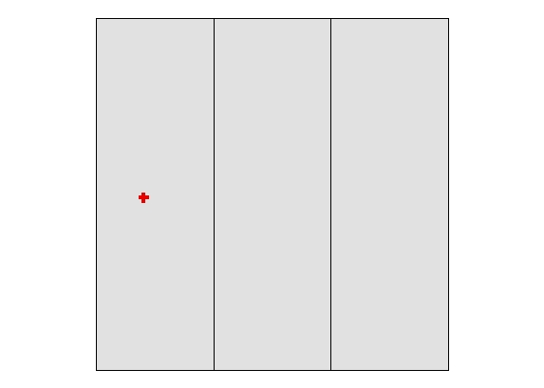
Result: test worked – 1 outbreak occurred

Test 3 – Epicenter # equals 0
(red = outbreak zone)

Result: test worked – no outbreak zones

Test 4 – Dispersal On
(red = outbreak zone)
Result: test worked – outbreaks occurred in 10 zones

Test 5 – Dispersal Off
(red = outbreak zone)
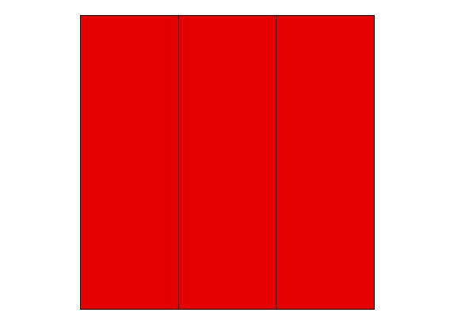
Result: test worked – outbreak occurred everywhere

Test 6 – Dispersal rate equals 50
(red = outbreak zones)
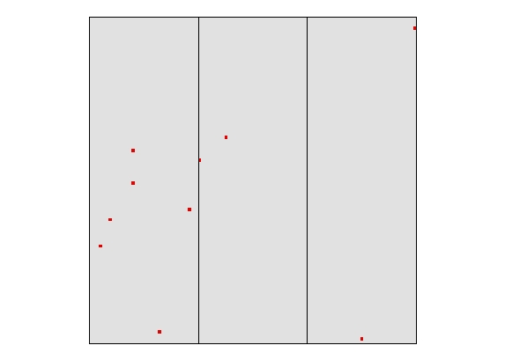
Result: test worked – outbreak zones are < 100 m wide

Test 7 – Dispersal rate equals 100
(red = outbreak zone)
Result: test worked – outbreak zones are up to 300 m wide

Test 8 – Dispersal rate equals 500
(red = outbreak zone)
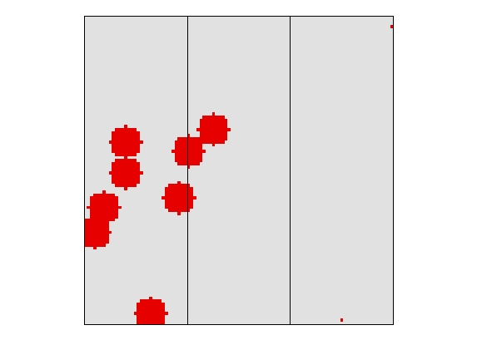
Result: test worked – outbreak zones up to 1100 m wide

Test 9 – Dispersal template equals 4N
(red = outbreak zone)
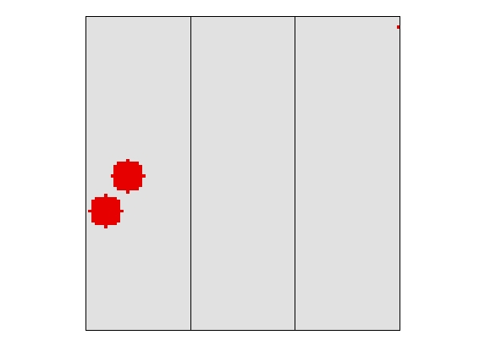
Result: test worked – outbreak zones followed 4N dispersal

Test 10 – Dispersal template equals 8N
(red = outbreak zone)
Result: test worked – outbreak zones followed 8N dispersal

Test 11 – Dispersal template equals 12N
(red = outbreak zone)
Result: test worked – outbreak zones followed 12N dispersal

Test 12 – Dispersal template equals 24N
(red = outbreak zone)
Result: test worked – outbreak zones followed 24N dispersal

Test 13 – Dispersal template equals MaxRadius
(red = outbreak zone)
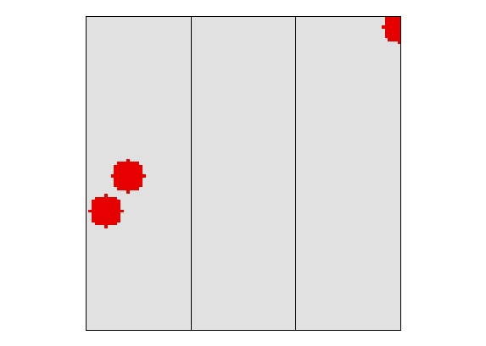
Result: test worked – outbreak zones followed MadRadius dispersal

Test 14 – Seed Epicenter equals yes

Timestep1 – Outbreak zones
(red = current outbreak zone, orange = last year’s outbreak zone)
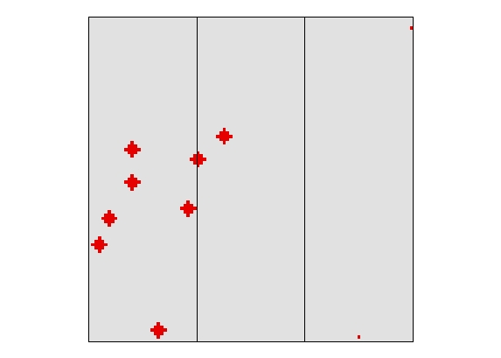
Timestep1 – Severity
(red = 3, orange = 2)
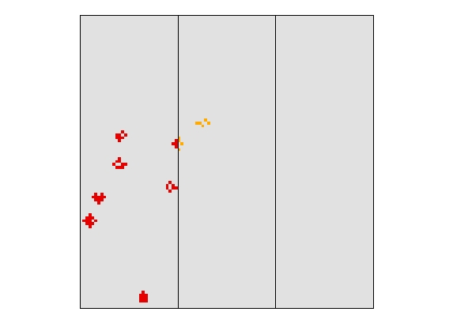

Test 14 (cont.)

Timestep2 – Outbreak zones
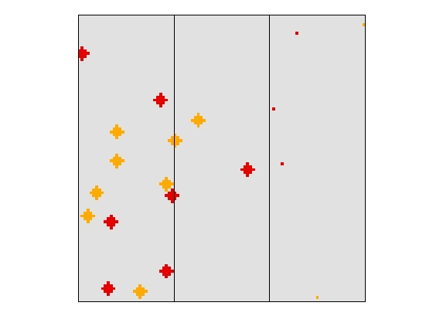

Timestep2 – Severity (3 = red, 2 = orange)
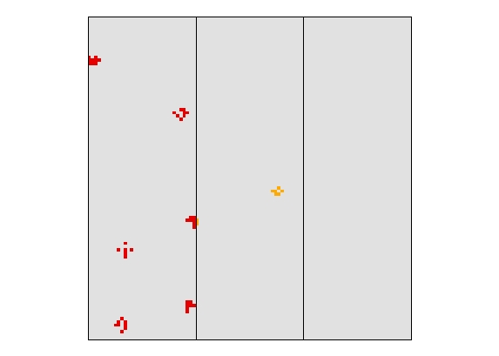

Test 14 (cont.)

Timestep3 - Outbreak zones
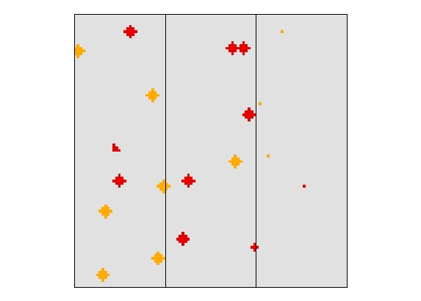

Timestep3 – Severity
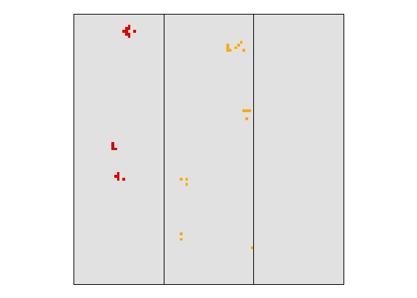
Results: test worked – new outbreak zones occurred outside of old outbreak zones, severity was driven by ecoregion, and severely disturbed pixels did not host outbreaks multiple times

Test 15 - Seed Epicenter equals no

Timestep1 - Outbreak zones
(red = current outbreak zone, orange = last year’s outbreak zone)

Timestep1 – Severity
(red = 3, orange = 2)

Test 15 (cont.)

Timestep2 - Outbreak zones
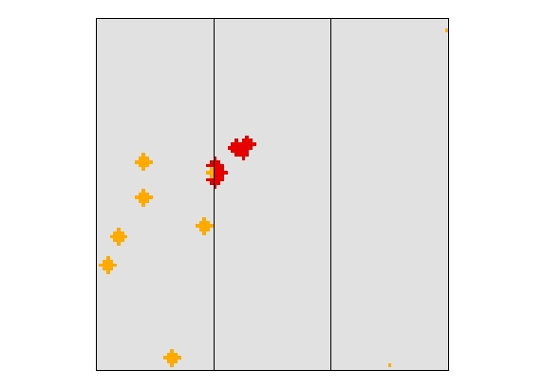

Timestep2 – Severity
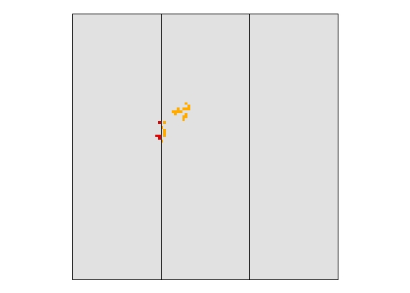

Test 15 (cont.)

Timestep3 - Outbreak zones
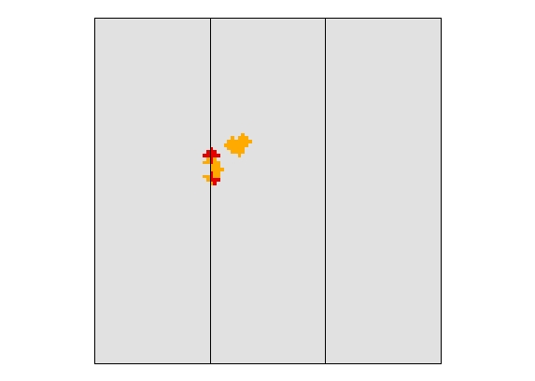

Timestep3 – Severity
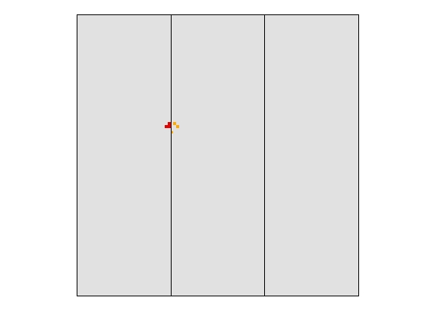
Result: test worked – new outbreak zones only occurred inside of old outbreak zones, severity was driven by ecoregion, and severely disturbed pixels did not host outbreaks multiple times

Test 16 – Actual Outbreak percentage vs. Expected

Outbreak Zones (red = outbreak zone)

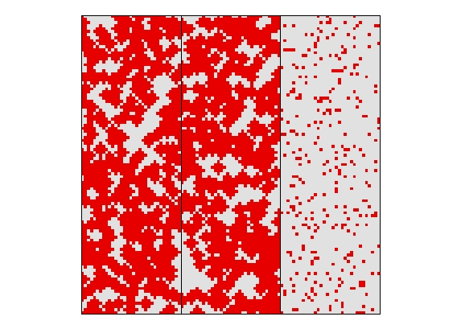

Actual Outbreak (red = outbreak)
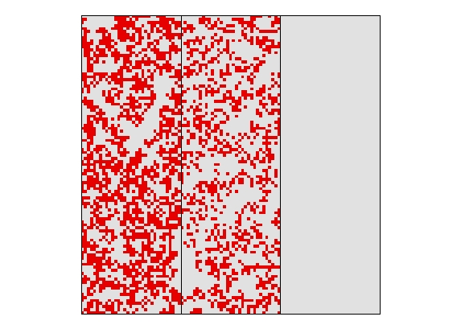
Results: the percentage of possible outbreak zones where actual outbreaks occur - .675 for zone 1, .446 for zone 2, 0 for zone 3 (threshold is at .3, zone 3’s vulnerability is .29) is as expected based on the initial vulnerability values
Test 17 – Outbreak Epicenter Coefficient equals .001
Severity at Time 1 (Red = 3, orange = 2)
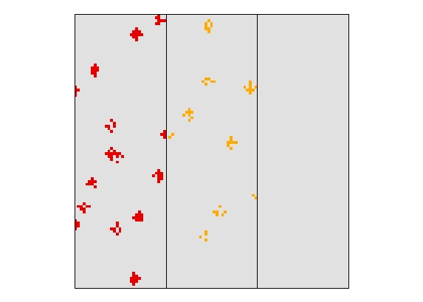
Outbreak zones at Time 2 (red = new outbreak, orange = old outbreak)
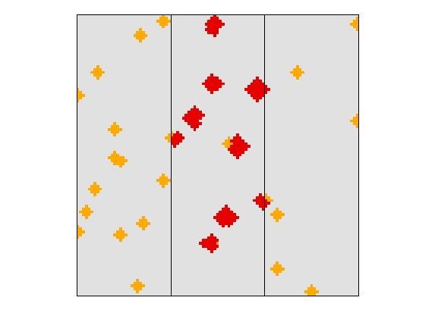
Results: 51 new epicenters were created from the 53 potential epicenter sites (severity = 2 in Time 1), as expected given a very small epicenter coefficient

Test 18 – Outbreak Epicenter Coefficient equals .01
Severity at Time 1 (Red = 3, orange = 2)
Outbreak zones at Time 2 (red = new outbreak, orange = old outbreak)
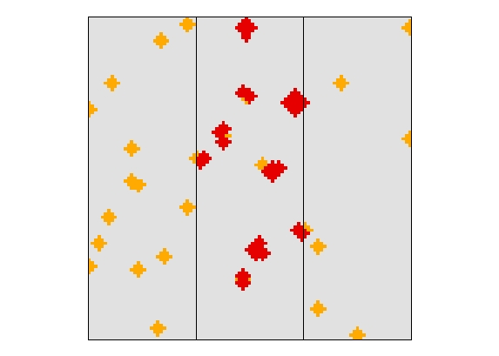
Results: 39 new epicenters were created from the 53 potential epicenter sites (severity = 2 in Time 1), as expected given a slightly higher epicenter coefficient

Test 19 – Outbreak Epicenter Coefficient equals 0.1
Severity at Time 1 (Red = 3, orange = 2)
Outbreak zones at Time 2 (red = new outbreak, orange = old outbreak)
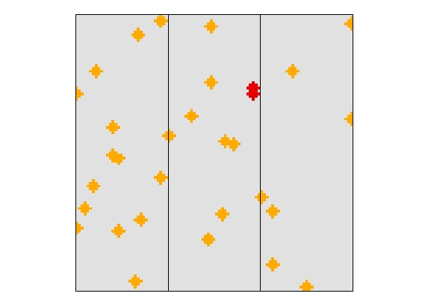
Results: 2 new epicenters were created from the 53 potential epicenter sites (severity = 2 in Time 1), as expected given a higher epicenter coefficient

Test 20 – Outbreak Epicenter Coefficient equals 0.2
Severity at Time 1 (Red = 3, orange = 2)
Outbreak zones at Time 2 (red = new outbreak, orange = old outbreak)
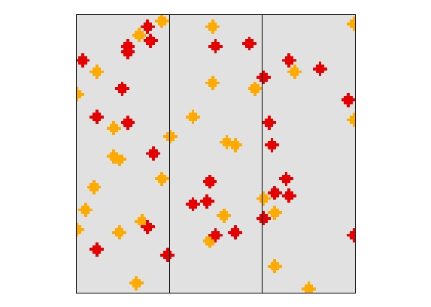
Results: 0 new epicenters were created from the 53 potential epicenter sites (severity = 2 in Time 1), as expected given a high epicenter coefficient; the program then defaults to seed dispersal, creating 30 new epicenter sites randomly across the landscape

Test 21 - 26 – Seed Epicenter Coefficient

Seed Epi. Coeff. | # Epi. TimeStep 1 | # Epi. TimeStep 2 | # Epi. Timestep 3
.01 | 30 | 40 | 40
.05 | 30 | 17 | 18
.1 | 30 | 11 | 12
.2 | 30 | 5 | 9
.3 | 30 | 1 | 8
.5 | 30 | 30 | 30

Results: As expected, the number of new epicenters created by seed dispersal is inversely related to the seed epicenter coefficient; as the coefficient values increase, less new epicenters are created, until no new epicenters are created by seeding and the program defaults to the initial epicenter number (30)

Test 27 – NeighborRadius equals 100 m

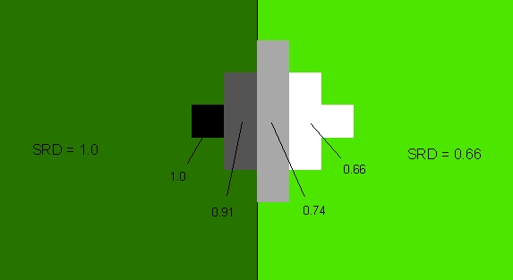

Result: Neighborhood Resource Dominance (NRD) is equal to the average Site Resource Dominance (SRD) of the 4 nearest neighbors

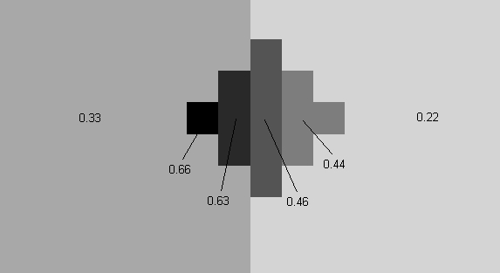

Result: Site Vulnerability (SV) is equal to (SRD + (NRD*NW)) / (1 + NW) * ROS/3; in this case ROS (regional outbreak status) = 2 and NW (NeighborWeight) = 1

Test 28 – NeighborRadius equals 200 m

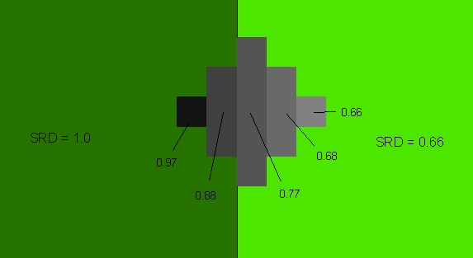

Result: Neighborhood Resource Dominance (NRD) is equal to the average Site Resource Dominance (SRD) of the 12 nearest neighbors

Test 29 – NeighborRadius equals 500 m

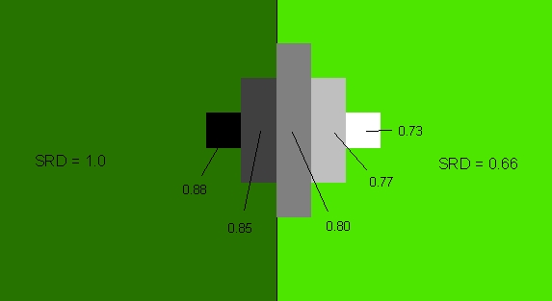

Result: Neighborhood Resource Dominance (NRD) is equal to the average Site Resource Dominance (SRD) of the 80 nearest neighbors

Test 30 – NeighborShape equals linear

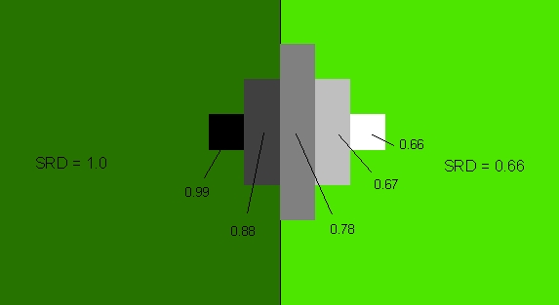

Result: Neighborhood Resource Dominance (NRD) is equal to the weighted (by distance from cell) average Site Resource Dominance (SRD) of the 12 nearest neighbors

Test 31 – NeighborShape equals gaussian

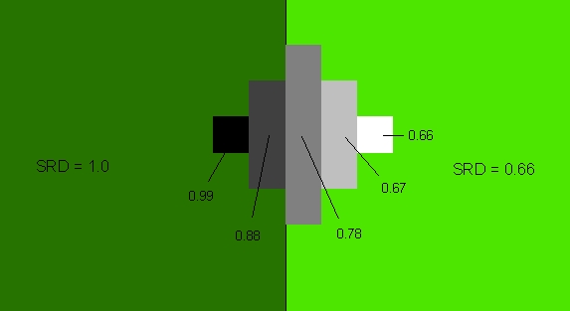

Result: NRD is based on a Gaussian formula

NRD values used for tests 32-34

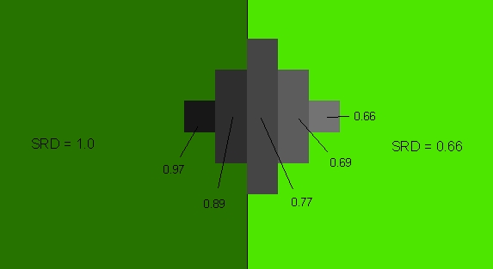

Test 32 – NeighborWeight equals .5

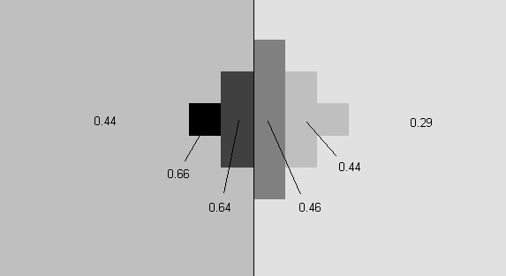

Result: values equal SV equation (referenced in test 27) using NW = .5 and ROS = 2

Test 33 – NeighborWeight equals 2

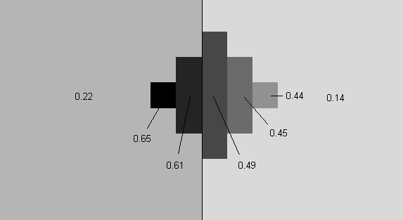

Result: values equal SV equation (referenced in test 27) using NW =2 and ROS = 2

Test 34 – NeighborWeight equals 10

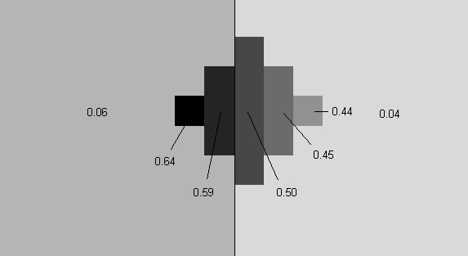

Result: values equal SV equation (referenced in test 27) using NW =10 and ROS = 2

Test 35 – NeighborSpeedUp equals none

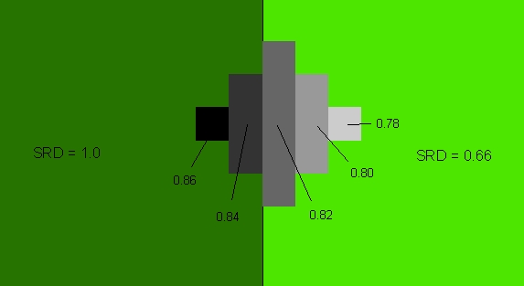

Test 36 – NeighborSpeedUp equals 2x

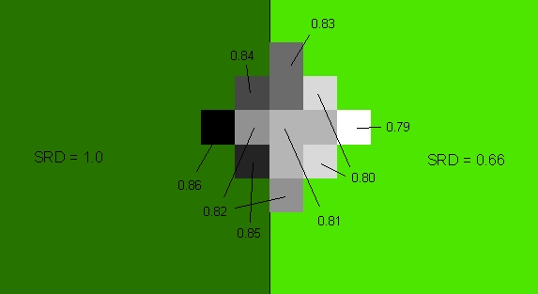

Result:

Test 37 – NeighborSpeedUp equals 3x

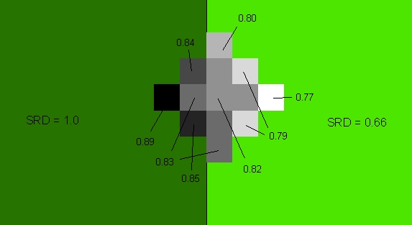

Result:

Test 38 – NeighborSpeedUp equals 4x

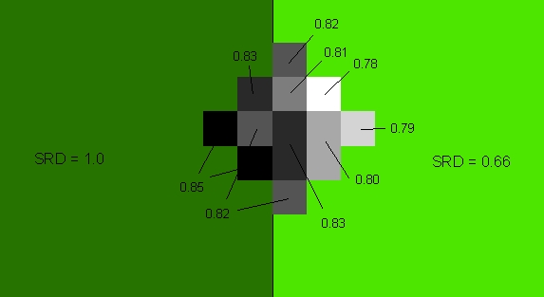

Result:

Test 39 – EcoregionModifiers equals none

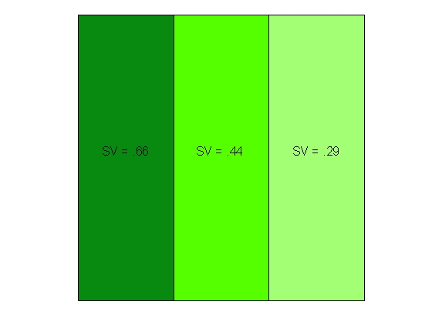

Test 40 – EcoregionModifiers equal -0.1(eco2), 0.1(eco3)

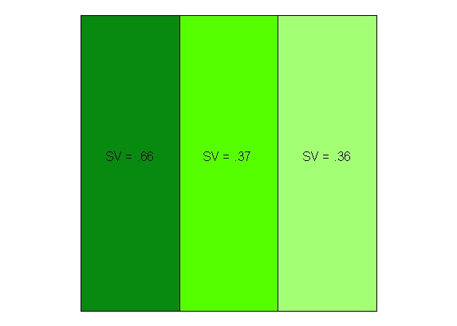

Result: As expected, Site Vulnerability (SV) in eco2 decreases while eco3’s SV increases

Test 41 – MinROS and MaxRos equal 2

Test 42 – MinROS and MaxROS equal 1

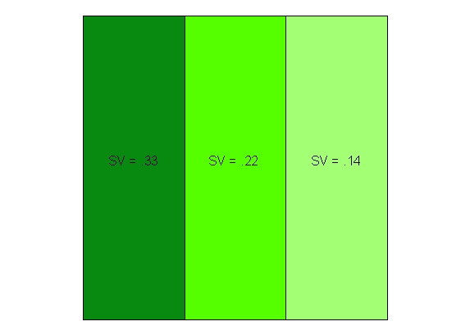
Result: SV values are halved, as expected

Test43 – TemporalType equals Pulse

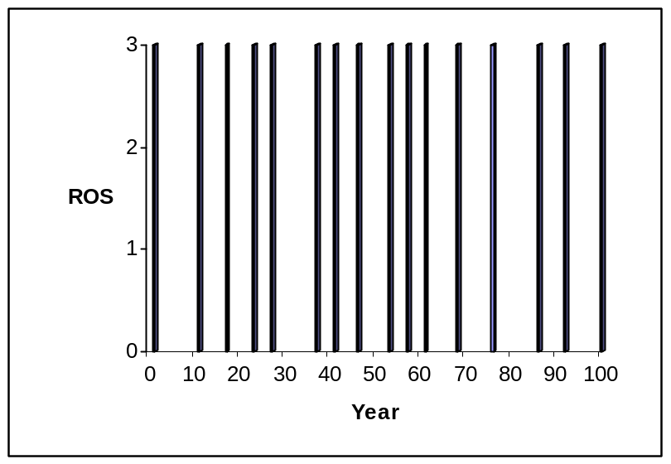

Result: With MinROS = 0 and MaxROS = 3, ROS will be either 0 (no outbreak) or 3

Test44 – TemporalType equals VariablePulse

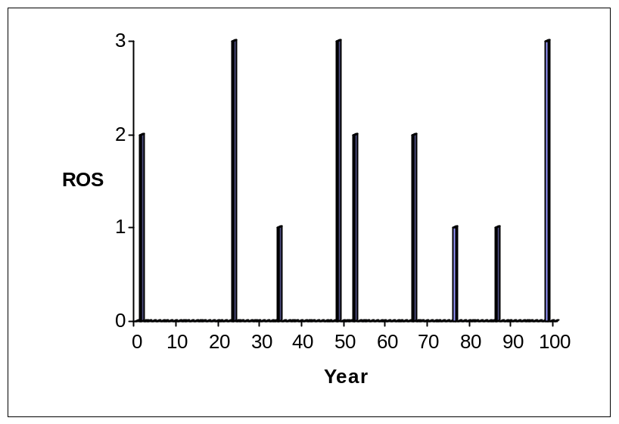

Result: With MinROS = 0 and MaxROS = 3, ROS will be either 0 (no outbreak) or in the range from MinROS+1 to 3

Test 45 – RandomParameter1 equals 10

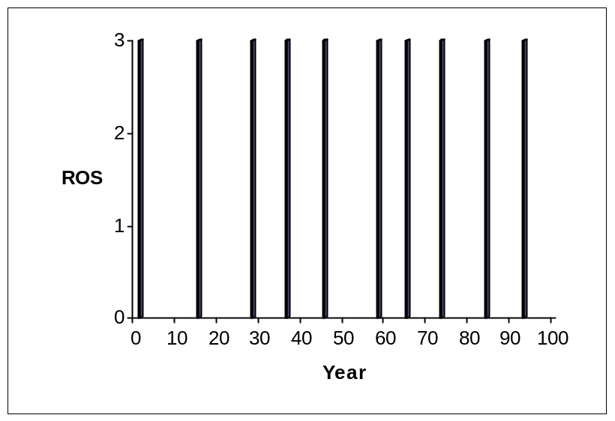

Result: Outbreaks occur approximately once every 10 years, as expected

Test 46 – RandomParameter1 equals 25

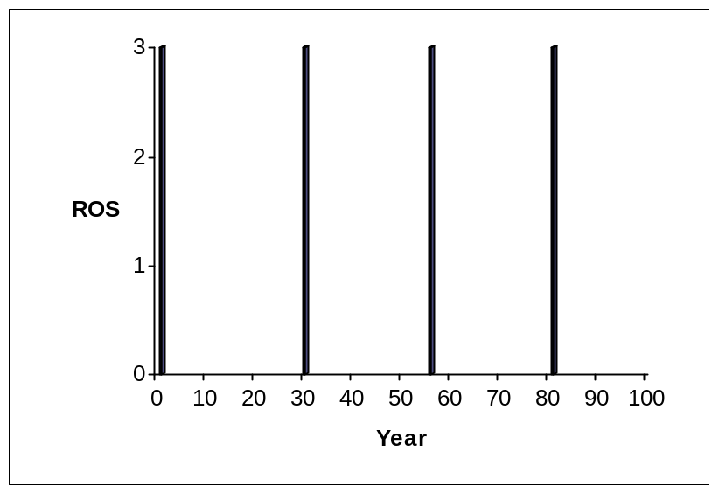

Result: Outbreaks occur approximately once every 25 years, as expected

Test 47 – RandomParameter2 equals 0

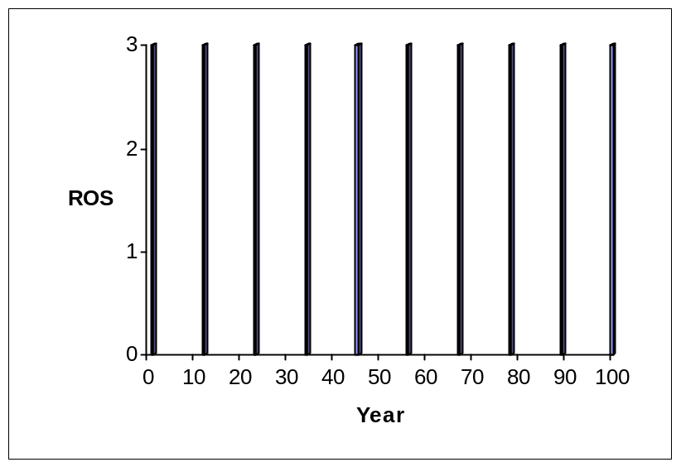

Result: Outbreak occurrence has no standard deviation, as expected

Test 48 – RandomParameter2 equals 4

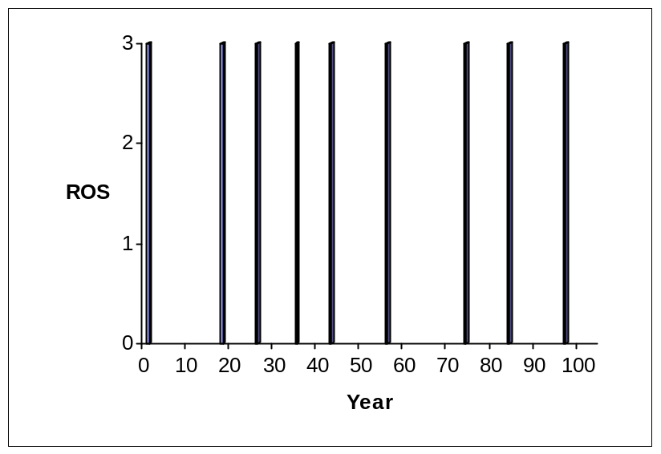

Result: Outbreak occurrence has standard deviation, as expected

Test 49 – RandomFunction equals RFNormal

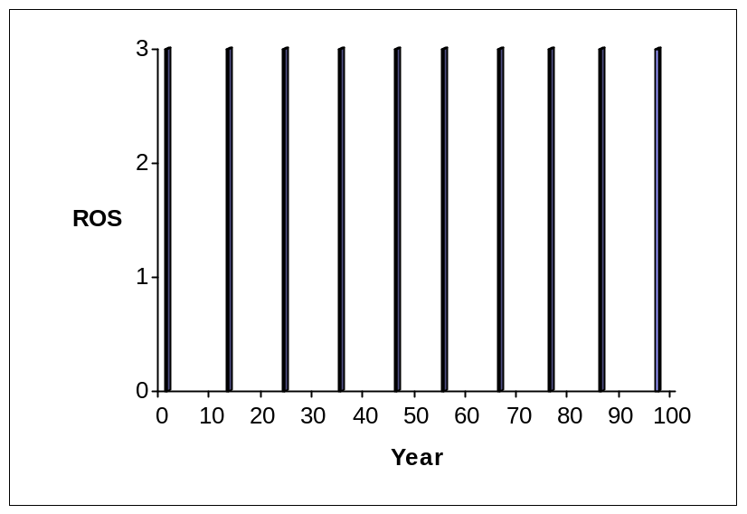

Result: Outbreaks occur at a normal distribution, where mean occurrence equals RandomParameter1 (10) and standard deviation equals RandomParameter2 (2)

Test 50 – RandomFunction equals RFUniform

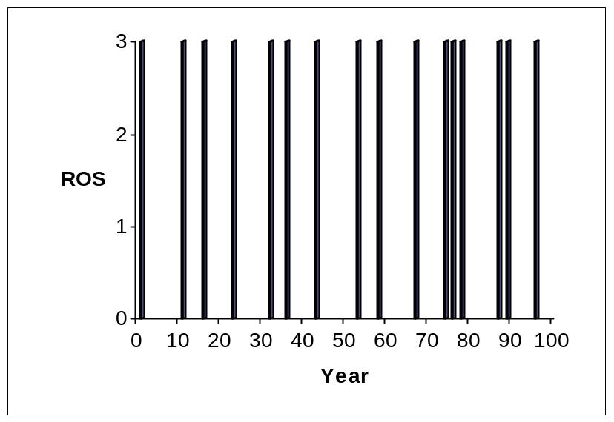

Result: Outbreaks occur at a uniform distribution, where outbreaks occur between RandomParameter1 (1) and RandomParameter2 (10) years apart

