**RCEW Species Distribution Modeling**

OBJECTIVE:

Develop species distribution models to assign establishment probabilities to the RCEW area of interest for aspen, western juniper, and Douglas fir.

METHODS:

Species distribution models (SDMs) were built using the known distribution of each species in the Northern Basin and Range Ecoregion (in which RCEW falls) and surrounding Level III Ecoregions (Fig. 1). By utilizing distribution information within this area rather than for the entire range of each species, the SDMs reflect the realized species niches for the Great Basin, and exclude the influence of more distant populations that are adapted to climatically distinct environments. This provides a reasonable balance between locally adapted populations in the Reynolds Creek area and the theoretical climatic landscapes where local populations of each species could establish within the study area under climate change.

Figure 1. Level III Ecoregions from which presences and absences were collected for each species using the FIA database.

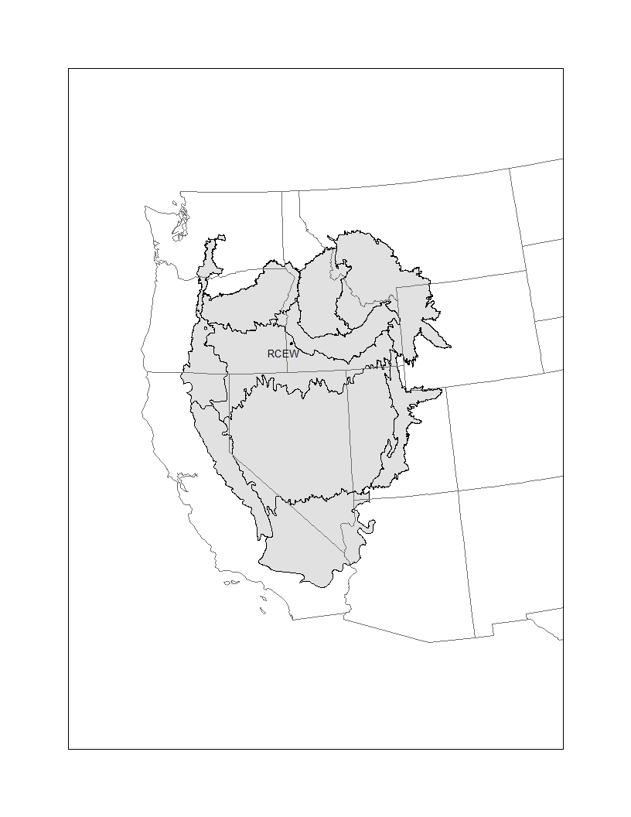

*Occurrences* – Presences and true absences were drawn from Forest Inventory and Analysis (FIA) plot data from the ecoregions shown in Figure 1 for each species (Table 1). Because Douglas Fir had more presences than absences, additional absences were added from sampling the U.S. Geological Survey national Gap Analysis Program (<http://gapanalysis.usgs.gov>) vegetation layer where Douglas fir was not a component of the vegetation type (Appendix A). To remove spatial autocorrelation and to match the scale of the climate data (800 m), if two or more plots fell within the same 800 m pixel, they were reduced to one point. Climate data was extracted for each presence and absence point for each species.

Table 1. Species and number of presence and absence points.

|  |  |  |
| --- | --- | --- |
| **Species** | **Presences** | **Absences** |
| *Populus tremuloides* | 617 | 10646 |
| *Pseudostsuga menziesii* | 3981 | 16884 |
| *Juniperus occidentalis* | 1118 | 13582 |

*Climate Data* – Monthly climate data (precipitation, minimum temperature and maximum temperature) are from the PRISM Climate Group (www.prism/oregonstate.edu) (30 year normals; 1981-2010) at 800 m resolution. Sixteen variables were derived from these data (Table 2). Climatic water deficit and actual evapotranspiration were calculated following Dilts et al. (2015) and the R function “cwd_function” developed by Miranda Redmond (http:s//naes.unr.edu/Weisberg/old_site/downloads). To remove correlated variables, Pearson correlation coefficients were computed for each pair of variables and the least biologically meaningful variable was removed from a correlated pair with a cut off of 0.8. This resulted in eight final climate variables used in the SDMs.

Table 2. PRISM climate variables. Precipitation variables are in mm and temperatures are in ⁰ C. Gray shaded rows are the variables used in final models, and white rows are the correlated variables that are less biological meaningful and were removed from further consideration.

|  |  |
| --- | --- |
| Climate Variable | Explanation |
| MTWM | Warmest temperature of the warmest month |
| MTCM | Minimum temperature of the coldest month |
| MAT | Mean Annual Temperature |
| TDIFF | Summer-winter temperature differential; MTWM-MTCM |
| MAP | Annual Precipitation |
| GSP | Growing season precipitation; Apr. through Sept. |
| SUMP | Summer precipitation; July+Aug. |
| SMRPB | Summer precipitation balance; (July+Aug.+Sept.)/(Apr.+May+June) |
| SMRSPRPB | Summer-spring precipitation balance: (July+Aug.)/(Apr.+May) |
| SPRP | Spring precipitation; Apr.+May |
| WINP | Winter precipitation; Nov. through Feb. |
| PRATIO | Precipitation ration; GSP/MAP |
| MCWD | Mean Annual Climatic Water Deficit |
| CCWD | Cumulative Climatic Water Deficit |
| MAET | Mean Annual Actual Evapotranspiration |
| CAET | Cumulative Actual Evapotranspiration |

*Model Implementation*

Multivariate adaptive regression spline (MARS) modeling was used to fit distribution models for each species in which presence/absence was the binary dependent variable. Model prevalence was set to 0.5 in order to equally weight presences and absences. By doing so, we can compare the predicted occurrence probabilities across species in a more direct manner. Models were projected to the Reynolds Creek study area using 30-year averaged (1981-2010) climate data at 270 m resolution obtained from the Basin Characterization Model (BCM; Flint et al. 2016). We modeled species distributions with and without the direct influence of snow banks, which are known to provide a water subsidy to aspen communities during the growing season, when precipitations levels are generally low in the Great Basin region. In attempt to consider both spatial and seasonal redistribution of water via snowbank ecoregions, we projected the SDM models using three alternative snowbank scenarios (see description of each snowbank scenario in the Results, below).

RESULTS:

*SDM models with no direct snowbank influence.* The MARS species distribution models performed well (AUC >0.9). Their projections without snowbanks provided reasonable distributions of the three species in RCEW (Fig. 2). However, occurrence probabilities from the MARS models are generally too high to use as establishment probabilities in LANDIS-II (aspen range from 0.01-0.49; Douglas fir range from 0-0.74; juniper range from 0.01-0.38).

*SDM models with snowbank influence.*

[Note: The correction for species prevalence was not applied to the snowbank models results described below, but we will want to do this so species probabilities are comparable.] NOTE: I WENT BACK AND APPLIED THE CORRECTION FOR FINAL MODELS GIVEN TO ALEC.

In the first snowbank model (Fig. 4), precipitation in snowbank cells for December through April were multiplied by a “snow drift factor” of 1.45 and non-snowbank cells were multiplied by a “precipitation redistribution factor” of 0.187. This scenario makes no explicit assumptions about seasonal redistribution of snowbank moisture, rather, it assumes that advantageous winter precipitation values inherently reflect superior growing conditions.

In the second snowbank model (Fig. 5), precipitation in snowbank cells for April through July were multiplied by a “snow drift factor” of 1.45 and non-snowbank cells in December through April were multiplied by a “precipitation redistribution factor” of 0.187. This scenario represents seasonal redistribution of moisture from non-snowbank cells, in which snowbank cells are assumed to release their moisture during spring months (as snowmelt) and made available as a water subsidy for aspen and other species during the growing season.

In the third snowbank model (Fig. 6), winter precipitation in snowbank cells for December through April was set to an optimal amount for aspen. This optimal value was calculated as the mean of winter precipitation from aspen occurrences in the FIA dataset across the landscape depicted in Figure 1. Thus, this scenario equates snowbank locations with optimal winter precipitation values for aspen across the broader Great Basin region. Water is not seasonally redistributed, rather it is assumed that advantageous winter precipitation values inherently reflect superior growing conditions.

INTERPRETATION

Projecting models to the BCM climate data without altering the snowbank precipitation produces relatively good distribution maps that have probability of occurrence varying across the landscape that reasonably match actual aspen locations (Fig. 2). Adjusting the occurrence probabilities by species prevalence resulted in establishment probabilities that are more comparable for the three tree species and better reflect their actual dominance on the landscape (Fig. 2).

Adding a snow drift factor and redistributing precipitation in the winter months (Fig. 4) led to lower occurrence probabilities of all species in snowbank cells (except Douglas fir in the northwestern portion of the study area). This is likely because most (>50%) of the annual precipitation occurs during the winter months; thus, using a snow drift factor of 1.4 leads to high annual precipitation values that are outside the species’ niche.

Adding a snow drift factor in the growing season months (Fig. 5) decreased aspen occurrence probabilities in higher elevations (semi-realistic), and increased aspen occurrence probabilities at lower elevations (more realistic) in snow bank cells. In general, this approach also decreased the occurrence probability of Douglas fir and juniper in snowpack areas. Precipitation in the growing season is only ~30% of the annual precipitation amount; thus, the snow-drift factor applied only to the spring-summer months does not increase total (annual) precipitation as much as in the first snow-bank scenario, and precipitation levels generally remain within each species’ niche. This scenario also seems the most reasonable in terms of resulting probability distributions, and also better represents when the water is actually made available to aspen via the snow-drift water subsidy. [Note: because this scenario had different effects on aspen at different elevations, it might be worth considering breaking our snow-bank ecoregions into 2-3 elevation zones; otherwise all snowbank ecoregions will be averaged.]

Assigning snowbank cells the optimal winter precipitation value of aspen (Fig. 6) resulted in high (>0.9) occurrence probabilities for all aspen on snowbanks and drastically decreases the occurrence probabilities of Douglas fir and juniper on snowbanks. These optimal values could potentially be adjusted, but this approach currently seems least realistic.

CONCLUSIONS

Given that establishment probabilities will be averaged by ecoregion in the RCEW, altering snowbank precipitation may not be necessary or may not alter establishment probabilities in the way we originally intended. One problem is that we are building our SDM models for a larger region and at a coarser scale, and then projecting to a smaller region at finer-scales with additional post-hoc, fine-scale spatial adjustments made to reflect the redistribution of water via snowbanks.

Thus, we suggest using both a no-snowbank and a snowbank approach in the final LANDIS-II model. This will allow comparison of how important snowbanks might (theoretically) be in the future, but also might assuage reviewers if they feel the snowbank approach is too theoretical and loosely parameterized. To do this, we need to pick the best approach from the snow-bank scenarios and make any last adjustments to that approach (e.g., adjusting the relative probabilities based on species prevalence on the landscape). Finally, we need to consider how the other species will interact with aspen in LANDIS-II, including a semi-arid and/or mountain shrub component.

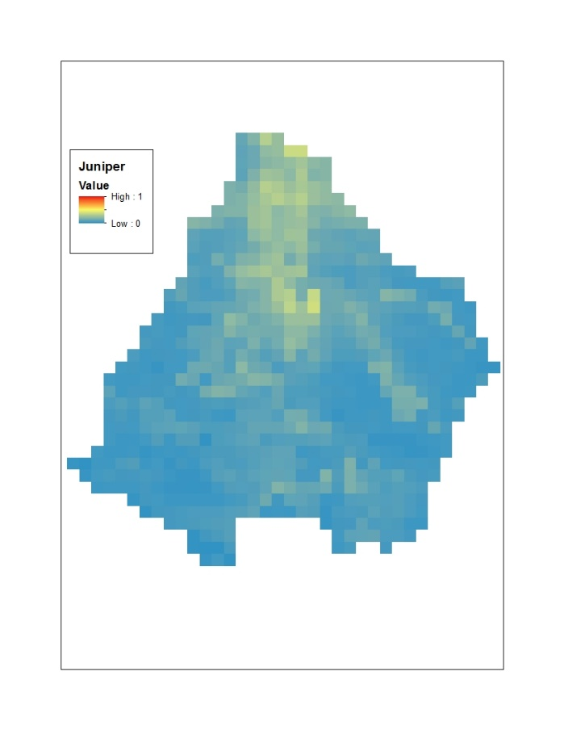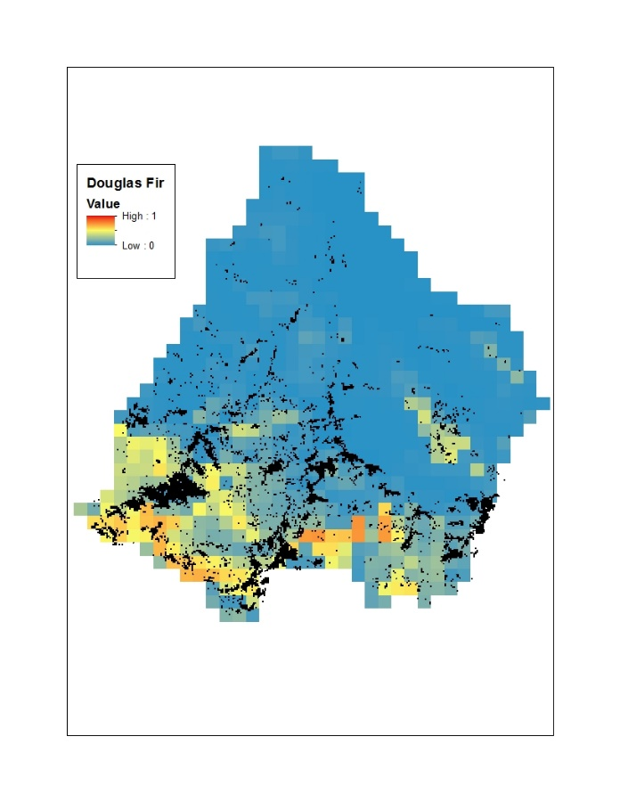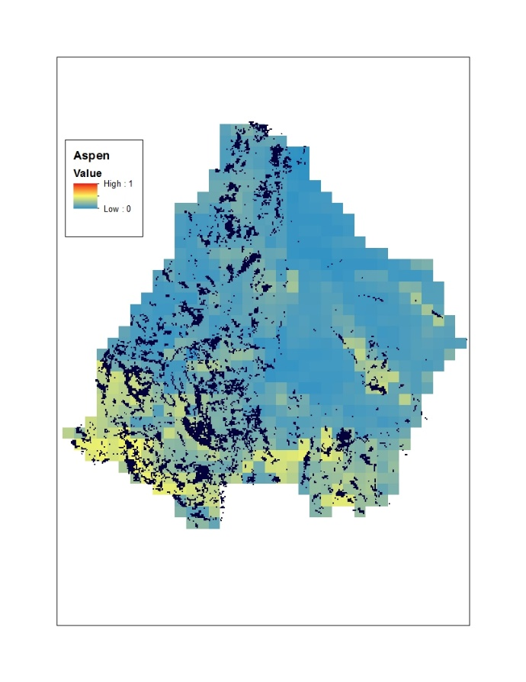Figure 2. MARS species distribution models projected onto BCM climate data of RCEW at 270m resolution, adjusted for prevalence. Overlain in black is known distribution of species (the distribution of juniper at RCEW is unknown).

Figure 3. (Removed because prevalence correction added in Figure 2.)

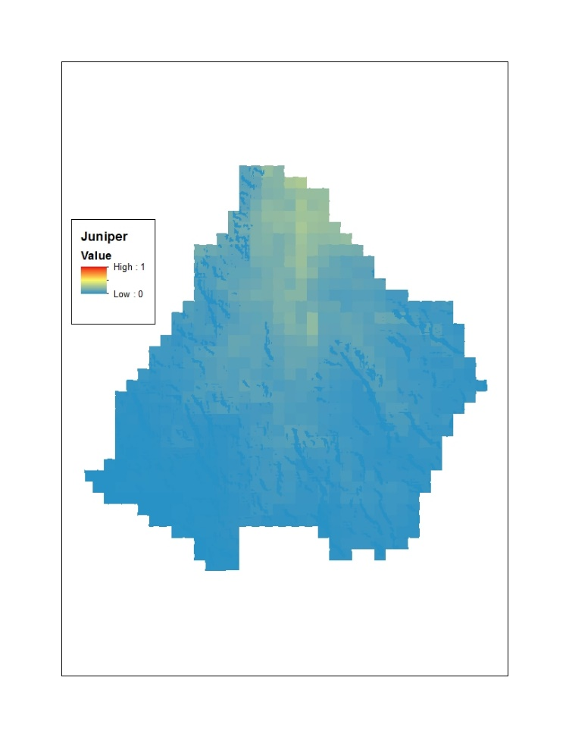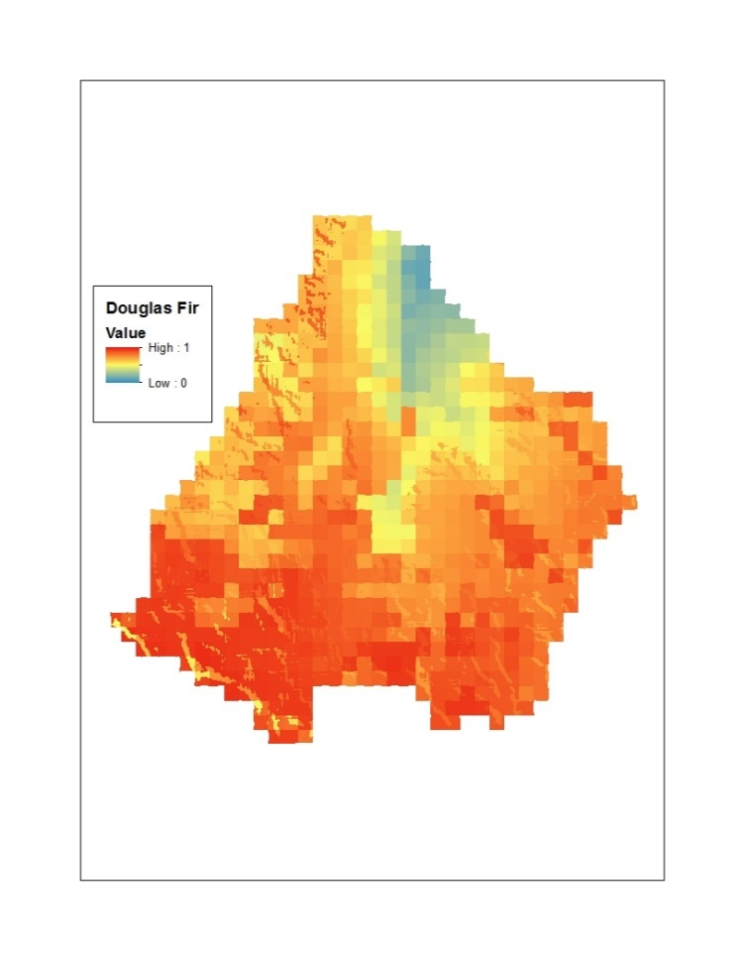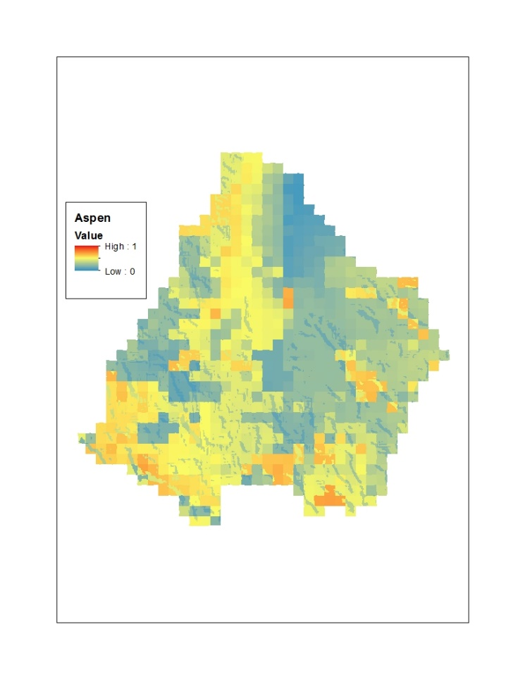Figure 4. MARS species distribution models projected onto BCM climate data of RCEW at 10m resolution with precipitation of snowbank cells December through April multiplied by a drift factor of 1.45 and non-snowbank cells multiplied by a redistribution factor of 0.187. Note: These probabilities are not adjusted for prevalence.

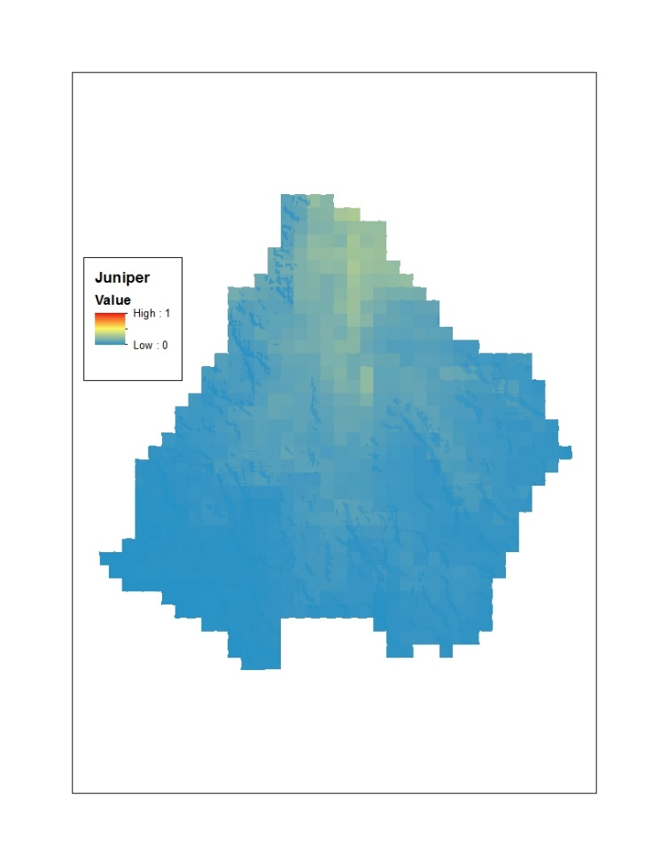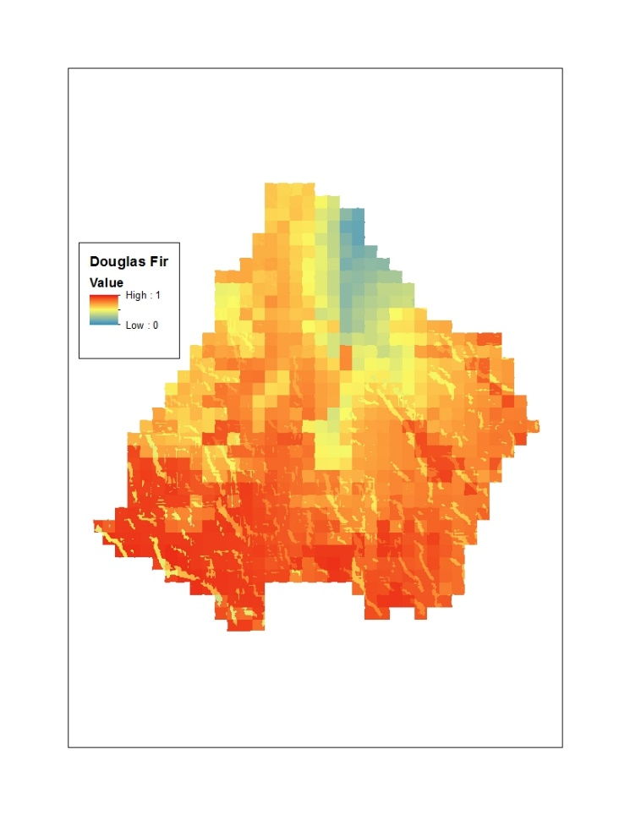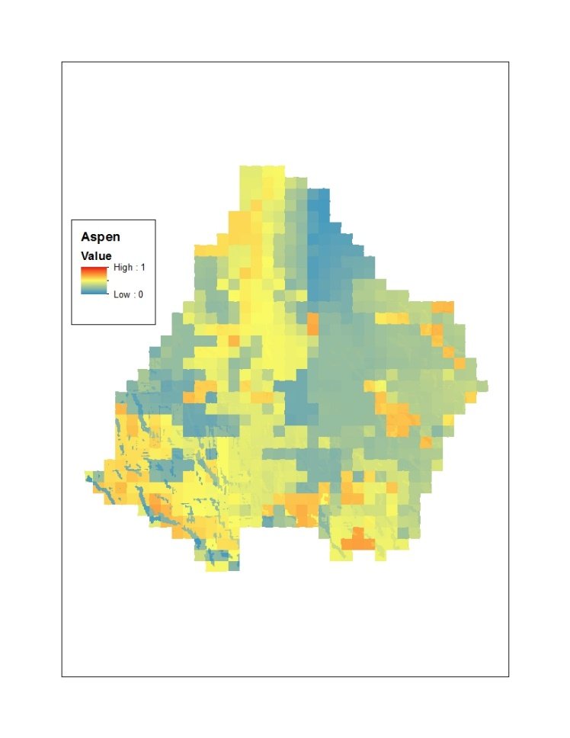Figure 5. MARS species distribution models projected onto BCM climate data of RCEW at 10m resolution with precipitation of snowbank cells April through July multiplied by a drift factor of 1.45 and non-snowbank cells December through April multiplied by a redistribution factor of 0.187. Note: These probabilities are not adjusted for prevalence.

Figure 6. MARS species distribution models projected onto BCM climate data of RCEW at 10m resolution with winter precipitation of snowbank cells December through April set to the optimal winter precipitation value of aspen across the landscape. Note: These probabilities are not adjusted for prevalence.

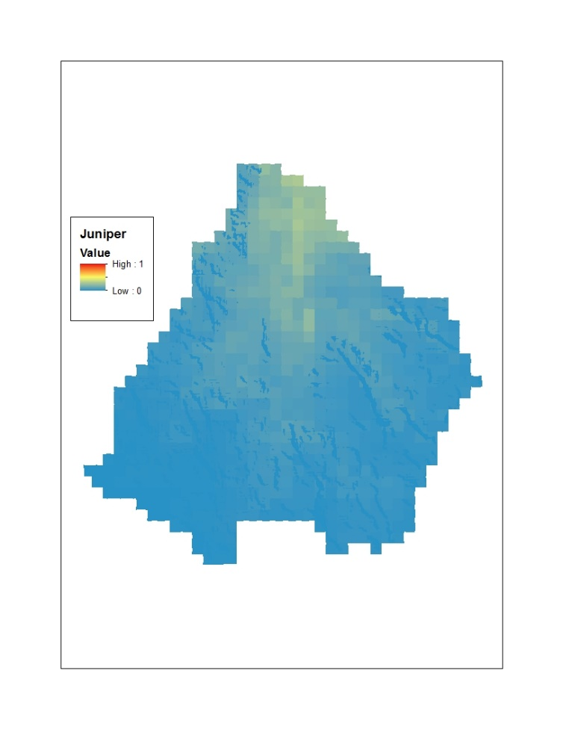

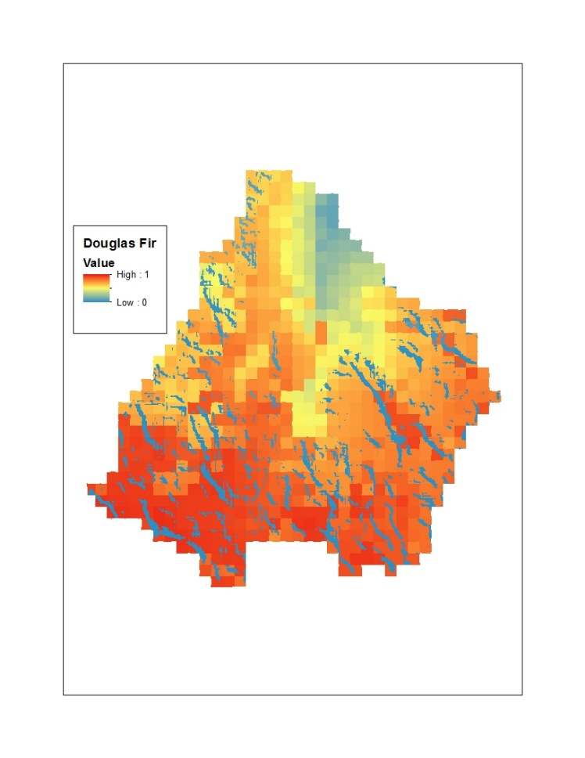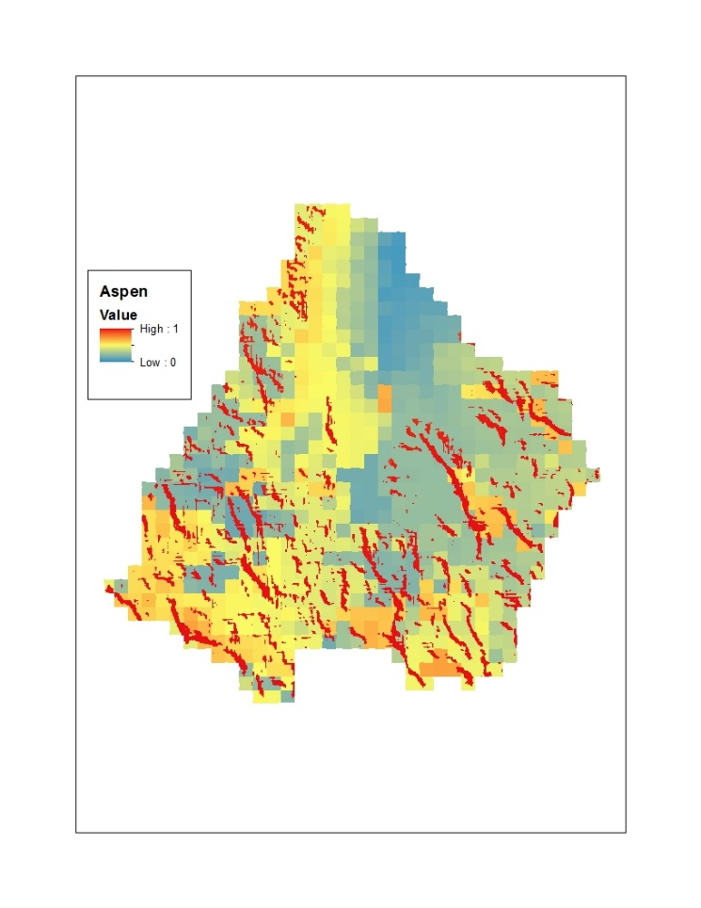

**Appendix A**

USGS National GAP Analysis Program vegetation classes for Douglas fir. Absences were drawn from all GAP classes except those listed here.

|  |  |
| --- | --- |
| **Class Name** | **Class #** |
| Middle Rocky Mountain Montane Douglas-fir Forest and Woodland | 137 |
| Northern Rocky Mountain Dry-Mesic Montane Mixed Conifer Forest | 138 |
| Northern Rocky Mountain Mesic Montane Mixed Conifer Forest | 140 |
| Northern Rocky Mountain Ponderosa Pine Woodland and Savanna | 141 |
| Northern Rocky Mountain Western Larch Savanna | 142 |
| Inter-Mountain Basins Aspen-Mixed Conifer Forest and Woodland | 145 |
| Rocky Mountain Lodgepole Pine Forest | 149 |
| Rocky Mountain Poor-Site Lodgepole Pine Forest | 150 |
| Rocky Mountain Subalpine Dry-Mesic Spruce-Fir Forest and Woodland | 151 |
| Rocky Mountain Subalpine-Montane Limber-Bristlecone Pine Woodland | 153 |
| Southern Rocky Mountain Dry-Mesic Montane Mixed Conifer Forest and Woodland | 155 |
| Southern Rocky Mountain Mesic Montane Mixed Conifer Forest and Woodland | 156 |
| Great Basin Foothill and Lower Montane Riparian Woodland and Shrubland | 266 |
| Rocky Mountain Lower Montane Riparian Woodland and Shrubland | 270 |
| Rocky Mountain Subalpine-Montane Riparian Woodland | 272 |
| Rocky Mountain Cliff, Canyon and Massive Bedrock | 529 |