Carbon

Vincent Bisquay Gracia

12/05/2021

#I. set up

Used pakages :

setwd(  
 "D:/Users/181248/Documents/R")  
library(magrittr)  
library(cowplot)  
library(ggplot2)  
library(raster)

CC_input =   
 "D:/Users/181248/Documents/Klamath_(CA_only)_2021 - CC only/"  
Dist_input =   
 "D:/Users/181248/Documents/Klamath_(CA_only)_2021 - CC & disturbances/"  
  
BAU_input =  
 "D:/Users/181248/Documents/Klamath_(CA_only)_2021 - Harvest BAU1/"

#II.

CC_NECN_long = paste(CC_input,"NECN-succession-log.csv",sep="") %>% read.csv()  
  
CC_NECN = aggregate(data=CC_NECN_long, cbind(NEEC, SOMTC, AGB, AG_NPPC, BG_NPPC, Litterfall, AgeMortality, MineralN, TotalN, GrossMineralization, C_LiveLeaf, C_LiveFRoot, C_LiveWood, C_DeadWood, C_DeadCRoot, C_DeadLeaf_Struc, C_DeadLeaf_Meta, C_DeadFRoot_Struc, C_DeadFRoot_Meta, C_SOM1surf, C_SOM1soil, C_SOM2, C_SOM3, N_Leaf, N_FRoot, N_Wood, N_CRoot, N_DeadWood, N_DeadCRoot, N_DeadLeaf_Struc, N_DeadLeaf_Meta, N_DeadFRoot_Struc, N_DeadFRoot_Meta, N_SOM1surf, N_SOM1soil, N_SOM2, N_SOM3, SurfStrucNetMin, SurfMetaNetMin, SoilStrucNetMin, SoilMetaNetMin, SOM1surfNetMin, SOM1soilNetMin, SOM2NetMin, SOM3NetMin, TotalNdep, LeachedC, LeachedN, FireCEfflux, FireNEfflux, Nuptake, Nresorbed, TotalSoilN, Nvol, FrassC) ~ Time, mean)  
  
CC_NECN$Scenario = "CC"  
  
  
Dist_NECN_long = paste(Dist_input,"NECN-succession-log.csv",sep="") %>% read.csv()  
  
Dist_NECN = aggregate(data=Dist_NECN_long, cbind(NEEC, SOMTC, AGB, AG_NPPC, BG_NPPC, Litterfall, AgeMortality, MineralN, TotalN, GrossMineralization, C_LiveLeaf, C_LiveFRoot, C_LiveWood, C_DeadWood, C_DeadCRoot, C_DeadLeaf_Struc, C_DeadLeaf_Meta, C_DeadFRoot_Struc, C_DeadFRoot_Meta, C_SOM1surf, C_SOM1soil, C_SOM2, C_SOM3, N_Leaf, N_FRoot, N_Wood, N_CRoot, N_DeadWood, N_DeadCRoot, N_DeadLeaf_Struc, N_DeadLeaf_Meta, N_DeadFRoot_Struc, N_DeadFRoot_Meta, N_SOM1surf, N_SOM1soil, N_SOM2, N_SOM3, SurfStrucNetMin, SurfMetaNetMin, SoilStrucNetMin, SoilMetaNetMin, SOM1surfNetMin, SOM1soilNetMin, SOM2NetMin, SOM3NetMin, TotalNdep, LeachedC, LeachedN, FireCEfflux, FireNEfflux, Nuptake, Nresorbed, TotalSoilN, Nvol, FrassC) ~ Time, mean)  
  
Dist_NECN$Scenario = "Dist"  
  
  
BAU_NECN_long = paste(BAU_input,"NECN-succession-log.csv",sep="") %>% read.csv()  
  
BAU_NECN = aggregate(data=BAU_NECN_long, cbind(NEEC, SOMTC, AGB, AG_NPPC, BG_NPPC, Litterfall, AgeMortality, MineralN, TotalN, GrossMineralization, C_LiveLeaf, C_LiveFRoot, C_LiveWood, C_DeadWood, C_DeadCRoot, C_DeadLeaf_Struc, C_DeadLeaf_Meta, C_DeadFRoot_Struc, C_DeadFRoot_Meta, C_SOM1surf, C_SOM1soil, C_SOM2, C_SOM3, N_Leaf, N_FRoot, N_Wood, N_CRoot, N_DeadWood, N_DeadCRoot, N_DeadLeaf_Struc, N_DeadLeaf_Meta, N_DeadFRoot_Struc, N_DeadFRoot_Meta, N_SOM1surf, N_SOM1soil, N_SOM2, N_SOM3, SurfStrucNetMin, SurfMetaNetMin, SoilStrucNetMin, SoilMetaNetMin, SOM1surfNetMin, SOM1soilNetMin, SOM2NetMin, SOM3NetMin, TotalNdep, LeachedC, LeachedN, FireCEfflux, FireNEfflux, Nuptake, Nresorbed, TotalSoilN, Nvol, FrassC) ~ Time, mean)  
  
BAU_NECN$Scenario = "BAU"  
  
NECN = rbind(CC_NECN, Dist_NECN, BAU_NECN)

SOMTp = ggplot(NECN, aes(x=Time, y=SOMTC, col=Scenario, shape = Scenario)) +  
 geom_point() +  
 scale_x_continuous(name= "Time (in years)") +  
 scale_y_continuous(name = "SOMTC (g C m-2)") +  
 ggtitle("Evolution of the soil organic mater") +  
 theme(plot.title = element_text(hjust = 0.5))  
  
CDWp = ggplot(NECN, aes(x=Time, y=C_DeadWood, col=Scenario, shape = Scenario)) +  
 geom_point() +  
 scale_x_continuous(name= "Time (in years)") +  
 scale_y_continuous(name = "Dead wood Carbon (g C m-2)") +  
 ggtitle("Evolution of the dead wood carbon") +  
 theme(plot.title = element_text(hjust = 0.5))  
  
AGBp = ggplot(NECN, aes(x=Time, y=AGB, col=Scenario, shape = Scenario)) +  
 geom_point() +  
 scale_x_continuous(name= "Time (in years)") +  
 scale_y_continuous(name = "Above ground biomass (g C m-2)") +  
 ggtitle("Evolution of the above ground biomass") +  
 theme(plot.title = element_text(hjust = 0.5))  
  
plot_grid(SOMTp, CDWp, AGBp, labels="AUTO", ncol = 2, nrow = 2)

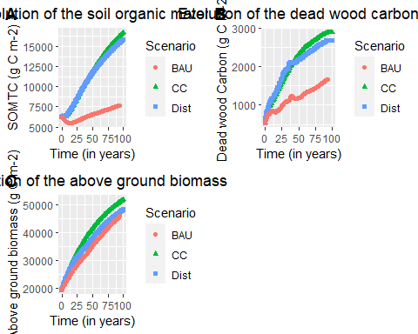

# III. Perturbations analysis

Dist_BDA_Tot = read.csv("D:/Users/181248/Documents/Klamath_(CA_only)_2021 - CC & disturbances/bda_log.csv")  
Dist_BDA = cbind(Dist_BDA_Tot$Time, Dist_BDA_Tot$TotalBiomassMortality) %>% as.data.frame()  
colnames(Dist_BDA) = c("Time", "Mortality")  
  
Dist_BDA = aggregate(Dist_BDA$Mortality, by=list(Time=Dist_BDA$Time), FUN=sum)  
  
colnames(Dist_BDA) = c("Time", "Mortality")  
Dist_BDA$Disturbancy = "Insects"  
  
  
Dist_scrapple_Tot = read.csv("D:/Users/181248/Documents/Klamath_(CA_only)_2021 - CC & disturbances/scrapple-summary-log.csv")  
Dist_scrapple_Acc = cbind(Dist_scrapple_Tot$SimulationYear,  
 Dist_scrapple_Tot$TotalBiomassMortalityAccidental) %>% as.data.frame()  
colnames(Dist_scrapple_Acc) = c("Time", "Mortality")  
Dist_scrapple_Acc$Disturbancy = "Fire accidental"  
  
  
Dist_scrapple_Nat = cbind(Dist_scrapple_Tot$SimulationYear,  
 Dist_scrapple_Tot$TotalBiomassMortalityLightning) %>% as.data.frame()  
colnames(Dist_scrapple_Nat) = c("Time", "Mortality")  
Dist_scrapple_Nat$Disturbancy = "Fire lightning"  
  
Dist_Mortality = rbind(Dist_BDA, Dist_scrapple_Acc, Dist_scrapple_Nat)

BAU_BDA_Tot = read.csv("D:/Users/181248/Documents/Klamath_(CA_only)_2021 - Harvest BAU1/bda_log.csv")  
BAU_BDA = cbind(BAU_BDA_Tot$Time, BAU_BDA_Tot$TotalBiomassMortality) %>% as.data.frame()  
colnames(BAU_BDA) = c("Time", "Mortality")  
  
BAU_BDA = aggregate(BAU_BDA$Mortality, by=list(Time=BAU_BDA$Time), FUN=sum)  
  
colnames(BAU_BDA) = c("Time", "Mortality")  
BAU_BDA$Disturbancy = "Insects"  
  
  
BAU_scrapple_Tot = read.csv("D:/Users/181248/Documents/Klamath_(CA_only)_2021 - Harvest BAU1/scrapple-summary-log.csv")  
BAU_scrapple_Acc = cbind(BAU_scrapple_Tot$SimulationYear,  
 BAU_scrapple_Tot$TotalBiomassMortalityAccidental) %>% as.data.frame()  
colnames(BAU_scrapple_Acc) = c("Time", "Mortality")  
BAU_scrapple_Acc$Disturbancy = "Fire accidental"  
  
  
BAU_scrapple_Nat = cbind(BAU_scrapple_Tot$SimulationYear,  
 BAU_scrapple_Tot$TotalBiomassMortalityLightning) %>% as.data.frame()  
colnames(BAU_scrapple_Nat) = c("Time", "Mortality")  
BAU_scrapple_Nat$Disturbancy = "Fire lightning"  
  
  
BAU_Mortality = rbind(BAU_BDA, BAU_scrapple_Acc, BAU_scrapple_Nat)

title = ggdraw() +   
 draw_label(  
 "Figure X",  
 fontface = 'plain', x = 0, hjust = 0, size = 14) +  
 theme(plot.margin = margin(0, 0, 0, 50))  
  
Mort1 = ggplot(Dist_Mortality, aes(x=Time, y=Mortality, color=Disturbancy, group=Disturbancy)) +  
 geom_area(aes(fill=Disturbancy)) +  
 xlab("") +  
 ylab("Mortality in biomass") +  
 ggtitle("Evolution of mortality due to disturbancies (no managment)") +  
 theme(plot.title = element_text(hjust = 0.5))  
  
Mort2 = ggplot(BAU_Mortality, aes(x=Time, y=Mortality, color=Disturbancy, group=Disturbancy)) +  
 geom_area(aes(fill=Disturbancy)) +  
 xlab("Time (years)") +  
 ylab("Mortality in biomass") +  
 ggtitle("Evolution of mortality due to disturbancies (with managment)") +  
 theme(plot.title = element_text(hjust = 0.5))  
  
plot_row = plot_grid(Mort1, Mort2, ncol=1, labels="AUTO")  
  
plot_grid(title, plot_row, ncol=1, rel_heights = c(0.1, 0.7))

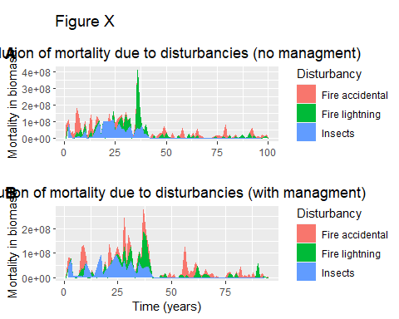

title = ggdraw() +   
 draw_label(  
 "Figure X : Smooth",  
 fontface = 'plain', x = 0, hjust = 0, size = 14) +  
 theme(plot.margin = margin(0, 0, 0, 50))  
  
Mort1 = ggplot(Dist_Mortality, aes(x=Time, y=Mortality, color=Disturbancy, group=Disturbancy)) +  
 geom_smooth(span = 0.1, se=FALSE) +  
 xlab("Time (years)") +  
 ylab("Mortality in biomass") +  
 ggtitle("Evolution of mortality due to disturbancies (no managment)") +  
 theme(plot.title = element_text(hjust = 0.5))  
  
Mort2 = ggplot(BAU_Mortality, aes(x=Time, y=Mortality, color=Disturbancy, group=Disturbancy)) +  
 geom_smooth(span = 0.1, se=FALSE) +  
 xlab("Time (years)") +  
 ylab("Mortality in biomass") +  
 ggtitle("Evolution of mortality due to disturbancies (with managment)") +  
 theme(plot.title = element_text(hjust = 0.5))  
  
plot_row = plot_grid(Mort1, Mort2, ncol=1, labels="AUTO")  
  
plot_grid(title, plot_row, ncol=1, rel_heights = c(0.1, 0.7))

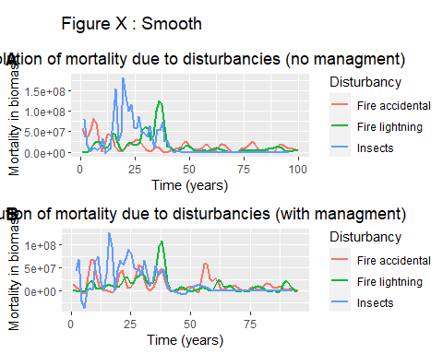

Mean mortality, max, f pics

biomass recover after disturbancy (slope).