Landis II Visualization
Development
Johannes Liem

Development Environment for PreProcTool
- Python 2.7 (https://www.python.org/downloads/)
- Python modules (use the mose current win32-py2.7 version):
  - lxml 3.3.5 (http://www.lfd.uci.edu/~gohlke/pythonlibs/#lxml)
  - gdal 1.11.0 (http://www.lfd.uci.edu/~gohlke/pythonlibs/#gdal)
  - PyYaml 3.11 (http://www.lfd.uci.edu/~gohlke/pythonlibs/#pyyaml)
  - Regex 2014.05.23 (http://www.lfd.uci.edu/~gohlke/pythonlibs/#regex)
  - Pillow 2.4.0 (http://www.lfd.uci.edu/~gohlke/pythonlibs/#pillow) (PIL replacement)
  - Numpy 1.8.1 (http://sourceforge.net/projects/numpy/files/NumPy/)
  - Scipy 0.14.0 (http://sourceforge.net/projects/scipy/files/scipy/)
- PyInstaller (for freezing the application to an executable):
  - PyInstaller 2.1 (http://www.pyinstaller.org/)
  - pywin32 Build 219 (http://sourceforge.net/projects/pywin32/files/)
- Local Server (for freezing the local server script (creating an exe) use also pyisntaller)
  - CehrryPy 3.2.4 (http://www.cherrypy.org/)

How-To: Test the PreProcTool

How-To: Build the PreProcTool
- Run the build_preproctool batch-file (PreProcTool/build/build_preproctool.bat)
- In case of Errors, try:
  - delte the folders/file:
    - PreProcTool/build/build
    - PreProcTool/build/dist
    - PreProcTool/preproctool.spec
  - run build_preproctool.bat again

How-To: Create the MSI-Installer
- The Windows-Installer was created with the application Advanced Installer (http://www.advancedinstaller.com/)
- To open the existing Advanced Installer Project go to: PreProcTool/build/installer and open the "LandisPreProcTool" Advanced Installer Project file

Settings in Advanced Installer

Product Details
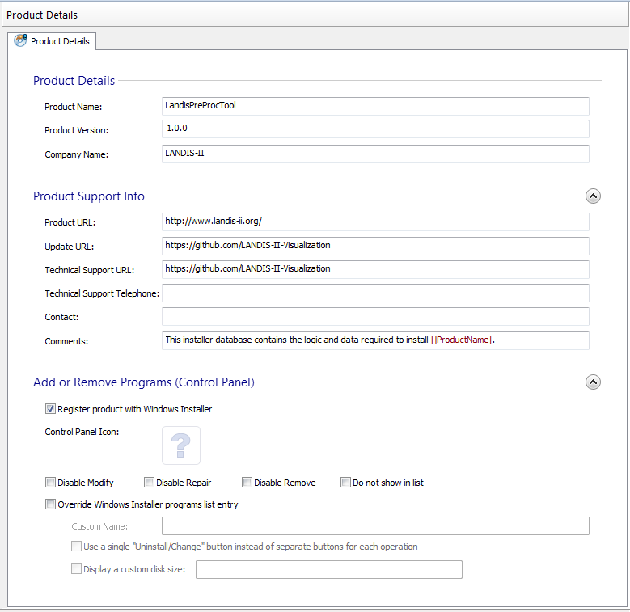

Install Parameters
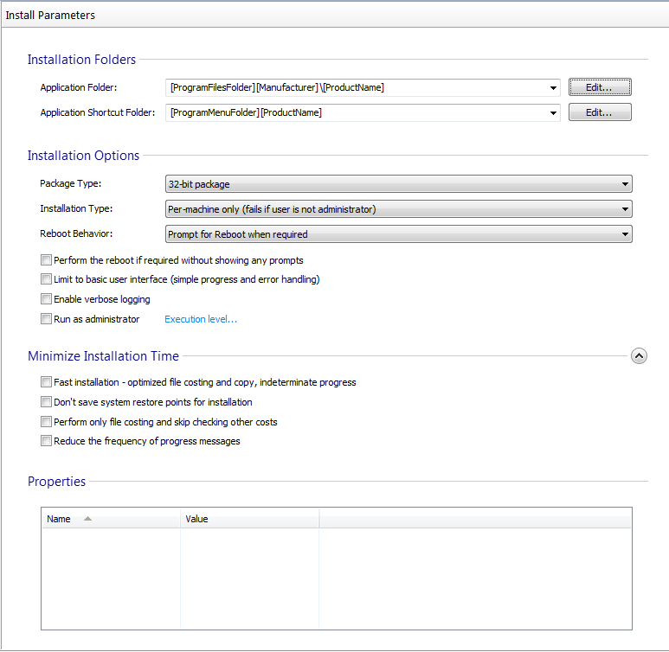

Files and Folders
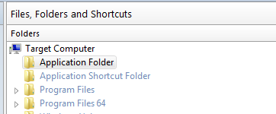
- Application Folder: right click > Add Files...
  - GoTo: LandisVisualizationDevel\PreProcTool\build\dist\PreProcTool
  - Select all Files (Crtl+A) > cklick Open
- Application Folder: right click > Add Folder ...
  - GoTo: LandisVisualizationDevel\PreProcTool\build\dist\PreProcTool
  - select folder: config > click Select Folder
- Repeat for the folders: gdal-data, include, webbase
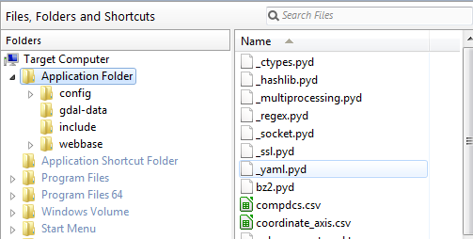

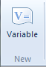
System Changes > Environment:
- add APPDIR to the PATH variable (left)
- create GDAL_DATA variable (right)
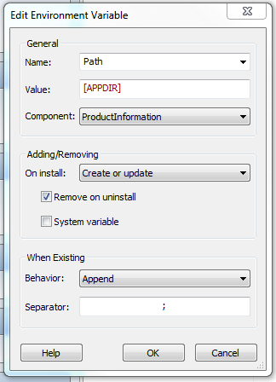
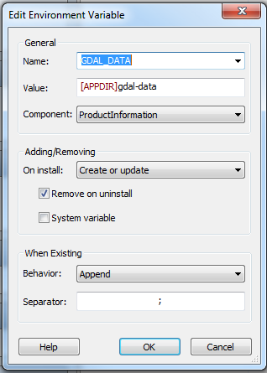
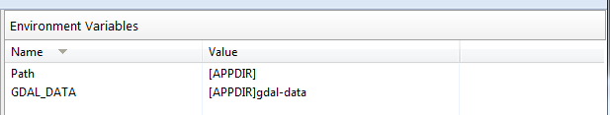

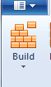
Build Isntaller
- Start the building process by clicking the Build-Button:

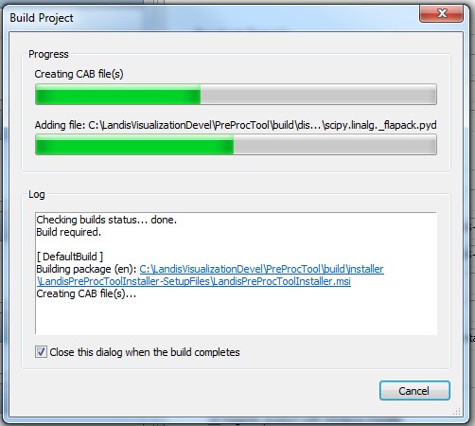

- When done, close the Application
- The Installer is now located at:
  - \LandisVisualizationDevel\PreProcTool\build\installer\LandisPreProcToolInstaller-SetupFiles\LandisPreProcToolInstaller.msi

