Landis II Visualization

Documentation

Johannes Liem & Helen Jenny

Document Structure:
Chapter A: WebVisualization Tool (WebVisTool)
For users of the web interface.

Chapter B: PreProcessingTool (PreProcTool)
For users/modelers, who want to publish their LANDIS-II model results with the WebVisTool.

Chapter C: Landis Visualization Development
For developers, who want to make changes in the WebVis or PreProc source.

Version 1.0, 06/24/2014

Table of Contents
Chapter A: WebVisTool User Guide 4
1 Dataset Selection 4
2 Interactive Map Legend 5
3 Filtering Chart Data 6
4 Spatial Map Navigation 6
5 Temporal Animation and Navigation 6
Chapter B: PreProcTool Modeler Guide 8
1 Introduction 8
1.1 Description 8
1.2 Installation 8
1.2.1 Uninstall 8
2 Usage 9
2.1 LANDIS-II scenario output folder 9
2.2 Configure the projext xml file for PreProcTool (preproc_example_project.xml) 9
2.2.1 Project name 9
2.2.2 Input 9
2.2.2.1 Scenarios 9
2.2.2.2 Spatial Refernce 10
2.2.3 Output 11
2.2.3.1 Zoom 11
2.2.3.2 Base Map 12
2.2.3.3 Legend 13
2.2.4 Example 14
2.3 Run the PreProcTool (run_preproctool.bat) 15
3 Output 16
3.1 Output folder 16
3.1.1 Change settings of the WebVisTool 16
3.2 Zip file for server upload 17
4 Examples 18
4.1 Example 1 18
4.2 Example 2 19
4.3 Example 3 20
Chapter C: LandisVis Developer Guide 21
1 Development Environment of PreProcTool 21
2 The LandisVisualizationDevel Folder 21
3 How-To: Build the WebVisTool and PreProcTool 22
4 How-To: Create the MSI-Installer 23
4.1 Settings in Advanced Installer 23
4.1.1 Product Details 23
4.1.2 Install Parameters 24
4.1.3 Files and Folders 25
4.1.4 System Changes > Environment: 26
4.2 Build Installer 27

WebVisTool User Guide
For best results, use the current Mozilla Firefox Browser.

Dataset Selection

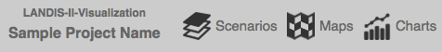
Figure 1. Drop down menus for dataset selection

The LANDIS-II WebVizTool offers different entry paths to view and analyze datasets.
By default, the first scenario in the scenario drop down menu is selected.
Each scenario contains a number of datasets visualized as maps or charts. To display a map or chart, use the corresponding drop down menus (Figure 1). Datasets are organized by LANDIS-II extensions in the maps and charts drop down menus. Click next to the drop down menu on the map to update your selection.

You can compare scenarios by selecting additional scenarios in the scenario drop down menu; the map and chart selections will be applied to all selected scenarios. Datasets that are available as map and as chart need to be activated in both, the maps and in the charts drop down menu.
Displayed datasets are labeled with extension and parameter name (Figure 2.) The maximum of displayable maps is four and the maximum of displayable charts is also four.

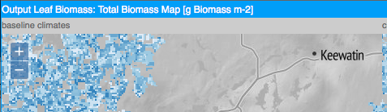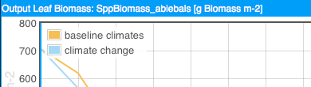
Figure 2. Labeling of selected datasets; extension name & parameter name

While a map only shows one parameter, a chart can show more than one parameter if more than one scenario is selected (Figure 3).

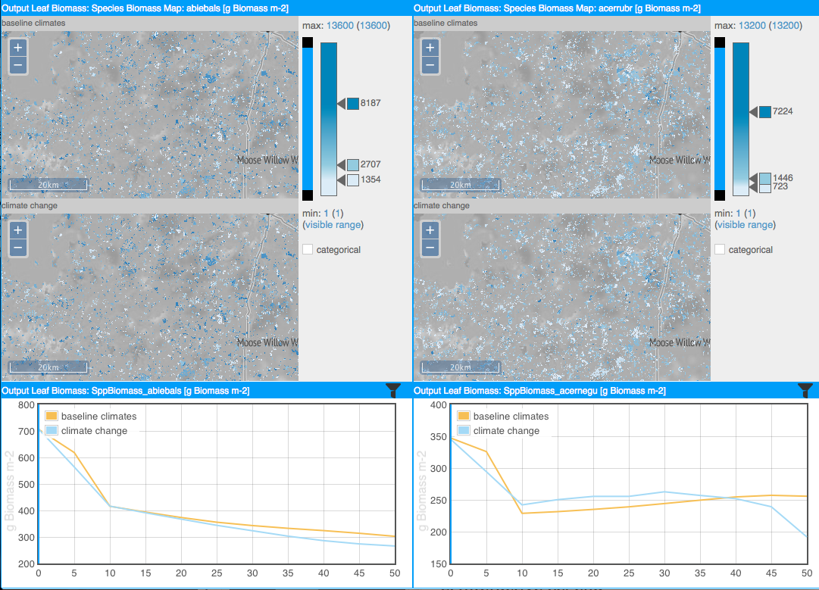
Figure 3. Two scenarios, two map parameters, and two chart parameters result in four maps and two charts.

Interactive Map Legend
You can interact with the classification bar (Figure 4 right) and filter bar (Figure. 4 left) to set class breaks, add or remove classes, change colors, and switch between continuous (interpolated colors) and discrete color schemes (color bins) .
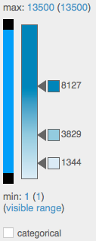
Figure 4. Map legend.
The default settings for the classification bar are calculated based on dataset statistics over the entire time period availability of the dataset; this is necessary to allow temporal animation. If more than one scenario is activated, statistics are calculated based on the entire time period and range of the parameter in all scenarios (Figure 5). For this reason, you may see a change in the classification when additional scenarios are activated. If different parameters are selected, one legend per parameter will be displayed.

To inspect the distribution of data in detail, you may want to change the classification. Double click the classification bar to add another class; double click a class break arrow to remove the class. Click a color square next to a class break arrow to assign a different data color to the class. Select the categorical option to switch to color bins. Drag the arrow next to a class break to move the break.

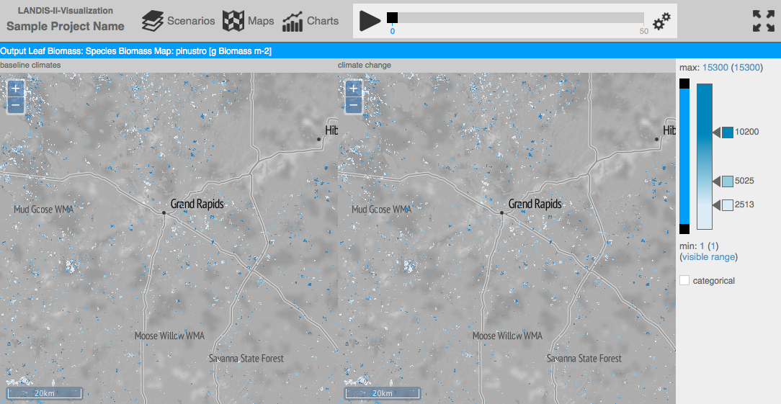
Figure 5. Two maps that share the same legend because they show the same parameter for two different scenarios.

To filter map data to show only a certain data range, drag the black squares on the filter bar to adjust the visible range.

Filtering Chart Data
To filter chart data, click the filter icon on the right of the chart’s title bar. Select a filter criterion and filter value to see a temporal chart for spatial areas that correspond to the filter value. Valid filter criteria are qualitative, e.g. ecoregions by ID and harvest prescriptions by name. The list of filters may contain invalid filter suggestions, usually quantitative parameters, which will produce an array of unique numbers that cannot be shown on the chart. The presence of these invalid filter criteria in the drop down menu is a trade-off to guaranty maximum tool flexibility; contact the software administrator if you are not sure which filter criteria are valid.

Spatial Map Navigation
Use the plus and minus buttons to zoom in and out of the map. Available zoom levels are set by the software administrator at the time of creating the map tiles; zoom level limitations are a result of theses settings. Click and drag to pan on the map. If you navigate in one map window, all other map windows will update to the new location and zoom level automatically.

Temporal Animation and Navigation
Click the play button on the top menu bar to start a temporal animation. On charts, the moving blue vertical line helps identifying parameter values that correspond to the current point in time. The maps are updated by displaying the map corresponding to the current time step; maps are not interpolated between time steps. Interactive legend and spatial navigation are enabled while the animation is running. Click on the gears symbol to the right of the temporal animation bar to adapt animation speed.
By default the playback interval is by year. If a parameter on a map has a time inverval of 5 years, the map is updated every 5th year. Maps, where time steps are available only every 10 years, is updated every 10th year.
Select snap to greatest common interval in the gears menu to change the playback interval. If the first parameter has a time interval of 5 years and the second of 10 years, the playback time is based on the greatest common divisor (5 in this case). The playback interval is now 5 years.

PreProcTool Modeler Guide

Introduction

Description
The LANDIS-II PreProcTool is a command line tool to generate a web application to visualize LANDIS-II model data (http://www.landis-ii.org).

Installation
Download the MS I-Installer LandisPreProcToolInstaller.msi
https://github.com/LANDIS-II-Visualization/LandisVisualizationInstaller
- Important: for the installation you have to use a windows administrator account
- double-click the installer
- click Next
- Select an install destination ore use the default install folder > Next
- click Install
- this may take several minutes
- User Account Control pop-up: click Yes
- click Finish

Uninstall
- Open the Control Panel > Programs and Features
- Select LandisPreProcTool
- click Uninstall
- click Yes
- User Account Control pop-up: click Yes
Or:
- Run the Installer
- click Next
- click the Remove Icon
- click Remove
- User Account Control pop-up: click Yes
- click Finish

Usage
Download example_project.zip
https://github.com/LANDIS-II-Visualization/LandisVisualizationInstaller
This archive contains:
- LANDIS-II scenario output folder (used extensions: Base Wind, Leaf Biomass Harvest, Output Leaf Biomass Reclass)
- run_preproctool.bat
- preproc_example_project.xml

LANDIS-II scenario output folder
[Information about the Version of LANDIS-II, Metadata Extension, ...]

Configure the projext xml file for PreProcTool (preproc_example_project.xml)
The project xml file contains all important configurations for the PreProcTool. To change or update the configuration, open the file in a text editor (Notepad, Notepad++, Sublime Text, jEdit, ...). For your own projects use this example project xml file as a template and change the configuration based on your project and data.

Project name
Choose a short name which describes your project. This Name will be displayed in the WebVisTool header.
<landisPreProcProject projectName="Name of a Forest">

Input

Scenarios
For every scenario you want to include into the WebVisTool, use a scenario element:
Important: All included scenarios have to have the same outputs and extensions! Otherwise the WebVisTool won't work properly.
Attributes of scenario element:
- inputPath: relative (to xml file) or absolute path to the LANDIS scenario folder
- displayName: this name is used in the menu within the WebVisTool
<scenarios>
<scenario inputPath="example_scenario_1" displayName="baseline climates" />
<scenario inputPath="example_scenario_2" displayName="climate change"/>
<scenario inputPath="C:\Landis\scenario_5" displayName="bussines as usual"/>
</scenarios>
Note: To comment a scenario use: <!-- ... --> around the scenario element. It is not going to be included in the WebVisTool. If you want to use it later again, just remove the comment elements.
<!--<scenario inputPath="example_scenario_2" displayName="climate change"/>-->

Spatial Refernce
Here you have to provide information about the projection/datum and extent used by the ecoregion raster. Important: Therefore the ecoregion raster file has to have a proper spatial reference assigned!
Attributes for projection element:
- proj4: the Proj4 string contains Information about the used projection and datum
Attributes of extent element:
- ulx: x-coordinate of upper left corner of raster (value is in the unit of the used projection)
- uly: y-coordinate of upper left corner
- lrx: x-coordinate of lower right corner
- lry: y-coordinate of lower right corner
<spatialRefernce>
<projection proj4="+proj=utm +zone=15 +datum=NAD83 +units=m +no_defs " />
<extent ulx="293234.718" uly="5314517.522" lrx="566034.718" lry="5104517.522" />
</spatialRefernce>

How Can I gather this Information?
The PreProcTool comes with an additional tool: Proj4Extent.exe
If the PreProcTool is installed correctly:
- GoTo: the folder where you stored the ecoregion raster used for the landis model
- make a Shift + rigth-click on the folder
- In the context menu select: Open command window here
- use the command: proj4extent.exe ecoregion.img
- replace ecoregion.img with the file name of your ecoregion raster
- press Enter to execute the command
- if everything went ok, you should see following information (the values will differ based on your ecoregion raster):
  - proj4="+proj=aea +lat_1=43 +lat_2=48 +lat_0=34 +lon_0=-120 +x_0=600000 +y_0=0 +datum=NAD83 +units=m +no_defs "
  - ulx="333923.828239" uly="1255638.5427" lrx="346623.828239" lry="1248038.5427"
- copy this two lines to your project.xml file:
  - right-click somewhere in command window > Mark
  - with your mouse select both lines:
  - press Enter to copy the lines
  - in your project.xml file paste the lines at the bottom (Ctrl+V)
  - finally: replace the attributes of the projection and extent element by copying the strings into their places:
Before:
<spatialRefernce>
<projection proj4="+proj=utm +zone=15 +datum=NAD83 +units=m +no_defs " />
<extent ulx="293234.718" uly="5314517.522" lrx="566034.718" lry="5104517.522" />
</spatialRefernce>
After:
<spatialRefernce>
<projection proj4="+proj=aea +lat_1=43 +lat_2=48 +lat_0=34 +lon_0=-120 +x_0=600000 +y_0=0 +datum=NAD83 +units=m +no_defs " />
<extent ulx="333923.828239" uly="1255638.5427" lrx="346623.828239" lry="1248038.5427" />
</spatialRefernce>
Important: delete the two pasted lines at the end of the xml file before you safe the project file. If you don't change the ecoregion file (projection and/or extent) between model runs, you can use the result for every run of the PreProcTool.

Output

Zoom
The zoom element defines the zoom-range (min-max) of the maps in the WebVisTool. As well as the initial zoom level when starting the web application.
The valid zoom-range is between (including) 0 and 18.
Attributes of zoom element:
- min: the minimum zoom level for maps in the WebVisTool
- max: the maximum zoom level for maps in the WebVisTool
- init: the initial zoom level on start up (has to be within the range of min and max)
For just one zoom level use the same value for min, max and init.

How to select correct values?
The Proj4Extent.exe tool calculates a value for the min zoom (3rd output line). It is based on the extent of the ecoregion map and an assumed (small) view port of the web map of 400 x 300 pixel. The values for max and init are: max = min+4 and init = min+2. For a more detailed map use a bigger max value.
Note: more and/or bigger zoom levels result in a longer run-time of the PreProcTool!
The difference between two zoom levels: An area in zoom level n is 4 times bigger in zoom level n+1. The example shows zoom level 0 and zoom level 1.

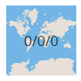
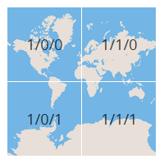
More information about web map zoom levels:
http://wiki.openstreetmap.org/wiki/Zoom_levels
https://www.mapbox.com/foundations/how-web-maps-work/
http://www.maptiler.org/google-maps-coordinates-tile-bounds-projection/

Base Map
The base map element defines the background map of the maps in the WebVisTool.
Attributes of baseMap element:
- source: for the source of the base map choose between:
  - terrain: stamen terrain map http://maps.stamen.com/#terrain
  - osm: open street map http://www.openstreetmap.org/
  - toner: stamen toner map http://maps.stamen.com/#toner
  - plain: solid background (white to black; depends on following attributes). Use this option if you use the local server (See output chapter) and there is no internet connection!
- brightness: regulate brightness of base map (from -1 to 1)
- contrast: regulate contrast of base map (from 0 to 2)
- saturation: regulate saturation of base map (from 0 to 2)

The following figure is based on this configuration for the base map:
<baseMap source="terrain" brightness="0" contrast="1" saturation="0" />
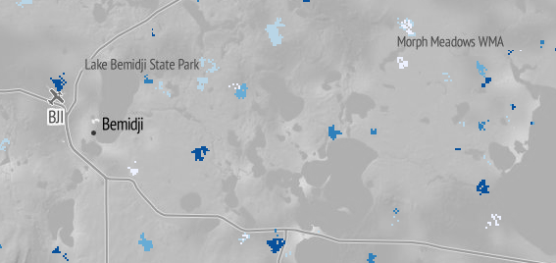

Legend
Configuration of the legend in the WebVisTool.
Attributes of legend element:
- initClassCount: the number of colors in a legend for continuous data (handles in color slider legend)
- sequentialCol: color scheme for ordinal or continuous data
- divergingCol: color scheme for diverging (minus to plus) ordinal or continuous data
- qualitativeCol: color scheme for nominal data

<legend initClassCount="3" sequentialCol="Reds" divergingCol="PiYG" qualitativeCol="Paired" />

Where can I find the color scheme definitions?
The WebVisTool uses color schemes defined by Colorbrewer:
- go to: http://colorbrewer2.org/
- Select the Nature of Data
- Pick a color scheme
- Copy and paste the name of the scheme into the project xml file (see the highlighted area in the figure; „Reds“)
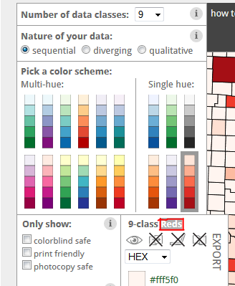

Example
<landisPreProcProject projectName="Example Project Name">
<input>
<scenarios>
<scenario inputPath="example_scenario" displayName="baseline climates" />
</scenarios>
<spatialRefernce>
<projection proj4="+proj=utm +zone=15 +ellps=GRS80 +datum=NAD83 +units=m +no_defs" />
<extent ulx="293234.718" uly="5314517.522" lrx="566034.718" lry="5104517.522" />
</spatialRefernce>
</input>
<output>
<map>
<zoom min="7" max="11" init="9" />
<baseMap source="terrain" brightness="0" contrast="1" saturation="0" />
<legend initClassCount="3" sequentialCol="Reds" divergingCol="PiYG" qualitativeCol="Paired" />
</map>
</output>
</landisPreProcProject>

Run the PreProcTool (run_preproctool.bat)
To run the PreProcTool double click the run_preproctool.bat file. This batch file starts a command window and calls the PreProcTool with the parameters -p and -o.
- parameter -p (project xml file)
  - the path to the project xml-file (relative to batch file or absolute)
  - see above to learn how to configure the project xml file
- parameter -o (output folder)
  - the path of the output folder (relative to batch file or absolute)
  - the output (= WebVisTool) generated by the PreProcTool is stored in this folder
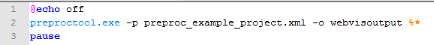
For more configurations see the examples chapter below.

Output
example_project\
|--example_scenario_1\
|--example_scenario_2\
|--webvisoutput\
|--config\
|--css\
|--img\
|--js\
|--lib\
|--index.html
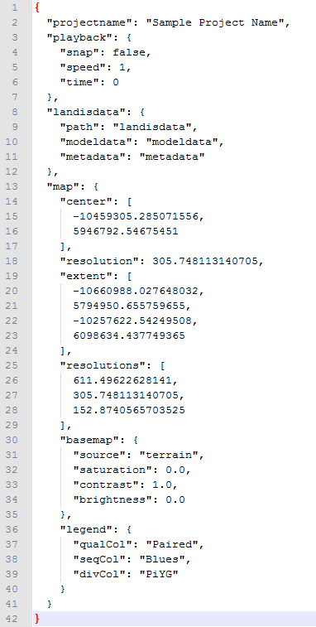
|--start-landis-vis-local.exe
|--preproc_example_project.xml
|--run_preproctool.bat
|--webvisoutput.zip

Output folder
The ouptut folder contains the web application LANDIS-II WebVisTool.
To start the application on your local Windows machine, execute the start-landis-vis-local.exe file (double-click). The WebVisTool starts up in your default web browser. If this is not Firefox or Chrome (use the current versions), open Firefox or Chrome and open http://localhost:8080/.

Change settings of the WebVisTool
A few settings that were defined in the project xml file can be changed in the default_settings.json file (webvisoutput\config\default_settings.json, see figure on the right) after running the PreProcTool.
After making changes in the default settings.json file update the file on the server as well!
You can change the values within: projectname, playback, basemap and legend.
However DON'T change: landisdata, center, resolution, extent and resolutions!

Zip file for server upload
Besides the output folder, a zip-archive is created. If you are able to unzip files on your web server (e.g. with ssh) upload the zip-archive with a FTP-Client and unzip the file (using e.g. putty).
If you can't unzip files on your server you have to upload the output folder (this can take a while: depending on the used zoom levels, the extent of the area and the number of map outputs, a big number of little map tiles are created).

Examples

Example 1
folder structure (BEFORE PreProcTool)
example_project\
|--example_scenario_1\
|--example_scenario_2\
|--preproc_example_project.xml
|--run_preproctool.bat

project xml file (scenarios)
<scenarios>
<scenario inputPath="example_scenario_1" displayName="baseline climates" />
<scenario inputPath="example_scenario_2" displayName="climate change" />
</scenarios>

batch file (command for starting the PreProcTool)
preproctool.exe -p preproc_example_project.xml -o webvisoutput

folder structure (AFTER PreProcTool)
example_project\
|--example_scenario_1\
|--example_scenario_2\
|--webvisoutput\
|--preproc_example_project.xml
|--run_preproctool.bat
|--webvisoutput.zip

Example 2
folder structure (BEFORE PreProcTool)
my_landis_project\
|--config_utils\
|--preproc_example_project.xml
|--run_preproctool.bat
|--scenarios\
|--example_scenario_1\
|--example_scenario_2\
|--example_scenario_3\

project xml file (scenarios)
<scenarios>
<scenario inputPath="..\scenarios\example_scenario_1" displayName="baseline climates" />
<scenario inputPath="..\scenarios\example_scenario_2" displayName="climate change" />
<scenario inputPath="..\scenarios\example_scenario_3" displayName="harvesting" />
</scenarios>

batch file (command for starting the PreProcTool)
preproctool.exe -p preproc_example_project.xml -o ..\output

folder structure (AFTER PreProcTool)
my_landis_project\
|--config_utils\
|--preproc_example_project.xml
|--run_preproctool.bat
|--output\
|--scenarios\
|--example_scenario_1\
|--example_scenario_2\
|--example_scenario_3\
|--output.zip

Example 3
folder structure (BEFORE PreProcTool)
C:\LandisModel\
|--project_oregon\
|--or_scenario_1\
|--or_scenario_2\

C:\LandisVis\
|--project_oregon\
|--oregon_project.xml
|--run_preproctool.bat

project xml file (scenarios)
<scenarios>
<scenario inputPath="C:\LandisModel\project_oregon\or_scenario_1" displayName="or base" />
<scenario inputPath="C:\LandisModel\project_oregon\or_scenario_2 displayName="or change" />
</scenarios>

batch file (command for starting the PreProcTool)
preproctool.exe -p oregon_project.xml -o output\webvistool

folder structure (AFTER PreProcTool)
C:\LandisModel\
|--project_oregon\
|--oregon_scenario_1\
|--oregon_scenario_2\

C:\LandisVis\
|--project_oregon\
|--oregon_project.xml
|--run_preproctool.bat
|--output\
|--webvistool\
|--webvistool.zip

LandisVis Developer Guide

Development Environment of PreProcTool
- Python 2.7 (https://www.python.org/downloads/)
- Python modules (use the mose current win32-py2.7 version):
  - lxml 3.3.5 (http://www.lfd.uci.edu/~gohlke/pythonlibs/#lxml)
  - gdal 1.11.0 (http://www.lfd.uci.edu/~gohlke/pythonlibs/#gdal)
  - PyYaml 3.11 (http://www.lfd.uci.edu/~gohlke/pythonlibs/#pyyaml)
  - Regex 2014.05.23 (http://www.lfd.uci.edu/~gohlke/pythonlibs/#regex)
  - Pillow 2.4.0 (http://www.lfd.uci.edu/~gohlke/pythonlibs/#pillow) (PIL replacement)
  - Numpy 1.8.1 (http://sourceforge.net/projects/numpy/files/NumPy/)
  - Scipy 0.14.0 (http://sourceforge.net/projects/scipy/files/scipy/)
- PyInstaller (for freezing the application to an executable):
  - PyInstaller 2.1 (http://www.pyinstaller.org/)
  - pywin32 Build 219 (http://sourceforge.net/projects/pywin32/files/)
- Local Server (for freezing the local server script (creating an exe) use also pyisntaller)
  - CehrryPy 3.2.4 (http://www.cherrypy.org/)

The LandisVisualizationDevel Folder
For development purposes download the repository from GitHub:
https://github.com/LANDIS-II-Visualization/LandisVisualizationDevel
LandisVisualizationDevel\
|--Documentation\
|--PreProcTool\
|--build\
|--source\
|--test\
|--WebVisTool\
|--build\
|--localenv\
|--source\

In your local LandisVisualizationDevel folder unzip:
- PreProcTool\build\gdal-data.zip (new folder: PreProcTool\build\gdal-data\)
- PreProcTool\build\pyinstaller.zip (new folder: PreProcTool\build\pyinstaller\)

How-To: Build the WebVisTool and PreProcTool
After you made chanes in the source of the WebVisTool and/or the PreProcTool the following building steps have to be executed:

- Run the build-landis-webbase.bat (WebVisTool\build\build-lanids-webbase.bat
- Run the build_preproctool batch-file (PreProcTool\build\build_preproctool.bat)
- In case of Errors, try:
  - delte the folders/file:
    - PreProcTool/build/build
    - PreProcTool/build/dist
    - PreProcTool/preproctool.spec
  - run build_preproctool.bat again

How-To: Create the MSI-Installer
- The Windows-Installer was created with the application Advanced Installer (http://www.advancedinstaller.com/)
- To open the existing Advanced Installer Project go to: PreProcTool/build/installer and open the "LandisPreProcTool" Advanced Installer Project file

Settings in Advanced Installer

Product Details
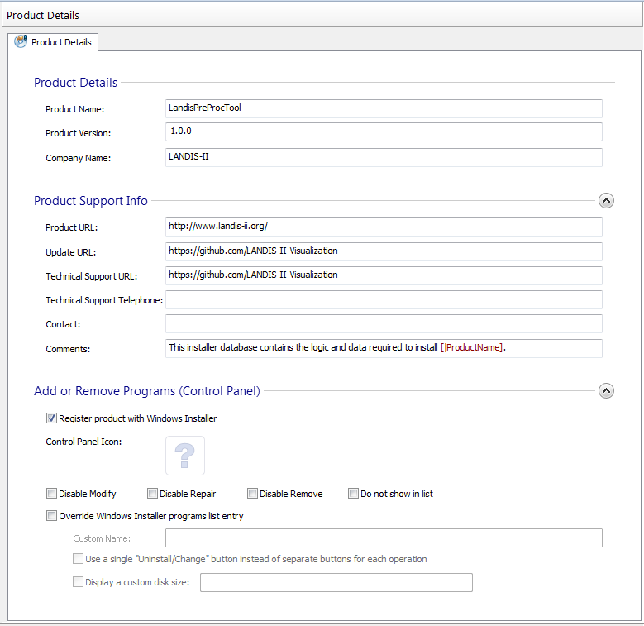

Install Parameters
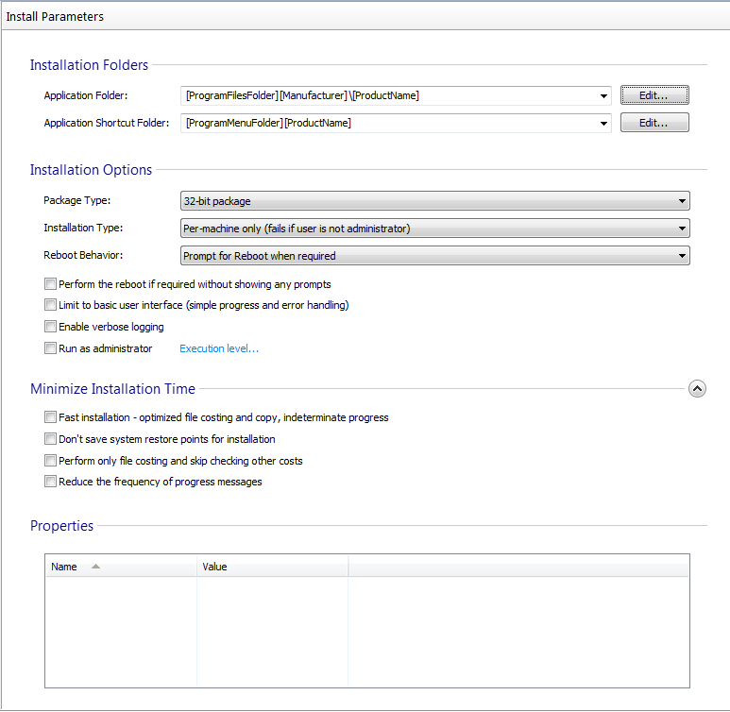

Files and Folders
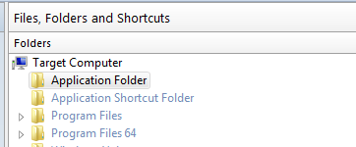
- Application Folder: right click > Add Files...
  - GoTo: LandisVisualizationDevel\PreProcTool\build\dist\PreProcTool
  - Select all Files (Crtl+A) > cklick Open
- Application Folder: right click > Add Folder ...
  - GoTo: LandisVisualizationDevel\PreProcTool\build\dist\PreProcTool
  - select folder: config > click Select Folder
- Repeat for the folders: gdal-data, include, webbase
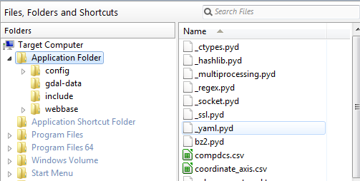

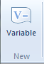
System Changes > Environment:
- add APPDIR to the PATH variable (left)
- create GDAL_DATA variable (right)
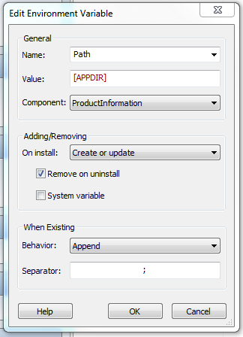
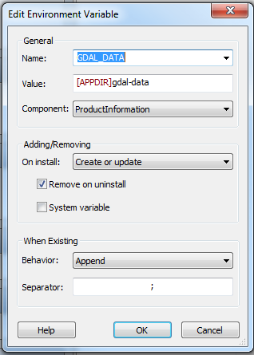
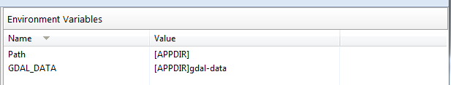

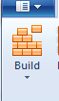
Build Installer
- Start the building process by clicking the Build-Button:

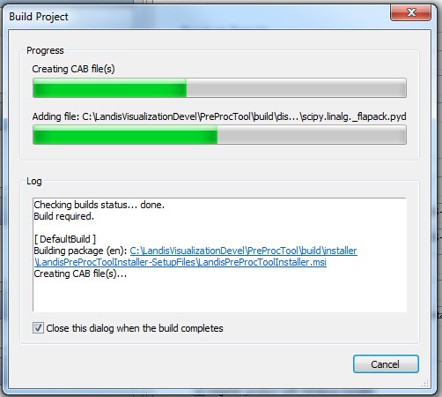

- When done, close the Application
- The Installer is now located at:
  - \LandisVisualizationDevel\PreProcTool\build\installer\LandisPreProcToolInstaller-SetupFiles\LandisPreProcToolInstaller.msi

