**Problem A Pole vaulting - a story of harmonious combination between man and pole**



Pole vault is considered one of the most difficult sports. The 6.14-meter world record set by Ukrainian pole vaulter Bubka in 1994 was once considered one of the records to break most hardly, but now the record has been repeatedly broken. On August 25th of this year, at the Silesia station of the World Association of Athletics Federations Diamond League, Swedish pole vault world record holder Duplandis broke his own 6.25-meter jump at the Paris Olympics with an astonishing 6.26-meter result and won the gold medal. In fact, Duplandis has broken his own world records multiple times.

Technically speaking, pole vaulting involves several main processes, including "Approach Run, plant, takeoff, swing, and clearance ", which are not only related to the athlete's physical features and ability, but also closely related to the pole used. Your team is requesting solutions to the following issues:

(1) Collect relevant data, including some physical parameters of athletes, as well as data on the material, mechanical characters, and performance of the poles used.

(2) Establish a mathematical model for the pole vault process and calculate the athlete's performance based on the aforementioned parameters.

(3) Study the relation between the grades and length, material of pole, etc., and also consider the effect on heights, weights, genders and speed of player.

(4) Write a short report recommending poles for players with different levels.



**Problem B If you spot a lantern fly…**

Spotted lanternflies *(Lycorma delicatula)* are insects from Asia that are quickly spreading in North America and have a growing negative effect on agricultural production. Since their arrival to the USA about ten years ago, they have now spread to at least 16 states (PA, NY, NJ, MD, MI, OH, IN, WV, VA, NC, DE, CT, RI, MA, KY, TN). These insects are particularly dangerous for grapevines, which is becoming a major concern for many vineyards and wineries present in NY State. Spotted lanternflies feast on plant’s sap and remove so much of it that the vine has far lower chances of surviving the cold temperatures. Even if a seriously affected vine survives, it is much less likely to produce any grapes next season. Quarantine measures in several states and [public eradication campaigns](https://www.nytimes.com/2023/09/02/nyregion/spotted-lanternfly-nyc.html) have not proven successful in eliminating this threat. Most scientists expect the spread to continue until the lanternflies face off with some natural predators– either those already keeping the lanternfly population limited in Asian countries1 or the native US birds and insects once they recognize the spotted lanternflies as suitable food. Either way, this process will take at least 5-10 years and for now the goal is to slow down the spread (e.g., through quarantine measures) and limit the immediate economic impact (e.g., by treating vines with insecticides).

**Your team is asked to address the following two challenge problems.**

**In addition to your detailed manuscript, please provide a one-page executive summary for the members of the** [**Integrated Pest Management Program**](https://cals.cornell.edu/new-york-state-integrated-pest-management) **. While highlighting your recommendations, please make sure to also address the limitations of your modeling approach and possible directions for future improvement.**

1 But these would have to be checked carefully before introducing them to the US to avoid harming the local/native insect species!

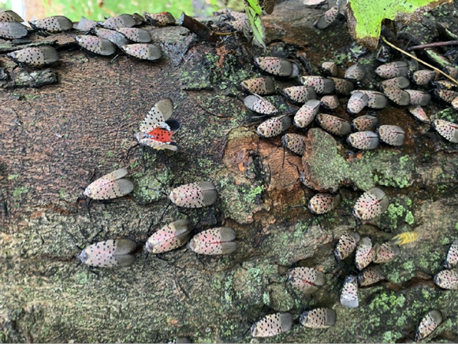

**Challenge 1: Limiting the spread in NY State**

Spotted lanternflies (SLF) hatch from eggs & start their life as nymphs in April, become adults by late July, lay their eggs in September-November, and then die in December. Each female SLF usually lays at least one “eggmass” with about 35 eggs in it.

SLF can feed on more than 100 different plants (which makes it much easier for them to spread), but their all-time favorite is the so-called [“Tree of Heaven”](https://www.thespruce.com/tree-of-heaven-invasive-plant-profile-5184401) *(Ailanthus altissima)*. If it is present in the vicinity, the lanternflies are known to lay about 7 times as many eggs as usual. Thus, removing these trees (present in Ithaca and, more broadly, in the Finger Lakes region) may be one of the most effective anti-SLF measures. But [some of the current guidelines](https://www.pubs.ext.vt.edu/ENTO/ENTO-323/ENTO-323.html) recommend using a “tree trap” approach; i.e., removing only small Trees of Heaven while treating the larger ones with a long lasting insecticide (dinotefuran) to kill the returning SLF.

SLF cannot fly too far on their own – the natural distance they can cover in one year is estimated to be between 4 and 10 miles only. But the spread becomes much faster when they lay the eggmass on shipping materials, railroad cars, or automobiles, which by April, when the eggs hatch, can be in a very different location. Thus, the quarantine measures are usually focused on finding and destroying the eggmasses before they have a chance to travel far.

**You need to model the SLF population spread in NY State and suggest the best strategy for slowing it down. Regular inspections of vehicles & railroad cars require resources (money, time, coordination with businesses and agencies, human efforts), which could be otherwise spent on other measures – e.g., on reducing the number of Trees of Heaven (TOH) or setting up “tree traps”. Suggest a strategy for balancing these efforts. Explain the predicted effect on the overall SLF population as well as the economic and environmental impact in the next five years.**

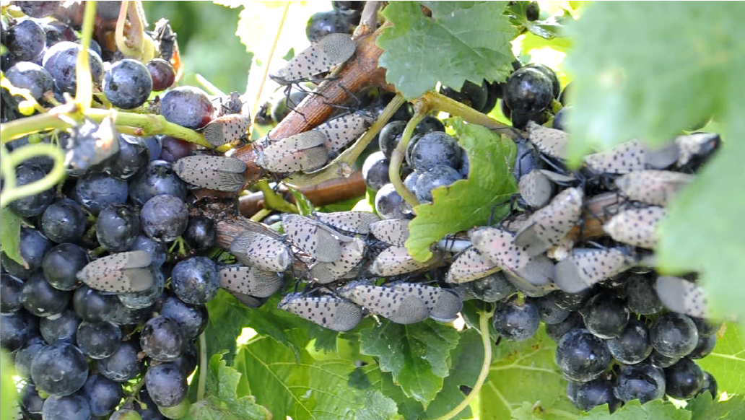

**Challenge 2: Saving the grapes and/or saving the vines?**

Protecting a vineyard from SLF is primarily accomplished through using insecticides. Usually, this is not done in advance – partly because the effect of such chemicals is only temporary and partly to avoid the unnecessary costs/work & side effects. Instead, [it is currently recommended](https://www.virginiafruit.ento.vt.edu/SLF.html) to apply the chemicals only after observing some threshold number of SLFs:

● In the Spring: at least 15-20 nymphs per vine before you spray (one application should be enough).

● In August-September, when the adult SLF are migrating and many of them move to vineyards: at least 5-10 adult SLF per vine before you spray (repeated applications might be needed).

All insecticides have different effectiveness against the SLF, but also come with [different restrictions](https://www.virginiafruit.ento.vt.edu/SLF_Insecticides.pdf): on the maximum dose that can be used per year **and** on the Pre-Harvest Intervals (PHI) – i.e., the number of days that has to pass after the last application before you are allowed to harvest the grapes.

This presents a hard dilemma when the adult lanternflies arrive close to the harvest time.

If you start using insecticides, you will likely have to harvest later than intended, which increases the potential incidence and severity of fungal diseases, resulting in reduced yield as well as reduced grape quality. On the other hand, if you decide to wait with the insecticide until after the harvest, you risk long-term damage to your vines due to SLF sap feeding.

**Suggest an optimal strategy for using insecticides throughout the season. Among other measures, this might involve changing the threshold of observed SLF (nymphs and adults) before you spray or, more generally, making that threshold depend on**

**● SLF migration patterns,**

**● the number of days remaining until the harvest,**

**● the chemicals already used up to that point, and/or**

**● the predicted weather (which influences the development of fungal diseases).**

**In addition to financial considerations, please also address a possible impact of your approach on other (beneficial) insects.**

**Problem C The Federal Reserve Raises Interest Rates**

In 2023, the Federal Reserve basically continued the aggressive interest rate hike policy of the previous year, holding a total of 8 monetary policy meetings throughout the year Among them, there were four interest rate hikes in January, March, May, and July meetings, each by 25 basis points. The US federal funds rate reached 5.25% to 5.5%, the highest level in 22 years.

The Federal Reserve's aggressive interest rate hikes continue to disrupt the world economy. First, the aggressive interest rate increase policy has led to the soaring yield of long-term U.S. treasury bond bonds, increased the cost of auto loans, credit card lending and various forms of commercial loans, raised the cost of living of U.S. residents, and severely squeezed small and medium-sized banks from the asset side and the liability side, leading to financial risks; Secondly, the aggressive interest rate hike policy has generated strong spillover effects. It has driven the strengthening of the US dollar, prompted international capital to flow massively from emerging markets to the United States in pursuit of higher returns, continuously compressed the monetary policy space of other economies, and forced many countries to make more difficult choices between cross-border capital flows, monetary policy independence, and exchange rate stability; Thirdly, aggressive interest rate hikes have increased the debt servicing costs of emerging markets and developing economies, leading to currency weakness in some economies, making their economic growth prospects even more bleak, exacerbating global financial market turbulence, and hindering the recovery process of the world economy.

At the monetary policy meeting in December 2023, the Federal Reserve announced that the target range for the federal funds rate would remain unchanged between 5.25% and 5.5%. Federal Reserve Chairman Powell said at a press conference after the meeting that the current federal funds rate "may be close to the peak of this tightening cycle," and attending Fed officials generally believe that "further interest rate hikes are unlikely to be appropriate," but they also do not want to rule out this possibility.

Analysts believe that it is not easy for the Federal Reserve to control a reasonable shift in monetary policy. On the one hand, the Federal Reserve still faces the "last mile" challenge of combating inflation; On the other hand, it is necessary to ensure the flexibility of monetary policy and avoid overcorrection. During the policy shift, it may also have an impact on the global financial market and bring more uncertainty to the world economy.

In September 2024, the Federal Reserve unexpectedly announced a rate cut, causing global capital markets to flock to the Chinese stock market. In early October, the unexpected non farm payroll data released by the United States once again left the market confused. Will the Federal Reserve raise interest rates again? Can the Chinese market continue to attract global capital? How will the future of the global market go?

Consider the background information and address the following:

(1) In history, the Federal Reserve has adopted strategies of raising or lowering interest rates at different times. Please choose appropriate indicators, collect data, establish a model to predict the Fed's strategy of raising or lowering interest rates, and discuss the effectiveness and accuracy of the model;

(2) Please establish a model to analyze the monetary policy that China will adopt when the Federal Reserve implements a rate hike or cut strategy. And what kind of impact will the policies adopted by China have on the national economy. Among them, please choose appropriate indicators to characterize the specific impact.

(3) Please establish a model to describe the impact of the Federal Reserve's interest rate hike or rate cut strategy on the world economy after a period of time (such as one year)? What strategies should major economies (such as the European Union, ASEAN, Japan, and South Korea) adopt to overcome this impact? What is the impact on the economy?

**Problem D Scheduling and Path Optimization for Autonomous Cleaning Vehicles on Campus**

As campus sizes continue to expand, the challenges of environmental sanitation management have become increasingly prominent. Traditional manual cleaning methods are not only inefficient but also susceptible to factors such as weather and personnel arrangements, making it difficult to maintain cleanliness on campus. To address this issue, many universities have started to adopt smart technologies, with autonomous cleaning vehicles emerging as a new cleaning tool that is gradually gaining attention.

These autonomous cleaning vehicles utilize advanced sensors and navigation systems to automatically identify cleaning areas, avoid obstacles, and plan their routes, thereby efficiently completing cleaning tasks. Their advantages include 24/7 operation, reduced labor costs, and improved cleaning efficiency. However, effectively scheduling multiple autonomous cleaning vehicles and reasonably planning their cleaning paths to meet the cleanliness needs of different campus areas at various times remains a pressing challenge.

In this context, establishing a mathematical model to optimize the scheduling and path planning of autonomous cleaning vehicles is particularly important. Through scientific task allocation and path optimization, it is possible to enhance the operational efficiency of the cleaning vehicles, reduce operational costs, and address challenges posed by unforeseen events. Ultimately, the goal is to achieve intelligent management of the campus environment, creating a cleaner and more comfortable learning and living space for students and faculty.

Chongqing University’s Huxi Campus plans to introduce autonomous cleaning vehicles to improve the efficiency of environmental sanitation management. A mathematical model needs to be established to optimize the scheduling and routes of these cleaning vehicles.



https://mp.weixin.qq.com/s?__biz=MzA5MTU2MTcwNw==&mid=2653094179&idx=1&sn=171c9163a8752d09b9643a364c6607ad&chksm=8a7a1059e21f1fd4b748366d16437c462757f34667cbf80f7b29567ccae08bbaf75a5c67e537&mpshare=1&scene=23&srcid=1018Cqr4OZ2Y60g57pqZIQaa&sharer_shareinfo=4e26de04df6b5d416d5b7c5a62c70ca7&sharer_shareinfo_first=4e26de04df6b5d416d5b7c5a62c70ca7#rd

(1) The campus needs to be divided into multiple cleaning areas to facilitate task allocation for autonomous cleaning vehicles.

(2) A task allocation model should be developed based on the cleaning areas to optimize the efficiency and time utilization of the cleaning vehicles.

(3) An algorithm must be designed to plan efficient routes for the autonomous cleaning vehicles to cover all designated cleaning areas.

(4) A dynamic scheduling algorithm should be designed to address the impact of unforeseen events (such as activities and weather changes) on cleaning tasks within the campus.

(5) A mathematical model needs to be established to evaluate the operational costs and cleaning effectiveness of autonomous cleaning vehicles to determine their overall benefits in campus management.

**Problem E Optimal urban population size and employment structure**

With the continuous advancement of urbanization, the urban population size is getting larger and larger, and the survival and development of the urban population are facing many challenges, including survival needs, housing needs, education needs, medical needs, employment needs, public service needs, entertainment needs, etc.

In order to meet the various needs of the urban population, a large amount of resources need to be invested, especially a large amount of human resources are needed, so that the development of the urban population also provides more diversified employment opportunities for the society, forming the employment structure of the population in various industries.

Assuming that the urban population are all active and hardworking workers, with professional knowledge and skills in the required industries, they are efficient production labor after their survival and development needs are met.

In order to determine the relationship between urban population size and employment structure, please establish mathematical models and answer the following questions:

(1) Establish a mathematical model to describe the relationship between urban population size and population demand, and determine the quantitative relationship between urban population size and various demands;

(2) Establish a mathematical model to describe the relationship between the number of practitioners and the number of products and services they provide, and determine the mathematical model of the number of employed people in each industry;

(3) Based on the urban population quantity model and population employment model established in (1) and (2), describe the distribution pattern of urban population among various industries;

(4) Based on the model established in (3), find the optimal urban size;

(5) Based on the model established in (4), find the optimal population employment structure.