**InfraTaup 1.0 Users Guide**

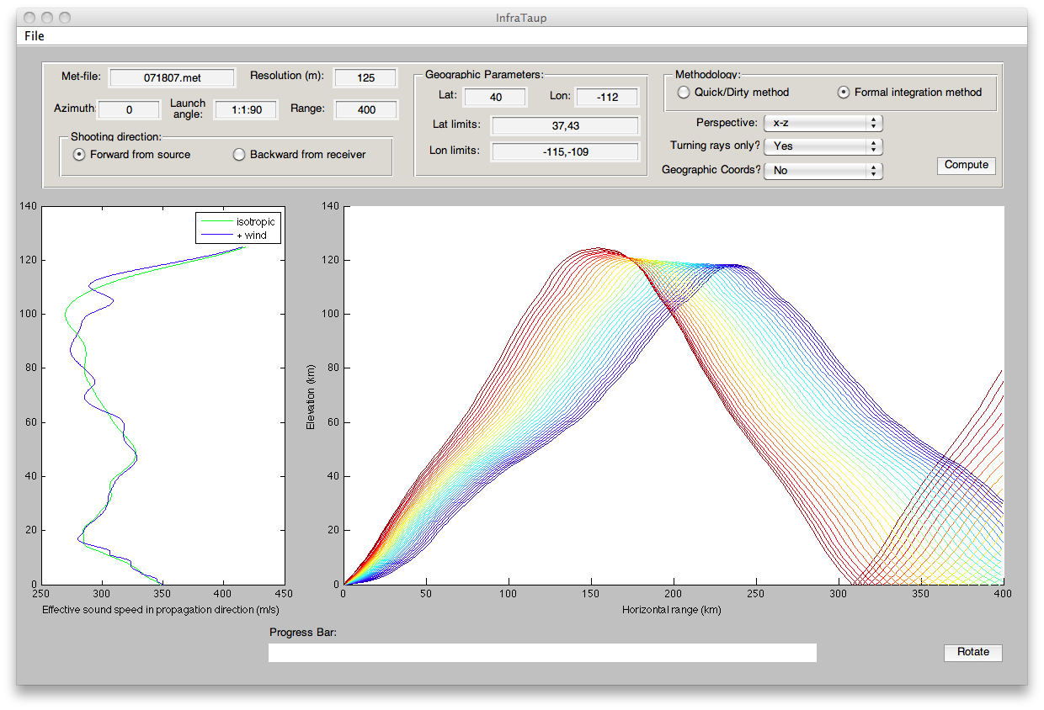

Stephen J. Arrowsmith

**Executive Summary**

InfraTaup is a Matlab implementation of the Tau-P method as outlined by *Drob et al.* [2010]. This code is available subject to the understanding that the user will not distribute it without prior authorization. Please contact Stephen Arrowsmith ([arrows@lanl.gov](mailto:arrows@lanl.gov)) with any questions or comments.

**1.0 Installation**

InfraTaup requires InfraMonitor 2.7+ to be installed and in the users Matlab path.

To install InfraTaup, first unpack the tar file in a suitable directory (this directory will be referred to here as <InfraROOT>):  
tar xvf InfraTaup1.0.tar

Next, add the InfraTaup1.0 directory to your Matlab path (adding this to your startup.m file will automatically add InfraTaup1.0 to your path each time you open a new Matlab session):

addpath(‘<InfraROOT>/InfraTaup1.0’)

Place the example met-file, 071807.met, in the working directory (this need not necessarily be in the InfraTaup1.0 directory).

**2.0 Running InfraTaup**

Type InfraTaup in a Matlab window to launch the graphical user interface. If necessary, change the working directory to where a met-file resides (or copy the met-file into your working directory).

**2.1 Met-file**

The met (meteorology) file is an ASCII file containing four columns with the following format:

Elevation (km), Temperature (K), Zonal wind (m/s), Meridional wind (m/s)

Met-files can be easily extracted from G2S models or from radiosonde data.

**2.2 Basic Parameters**

For any run, the following basic parameters should be set:

Met-file, Resolution, Azimuth, Launch angle, Range

1. Met-file: This should be set to the name of an appropriate ASCII file in the current (working) directory.
2. Resolution: Ensure that the resolution corresponds to the vertical sampling in your met-file (but note that it should be entered in meters).
3. Azimuth: The azimuth in degrees clockwise from North. For shooting rays at multiple azimuths, enter the minimum azimuth, increment, and maximum azimuth (e.g., 0:1:359 will shoot rays from 1° to 359° in increments of 1°).
4. Launch angle: The launch angle in degrees from the horizontal. For shooting rays at multiple launch angles, enter the minimum launch angle, increment, and maximum launch angle (e.g., 1:1:89 will shoot rays from 1° to 89° in increments of 1°).
5. Range: The maximum range in kilometers for which to compute the ray path.

**2.3 Shooting Direction**

Choose ‘Forward from source’ or ‘Backward from receiver’. For the latter option, the meteorological profiles will be reversed such that shooting backward from the receiver at a particular azimuth will simulate a ray arriving at the receiver from that direction.

**2.4 Methodology**

The final solution should always be run using the ‘Formal integration method’ which uses the approach outlined by Drob et al. (2010). The ‘Quick/Dirty method’ is not recommended for anything other than a quick survey of a large simultation before running the more computationally expensive ‘Formal integration method’.

**2.5 Perspective**

Set the perspective to x-z or x-y before clicking on the Compute button to define what perspective the ray solutions are plotted from. Note that the perspective can be modified by clicking on the Rotate button after the full solution has been obtained. Clicking Rotate will bring up the Matlab rotate tool, enabling the user to rotate the axes by clicking and dragging on the ray figure. Clicking Rotate a second time will deactivate the rotate tool.

**2.6 Turning Rays Pop-up Menu**

Select ‘Yes’ to compute and plot only rays that turn and are refracted back to the surface. Select ‘No’ to compute and plot all rays, including those that do not refract back to the surface, noting that this option is slower and may overcomplicate the plot in some cases.

**2.7 Geographic Coordinates Pop-up Menu**

The default coordinate system is (range, transverse offset). Selecting ‘Yes’ in the Geographic Coordinates pop-up menu will instruct InfraTaup to convert all coordinates to a geographic coordinate system (longitude, latitude). InfraTaup will then use the parameters specified in the ‘Geographic Parameters’ box (Lat and Lon correspond to an event location – or receiver location for shooting rays backwards) This option is recommended when computing multiple azimuths because otherwise all solutions will be projected onto the same azimuth. Selecting this option also instructs InfraTaup to generate a map of predicted bounce points, color coded by group velocity, for the region specified by Lat limits and Lon limits.

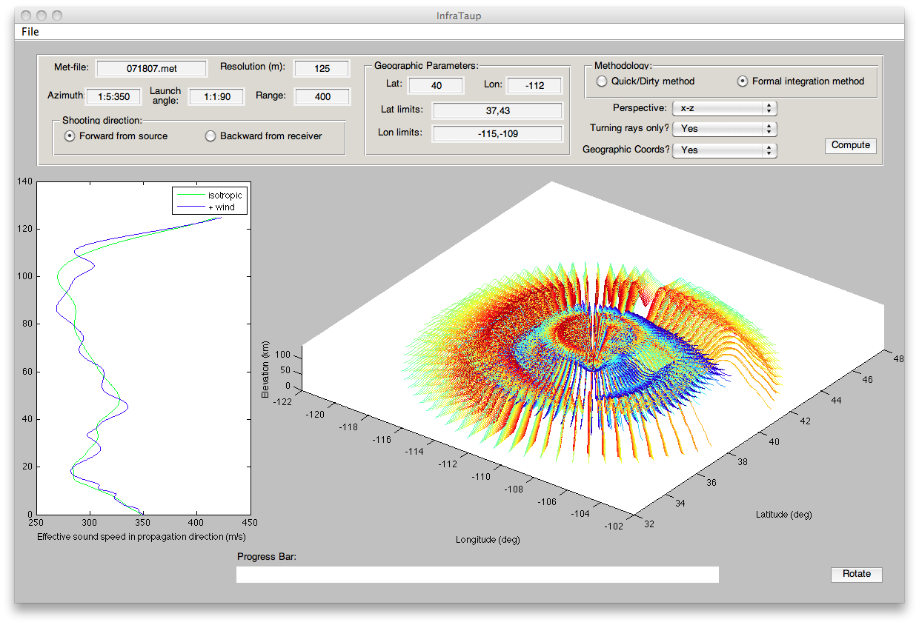

**Figure showing an InfraTaup simulation in geographic coordinates**

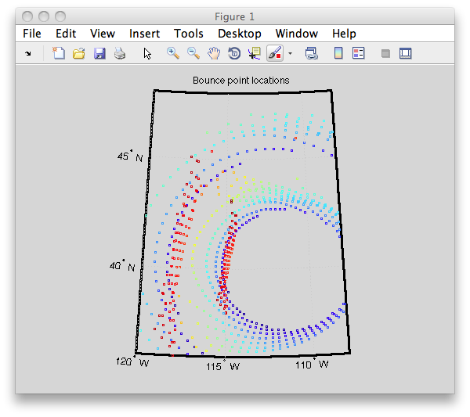

**Figure showing the bounce-points (color-coded by group velocity) from an InfraTaup simulation in geographic coordinates**

**3.0 Output Data Structure**

InfraTaup creates a global Matlab structure array called ray. Each element in the structure array corresponds to a different ray. To view this structure array (only after performing a computation), type:

global ray

in the Matlab command window.

This will make available to the user all the ray parameters calculated by InfraTaup. These include:

* ray.phi: The launch azimuth in degrees for the ray.
* ray.theta: The launch angle in degrees for the ray.
* ray.x: A vector containing either (i) the range in km at discrete points along the ray, or (ii) the longitude at discrete points along the ray (depending on whether Geographic Coordinates is selected as No (i) or Yes (ii)).
* ray.y: A vector containing either (i) the transverse offset in km at discrete points along the ray, or (ii) the latitude at discrete points along the ray (depending on whether Geographic Coordinates is selected as No (i) or Yes (ii)).
* ray.z: A vector containing the elevation in km at discrete points along the ray.
* ray.v_g: The group velocity of the ray.
* ray.bp: Bounce points for the ray (only gets computed for a geographic coordinate system).

**4.0 Equivalent Command Line Functions**

Ray computations can also be run from the Matlab command line. This option enables the user to call InfraTaup functions from their own Matlab scripts.

To shoot a ray, use the taup function:

**taup(metfile,dz,h,phi,theta,max_range,plotflag,I,reverse,fullray,turningRays)**

Where the input parameters are:

* metfile: An ASCII file containing a vertical profile of winds and temperatures [format: elevation (km), temperature (K), zonal wind (m/s), meridional wind (m/s)]%
* dz: Vertical sampling distance for meteorological profiles (m)
* h: Ground elevation (km)
* phi: Launch azimuth (degrees)
* theta: Launch angle from horizontal (degrees)
* max_range: Maximum straight line distance from source (km)
* plotflag: 1 for plotting meteorological data, 0 otherwise
* I: Ray number (set I=1 if processing a single ray)
* reverse: Forward propagation from source (=0) or reverse propagation from receiver (=1)
* fullray: Flag to indicate whether or not to compute the full ray coordinates (0) or just the bounce-points (1)
* turningRays: Flag to indicate whether to compute only turning rays (=1) or all rays, including those that do not turn (=2)

To convert a ray to geographic coordinates:

**BouncePoints(ray(i))**

Where i is the index of the ray that you wish to transform. To transform all rays, simply call BouncePoints in a for-loop.

**References**

Drob, D. P., M. Garces, M. A. H. Hedlin, and N. Brachet (2010), The Temporal Morphology of Infrasound Propagation, *Pure appl. geophys.*, doi:10.1007/s00024-010-0080-6