Table 1. Language-specific descriptive statistics
Variable | N | M (SD) | Median | Range | Distribution
Active language use | 439 | 2.29 (0.87) | 3.00 | 0.00–3.00 | 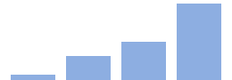
Interlocutor matching (%) | 439 | 74.65 (35.17) | 95.00 | 0.00–100.00 | 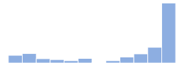
Child age (years) | 441 | 5.75 (1.69) | 6.00 | 1.00–10.00 | 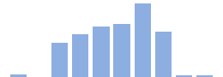
Regional speaker rate | 417 | 0.63 (0.34) | 0.73 | 0.00–1.00 | 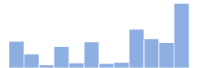
Book resources | 429 | 5.47 (2.03) | 7.00 | 1.00–7.00 | 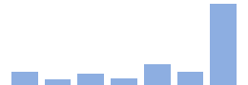
Overall language exposure | 439 | 44.87 (26.39) | 40.00 | 0.00–100.00 | 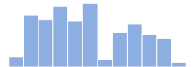
Book reading | 435 | 4.97 (2.18) | 6.00 | 1.00–7.00 | 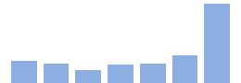
Number of language sources | 441 | 1.15 (0.72) | 1.00 | 0.00–2.00 | 

Table S1. Community language descriptive statistics
Variable | N | M (SD) | Median | Range | Distribution
Active language use | 359 | 2.38 (0.83) | 3.00 | 0.00–3.00 | 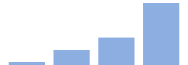
Interlocutor matching (%) | 359 | 77.89 (33.15) | 99.00 | 0.00–100.00 | 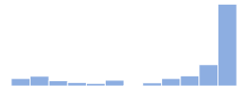
Child age (years) | 361 | 5.73 (1.67) | 6.00 | 1.00–10.00 | 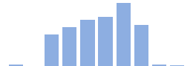
Regional speaker rate | 350 | 0.75 (0.25) | 0.84 | 0.18–1.00 | 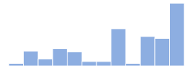
Book resources | 355 | 6.03 (1.53) | 7.00 | 1.00–7.00 | 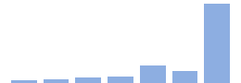
Overall language exposure | 359 | 48.89 (26.21) | 50.00 | 0.00–100.00 | 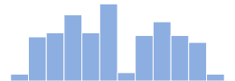
Book reading | 356 | 5.31 (2.01) | 6.00 | 1.00–7.00 | 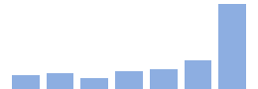
Number of language sources | 361 | 1.17 (0.72) | 1.00 | 0.00–2.00 | 

Table S2. Heritage language descriptive statistics
Variable | N | M (SD) | Median | Range | Distribution
Active language use | 80 | 1.88 (0.95) | 2.00 | 0.00–3.00 | 
Interlocutor matching (%) | 80 | 60.14 (40.20) | 80.00 | 0.00–100.00 | 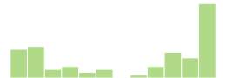
Child age (years) | 80 | 5.83 (1.79) | 6.00 | 1.00–10.00 | 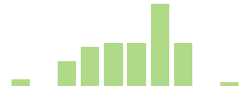
Regional speaker rate | 67 | 0.06 (0.14) | 0.02 | 0.00–0.91 | 
Book resources | 74 | 2.80 (2.01) | 2.00 | 1.00–7.00 | 
Overall language exposure | 80 | 26.84 (18.60) | 25.00 | 0.00–90.00 | 
Book reading | 79 | 3.46 (2.31) | 3.00 | 1.00–7.00 | 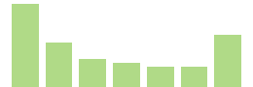
Number of language sources | 80 | 1.06 (0.70) | 1.00 | 0.00–2.00 | 

Table 2. Language-agnostic predictor descriptive statistics
Variable | N | M (SD) | Median | Range | Distribution
Child age (years) | 198 | 5.76 (1.67) | 6.00 | 1.00–10.00 | 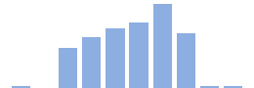
Multilingualism rate | 192 | 0.55 (0.20) | 0.52 | 0.17–0.79 | 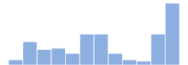
Beliefs: Future opportunities | 197 | 6.50 (0.92) | 7.00 | 3.00–7.00 | 
Beliefs: Belonging | 197 | 5.44 (1.59) | 6.00 | 1.00–7.00 | 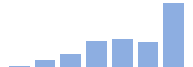
Beliefs: Cognitive benefits | 197 | 6.28 (1.07) | 7.00 | 1.00–7.00 | 
Concern: Language mastery | 197 | 3.95 (2.01) | 4.00 | 1.00–7.00 | 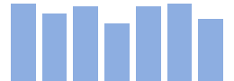
Concern: Cognitive difficulties | 197 | 2.31 (1.71) | 2.00 | 1.00–7.00 | 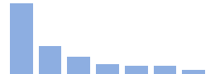
Concern: School difficulties | 197 | 2.43 (1.80) | 2.00 | 1.00–7.00 | 

