Bank System - Control Flow Graphs & Coverage

1. Create Account
This section covers the CFG and Coverage for the createAccount method in the Service layer.

Control Flow Graph
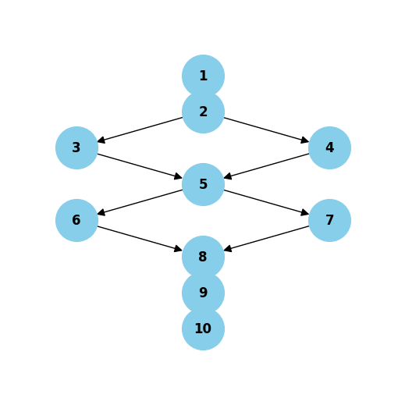

Node Descriptions
1: Entry createAccount(request)
2: Condition: request.soldeInitial() != null
3: soldeInitial = request.soldeInitial()
4: soldeInitial = BigDecimal.ZERO
5: Condition: request.currency() != null
6: currency = request.currency()
7: currency = 'XAF'
8: Create new Account object
9: accountRepo.save(account)
10: Return account

Coverage Table
Path | Edges Traversed | Condition 1 (Solde) | Condition 2 (Currency)
Path 1 | 1->2->3->5->6->8->9->10 | True | True
Path 2 | 1->2->3->5->7->8->9->10 | True | False
Path 3 | 1->2->4->5->6->8->9->10 | False | True
Path 4 | 1->2->4->5->7->8->9->10 | False | False
Cyclomatic Complexity: 3

2. Retrieve All Accounts
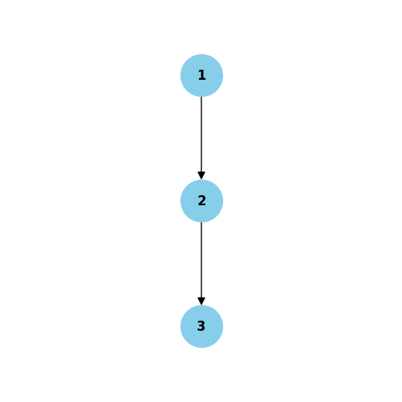
1: Entry getAllAccounts()
2: accountRepo.findAll()
3: Return List<Account>

Coverage Table
Path | Edges Traversed
Path 1 | 1->2->3
Cyclomatic Complexity: 1

3. Retrieve Account by ID
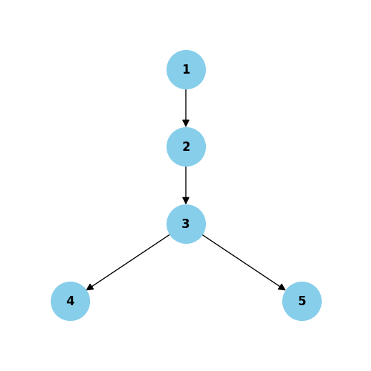
1: Entry getAccountById(id)
2: accountRepo.findById(id)
3: Condition: Account found?
4: Return account (True)
5: Throw NotfoundException (False)

Coverage Table
Path | Edges Traversed | Account Found?
Path 1 | 1->2->3->4 | True
Path 2 | 1->2->3->5 | False
Cyclomatic Complexity: 2

4. Update Account
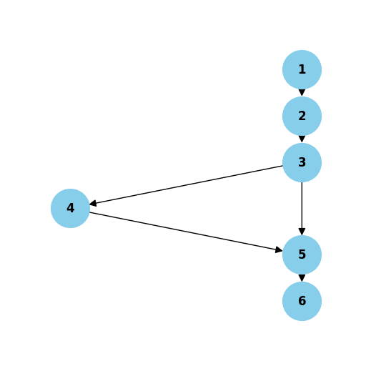
1: Entry updateAccount(id, request)
2: account = getAccountById(id)
3: Condition: name != null && not empty
4: account.setName(request.name())
5: accountRepo.save(account)
6: Return account

Coverage Table
Path | Edges Traversed | Name Provided?
Path 1 | 1->2->3->4->5->6 | True
Path 2 | 1->2->3->5->6 | False
Cyclomatic Complexity: 2

5. Delete Account
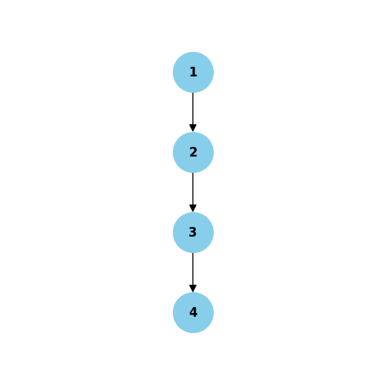
1: Entry deleteAccount(id)
2: account = getAccountById(id)
3: accountRepo.delete(account)
4: Return void

Coverage Table
Path | Edges Traversed
Path 1 | 1->2->3->4
Cyclomatic Complexity: 1

