Title of Contribution for 22nd ISGdR (do not exceed 100 characters including spaces)
Firstname Firstsurname¹, Secondname Secondsurname², Thirdname Thirdsurname³
(if possible, no more than 6 authors)

Abstract
This is an example text template for the full paper submission to the 21st International Symposium on Geo-disaster Reduction. The Abstract should be concise and self-contained, clearly stating main conclusions of the paper. The length should be of minimum 100 words, and within 300 words. The style to be used, according to the Template Style List, is the Normal Style with justification. At the end of the abstract text, a list of keywords (minimum: 3 maximum: 7) should be added as shown in this template. The paper size should be set to A4 size (210 mm × 297 mm). The paper length should be within 6 pages for a regular full paper, including references, tables / charts and keywords.
Keywords
keyword1, keyword2, keyword3…

General body of the manuscript
The first paragraph of each Section should not have left indentation whilst following paragraphs should, as in the following.
Left indentation is of 5 mm (as per Template Style Normal). The Normal style of text is based on the Constantia font, available within Microsoft Word software in all recent releases, size 10. Line spacing is single. The page format must be strictly respected as per Template Page Format. In particular, two columns formatting with column width of 77 mm and column spacing of 6 mm should be used. Page margins are: Top 40 mm; bottom 40 mm; Internal side 25 mm; External side 25 mm.

Sections of the manuscript

Section and sub-sections
Each manuscript section should use up to 3 levels of indentation: style Heading 1 for the main title of the section, style Heading 2 for a possible sub-section and, if needed, style Heading 3 for a further sub-level. We recommend not use more than 3 levels on titles and sub-sections. The example up here shows the use of two levels of titles for section and sub-section heading.
The font to be used for all Headings is Times New Roman. Heading 1 has font size 11, typeface bold and color blue with RGB = (0,102,153). Heading 2 has font size 10, typeface bold, black color. Finally, Heading 3 has font size 10, typeface bold + italic, black color. However, please choose the correct style in the Style List of the Template file so that formatting is automatically applied to avoid mistakes.

Maths and formulas
All mathematical notations should be kept outside normal text paragraphs with the exception of single (or very simple combination of) symbols. An example of use of in-text symbols is this: β is defined as the slope angle in degrees. More complex expressions should be placed and inserted in the manuscript as equation objects using the proper Microsoft Word commands (such as e.g. “insert -> object -> Mathtype”). Please avoid copy-pasting of equations as images. If equation numbering is necessary, please use a right-sided numbering between parentheses as in the following example.

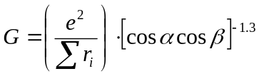 (1)
All the units of measurement used in the paper should be in the SI system and every time a new symbol, group of symbols or specific operator is introduced, it should be explained and described along with its unit of measurement if appropriate.

Figures and figure captions
Figures are allowed either in greyscale or in color. It is possible to insert column-wide figures (half-page width) with maximum width of 77 mm and double-column-wide figures as well with a max allowed dimension of 160 mm. In any case, the max height is 230 mm. Figure should be directly attached within the document at the right place using preferentially the “insert -> image -> from file” option of Microsoft Word using a recommended resolution of 400 dpi for greyscale images and of 300 dpi for color images. The following is an example of column-wide figure.
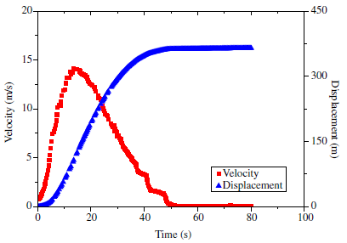
Fig. 1 Example of half page figure. Captions which are 2 or more rows long must be justified. Shorter caption must be column-centered. Please place caption below figure. Figures should be cited in text using the short: “Fig.”.

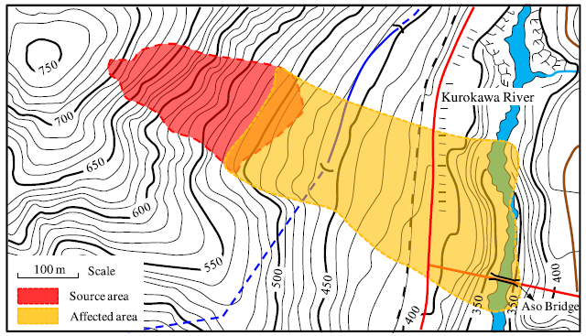

Fig. 2 Example of a two-column figure. In case the caption of the figure is only one row, it must be centered.

It is possible to add page-wide sections to insert large figures. The maximum allowed width is 170 mm. Also remind that max allowed height for both figures and tables is limited to 230 mm. Please remember that is this case you need to insert two section breaks (continuous): one just before the figure which starts single-column style, and the other one just after the figure caption, which tells the system to stop single column formatting and go back to double-column.
Please position your large figures in the best way, as to avoid large empty spaces on page. In case this is not possible, add empty rows typing carriage-return characters until the visual appearance of the page is maintained, as in the above example.

Tables
In all the manuscript, table has to be formatted according to the following example. It is possible to insert a single- or a double-column table (if needed) provided that the author insert the proper section breaks to ensure column formatting separation between sections. Table format has to be copy-pasted from the example below.

Table 1 Example of table. Formatting and fonts are as per template (Times New Roman 10pt). Please ensure left justification for alphanumeric text and right justification for numbers. Use same number of decimals with floating point numbers.
Col Head 1 | Col Head 2 | Col Head 3 | Col Head 4
Text | 34.4 | 34.4 | 34.4
Text | 16.4 | 16.4 | 16.4
Text | 33.2 | 33.2 | 33.2

Title, authors, affiliations and other issues

Title and authors
The paper should start with the title section which has a special single-column formatting (see top of first page). Please make sure to maintain section separation to ensure proper column formatting of the document. In case you inadvertently delete the section break, insert a new one on top of the beginning of manuscript main body using Microsoft Word option “insert -> break -> section break -> continuous”.
Author’s names should precede paper title as in the example above. Please use the following formatting: font Times New Roman, font size 10, typeface bold, color black, vertical spacing after 3 pts. Each author has to be followed by a superscript number in parentheses corresponding to the author’s affiliation (see also below).
Each author should also define a short or “running” title to be used in the right page heading (see example above in the page heading where the Template has the sentence “Author F, Author S, Author T – Running title of contribution”). The running title should be limited to a maximum of 20 characters, blank spaces included. The page headings have a specific style “Page heading” to be used.

Acknowledgments
In the Acknowledgments section, appearing just before the References, the authors may credit others for their guidance or help. Also, funding sources may be stated. Following this section, the References section begins for which authors must use the style: Font Times New Roman, font size 10, and use reference citation rules as per the journal Geoenvironmental Disasters (Website of journal: http://geoenvironmental-disasters.springeropen.com/). Please follow the rules of the same journal also for citations within the text body.
In the following section we present some examples of formatting for references related to edited books, conference proceedings, periodic journal papers and web sites. References must be, firstly, in alphabetical order and then in date order, descending.
For any other formatting issue please refer to the editorial guidelines and style used by the journal “Geoenvironmental Disasters”, edited by Springer.

References (in the alphabetical order)
Aaron M (1999) The future of genomics. In: Williams H (ed) Proceedings of the Genomic Researchers, Boston, 1999.
Adorno TW (1966) Negative Dialektik. Suhrkamp, Frankfurt. English edition: Adorno TW (1973) Negative Dialectics (trans: Ashton EB). Routledge, London.
Brown B, Aaron M (2001) The politics of nature. In: Smith J (ed) The rise of modern genomics, 3rd edn. Wiley, New York.
Cascini, L, Cuomo S, Pastor M, Sorbino G, Piciullo L (2014) SPH run-out modelling of channelised landslides of the flow type. Geomorphology 214: 502–513.
Chung ST, Morris RL (1978) Isolation and characterization of plasmid deoxyribonucleic acid from Streptomyces fradiae. In: Abstracts of the 3rd International Symposium on the Genetics of Industrial Microorganisms, University of Wisconsin, Madison, 4-9 June 1978.
Chung S-T, Morris RL (1978) Isolation and characterization of plasmid deoxyribonucleic acid from Streptomyces fradiae. Paper presented at the 3rd International Symposium on the Genetics of Industrial Microorganisms, University of Wisconsin, Madison, 4-9 June 1978.
Doe J (1999) Title of subordinate document. In: The dictionary of substances and their effects. Royal Society of Chemistry. Available via DIALOG. http://www.rsc.org/dose/title of subordinate document. Accessed 15 Jan 1999.
Doe J (2000) Title of supplementary material. http://www.privatehomepage.com. Accessed 22 Feb 2000.
Healthwise Knowledgebase (1998) US Pharmacopeia, Rockville. http://www.healthwise.org. Accessed 21 Sept 1998.
Mod Genomics J (1998) Rodent genes. Mod Genomics J 14(6):126-233.
Norman LO (1998) Lightning rods. US Patent 4,379,752, 9 Sept 1998.
Saito Y, Hyuga H (2007) Rate equation approaches to amplification of enantiomeric excess and chiral symmetry breaking. Topics in Current Chemistry. doi:10.1007/128_2006_108.
Schmidt H (1989) Testing results. In: Hutzinger O (ed) Handbook of Environmental Chemistry, Vol 2E. Springer, Heidelberg, p 111.
Slifka MK, Whitton JL (2000) Clinical implications of dysregulated cytokine production. J Mol Med 78:74-80. doi:10.1007/s001090000086.
Slifka MK, Whitton JL (2000) Clinical implications of dysregulated cytokine production. J Mol Med. doi:10.1007/s001090000086.
Slifka MK, Whitton JL (2000) Clinical implications of dysregulated cytokine production. Dig J Mol Med. doi:10.1007/s801090000086.
Smith J (ed) (1998) Rodent genes. Mod Genomics J 14(6):126-233.
Smith J, Brown B (eds) (2001) The demise of modern genomics. Blackwell, London.
Smith SE (1976) Neuromuscular blocking drugs in man. In: Zaimis E (ed) Neuromuscular junction. Handbook of experimental pharmacology, vol 42. Springer, Heidelberg, pp 593-660.
South J, Blass B (2001) The Future of Modern Genomics. Blackwell, London.
Trent JW (1975) Experimental Acute Renal Failure. Dissertation, University of California.
Zowghi D (1996) A framework for reasoning about requirements in evolution. In: Foo N, Goebel R (eds) PRICAI'96: Topics in Artificial Intelligence. 4th Pacific Rim Conference on Artificial Intelligence, Cairns, August 1996. Lecture Notes in Computer Science (Lecture notes in artificial intelligence), Vol 1114. Springer, Heidelberg, p 157.

Firstname Firstsurname ()
¹ Department of Geoscience, Kanazawa University, Kanazawa, Ishikawa 111-1111, Japan
E-mail: first@se.kanazawa-u.ac.jp

Secondname Secondsurname
2 Department of Geotechnical Engineering, College of Civil Engineering, Tongji University, Shanghai 200092, China
E-mail: second@tongji.edu,cn

Thirdname Thirdsurname
3 Department of Geotechnical Engineering, College of Civil Engineering, Tongji University, Shanghai 200092, China
E-mail: second@tongji.edu,cn

