Constraint & Mission Analysis

Night Ravens

Executive Summary
Given parameters from the RFP, the flight performance and mission were calculated to determine engine requirements. This resulted in a design point with a thrust loading of 0.4 at a wing loading of 60 lbf/ft². This point resulted in a service ceiling of 43369 ft, an absolute ceiling of 45137 ft and a max acceleration of 768 ft/min. The requirements for each phase were calculated and resulted in a W_{TO} guess of just under 16000 lb, a takeoff thrust of 5610 lbf, maneuvering thrust of 4661 lbf, and cruise thrust of 1260 lbf. Flight envelope was also evaluated to determine max speed of Mach 0.85 below 2000 ft. The engine diameter restriction of 25 in is a concern when compared to refence aircraft and requested performance.

Attribution & Declaration
The undersigned declare:
- That all work is presented herein is their own unless otherwise stated.
- To have abided by the university honor code and academic integrity policy.
- To have read and upheld the NSPE Code of Ethics for Engineers in the production of this work.
- That they have reviewed the entirety of the contents presented herein and take full responsibility for all results and data presented.
- That all team members agree with the areas of responsibility assigned below.
Engineer | Area of Responsibility | Signature
John Clardy | Gathering Information | John Clardy
Lauren Martins | Compilation & Editing | Lauren Martins

Introduction

The RFP requests a subsonic jet trainer for both the civilian and defense industries. It is requested that the aircraft be competitive against modern jet trainers like the Boeing-Saab T-7 Redhawk, AIDC T-5 Brave Eagle, and the Aero L-39 Skyfox, with various parameters given. The jet is required to have civil certification under the Federal Aviation Administration (FAA) and the European Union Aviation Safety Agency (EASA).

Table 1: RFP Requirements
Take-Off Runway Length | Density Altitude | Take-Off Configuration, C_{L, max} | Landing Configuration, C_{L, max} | Crew Weight | Payload Weight
≤ 2500 ft | 3000 ft | 1.6 | 2.3 | 200 kg | 300 kg
Cruising Time | Fuel Reserve Time | Service Ceiling | Cruising Time | Front-Face Diameter | Engine Length
90 mins | 45 mins | ≥ 42000 ft | 90 mins | 25 in | 3.4 m

Core Flow Bleed (Customer) | Core Flow Bleed (Turbine Sealing/Packing) | Core Flow Bleed (Turbine Cooling) | Shaft Power  (all Conditions) | Turbine Entry Temperature (TET)
1% | 5% | 15% | 100 kW | < 1850 K

Maneuver | Mach | Altitude
3x360° 3g turns | 0.5 | ≥ 10000 ft

The front face diameter of this RFP seems small for the requested performance. Compared to the reference aircraft, the AIDC T-5 has two Honeywell/ITEC F124 engines [2] with a diameter of 24 in [4]; the Boeing-Saab T-7 has one GE F404 [3] with a diameter of 28 in [6]; and the Aero L-39 has one FJ44-4M [1] with a diameter of 25.3 in [7]. The RFP requests performance comparable to the AIDC T-5 and surpassing the Aero L-39, despite a smaller engine, which may be infeasible. Requesting multiple engines at or below the 25 in diameter, and or one engine up to 30 in diameter
Requirements Specification
The RFP translates into the following flight performance parameters:

Table 2: Maneuver Flight Performance
Flight Conditions |  |  | Flight Phase Assumptions |  | Performance Required
Patm [kPa] | Tatm [K] | Minf | Thrust Lapse (α) | Weight Factor (β) | Load factor (n) | Vertical Speed [m/s] | Accel [m/s²]
69.7 | 268.38 | 0.5 | 0.816017839 | 0.75 | 3 | 0 | 0

Table 3: Cruise Flight Performance
Flight Conditions |  |  | Flight Phase Assumptions |  | Performance Required
Patm [kPa] | Tatm [K] | Minf | Thrust Lapse (α) | Weight Factor (β) | Load factor (n) | Vertical Speed [m/s] | Accel [m/s²]
20.72 | 216.7 | 0.65 | 0.271624263 | 0.85 | 1 | 0 | 0

Table 4: Service Ceiling Flight Performance
Flight Conditions |  |  | Flight Phase Assumptions |  | Performance Required
Patm [kPa] | Tatm [K] | Minf | Thrust Lapse (α) | Weight Factor (β) | Load factor (n) | Vertical Speed [m/s] | Accel [m/s²]
16.03 | 216.70 | 0.75 | 0.229791421 | 0.85 | 1 | 0.508 | 0

Table 5: Takeoff and Landing Flight Performance
Landing | Vs0 [knots] | 100
 | Landing config. Clmax | 2.3
 | Landing Density Ratio (ρ/ρref) | 1
 | Landing Weight Fraction | 0.9
Take off | Takeoff config. Clmax | 1.6
 | Takeoff Density Ratio (ρ/ρref) | 0.91522
 | Take-off Weight Fraction | 1
 | VR/Vs | 1.2
 | Take-off Thrust Lapse Rate | 1
 | Rotation time [s] | 3
 | Total ground run: SG + SR [ft] | 2500

Table 6: Mattingly Empirical Airframe Drag
Airframe
K1 | K2 | C_{D0} | C_{DR}
0.18 | 0 | 0.014 | 0
Methodology

All analysis was carried out in Excel. Goal seek was an essential tool in finding flight performance solutions such as service and absolute ceiling. Standard ISA tables were used.
The flight performance sheets are based on the Master Performance Equation (MPE) from [5]:
Thrust lapse ($α$) was determined using Mattingly guesses where:
$$α=\frac{P_{t}}{P_{ref}}$$
And $(β$) is guessed using typical values.
Using inputs from Requirements Specification the constraints are plotted as Thrust Loading vs. Wing Loading. Combining various flight performance requirements creates a design point for the aircraft. After determining the design point, the ceilings could be determined using goal seek to solve the MPE for altitude.
Mission analysis was carried out by determining sections of flight outlined in the RFP, such as maneuvers, takeoff, cruise and cruise reserve. The thrust loading from constraint analysis was used for the corresponding phase. TSFC was determined using Mattingly guesses where:
$$\frac{\text{TSFC}}{{\text{TSFC}}_{SLS}}=\frac{\left(0.9+0.3M\right)\sqrt{T_{atm}/T_{\text{ref}}}}{0.9}$$
This factor was then multiplied by the max TSFC at sea level static (0.8) to determine the TSFC for the phase. Now the fuel weight fraction can be determined where t = time:
$$\frac{W_{F}}{W_{TO}}=\left(\frac{T_{SLS}}{W_{TO}}\right)\left(α\right)\left(TSFC\right)\left(t\right)$$
This fraction is then used along with goal seek to determine the W_{TO} guess with Mattingly correlations for W_{E}/W_{TO}, and payload values from RFP. This allows the required installed thrust to be calculated:
$$T_{ INST}=\left(\frac{T_{SLS}}{W_{TO}}\right)\left(α\right)\left(W_{TO}\right)(1.05)$$
Where 1.05 is installation effect factor.

Constraint Analysis
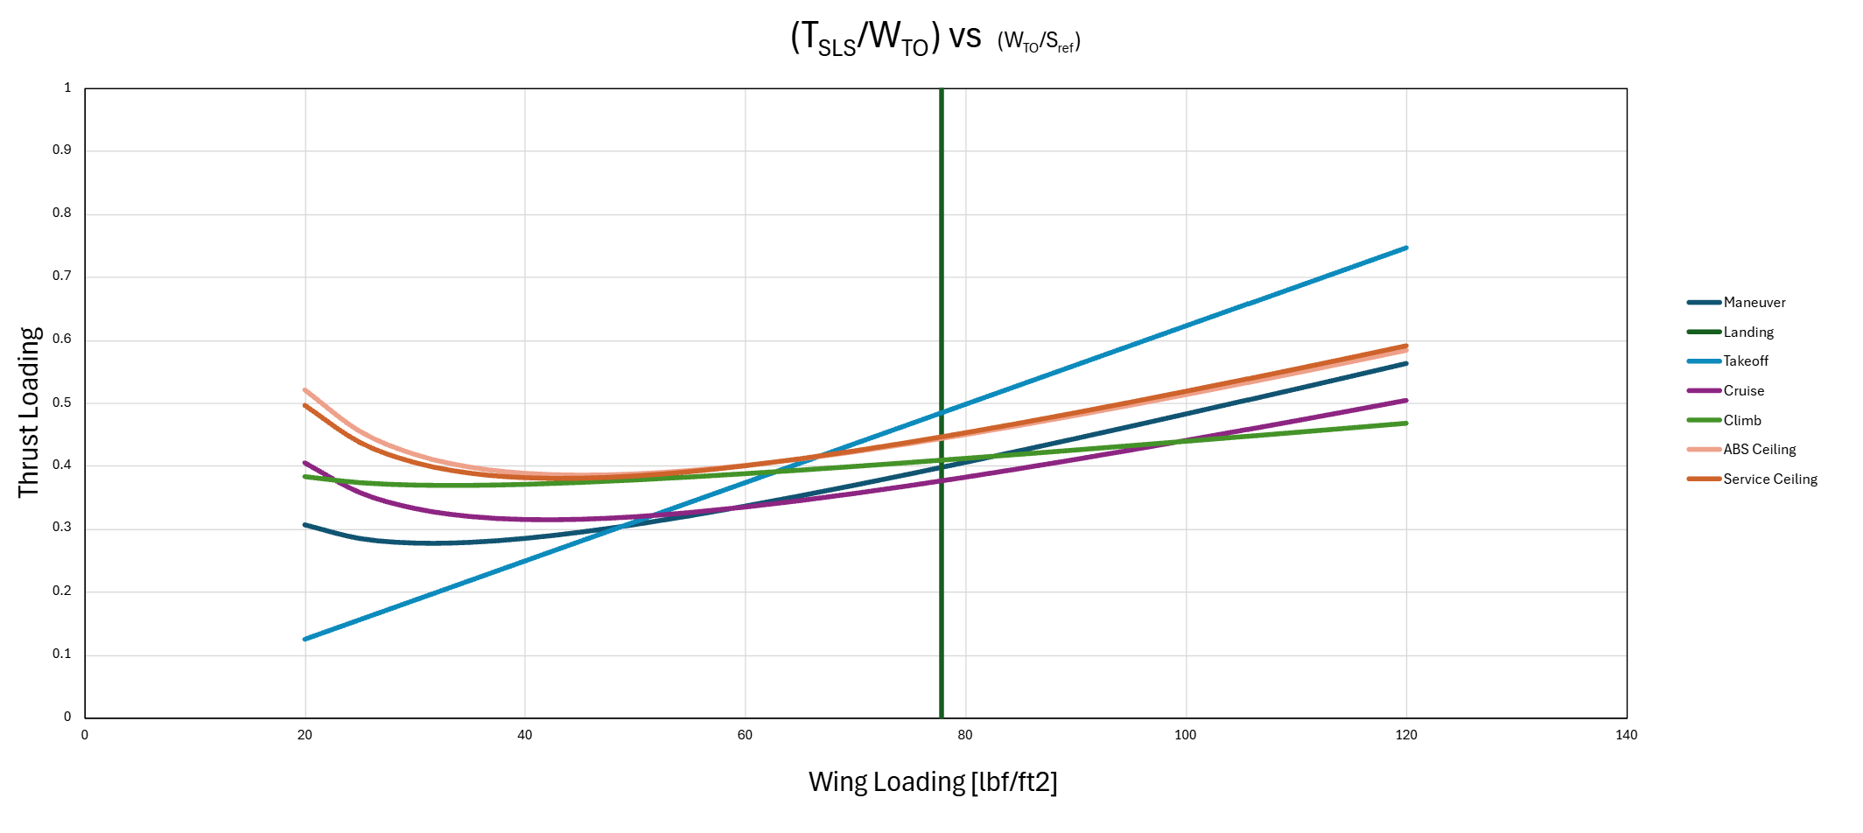Figure 1: Constraint analysis plot
Based on Figure 1, the thrust loading was chosen to be 0.4, while the wing loading was chosen to be 60 lbf/ft². This point is represented on the graph as a red ‘X’.
Table 7: Operating envelope of the jet trainer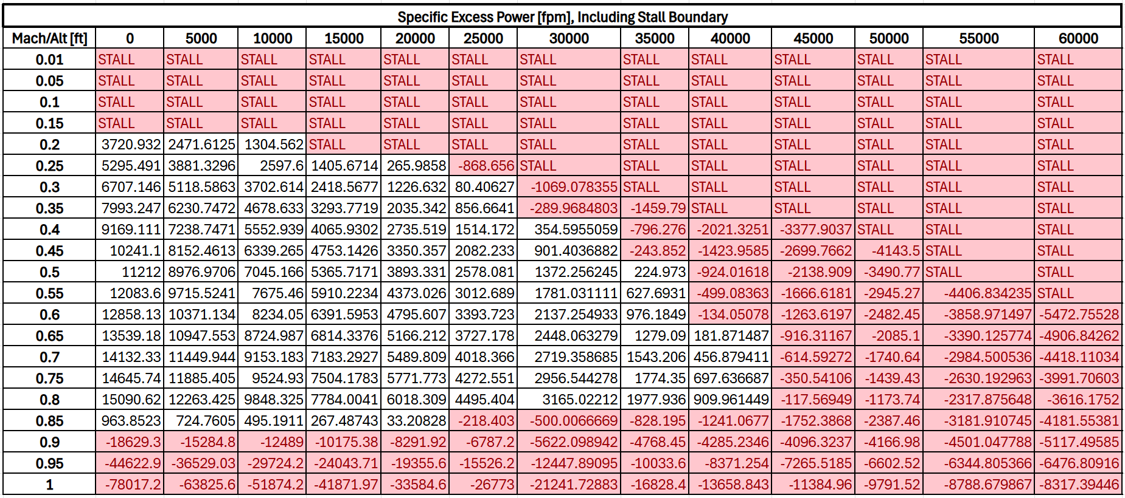
As seen in Table 6, each red box indicates a lack of excess power as climb in ft/min. The white boxes represent excess power available and depict the normal operating envelope.
Table 8: Design maximum performance
Max Speed  (SLS) | Max Acceleration (SLS) | Max Climb Rate (SLS) | Service Ceiling | Absolute Ceiling
Mach 0.85 | 768 ft/min | 5000 ft/min | 43369.47 ft | 45137.07 ft
Mission Analysis

In the “Design Tools” Excel spreadsheet, the “Mission” tab was used to conduct the analysis of the fuel requirements of the mission.
Table 9: Values for each leg of the mission.
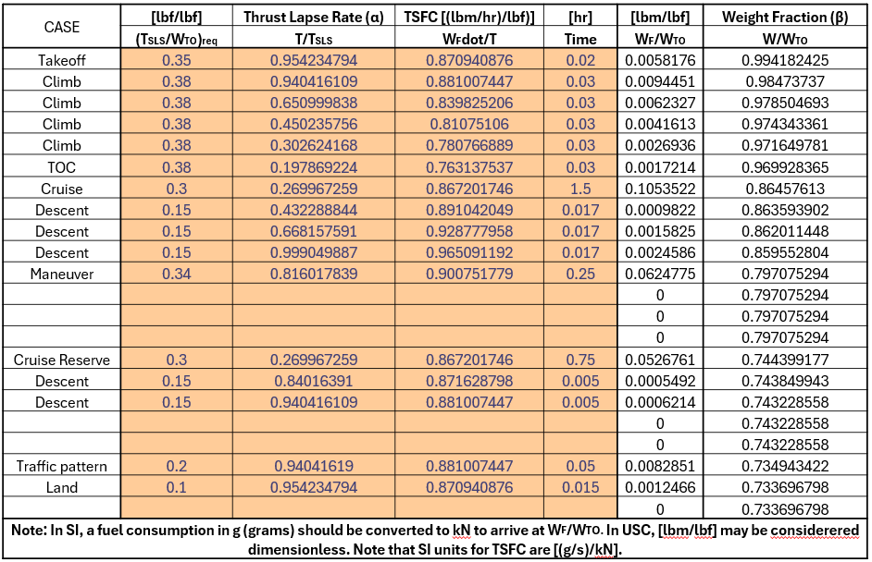
For the mission, the max TSFC of 0.8 (lbm/hr)/lbf at sea level static was used for all cases multiplied by the TSFC factor. The thrust loading was obtained from the constraint plot except where a thrust loading of 0.15 was assumed as flight-idle, 0.2 for the traffic pattern, and 0.1 for landing. All times were either estimated based on performance or directly from RFP.

Table 10: Take-off gross weight estimate.
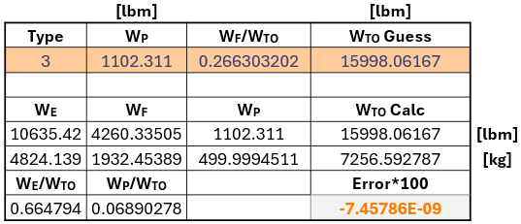
As seen in Table 10, the estimate for the take-off gross weight is just under 16000 lbm, which places it well within the region of maintaining competition against the reference aircraft.

Preliminary Engine Sizing
The engine requirements at each of the key operating points can be found in Table 11. Additionally, the current design for the jet trainer requires only one engine.
Table 11: Engine operation requirements
Parameters | Values
Engine Front Face Diameter | 25 in
Thrust at Take-Off | 5610 lbf
Thrust at Top of Climb | 1263 lbf
Thrust at Cruise | 1260 lbf
Thrust at Ceiling | 1489 lbf
Thrust at Maneuver | 4661 lbf
Thrust at Bottom of Descent | 2370 lbf
Required Specific Thrust (at Cruise) | 64.1 lbf
Required Minimum TSFC | 0.76
Reference Engine(s)
The reference engines for this aircraft were found by researching the three recommended comparable aircraft.
Table 12: Reference Engines
Aircraft | Boeing Saab T-7 Red Hawk | AIDC T-5 Brave Eagle | Aero L-39 Skyfox
Engine | GE F404 (afterburning) | Twin Honeywell/ITEC F124 Turbofans | Williams International FJ44 4M Turbofan

The after-burning engine is only used as a reference to see how far the jet trainer engine can be pushed to have the highest performance. However, the latter two engines are most closely resembling a realistic engine design for the jet trainer and will be used as the main references.

References

[1] “Aero L-39 Skyfox,” Wikipedia, Wikimedia Foundation, 17 Jan. 2026, en.wikipedia.org/ wiki/Aero_L-39_Skyfox.
[2] “AIDC T-5 Brave Eagle,” Wikipedia, Wikimedia Foundation, 26 Jan. 2026, en.wikipedia.org/ wiki/AIDC_T-5_Brave_Eagle.
[3] “Boeing–Saab T-7 Red Hawk,” Wikipedia, Wikimedia Foundation, 10 Jan. 2026, en.wikipedia. org/wiki/Boeing%E2%80%93Saab_T-7_Red_Hawk.
[4] “F124 Turbofan Engine,” Honeywell Aerospace Technologies, aerospace.honeywell.com/ us/en/products-and-services/products/power-and-propulsion/engines/turbofan-engines/f124-turbofan-engine.
[5] Ferrer-Vidal, L., “Flight Performance for Jet Propulsion,” AE435 Course Material.
[6] “General Electric F404,” Wikipedia, Wikimedia Foundation, 6 Dec. 2025, en.wikipedia.org/ wiki/General_Electric_F404
[7] “Williams FJ44,” Wikipedia, Wikimedia Foundation, 3 Dec. 2025 en.wikipedia.org/wiki/ Williams_FJ44

Appendices

Atmospheric Table
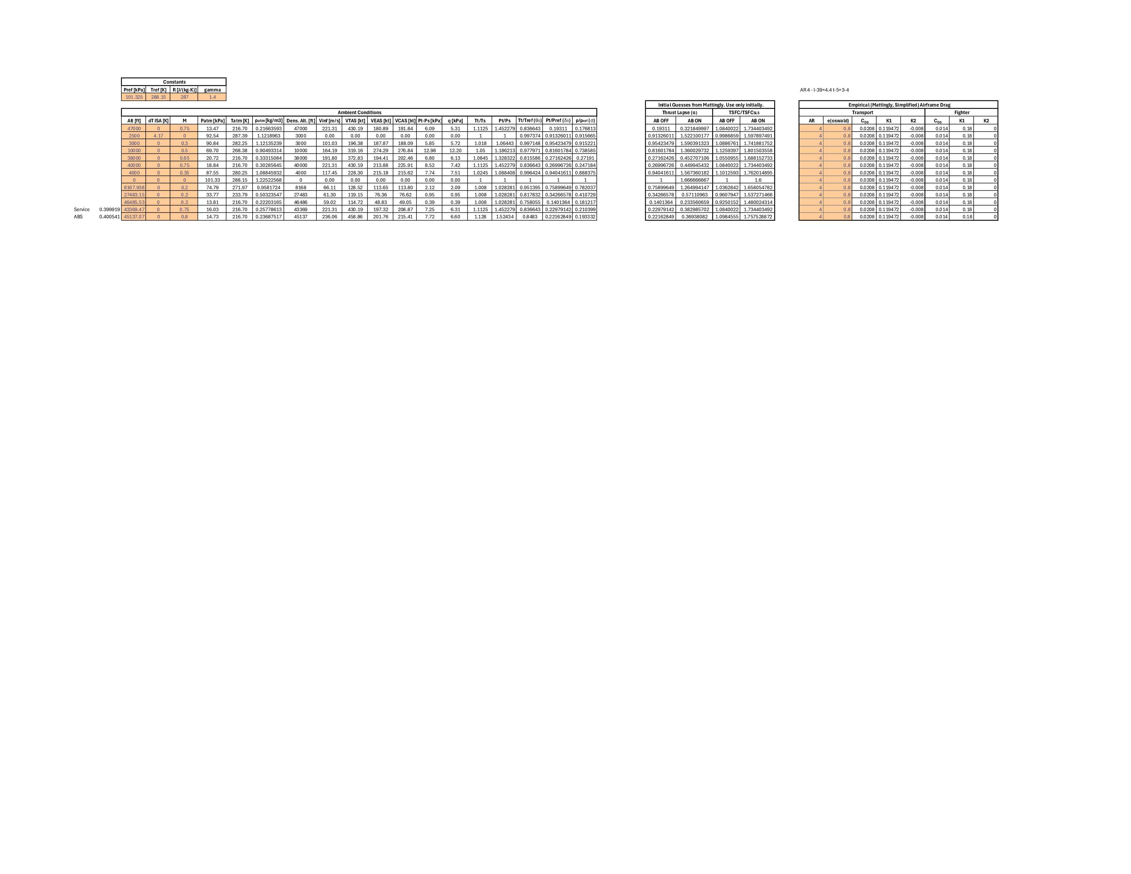
Absolute Ceiling Flight Performance
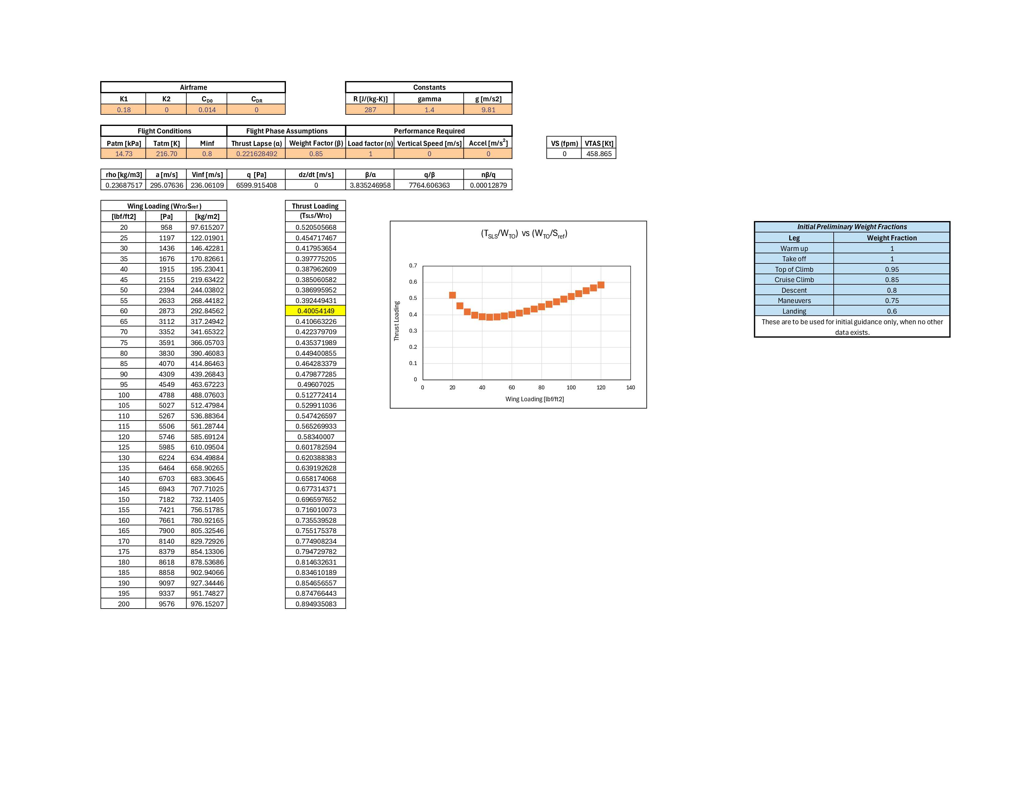
Service Ceiling Flight Performance
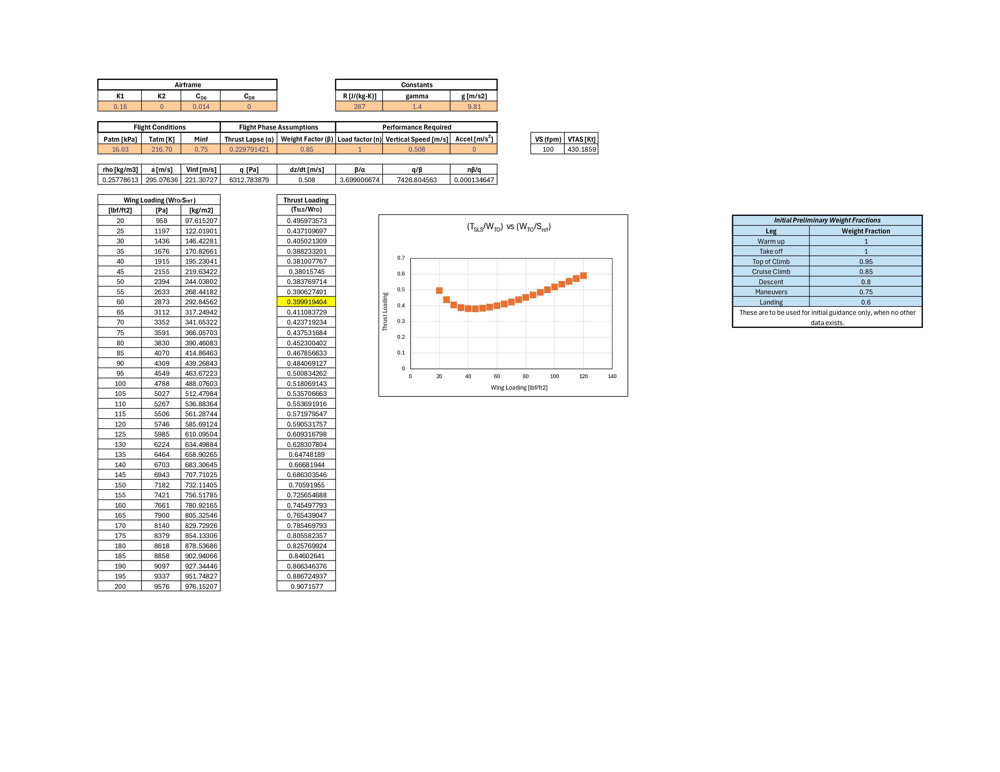
Maneuver Flight Performance
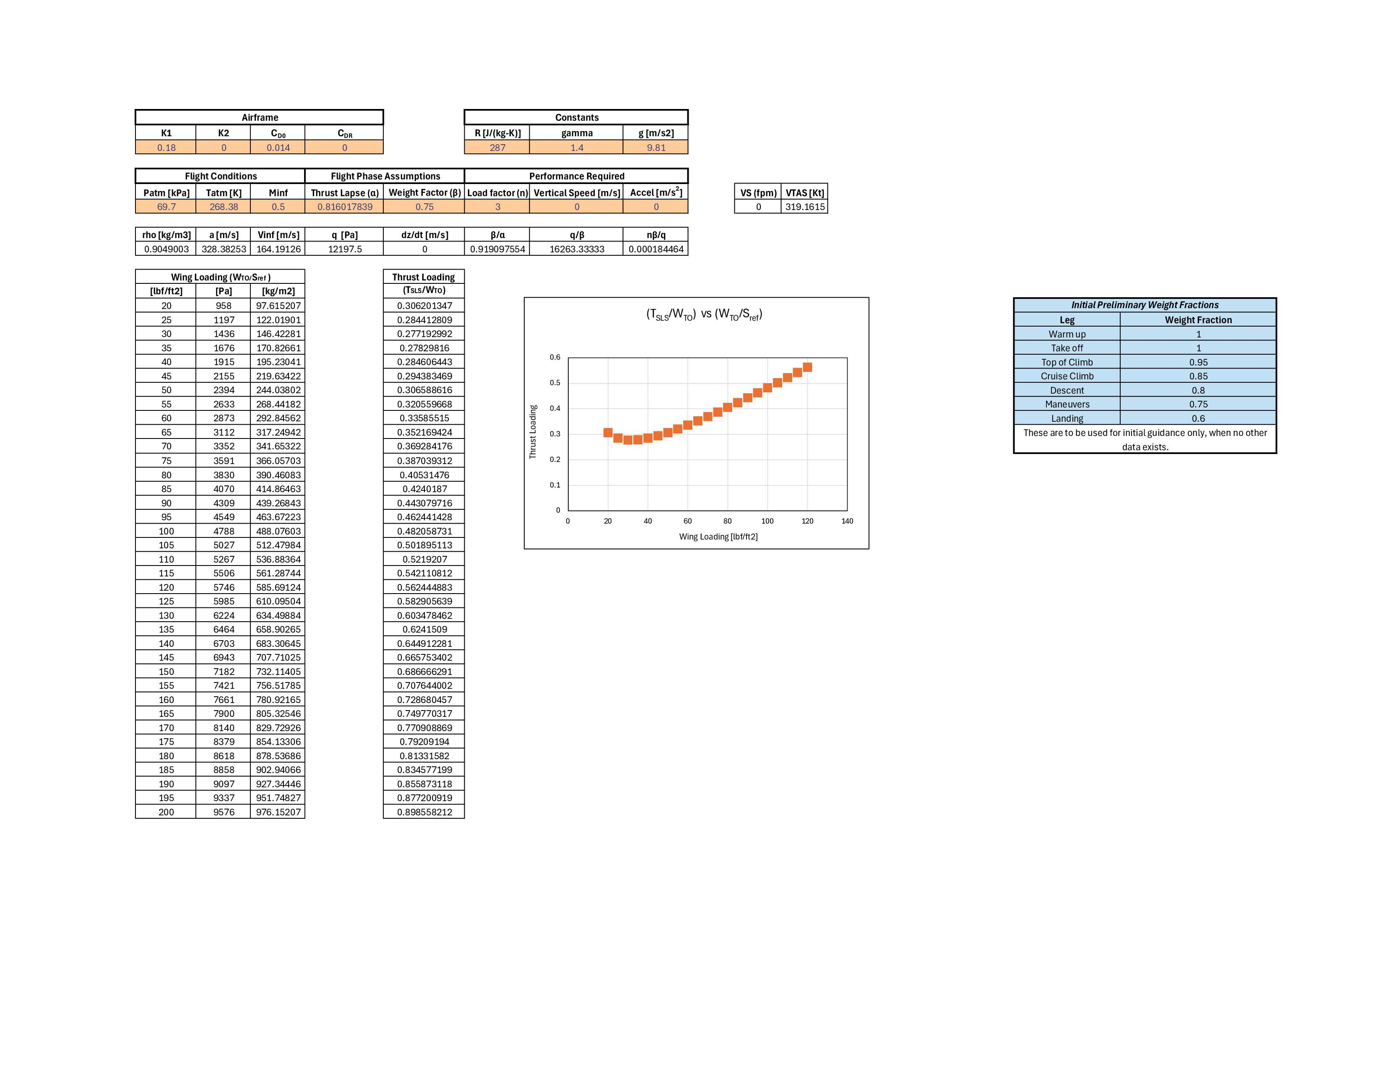
Cruise Flight Performance
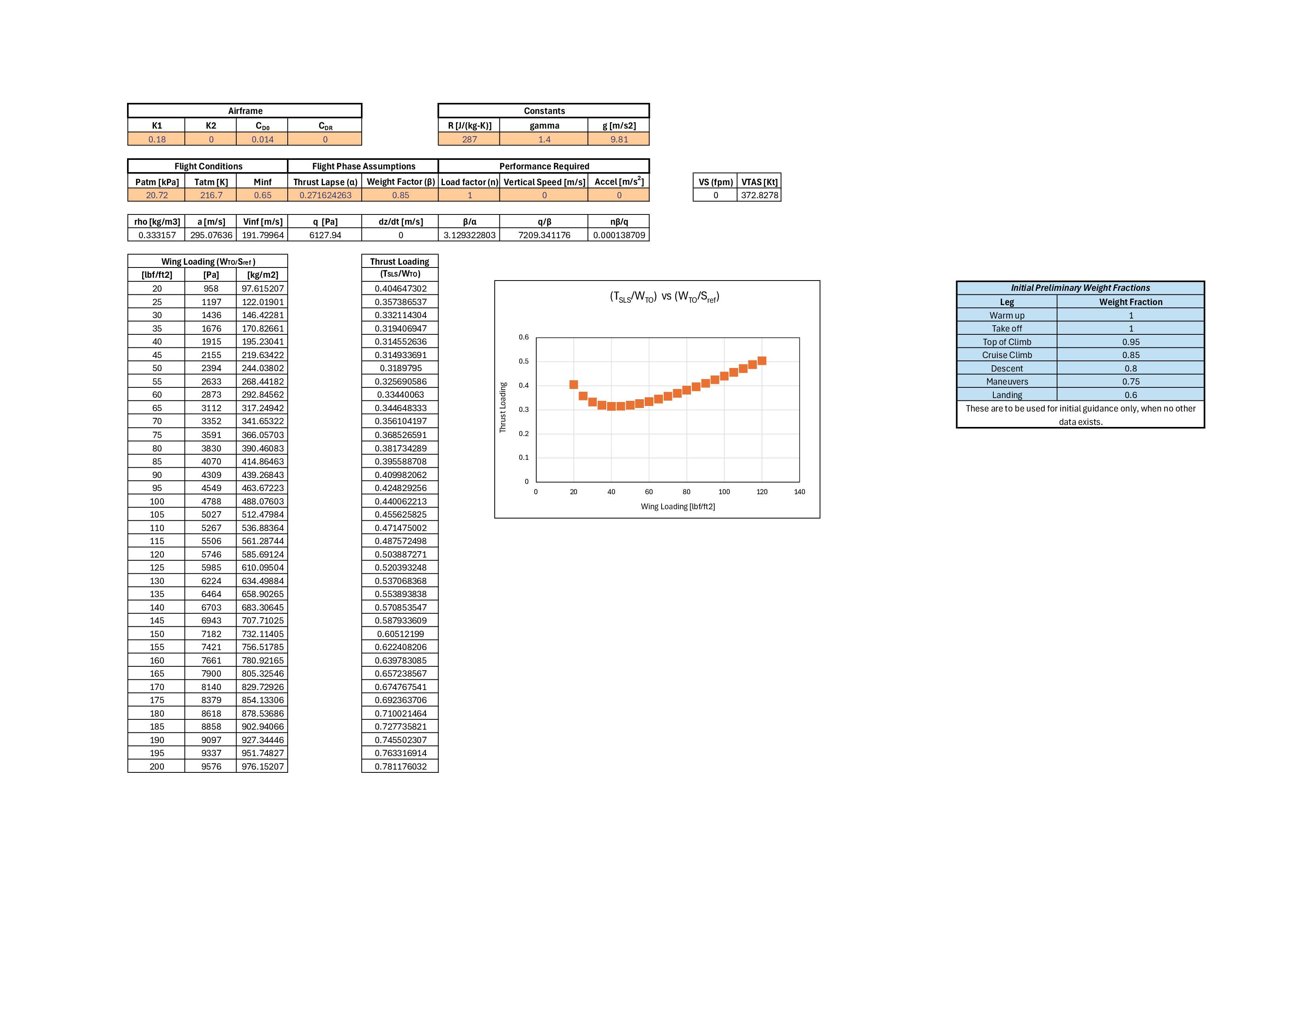
Climb Flight Performance
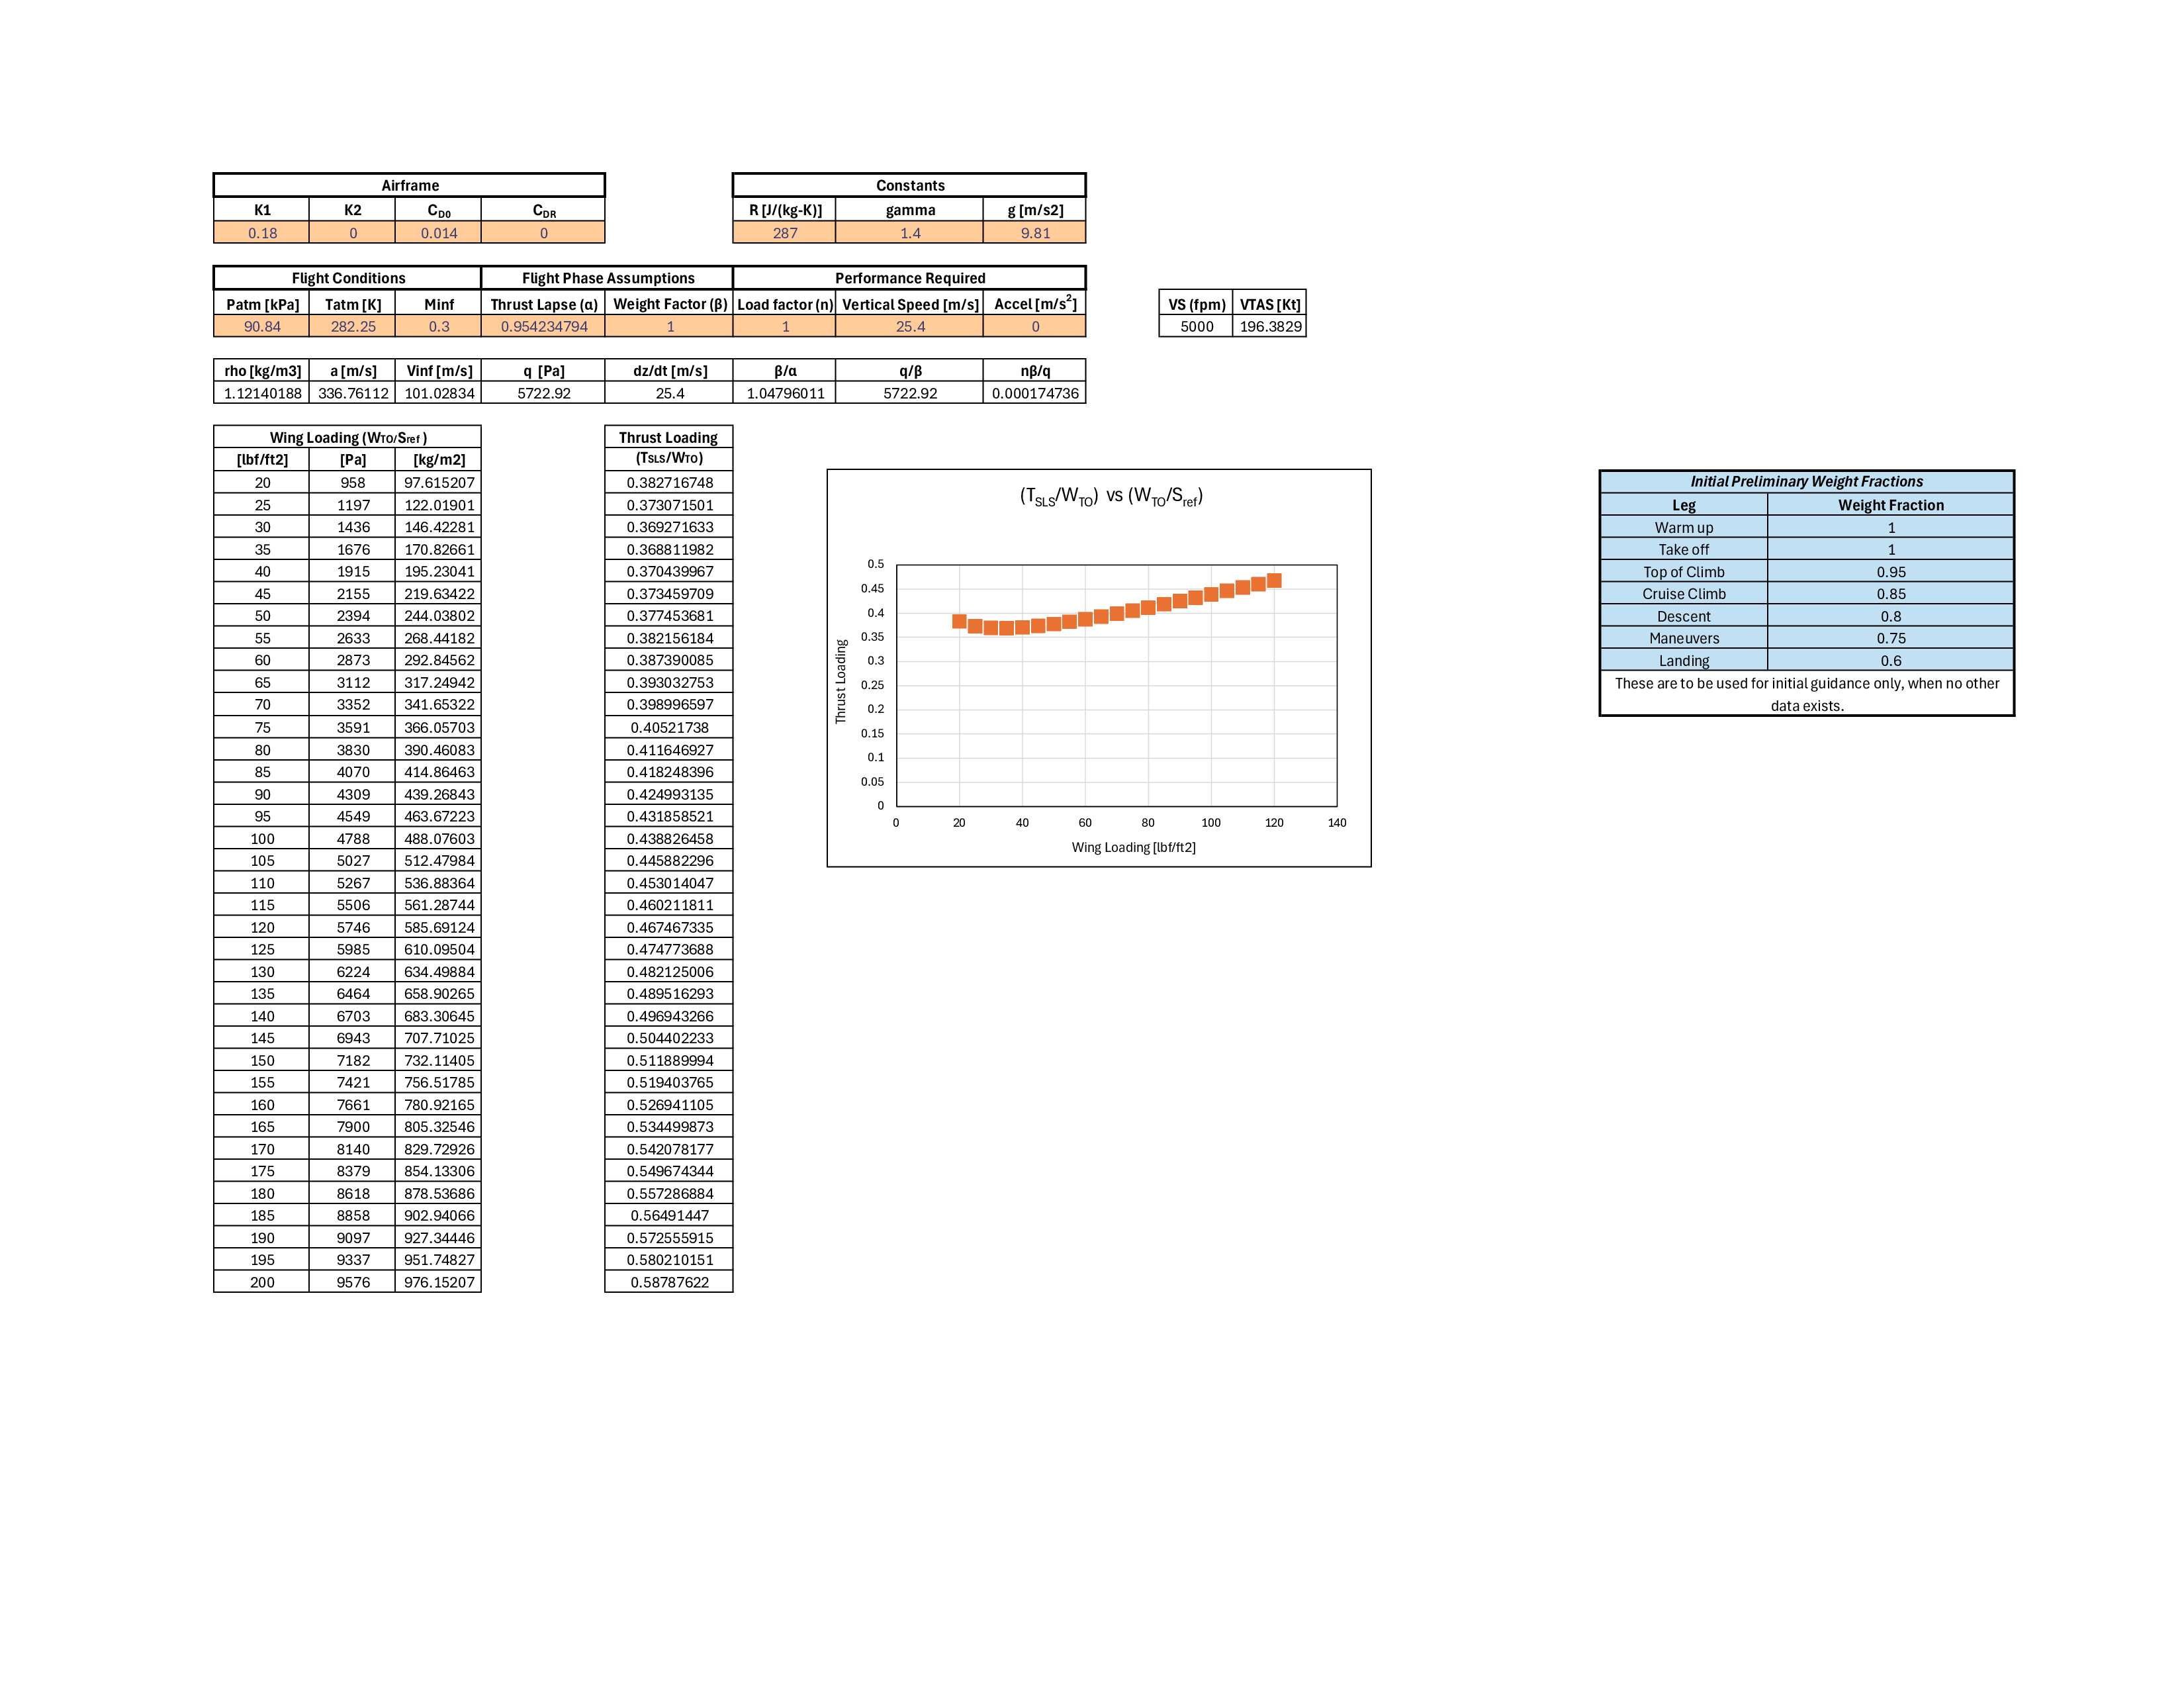
Takeoff and Landing Flight Performance
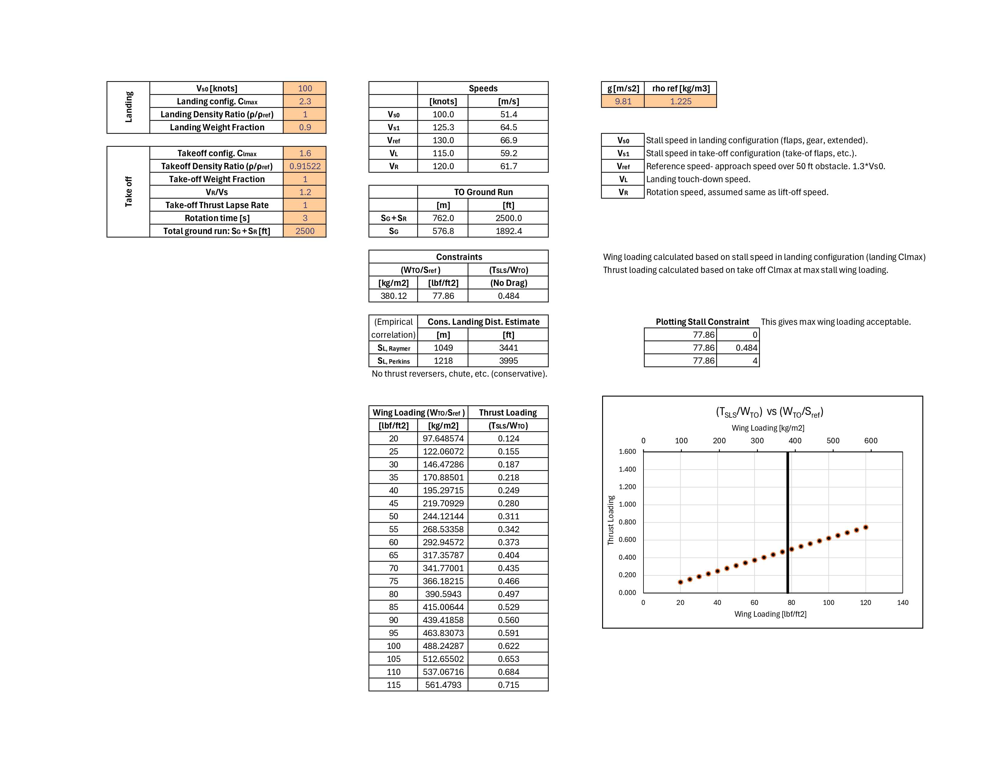
Mission Analysis
