Preliminary Cycle Specification

Night Ravens

Executive Summary
Using previously calculated flight performance and mission parameters, on-design cycle design was conducted with cruise as the design point. The resulting cycle produces 6.10 kN or 1371.35 lb of thrust, approximately 11 lb more than required. The TSFC lower compared to initial estimates at 21.46 g/(kN*s) or 0.7577 lb/(lb*hr), with the initial estimate being 0.867 lb/(lb*hr). The cycle meets the RFP requirement for bleeds totaling 21%. Key station data is provided following SAE ARP 755D numbering. Sensitivity studies were conducted to determine the effects of design choices on specific thrust and specific fuel consumption (SFC).

Attribution & Declaration
The undersigned declare:
- That all work is presented herein is their own unless otherwise stated.
- To have abided by the university honor code and academic integrity policy.
- To have read and upheld the NSPE Code of Ethics for Engineers in the production of this work.
- That they have reviewed the entirety of the contents presented herein and take full responsibility for all results and data presented.
- That all team members agree with the areas of responsibility assigned below.
Engineer | Area of Responsibility | Signature
John Clardy | GasTurb Manager, Mission Analysis Excel Sheet, Report Writing & Review | John Clardy
Lauren Martins | Preliminary Cycle Analysis Excel Sheet, External Research, Report Writing & Review | Lauren Martins

Introduction

The RFP requests a subsonic jet trainer for both the civilian and defense industries, with civil certification under the Federal Aviation Administration (FAA) and the European Union Aviation Safety Agency (EASA). It is requested that the aircraft be competitive against modern jet trainers. Since this report focuses on cycle analysis, the engines from the AIDC T-5 Brave Eagle – F124 Turbofan Engine – and the Aero L-39 Skyfox – Williams FJ44 – were used as close references.

Table 1: RFP Requirements
Take-Off Runway Length | Density Altitude | Take-Off Configuration, C_{L, max} | Landing Configuration, C_{L, max} | Crew Weight | Payload Weight
≤ 2500 ft | 3000 ft | 1.6 | 2.3 | 200 kg | 300 kg
Cruising Time | Fuel Reserve Time | Service Ceiling | Cruising Time | Front-Face Diameter | Engine Length
90 mins | 45 mins | ≥ 42000 ft | 90 mins | 25 in | 3.4 m

Core Flow Bleed (Customer) | Core Flow Bleed (Turbine Sealing/Packing) | Core Flow Bleed (Turbine Cooling) | Shaft Power  (all Conditions) | Turbine Entry Temperature (TET)
1% | 5% | 15% | 100 kW | < 1850 K

Maneuver | Mach | Altitude
3x360° 3g turns | 0.5 | ≥ 10000 ft

This report focuses on the content in the third row of Table 1 (along with the engine diameter and length from the second row), which will be used to conduct a preliminary cycle analysis.
Requirements Specification
Based on the preliminary analysis done on the engine and the RFP, the following requirements were found:

Table 2: Engine operation requirements at cruise
Parameters | Values
Maximum Engine Front Face Diameter | 25 in
Maximum Engine Length | 3.5 m
Required Installed Thrust | 1360.47 lbf
Required Specific Thrust | 64.1 lbf
Required TSFC | 0.867
Methodology
Initially, the cycle analysis was modeled in an Excel Spreadsheet, however minor optimizations – which were conducted entirely in GasTurb – were done prior to writing this report. From this point onwards, GasTurb became the main program used to model the cycle discussed in this report, being deemed amongst group members to be a more accurate modeling of an engine cycle than Excel.
An “on-design” cycle analysis was conducted, with cruise being the design point chosen where the cycle would be analyzed. This point was chosen to optimize fuel consumption (TSFC) [4]. The gas model chosen for this analysis assumed a thermally perfect gas: an ideal gas with properties that vary with temperature. Under this assumption, neither gamma nor heat capacity were considered constant. Component efficiencies and engine Mach values were assumed for simplification using typical values.
Installation effects were also considered for this cycle analysis. The installation effect factor for this engine is 1.05; this value represents the loss that comes from mounting the engine on an aircraft, as it will always produce less thrust when mounted compared to unmounted testing. The value used for the actual installed thrust required from the engine at cruise altitude factors in this installation effect factor, already accounting for the 5% thrust loss that will come from mounting the engine on the jet trainer.
Cycle Design Point
Cruise was chosen as the cycle design point to design a cycle with good TSFC at cruise. This will make a strong foundation for off design for designing a cycle with low TSFC while meeting all the requirements. While this cycle is optimal for cruise performance, further analysis in off design will determine the cycle’s viability for other mission design points. The cycle was designed for a two-spool bypass turbofan engine with a mixer and no afterburner. The preliminary cycle was optimized in GasTurb and then sensitivity studies were conducted on the cycle.

Table 3: Sensitivity Study
Study | Base | Delta | SFC (%) | Sp. Thrust (%)
Burner Exit Temperature (K) | 1606.68 | 10 | 0.43 | 0.81
Inner Fan Pressure Ratio | 2.8 | 0.1 | -0.45 | -0.25
Outer Fan Pressure Ratio | 2.8 | 0.1 | -0.42 | 0.42
HP Compressor Pressure Ratio | 10.51 | 0.1 | -0.12 | -0.08
Design Bypass Ratio | 1.42 | 0.2 | -2.67 | -5.1
Rel. Overboard Bleed W_Bld/W25 | 0.01 | 0.01 | 0.53 | -1.79
HPT NGV 1 Cooling Air / W25 | 0.05 | 0.01 | -0.42 | -0.85
HPT Rotor 1 Cooling Air / W25 | 0.05 | 0.01 | -0.27 | -0.99
LPT Rotor 1 Cooling Air / W25 | 0.05 | 0.01 | -0.28 | -0.99
Rel. HP Leakage to LPT exit | 0.05 | 0.01 | -0.16 | -1.11
Polytr. Inner LPC Efficiency | 0.92 | -0.01 | 0.06 | -0.28
Polytr. Outer LPC Efficiency | 0.92 | -0.01 | 0.1 | -0.1
Polytr. HPC Efficiency | 0.88 | -0.01 | 0.15 | -0.72
Polytr. HPT Efficiency | 0.9 | -0.01 | 0.26 | -0.25
Polytr. LPT Efficiency | 0.91 | -0.01 | 0.17 | -0.17
Polytr. Inner LPC Efficiency | 0.92 | 0.01 | -0.05 | 0.27
Polytr. Outer LPC Efficiency | 0.92 | 0.01 | -0.1 | 0.1
Polytr. HPC Efficiency | 0.88 | 0.01 | -0.13 | 0.68
Polytr. HPT Efficiency | 0.9 | 0.01 | -0.24 | 0.24
Polytr. LPT Efficiency | 0.91 | 0.01 | -0.16 | 0.16
Burner Design Efficiency | 0.99 | -0.01 | 0.95 | 0.06

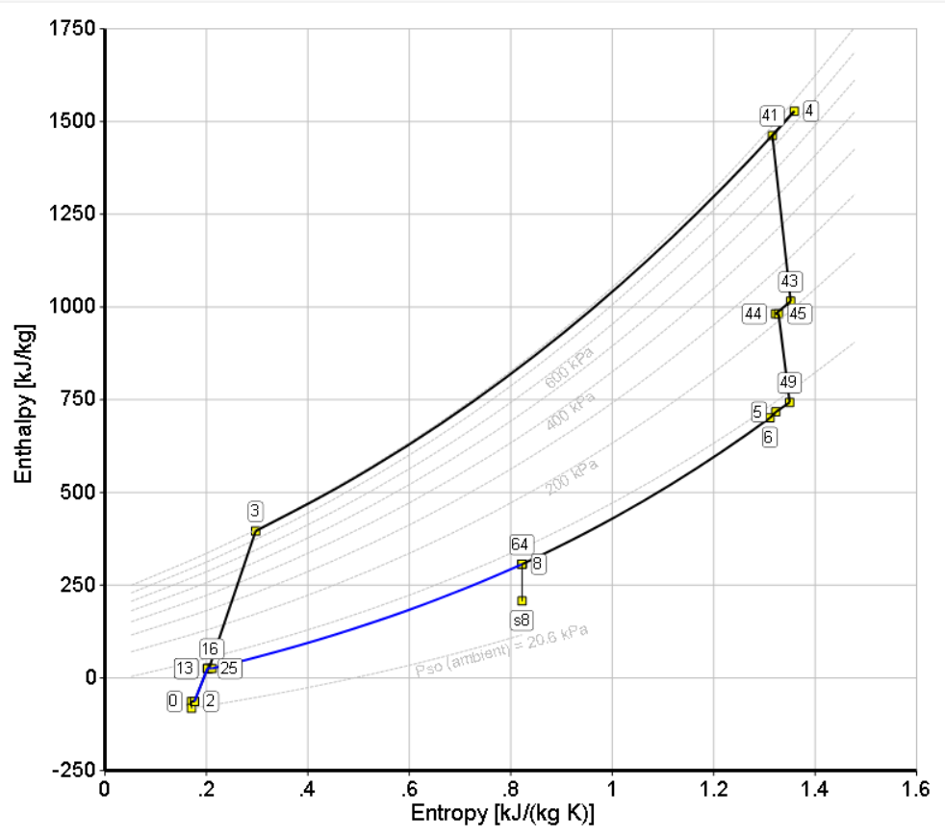
Figure 1: Mollier h-s Diagram

Table 4: Final Selected Cycle Parameters
Parameter | Value
OPR | 28.84
TET | 1606.68 K
FPR | 2.8
BPR | 1.42

Table 5: Performance Metrics
Parameter | Value | Value
Thrust | 6.10 kN | 1371.35 lb
Specific Thrust | 415.28 m/s | 1362.48 ft/s
TSFC | 21.46 g/(kN*s) | 0.7577 lb/(lb*hr)

Table 6: Efficiency Assumptions
Parameter | Value
LPC (Fan) | 0.92 (Polytropic)
HPC | 0.88 (Polytropic)
Burner | 0.9995 (Isentropic)
HPT | 0.90 (Polytropic)
LPT | 0.91 (Polytropic)
Mixer | 0.5 (Isentropic)
HP/LP Spool Mechanical | 0.99

Table 7: Bleed Flow Assumptions
Parameter | Value
Overboard (Customer) Bleed | 1%
LPT Cooling | 5%
HP Leak to LPT Exit (Packing) | 5%
NGV Cooling | 5%
HPT Cooling | 5%
Total | 21%

Table 8: Thermodynamic properties at major component inlet stations
Parameter | 2 | 25 | 3 | 4 | 45 | 13 | 64
 | Fan Inlet | HPC Inlet | Burner Inlet | HPT Inlet | LPT Inlet | Bypass Inlet | Mixer
Total Temperature (K) | 234.997 | 323.569 | 682.163 | 1606.68 | 1174.73 | 323.569 | 595.229
Total Enthalpy (J/kg) | -63357 | 25625.3 | 396123 | 1528220 | 981613 | 25625.3 | 306810
Mass Flow (kg/s) | 14.689 | 6.071 | 5.767 | 4.927 | 5.534 | 8.618 | 14.759
Corrected Mass Flow (kg/s) | 50 | 8.747 | 1.148 | 1.551 | 5.358 | 12.294 | 27.601

Table 9: Stations with static quantity assumptions
Parameter | 1 | 2 | 21 / 13 | 3 | 4 | 5 | 16
 | Inlet Face | Fan Inlet | Fan Exit / Bypass Inlet | HPC Exit | Burner Exit | LPT Exit | Bypass Exit
Mach | 0.65 | 0.5 | 0.52 | 0.55 | 0.4 | 0.5 | 0.5
Area (m²) | 0.235 | 0.277 | 0.0468  0.0664 | 0.00602 | 0.0106 | 0.0678 | 0.0704
Velocity (m/s) | 191.90 | 150.00 | 182.63 | 277.26 | 305.08 | 295.76 | 129.54
Static Pressure (kPa) | 20.65 | 22.67 | 62.61 | 640.39 | 686.21 | 76.64 | 61.56

Table 10: Turbomachinery Performance
Turbomachine | Corrected Mass Flow (kg/s) | PR / ER | Efficiency (Polytropic) | Power Production (kW)
LPC (Fan Root) | 8.660 | 2.800 | 0.92 | -540.192
LPC (Fan Tip) | 12.294 | 2.800 | 0.92 | -766.863
HPC | 1.148 | 10.514 | 0.88 | -2136.749
HPT | 5.358 | 3.525 | 0.90 | 2693.045
LPT | 11.939 | 2.343 | 0.91 | 1462.730

References

[1] “Aero L-39 Skyfox,” Wikipedia, Wikimedia Foundation, 17 Jan. 2026, en.wikipedia.org/ wiki/Aero_L-39_Skyfox.
[2] “AIDC T-5 Brave Eagle,” Wikipedia, Wikimedia Foundation, 26 Jan. 2026, en.wikipedia.org/ wiki/AIDC_T-5_Brave_Eagle.
[3] “F124 Turbofan Engine,” Honeywell Aerospace Technologies, aerospace.honeywell.com/ us/en/products-and-services/products/power-and-propulsion/engines/turbofan-engines/f124-turbofan-engine.
[4] Ferrer-Vidal, L., “On-design” Cycle Analysis of a Turbofan Engine,” AE435 Course Material.
[5] “Williams FJ44,” Wikipedia, Wikimedia Foundation, 3 Dec. 2025 en.wikipedia.org/wiki/ Williams_FJ44
[6] SAE International, “Aircraft Propulsion System Performance Station Designation and Nomenclature,” SAE Aerospace Recommended Practice ARP755D, SAE International, Warrendale, PA, Feb. 2014. https://doi.org/10.4271/ARP755D

Appendices
Appendix A: Preliminary Excel Cycle
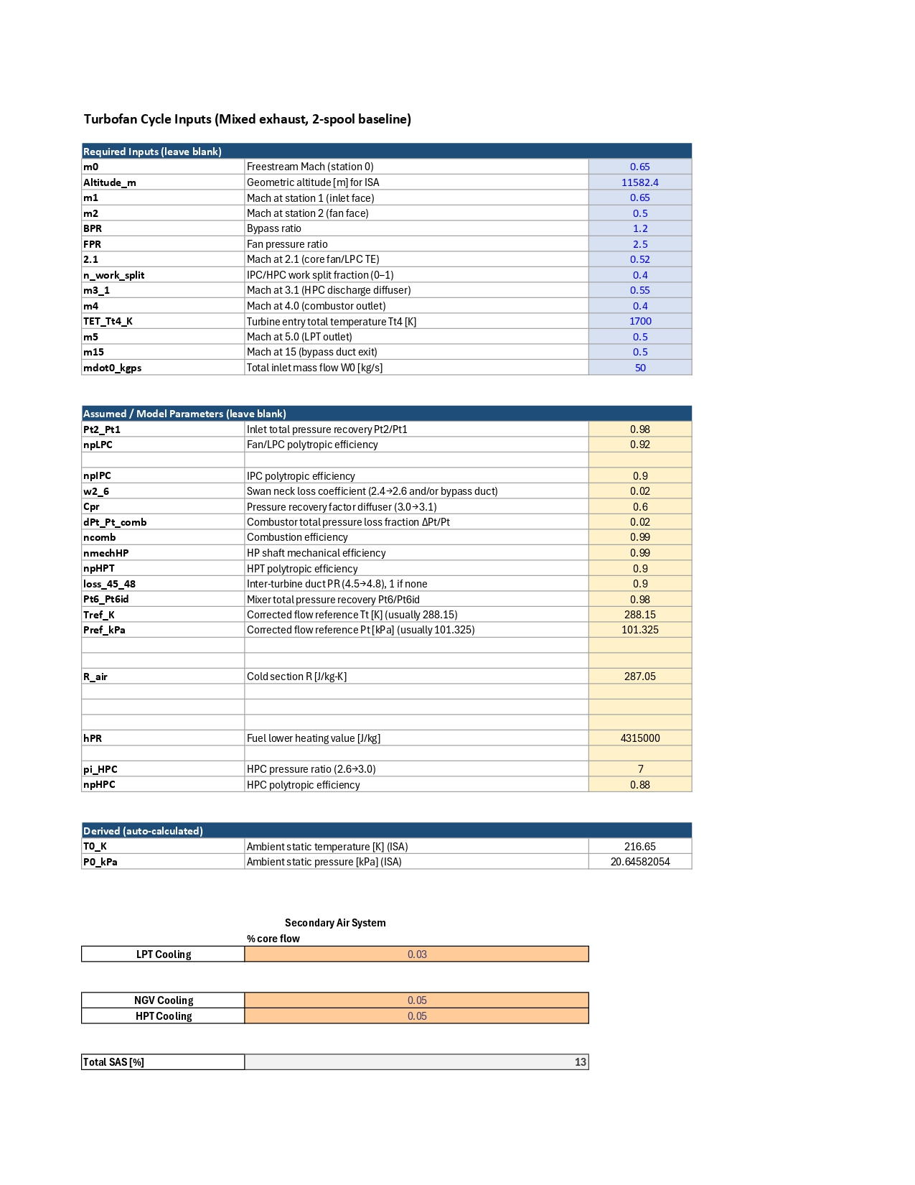
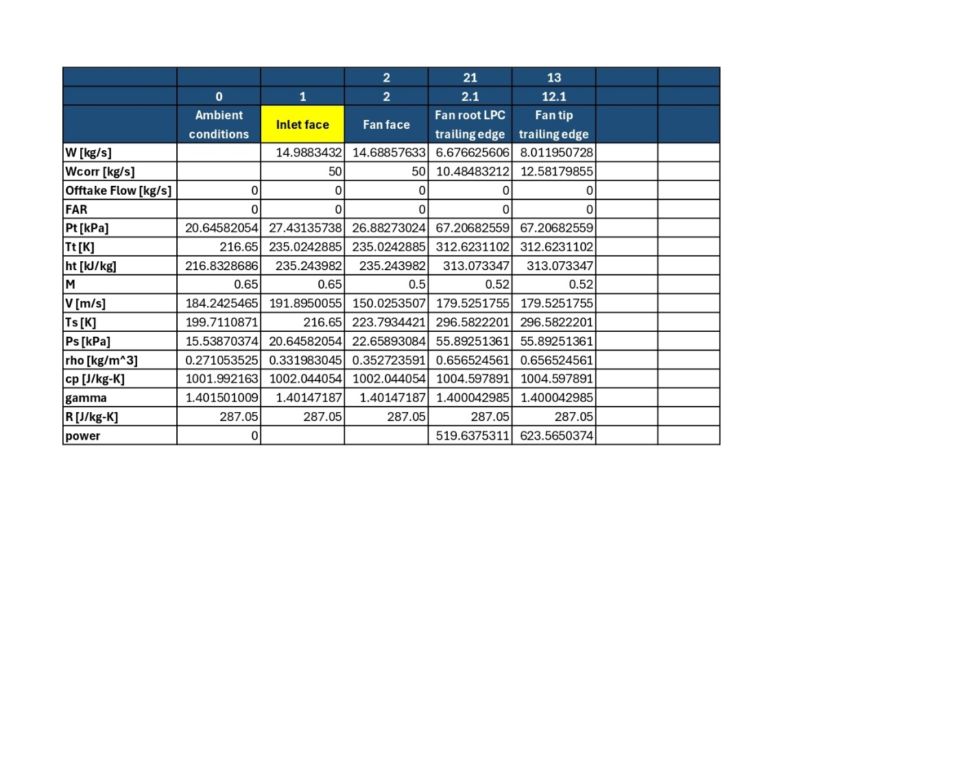
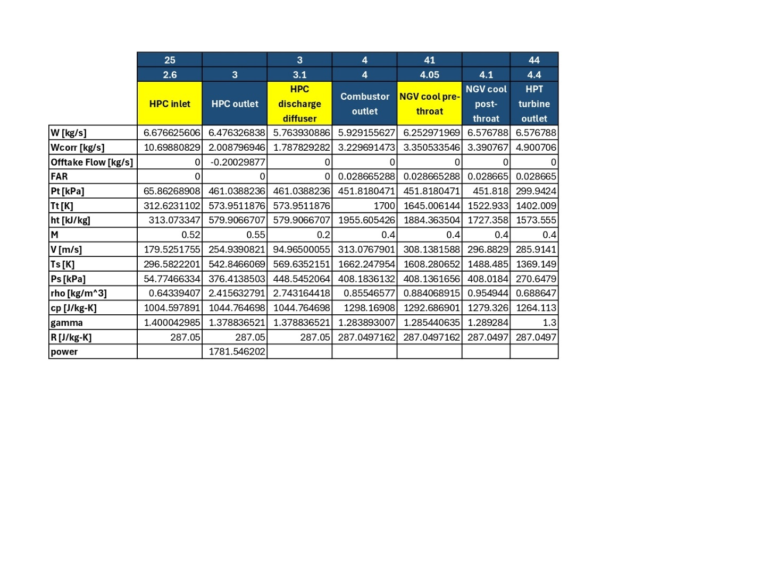
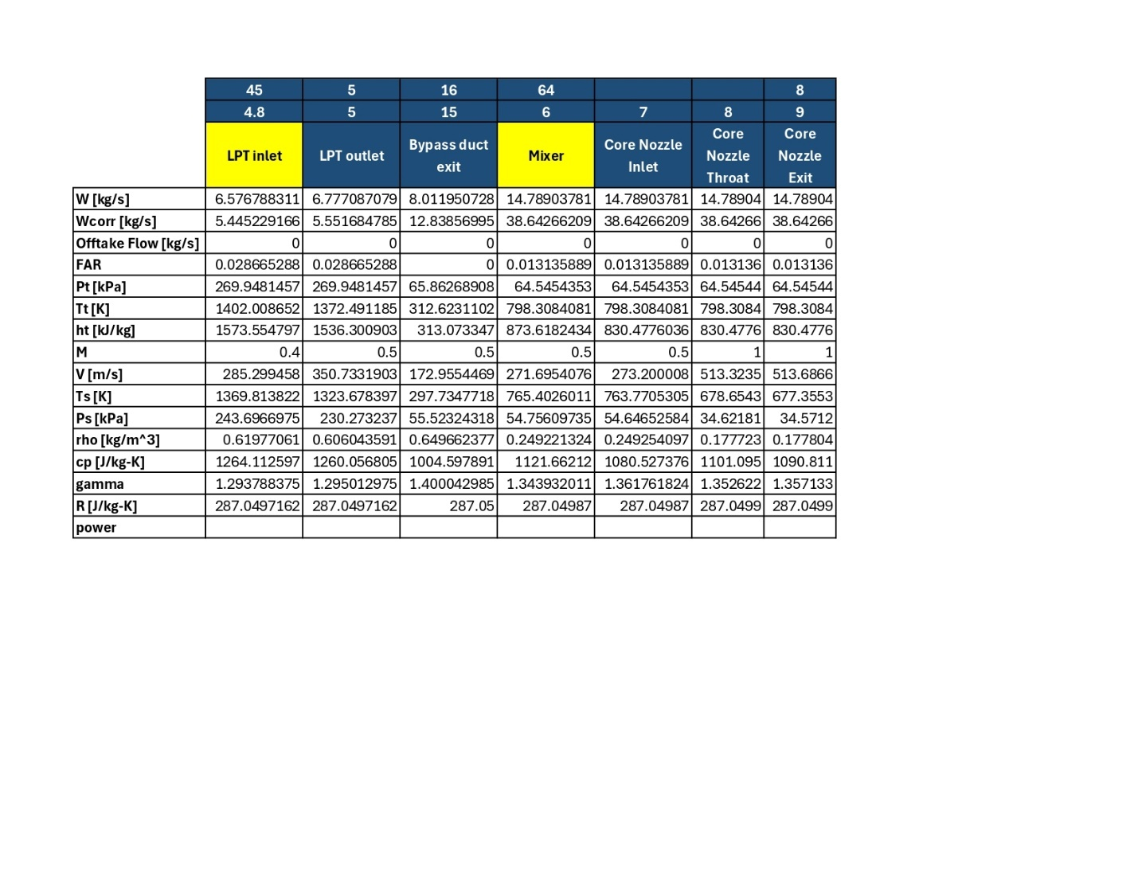

Appendix B: Preliminary GasTurb Cycle

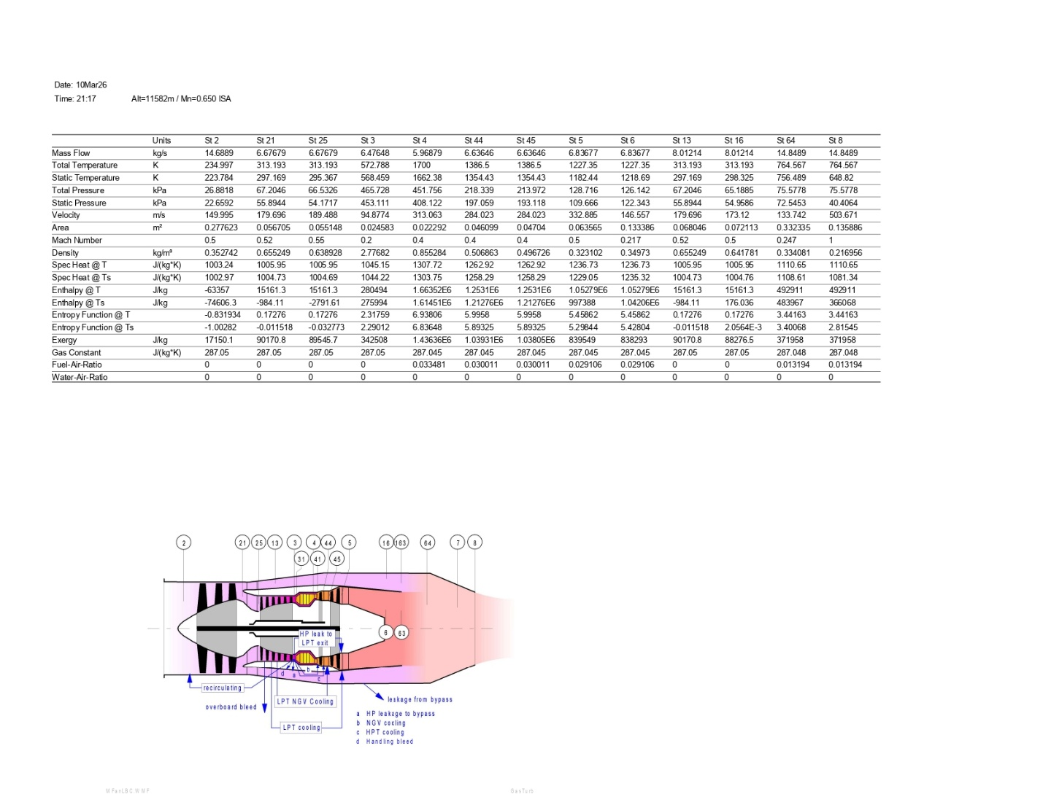
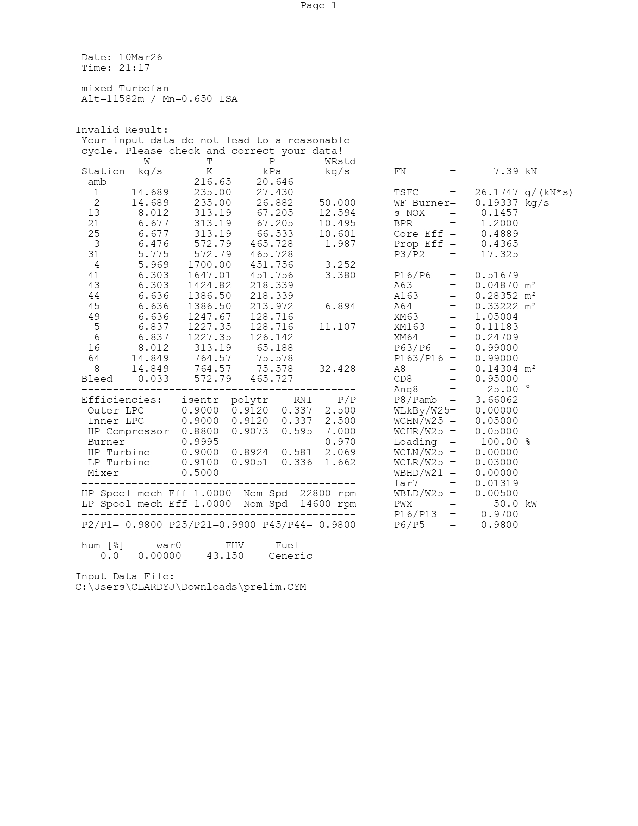
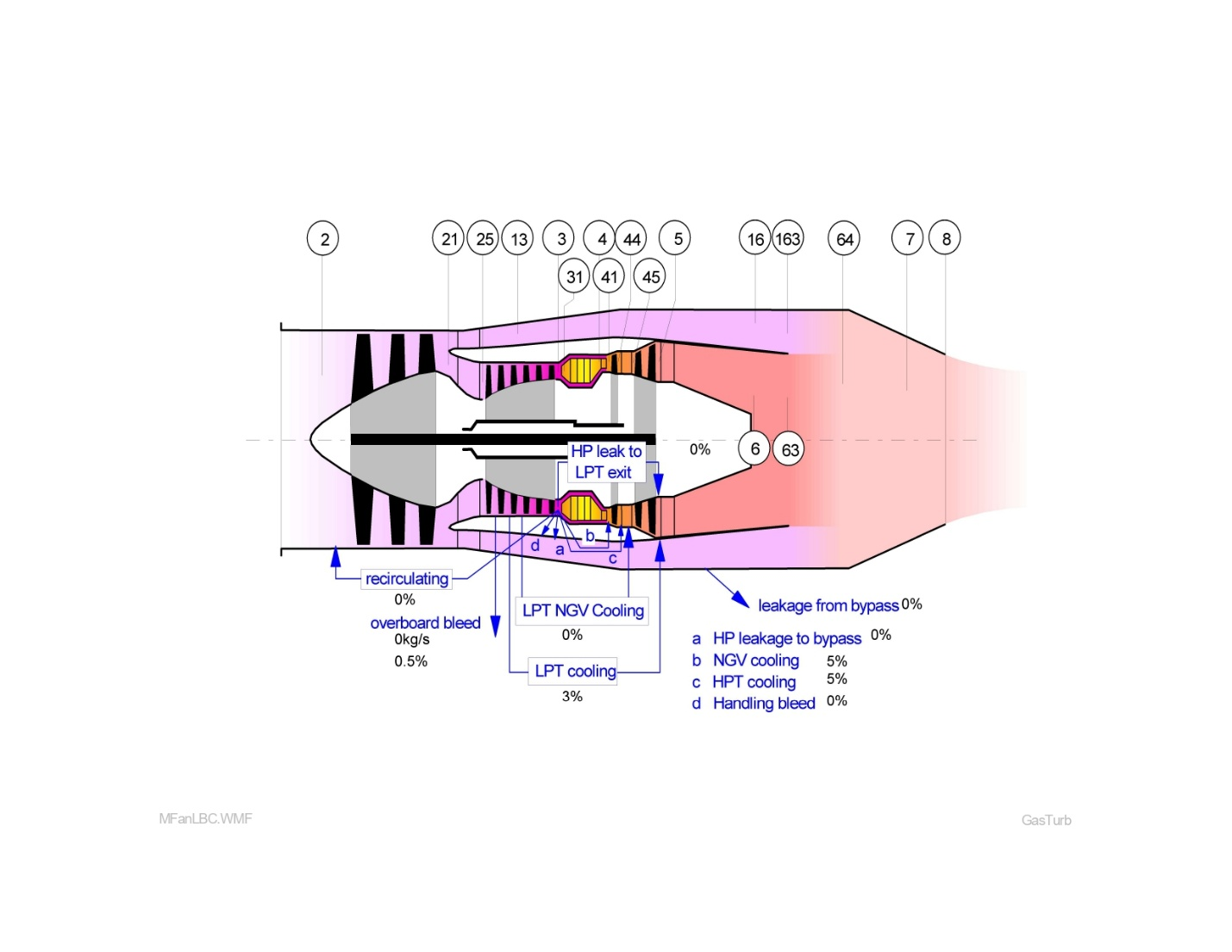

Appendix C: Optimized GasTurb Cycle
