Engine Cycle Proposal

Night Ravens

Executive Summary
Using previously calculated flight performance, mission parameters, and on-design cycle analysis, off-design cycle analysis was conducted for mission parameters. The resulting design point changed to a wing loading of 57.5 lbf/ft² and a thrust loading of 0.36. The aircraft takeoff weight was reduced to 13342 lbm causing the thrusts required across the mission to decrease. This resulted in a design point cycle at cruise of 1262 lbf and a TSFC of 0.7420 (lbm/hr)/lbf. The engine was found to have a climb rate of about 10000 ft/min shortly after takeoff with a max acceleration of 0.278g. Key station data is provided following SAE ARP 755D numbering. Parametric analysis and sensitivity studies were conducted to determine the effects of design choices on specific thrust and specific fuel consumption (SFC). Key engine and turbomachinery parameters are provided for different conditions across the mission.

Attribution & Declaration
The undersigned declare:
- That all work is presented herein is their own unless otherwise stated.
- To have abided by the university honor code and academic integrity policy.
- To have read and upheld the NSPE Code of Ethics for Engineers in the production of this work.
- That they have reviewed the entirety of the contents presented herein and take full responsibility for all results and data presented.
- That all team members agree with the areas of responsibility assigned below.
Engineer | Area of Responsibility | Signature
John Clardy | GasTurb Manager, Mission Analysis Excel Sheet, Parametric Studies, Sensitivity Studies, Report Writing & Review | John Clardy
Lauren Martins | Preliminary Cycle Analysis Excel Sheet, External Research, Report Writing & Review & Organization, Inlet and Combustor, Lead Project Poster Designer | Lauren Martins

Table of Contents
Introduction 3
Requirements Specification 4
Non-Technical Considerations 5
Public Health, Safety, and Welfare 5
Environmental and Economic Factors 5
Regulatory Factors 5
Methodology 7
On-Design Analysis 7
Off-Design Analysis and Cycle Optimization 7
Gas Model and Installation Effects 7
Performance Specifications 8
Aircraft Performance Assumptions 8
Aircraft TOGW Across the Mission 10
Maximum Achievable Performance 11
Engine Sizing 14
Intake 14
Combustor 15
Thermodynamic Cycle 17
Design Point Parametric Studies 17
Sensitivity Studies 18
Final Cycle Performance and Parameters 19
Engine Design Table 24
References 28
Appendices 29
Appendix A: Preliminary Excel Cycle 29
Appendix B: Preliminary GasTurb Cycle 32
Appendix C: Optimized GasTurb Cycle 35
Appendix D: Final Off-Design GasTurb Cycle at Cruise 38

Introduction
The RFP requests a subsonic jet trainer for both the civilian and defense industries, with civil certification under the Federal Aviation Administration (FAA) and the European Aviation Safety Agency (EASA). It is requested that the aircraft be competitive against modern jet trainers. Since this report focuses on cycle analysis, the engines from the AIDC T-5 Brave Eagle – F124 Turbofan Engine – and the Aero L-39 Skyfox – Williams FJ44 – were used as close references.

Table 1: RFP requirements
Take-Off Runway Length | Density Altitude | Take-Off Configuration, C_{L, max} | Landing Configuration, C_{L, max} | Crew Weight | Payload Weight
≤ 2500 ft | 3000 ft | 1.6 | 2.3 | 200 kg | 300 kg
Cruising Time | Fuel Reserve Time | Service Ceiling | Cruising Time | Front-Face Diameter | Engine Length
90 mins | 45 mins | ≥ 42000 ft | 90 mins | 25 in | 3.4 m

Core Flow Bleed (Customer) | Core Flow Bleed (Turbine Sealing/Packing) | Core Flow Bleed (Turbine Cooling) | Shaft Power  (all Conditions) | Turbine Entry Temperature (TET)
1% | 5% | 15% | 100 kW | < 1850 K

Maneuver | Mach | Altitude
3x360° 3g turns | 0.5 | ≥ 10000 ft

While these tables cover the entirety of the RFP, the focus of this report is specifically on the engine cycle, which means the third of these four tables will be most relevant for this report.

Requirements Specification
Based on the preliminary analysis done on the engine and the RFP, the following requirements were found:

Table 2: Off-design engine operation requirements at cruise
Parameters | Values (at Cruise)
Required Installed Thrust | 1260 lbf
Required Specific Thrust | 1304 ft/s  (397.4 m/s)
Cruise TSFC | <0.8 (lbm/hr)/lbf

The engine has the size limits stated in the RFP, with the maximum front face diameter of 25in continuing to be a concern when designing this engine. The “Engine Sizing” section of this report discusses more of these concerns in-depth.
The required installed thrust and TSFC impacted design the most since increased thrust raises TSFC, and the objective was to minimize TSFC at cruise. The initial cycle was optimized for both of those factors and during off-design improved as aircraft weight decreased.

Non-Technical Considerations

Public Health, Safety, and Welfare
Since the aircraft required by this RFP is a jet trainer, safety and reliability are the primary concerns when designing the engine, and all engineers designing this aircraft must abide by the NSPE Code of Ethics for Engineers [2] throughout the entire design process.
The noise of the aircraft needs to be certified under both the FAA’s 14 CFR Part 36 [11] and the EASA equivalent which is CS-36 [12]. This would limit the noise of the engine during takeoff and approach conditions, where the plane is closest to the public. To limit this noise, this design kept the bypass ratio at a higher-end value of around 1.6 at the take-off condition. This would also apply to the landing condition. Having a higher bypass ratio allows for lower noise generation of the aircraft. This same principal applies to TSFC; the lower it is the greater the noise reduction is for the aircraft.
These noise concerns and their impact on BPR and TSFC involved balancing the tradeoffs with performance of the aircraft, to ensure it was both competitive but complied with both the public and military regulations to mitigate disturbances around airport areas.

Environmental and Economic Factors
The environmental impact of this aircraft is influenced directly by the fuel consumption, emissions, and maintenance requirements. Since this engine is designed for a two-seat jet trainer, there will be a higher fuel consumption, which means the design should focus on making the cycle efficiency higher when it comes to TSFC. Having a lower TSFC allows for the engine to produce the needed amount of thrust by using less fuel, which would reduce the CO₂ emissions of the engine while not having to sacrifice thrust.
Additionally, optimizing the turbine entry temperature (TET) to be lower than the maximum of 1850K allows for a higher durability of the engine and a reduced cost of maintenance. The cycle of this engine limited the maximum TET at 1750K during any point in the mission, which limits the highest amount of heat the engine is at during the mission. However, since this is still an extremely high TET value, reliable materials at the turbine entry of the engine should be used to limit any durability issues. These materials should be able to stand high amounts of heat for long periods of time to prevent engine failure.

Regulatory Factors
The aircraft being designed falls under the FAA’s 14 CFR Part 23 at Level 2 due to it being designed to carry 2 passengers and falling under the maximum take-off weight of 19,000 lbm [11]. As for the EASA equivalent of this, the aircraft would fall under CS-23 [12].
As for the engine of this aircraft, it would be certified under the FAA’s 14 CFR Part 33 [11] with the EASA equivalent being CS-E [12].
Since the aircraft is designed for both military and civilian use, the military handbook also must be used to certify the aircraft under the military airworthiness authority. This certification would add to the FAA and EASA certification, making the aircraft suitable for use in both the military and civilian sectors. The certifications would fall under MIL-HDBK-516C as the guiding airworthiness handbook. This portion of the handbook addresses areas involving flight performance, structures, propulsions, crew systems, maintained, and operating limitations just to name a few [13]. It also addresses engine parameters like maximum thrust, turbine temperature limits, and most importantly the relight capability of the engine (covered under MIL-E-5007) [13]. These are all important factors to address and meet during certification so the RFP can be achieved while safety and reliability can be maintained.

Methodology

On-Design Analysis
Initially, the cycle analysis was modeled in an Excel Spreadsheet, however minor optimizations – which were conducted entirely in GasTurb – were done prior to writing this report. From this point onwards, GasTurb became the main program used to model the cycle discussed in this report. An “on-design” cycle analysis was conducted, with cruise being the design point chosen where the cycle would be analyzed. This point was chosen to optimize fuel consumption (TSFC) [4] for the portion of flight that lasted the longest. Fuel consumption is minimized to help reduce the takeoff weight of the aircraft.

Off-Design Analysis and Cycle Optimization
Cycle optimization was conducted initially using parametric analysis and sensitivity studies. This allowed a fundamental understanding of how the parameters changing would affect the cycle efficiency. From there cycle optimization was conducted using GasTurb’s cycle optimization tool. This tool iterated the cycle for design parameters like pressure ratios, and TET. After an optimal cycle was designed that met the minimum thrust from mission analysis the results were verified with the trends from the parametric and sensitivity studies.
Off-design was conducted in GasTurb using the “Mission Analysis” tab. All flight conditions from the original mission analysis in Excel were input into GasTurb. This generated the cycles thrust lapse and TSFC and those conditions which were then updated in the excel mission analysis. With these new values in excel Goal Seek was used to update the weight for these new parameters, which since weight decreased, required thrust decreased, which changed TSFC. This cycle was repeated multiple times to calculate the final takeoff weight and determine the final cycle parameters.

Gas Model and Installation Effects
The gas model chosen for this analysis assumed a pseudo-perfect gas: specific heat is treated as a function of temperature and FAR, but independent from pressure [9]. Under this assumption, neither gamma nor heat capacity were considered constant. Additionally, some simplifying assumptions are that it is an ideal gas model, with adiabatic components, and polytropic efficiencies [9]. These component efficiencies and engine Mach values were assumed during the design as typical values for simplification.
Installation effects were also considered for this cycle analysis. The installation effect factor for this engine is 1.05; this value represents the loss that comes from mounting the engine on an aircraft, as it will always produce less thrust when mounted compared to unmounted testing. The value used for the actual installed thrust required from the engine at cruise altitude factors in this installation effect factor, already accounting for the 5% thrust loss that will come from mounting the engine on the jet trainer.

Performance Specifications
Throughout this report, the engine will be referred to by the stations and numbering [6] seen in Figure 1 below. The bleeds are also modeled in this Figure, and they will be discussed later in the report.

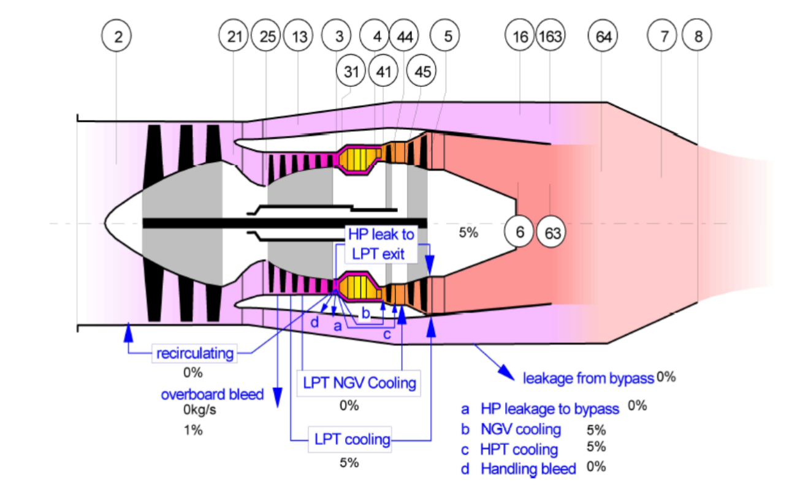
Fig. 1: Engine model according to GasTurb software and SAE numbering

Aircraft Performance Assumptions
Before conducting On-Design analysis, airframe performance assumptions seen in Table 3 were made:

Table 3: Assumed airframe values
K1 | K2 | C_{DO} | C_{CR}
0.18 | 0 | 0.014 | 0

Initially, based on the requirements stated in the RFP, the following constraint analysis diagram was created:

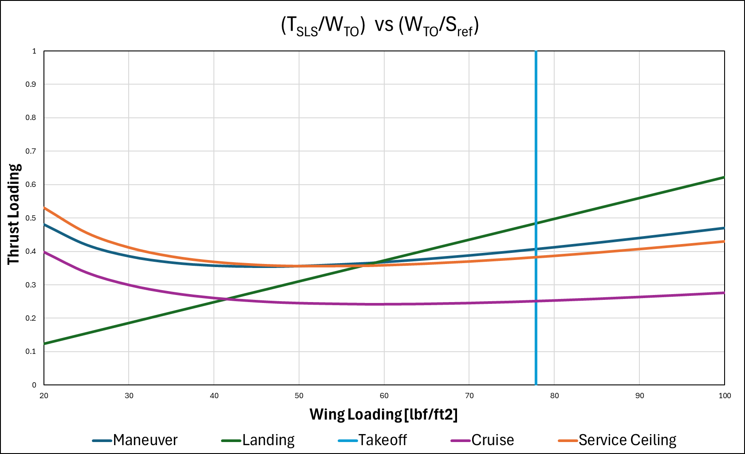
Fig. 2: Initial constraint analysis diagram based on the RFP requirements

From there, the numerous conditions on the graph were tightened to improve the engine, and the design point was moved to (57.7 lbf/ft², 0.36) for the wing loading and thrust loading respectively:

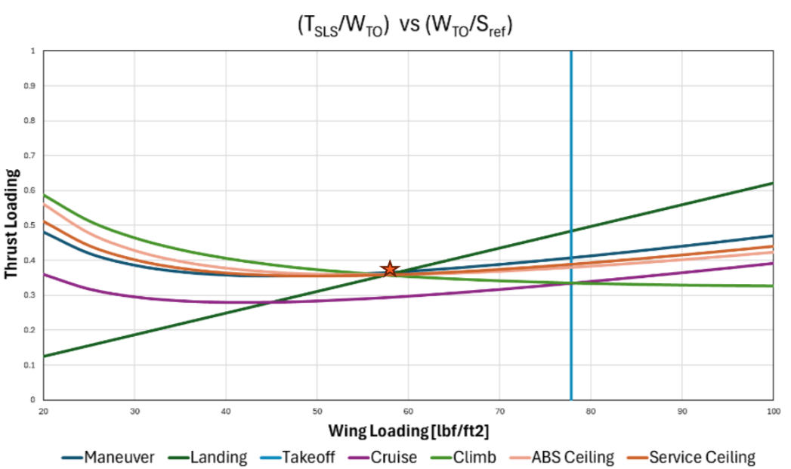
Fig. 3: Constraint analysis diagram of the engine

Note, the Cruise line is below the other parameters. This cruise design line represents the thrust loading at the end of cruise with a weight fraction of 0.85. This change in thrust loading from the design point is 0.066. In Fig. 4, the cruise line was replotted for initial conditions with a weight fraction of 0.95.

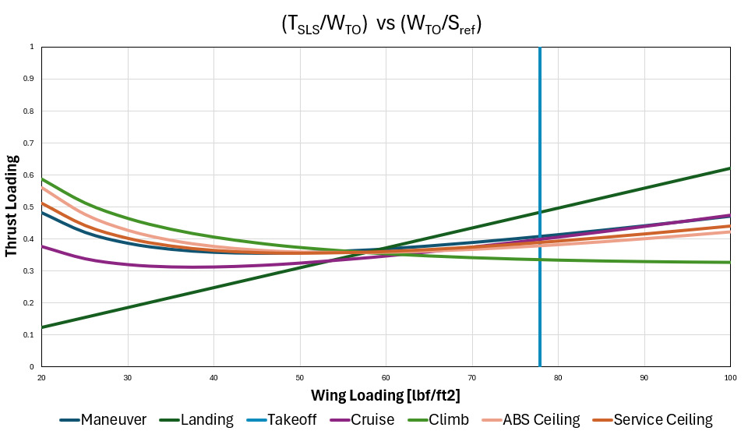
Fig. 4: Constrain analysis with cruise at starting weight fraction of 0.95.

Aircraft TOGW Across the Mission
From there, a mission analysis was done to see the TSFC and aircraft weight as the mission progressed. This analysis can be seen in Table 4 below.

Table 4: Thrust parameters across the mission
CASE | [lbf/lbf] | Thrust Lapse Rate (α) | TSFC [(lbm/hr)/lbf)] | [hr] | [lbm/lbf] | Weight Fraction (β)
 | (T_{SLS}/W_{TO})_{req} | T/T_{SLS} | W_{Fdot}/T | Time | W_{F}/W_{TO} | W/W_{TO}
Takeoff | 0.358 | 0.8325 | 0.6403 | 0.02 | 0.00382 | 0.9962
Climb 1 | 0.358 | 0.7283 | 0.7788 | 0.04 | 0.00812 | 0.9881
Climb 2 | 0.358 | 0.6189 | 0.7523 | 0.04 | 0.00667 | 0.9814
Climb 3 | 0.358 | 0.5210 | 0.7472 | 0.04 | 0.00557 | 0.9758
Climb 4 | 0.358 | 0.4199 | 0.7801 | 0.04 | 0.00469 | 0.9711
Climb 5/TOC | 0.358 | 0.3046 | 0.7996 | 0.04 | 0.00349 | 0.9676
Cruise | 0.294 | 0.3061 | 0.7420 | 1.50 | 0.10018 | 0.8675
Descent 5 | 0.159 | 0.3052 | 0.7734 | 0.08 | 0.00300 | 0.8645
Descent 4 | 0.127 | 0.4199 | 0.7880 | 0.08 | 0.00336 | 0.8611
Descent 3 | 0.121 | 0.5165 | 0.8241 | 0.08 | 0.00412 | 0.8570
Maneuver | 0.364 | 0.6519 | 0.7765 | 0.12 | 0.02211 | 0.8349
Cruise Reserve | 0.294 | 0.3061 | 0.7420 | 0.75 | 0.05009 | 0.7848
Descent 2 | 0.137 | 0.6119 | 0.8452 | 0.08 | 0.00567 | 0.7791
Descent 1 | 0.172 | 0.7210 | 0.8553 | 0.08 | 0.00849 | 0.7706
Traffic Pattern | 0.189 | 0.7210 | 0.8553 | 0.05 | 0.00583 | 0.7648
Landing | 0.150 | 0.8325 | 0.6403 | 0.02 | 0.00120 | 0.7636

This mission analysis resulted in a W_{TO} of 13342 lbm, and a plotted model of the aircraft weight across the mission time can be seen below:

Fig 5: Aircraft weight across the mission

Maximum Achievable Performance
As for the maximum achievable performance of the aircraft, below in Figure 6 are numerous operating envelopes for this engine across different weight fractions ranging from 0.65 to 1. As the weight fraction increases, the achievable Mach-altitude operating envelope contracts. This results in a reduction in maximum attainable altitude and sustained performance, especially at higher climb rates. When the weight fraction decreases, the operation envelope expands, which allows for higher attainable altitudes and an improved ability to climb at her rates.

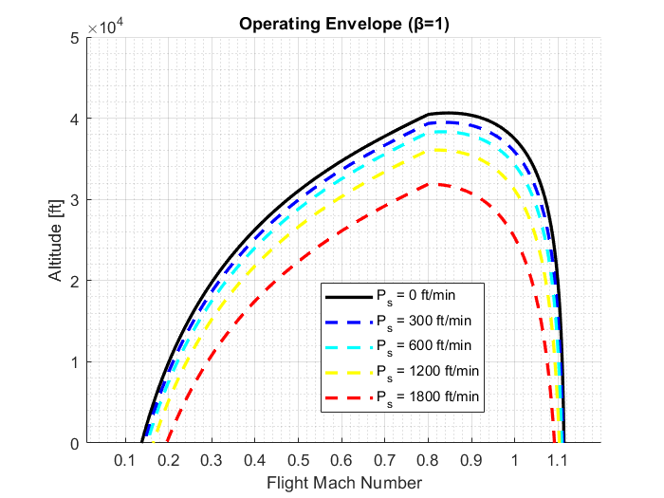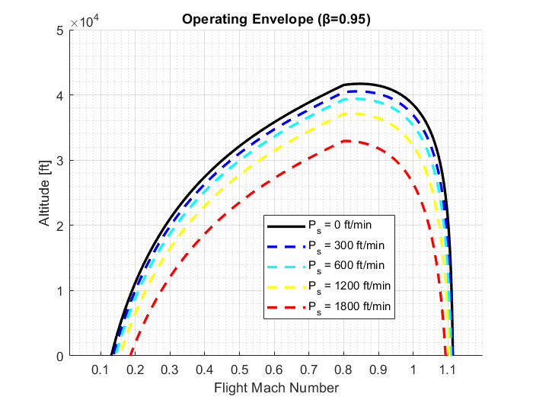
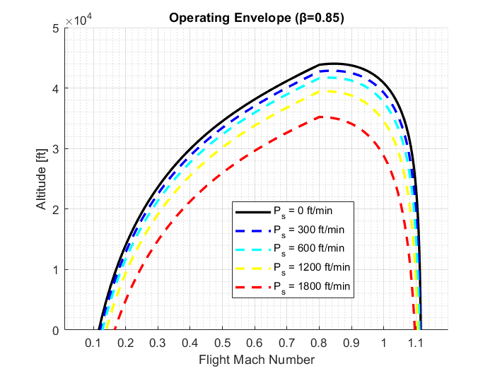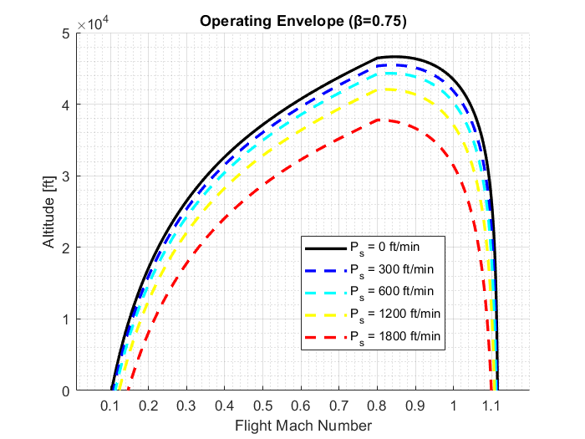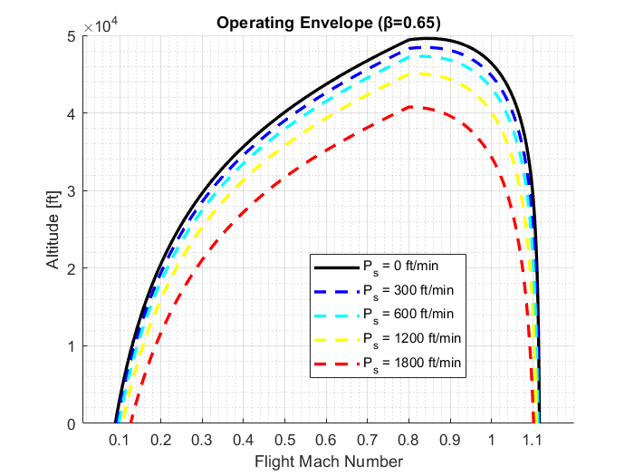
Fig 6: Operating envelope plots across different weight fractions

Below in Table 5, the maximum climb rate and maximum acceleration are listed for different points during climb:

Table 5: Max climb rate for different performance conditions
M=0.55, h=3500ft | Value
Max Climb Rate | 10100 ft/min (51.33 m/s)
Max Acceleration | 0.278g (2.722 m/s²)

M=0.55, h=10000ft | Value
Max Climb Rate | 7250 ft/min (36.83 m/s)
Max Acceleration | 0.204g (2.00 m/s²)

M=0.55, h=20000ft | Value
Max Climb Rate | 3700 ft/min (18.849 m/s)
Max Acceleration | 0.108g (1.063 m/s²)

M=0.6, h=30000ft | Value
Max Climb Rate | 1300 ft/min (6.591 m/s)
Max Acceleration | 0.036g (0.355 m/s²)

Engine Sizing
The sizing of the engine was determined by scaling the reference engines for mass flow. The reference engines were the GE F404 [1] and the Honeywell / ITEC F104 [3] engines. The diameters, lengths, and weights of these engines were averaged and scaled by the mass flow. The length and diameter used a liner scale, while the weight used a cubic scale.

Table 6: Estimated engine properties
Estimated Max Diameter | Estimated Length | Estimated Weight
30.38 in  (0.772 m) | 137.7 in  (3.498 m) | 1943 lbm  (881.4 kg)

Intake
The inlet of the engine is entirely subsonic, with high and low subsonic cones and a diffuser after the inlet throat until Station 2. Calculations were done using given information from class notes [7] to determine the engine intake diameters and areas for the design point of cruise. This involved the use of isentropic flow relations and engine cycle parameters at the design point. Mach numbers and flow areas at engine Stations 0, 1, and 2 were obtained from the GasTurb software to do the calculations.
Table 7 below details the values obtained from the calculations process detailed above:

Table 7: Intake values
Parameter | Value
A₁ Area | 418.5 in²  (0.27 m²)
A₂ Area | 573.5 in²  (0.37 m²)
A_{throat} Area | 263.5 in²  (0.17 m²)
A₁ Diameter | 22.96 in  (0.5823 m)
A₂ Diameter | 27.09 in  (0.6881 m)
A_{throat} Diameter | 18.44 in  (0.4684 m)
Intake Pressure Recovery | 91.04%

As was stated earlier in the report, the inlet face diameter (referred in Table 7 as A₂) is larger than what was required by the RFP. The inlet face diameter calculated for this engine at the cruise design point ended up being 27in which is greater than the maximum engine diameter of 25in from the RFP. This means a request needs to be made to the company to allow for a larger engine diameter to reach the rest of the requirements.

Combustor
The combustor was calculated using course notes [8] and the following values were obtained:

Table 8: Combustor values at different points in off-design
Condition | Mach | Volume [m³] | Cross-Sectional Area [m²] | Length [m] | Comb. Efficiency | Comb. Loading | Equiv. Ratio
Cruise (DP) | 0.65 | 0.0022 | 0.1034 | 0.0209 | 99.69 | 9.142 | 1.075
Serv. Ceiling | 0.8 | 0.0022 | 0.1022 | 0.0220 | 99.68 | 6.402 | 1.262
Abs. Ceiling | 0.9 | 0.0023 | 0.1026 | 0.0224 | 99.68 | 5.498 | 1.331
Maneuv | 0.6 | 0.0024 | 0.1062 | 0.0223 | 99.69 | 2.600 | 1.128
Takeoff | 0.2 | 0.0024 | 0.1062 | 0.0222 | 99.69 | 2.610 | 1.108
SLS | 0 | 0.0024 | 0.1078 | 0.0219 | 99.69 | 3.179 | 1.024
Climb 1 | 0.55 | 0.0024 | 0.1068 | 0.0224 | 99.69 | 2.330 | 1.107
Climb 2 | 0.55 | 0.0023 | 0.1059 | 0.0221 | 99.69 | 2.978 | 1.115
Climb 3 | 0.55 | 0.0023 | 0.1046 | 0.0221 | 99.69 | 3.648 | 1.160
Climb 4 | 0.55 | 0.0023 | 0.1027 | 0.0222 | 99.69 | 4.177 | 1.277
Climb 5 | 0.55 | 0.0023 | 0.1018 | 0.0222 | 99.69 | 5.652 | 1.347
Descent 5 | 0.6 | 0.0020 | 0.1010 | 0.0196 | 99.83 | 21.05 | 1.008
Descent 4 | 0.6 | 0.0020 | 0.1043 | 0.0194 | 99.79 | 19.02 | 0.8740
Descent 3 | 0.6 | 0.0021 | 0.1071 | 0.0197 | 99.72 | 14.18 | 0.8157
Descent 2 | 0.6 | 0.0022 | 0.1088 | 0.0202 | 99.69 | 9.180 | 0.8101
Descent 1 | 0.6 | 0.0023 | 0.1096 | 0.0210 | 99.69 | 5.406 | 0.8523

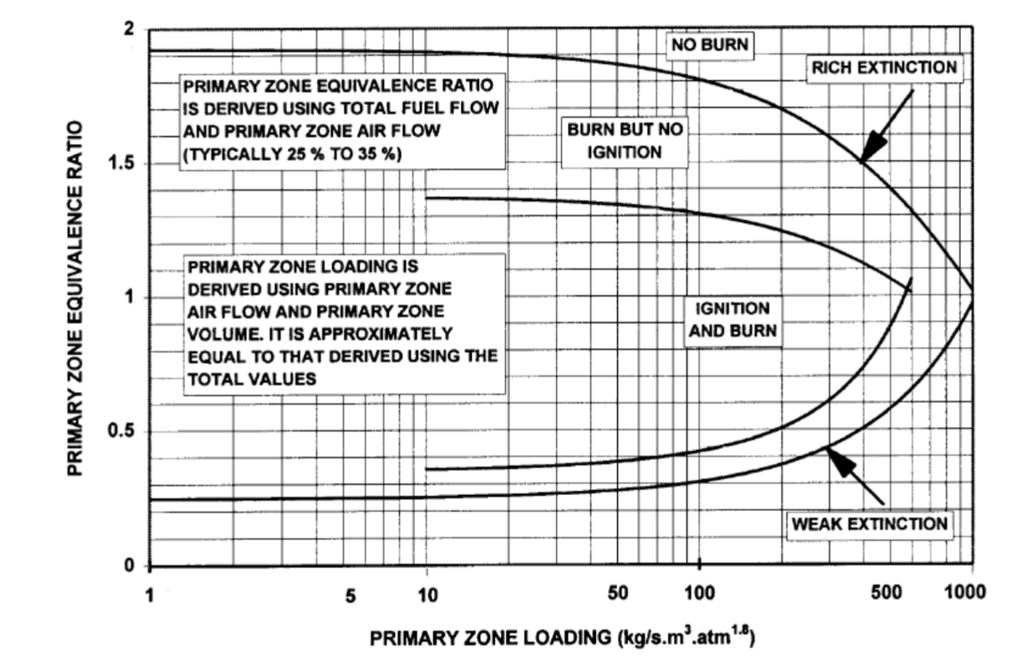
Fig. 7: Stability and ignition loops [Walsh & Fletcher] from [8]

According to Table 8 and Figure 7, the engine is only capable of relight during the first portion of the descent process. It is just barely not capable of relight at the design point of cruise, which would mean a lower altitude would likely be needed for relight. Since the engine can relight at Descent 5, 4, and 3 which have a Mach number of 0.6 and decreasing altitude, decreasing the altitude at cruise would create an ability to relight.
To fix the relight across the engine, the combustor volume should likely be increased via an increase in combustor length, which should not pose an issue as the engine is buried in the fuselage.

Thermodynamic Cycle
Cruise was chosen as the cycle design point to design a cycle with good TSFC at cruise. This made a strong foundation for off design for designing a cycle with low TSFC while meeting all the requirements. Off design analysis determined the cycle was viable for all mission points. The cycle was designed for a two-spool bypass turbofan engine with a mixer and no afterburner. The engine is designed to be embedded into the aircraft and will not be podded. This preliminary cycle was optimized in GasTurb and then parametric and sensitivity studies were conducted on the cycle to determine the effect of the FPR, HPR, TET, and BPR. This data was then used to optimize the cycle for TSFC along with GasTurb cycle optimization tools. This study allowed us to verify that the cycle parameters GasTurb iterated on were best optimized for TSFC.

Design Point Parametric Studies
Within GasTurb, various parametric studies were done for the chosen design point of cruise. The black dot on the figures below show the chosen design point.

Fig. 8: Parametric curve for FPR and TET

Fig. 9: Curve for specific fuel consumption VS bypass ratio

Sensitivity Studies
As for the sensitivity studies, they were done by picking different parameters of the engine and varying them to see what effect it would have on the TSFC and specific thrust of the engine. In Table 9, there are sensitivity studies for the bleed amounts, bleed locations, and component efficiencies. Along with that, there were sensitivity studies done on the TET, both the inner and outer FPR, the HPC pressure ratio, and the design BPR.

Table 9: Sensitivity studies for different parameters
Study | Base | Delta | SFC (%) | Sp. Thrust (%)
Burner Exit Temperature (K) | 1607 | 10 | 0.43 | 0.81
Inner Fan Pressure Ratio | 2.8 | 0.1 | -0.45 | -0.25
Outer Fan Pressure Ratio | 2.8 | 0.1 | -0.42 | 0.42
HP Compressor Pressure Ratio | 10.51 | 0.1 | -0.12 | -0.08
Design Bypass Ratio | 1.42 | 0.2 | -2.67 | -5.1
Rel. Overboard Bleed W_Bld/W25 | 0.01 | 0.01 | 0.53 | -1.79
HPT NGV 1 Cooling Air / W25 | 0.05 | 0.01 | -0.42 | -0.85
HPT Rotor 1 Cooling Air / W25 | 0.05 | 0.01 | -0.27 | -0.99
LPT Rotor 1 Cooling Air / W25 | 0.05 | 0.01 | -0.28 | -0.99
Rel. HP Leakage to LPT exit | 0.05 | 0.01 | -0.16 | -1.11
Polytr. Inner LPC Efficiency | 0.92 | -0.01 | 0.06 | -0.28
Polytr. Outer LPC Efficiency | 0.92 | -0.01 | 0.1 | -0.1
Polytr. HPC Efficiency | 0.88 | -0.01 | 0.15 | -0.72
Polytr. HPT Efficiency | 0.9 | -0.01 | 0.26 | -0.25
Polytr. LPT Efficiency | 0.91 | -0.01 | 0.17 | -0.17
Polytr. Inner LPC Efficiency | 0.92 | 0.01 | -0.05 | 0.27
Polytr. Outer LPC Efficiency | 0.92 | 0.01 | -0.1 | 0.1
Polytr. HPC Efficiency | 0.88 | 0.01 | -0.13 | 0.68
Polytr. HPT Efficiency | 0.9 | 0.01 | -0.24 | 0.24
Polytr. LPT Efficiency | 0.91 | 0.01 | -0.16 | 0.16
Burner Design Efficiency | 0.99 | -0.01 | 0.95 | 0.06

Final Cycle Performance and Parameters
After the sensitivity studies were conducted, the parameters below were chosen based on those studies along with determining which values would be best to reach the minimum required thrust to complete the mission. All these parameters were based on the chosen design point of cruise and can be found in Table 10 below.

Table 10: Final selected and performance parameters at cruise
Case | Cruise Parameters
TET [K] | 1504
OPR | 27.06
FPR | 2.69
BPR | 1.48
Fnet [kN] | 5.61
Fnet [lbf] | 1262
Sp. Thrust [m/s] | 393.2
Sp. Thrust [ft/min] | 77393
TSFC [g/kNs] | 21.02
TSFC [(lbm/hr)/lbf] | 0.7420

Additionally, the h-s diagram for the engine can be seen below. The difference in enthalpy between Station 4 and Station 41 is because the cooling flows are introduced between those stations, which sees a temperature decrease.

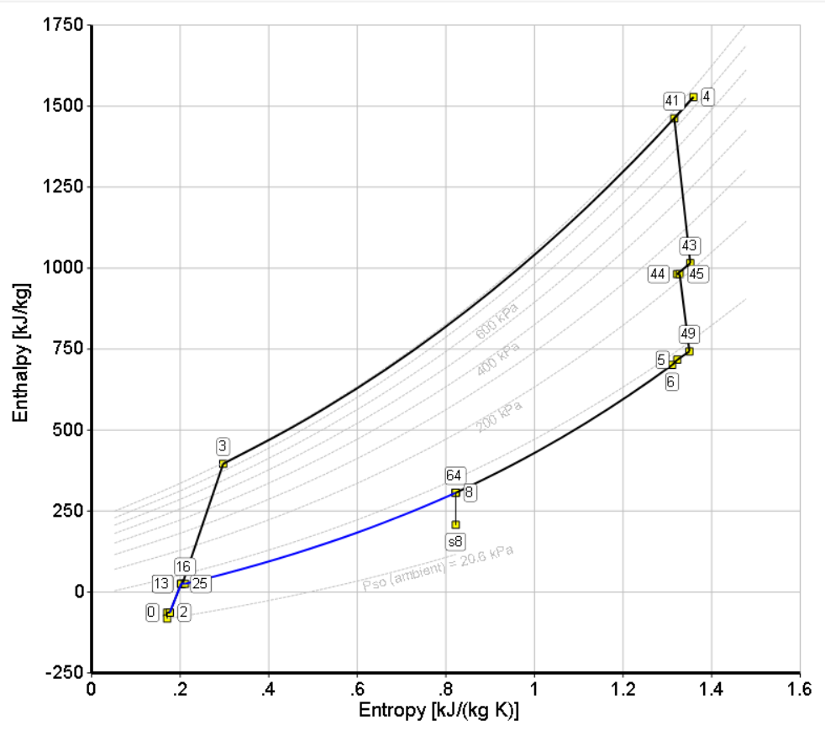
Fig. 10: The h-s diagram for the engine

As for the efficiency and bleed assumptions, along with any other loss assumptions, they can be found below. The assumptions were made based on class notes [4] and were used throughout the entire design process.

Table 11: Component efficiency assumptions
Parameter | Value
LPC (Fan) | 0.92 (Polytropic)
HPC | 0.88 (Polytropic)
Burner | 0.9995
HPT | 0.90 (Polytropic)
LPT | 0.91 (Polytropic)
Mixer | 0.5 (Isentropic)
HP/LP Spool Mechanical | 0.99

Table 12: Bleed assumptions
Parameter | Value
Overboard (Customer) Bleed | 1%
LPT Cooling | 5%
HP Leak to LPT Exit (Packing) | 5%
NGV Cooling | 5%
HPT Cooling | 5%
Total | 21%

Table 13: Additional loss assumptions
Parameter | Values [%]
$ω_{2.6}$(Swan neck loss coefficient) | 2
${\left(\frac{dP_{t}}{P_{t}}\right)}_{comb}$(Combustor total pressure loss) | 2

The total pressure and temperature across the stations are plotted below in Figure 11 and Figure 12 respectively.
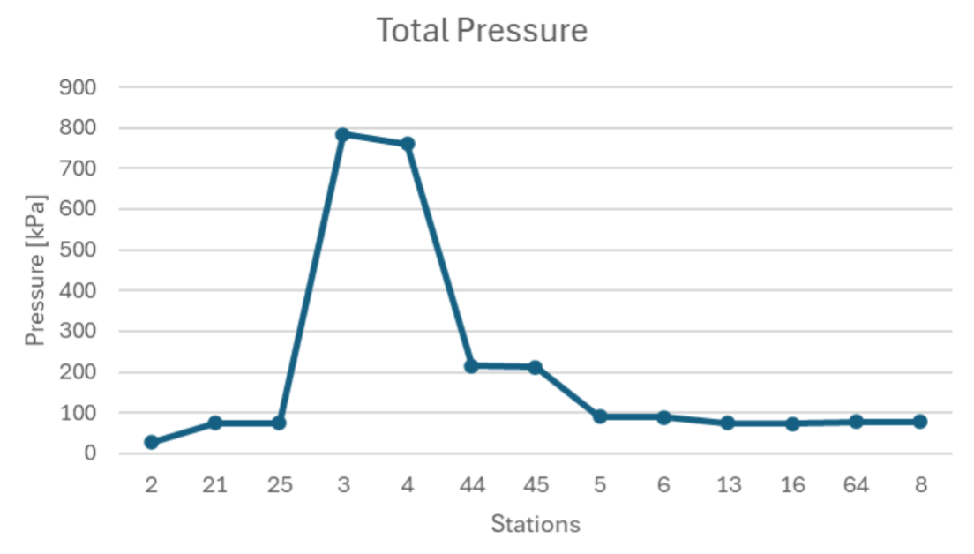
Fig. 11: Total pressure across each of the stations

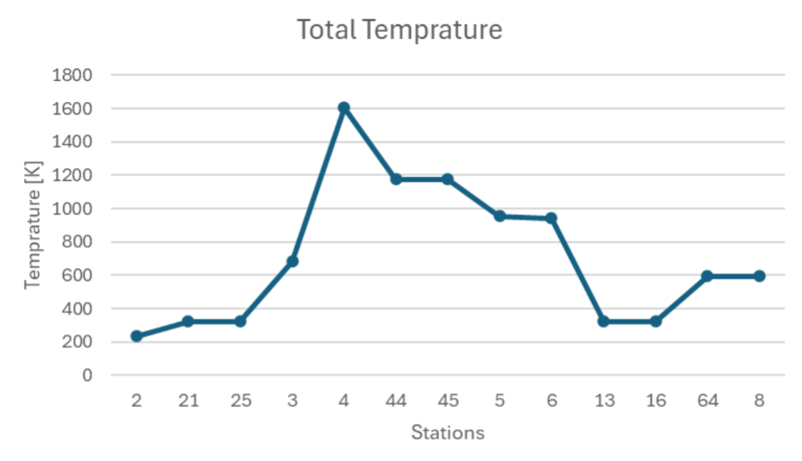
Fig. 12: Total temperature across each of the stations

Additionally, below are tables with the thermodynamic properties, static quantity assumptions, and turbomachinery performance. The former two tables have values for the important stations which were either inlets or stations where static quantities (mostly Mach) were assumed to carry out design point analysis.

Table 14: Thermodynamic properties at major component inlet stations
Parameter | 2 | 25 | 3 | 41 | 45 | 13 | 64
 | Fan Inlet | HPC Inlet | Burner Inlet | HPT Inlet | LPT Inlet | Bypass Inlet | Mixer
Total Temperature (K) | 234.9 | 316.9 | 660.8 | 1504 | 1132 | 316.9 | 564.4
Total Enthalpy (J/kg) | 0 | 82307 | 436764 | 1517227 | 991976 | 82307 | 342849
Mass Flow (kg/s) | 14.28 | 5.746 | 5.459 | 4.945 | 5.232 | 8.531 | 14.34
Corrected Mass Flow (kg/s) | 48.59 | 8.538 | 1.151 | 1.622 | 5.359 | 12.55 | 27.62
Note: Station 2 temperature used as reference point (234.9 K) for enthalpy.

Table 15: Stations with static quantity assumptions
Parameter | 1 | 2 | 21 / 13 | 3 | 4 | 5 | 16
 | Inlet Face | Fan Inlet | Fan Exit / Bypass Inlet | HPC Exit | Burner Exit | LPT Exit | Bypass Exit
Mach | 0.65 | 0.48 | 0.48 | 0.20 | 0.30 | 0.49 | 0.29
Area (m²) | 0.235 | 0.278 | 0.0481/  0.0810 | 0.0143 | 0.0136 | 0.0678 | 0.1138
Velocity (m/s) | 191.9 | 144.4 | 168.7 | 101.8 | 225.9 | 285.7 | 101.6
Static Pressure (kPa) | 20.65 | 22.65 | 61.53 | 707.84 | 665.9 | 72.46 | 66.07

Table 16: Turbomachinery Performance
Turbomachine | Corrected Mass Flow (kg/s) | PR / ER | Efficiency (Polytropic) | Power Production (kW)
LPC (Fan) | 48.6 | 2.69 | 0.9442 | -1175
HPC | 8.54 | 10.17 | 0.8826 | -1934
HPT | 1.62 | 3.53 | 0.8979 | 2127
LPT | 5.36 | 2.31 | 0.9112 | 1186
Note: 110 kW offtake from HPC and 0.99 mechanical efficiency.

Engine Design Table
Below are the cycle parameters for different points of interest across the mission. These cycle parameters can be seen for the engine, fan, HPC, HPT, and LPT.

Table 17: Engine cycle parameters
Case | SLS | RTO | TOC | CRZ
P_{amb} [kPa] | 101.3 | 90.81 | 18.75 | 20.65
T_{amb} [K] | 288.2 | 282.3 | 216.7 | 216.7
M₀ | 0 | 0.20 | 0.55 | 0.65
TET [K] | 1517 | 1597 | 1750 | 1504
OPR | 19.04 | 22.80 | 35.40 | 27.06
FPR | 2.10 | 2.37 | 3.14 | 2.69
BPR | 1.66 | 1.54 | 1.28 | 1.48
F_{net} [kN] | 18.37 | 18.59 | 6.60 | 5.61
F_{net} [lbf] | 4130 | 4178 | 1484 | 1262
Sp. Thrust [m/s] | 465.9 | 459.9 | 498.3 | 393.2
Sp. Thrust [ft/min] | 91711 | 90525 | 98081 | 77393
TSFC [g/kNs] | 15.79 | 18.14 | 22.65 | 21.02
TSFC [(lbm/hr)/lbf] | 0.5575 | 0.6403 | 0.7996 | 0.7420
FAR | 0.0206 | 0.0223 | 0.0271 | 0.0216

Table 18: Fan cycle parameters
Case | SLS | RTO | TOC | CRZ
Pt_{in} [kPa] | 99.30 | 91.51 | 22.58 | 26.88
Tt_{in} [K] | 288.15 | 284.47 | 229.79 | 235.00
W [kg/s] | 39.44 | 40.42 | 13.25 | 14.28
W_{corr} [kg/s] | 40.24 | 44.46 | 53.10 | 48.60
PR | 2.10 | 2.37 | 3.14 | 2.69
Power [kW] | 2893 | 3417 | 14670 | 1175
Eff [Poly] | 0.9407 | 0.9520 | 0.8329 | 0.9442
N_{mech} [%] | 89.10 | 95.88 | 113.84 | 95.46

Table 19: HPC cycle parameters
Case | SLS | RTO | TOC | CRZ
Pt_{in} [kPa] | 207.1 | 214.9 | 70.07 | 71.52
Tt_{in} [K] | 360.9 | 368.4 | 340.1 | 316.9
W [kg/s] | 14.83 | 15.93 | 5.81 | 5.75
W_{corr} [kg/s] | 8.12 | 8.49 | 9.14 | 8.54
PR | 9.13 | 9.71 | 11.41 | 10.17
Power [kW] | 5256 | 5981 | 2324 | 1935
Eff [Poly] | 0.8884 | 0.8880 | 0.8616 | 0.8826
N_{mech} [%] | 100.00 | 103.95 | 107.53 | 97.20

Table 20: HPT cycle parameters
Case | SLS | RTO | TOC | CRZ
Pt_{in} [kPa] | 1829 | 2019 | 776.2 | 705.6
Tt_{in} [K] | 1517 | 1597 | 1750 | 1504
W [kg/s] | 12.75 | 13.72 | 5.03 | 4.94
W_{corr} [kg/s] | 1.62 | 1.62 | 1.62 | 1.62
ER | 3.56 | 3.56 | 3.52 | 3.53
Power [kW] | 5589 | 6344 | 2533 | 2127
Eff [Poly] | 0.9012 | 0.9027 | 0.9010 | 0.8979
N_{mech} [%] | 100.0 | 103.9 | 107.5 | 97.20

Table 21: LPT cycle parameters
Case | SLS | RTO | TOC | CRZ
Pt_{in} [kPa] | 503.3 | 555.8 | 216.4 | 196.1
Tt_{in} [K] | 1141 | 1204 | 1328 | 1132
W [kg/s] | 13.49 | 14.51 | 5.32 | 5.23
W_{corr} [kg/s] | 5.41 | 5.41 | 5.35 | 5.36
ER | 2.18 | 2.24 | 2.41 | 2.31
Power [kW] | 2922 | 3451 | 1484 | 1187
Eff [Poly] | 0.9231 | 0.9308 | 0.9089 | 0.9112
N_{mech} [%] | 89.10 | 95.88 | 113.8 | 95.46

The below figures show the compressor and turbine maps of both the high and low pressure components.
Fig. 13: Low pressure compressor map
Fig. 14: High pressure compressor map
Fig. 15: High pressure turbine map
Fig. 16: Low pressure turbine map

References
[1] “General Electric F404,” Wikipedia, Wikimedia Foundation, 27 April. 2026, https://en.wikipedia.org/wiki/General_Electric_F404
[2] “NSPE Code of Ethics for Engineers,” National Society of Professional Engineers, https://www.nspe.org/career-growth/ethics/nspe-code-ethics-engineers.
[3] “F124 Turbofan Engine,” Honeywell Aerospace Technologies, aerospace.honeywell.com/ us/en/products-and-services/products/power-and-propulsion/engines/turbofan-engines/f124-turbofan-engine.
[4] Ferrer-Vidal, L., “On-design” Cycle Analysis of a Turbofan Engine,” AE435 Course Material.
[5] “Williams FJ44,” Wikipedia, Wikimedia Foundation, 3 Dec. 2025 en.wikipedia.org/wiki/ Williams_FJ44
[6] SAE International, “Aircraft Propulsion System Performance Station Designation and Nomenclature,” SAE Aerospace Recommended Practice ARP755D, SAE International, Warrendale, PA, Feb. 2014. https://doi.org/10.4271/ARP755D
[7] Ferrer-Vidal, L., “AE440 Inlets,” AE435 Course Material.
[8] Ferrer-Vidal, L., “Gas Turbine Combustors,” AE435 Course Material.
[9] Gas Turb, “Gas Turb 14 Manual,” https://www.gasturb.com/.
[10] Ferrer-Vidal, L., “Introduction to Regulations and Airworthiness for Jet Propulsion.” AE435 Course Material.
[11] “Code of Federal Regulations,” https://www.ecfr.gov/current/title-14/chapter-I/subchapter-C/part-23.
[12] European Union Aviation Safety Agency, “Certification Specifications,” https://www.easa.europa.eu/en/document-library/certification-specifications.
[13] Department of Defense Handbook, “MIL-HDBK-0500-0599,” EverySpec, https://everyspec.com/MIL-HDBK/MIL-HDBK-0500-0599/MIL-HDBK-516C_52120/?utm_source=chatgpt.com

Appendices

Appendix A: Preliminary Excel Cycle

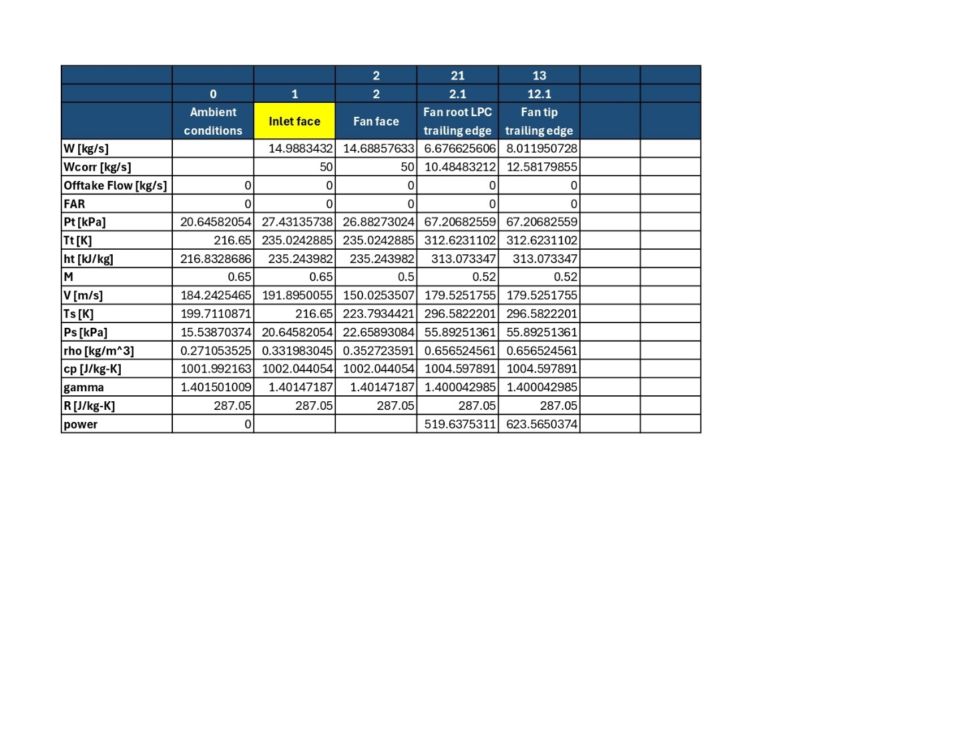
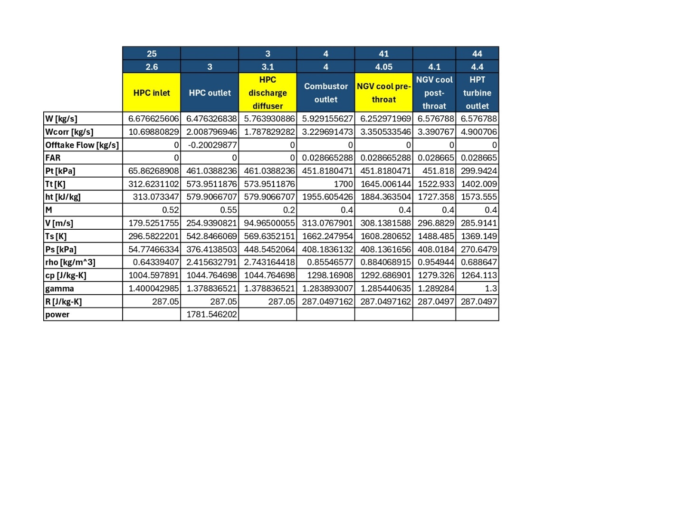
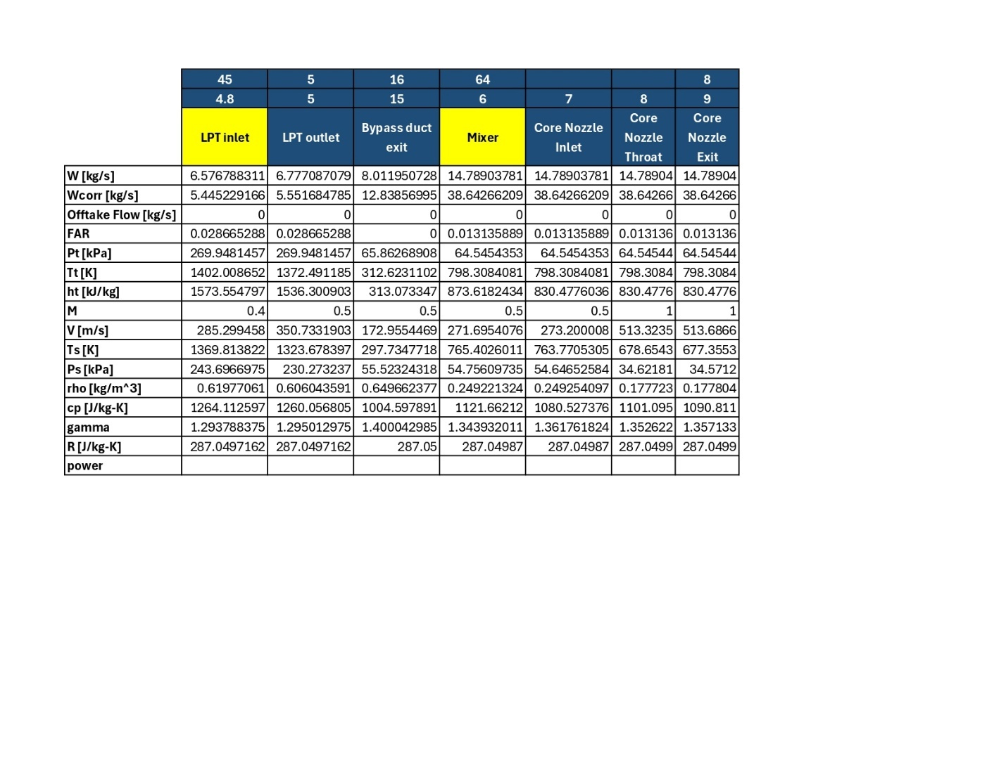

Appendix B: Preliminary GasTurb Cycle

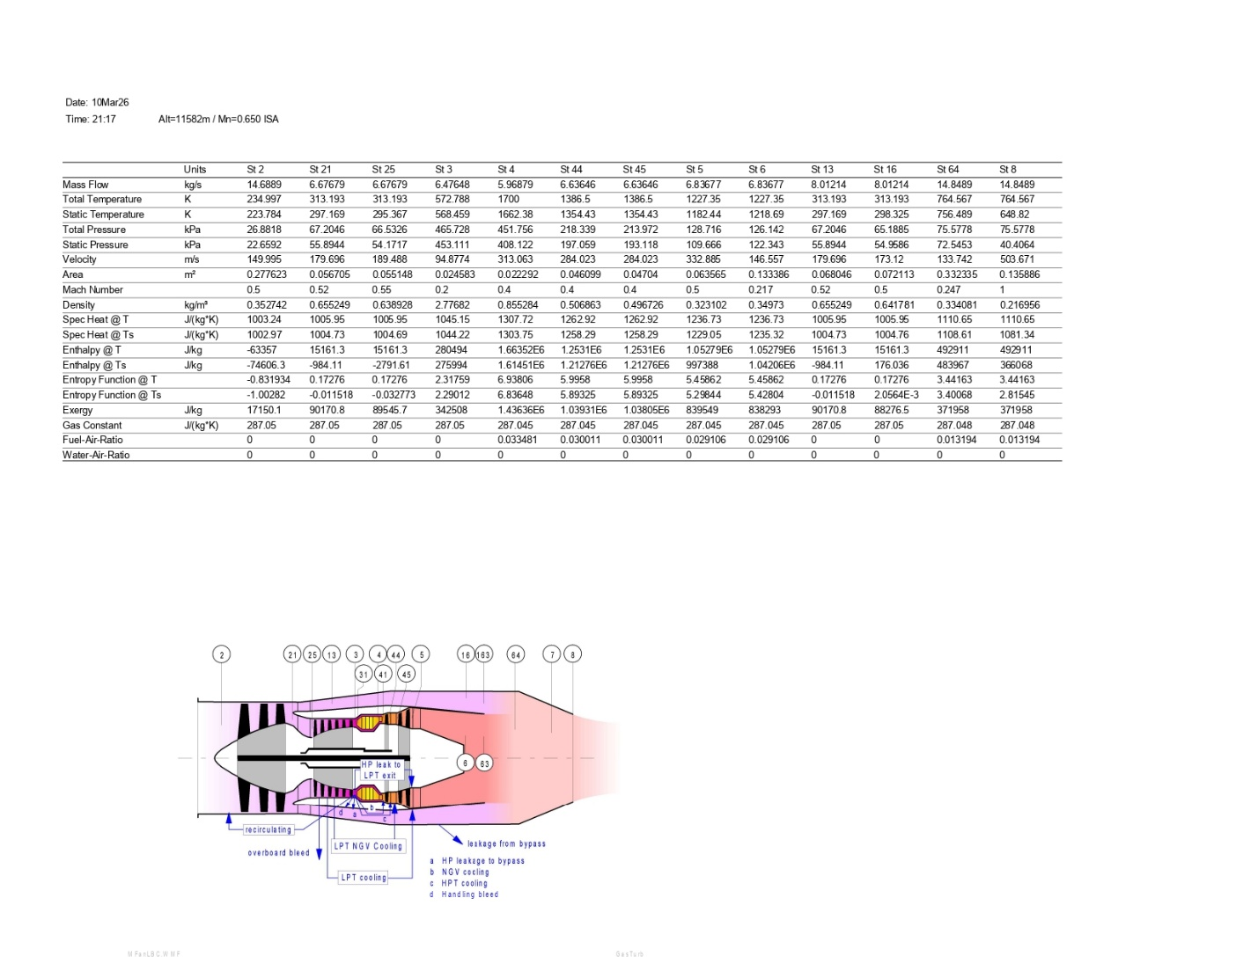
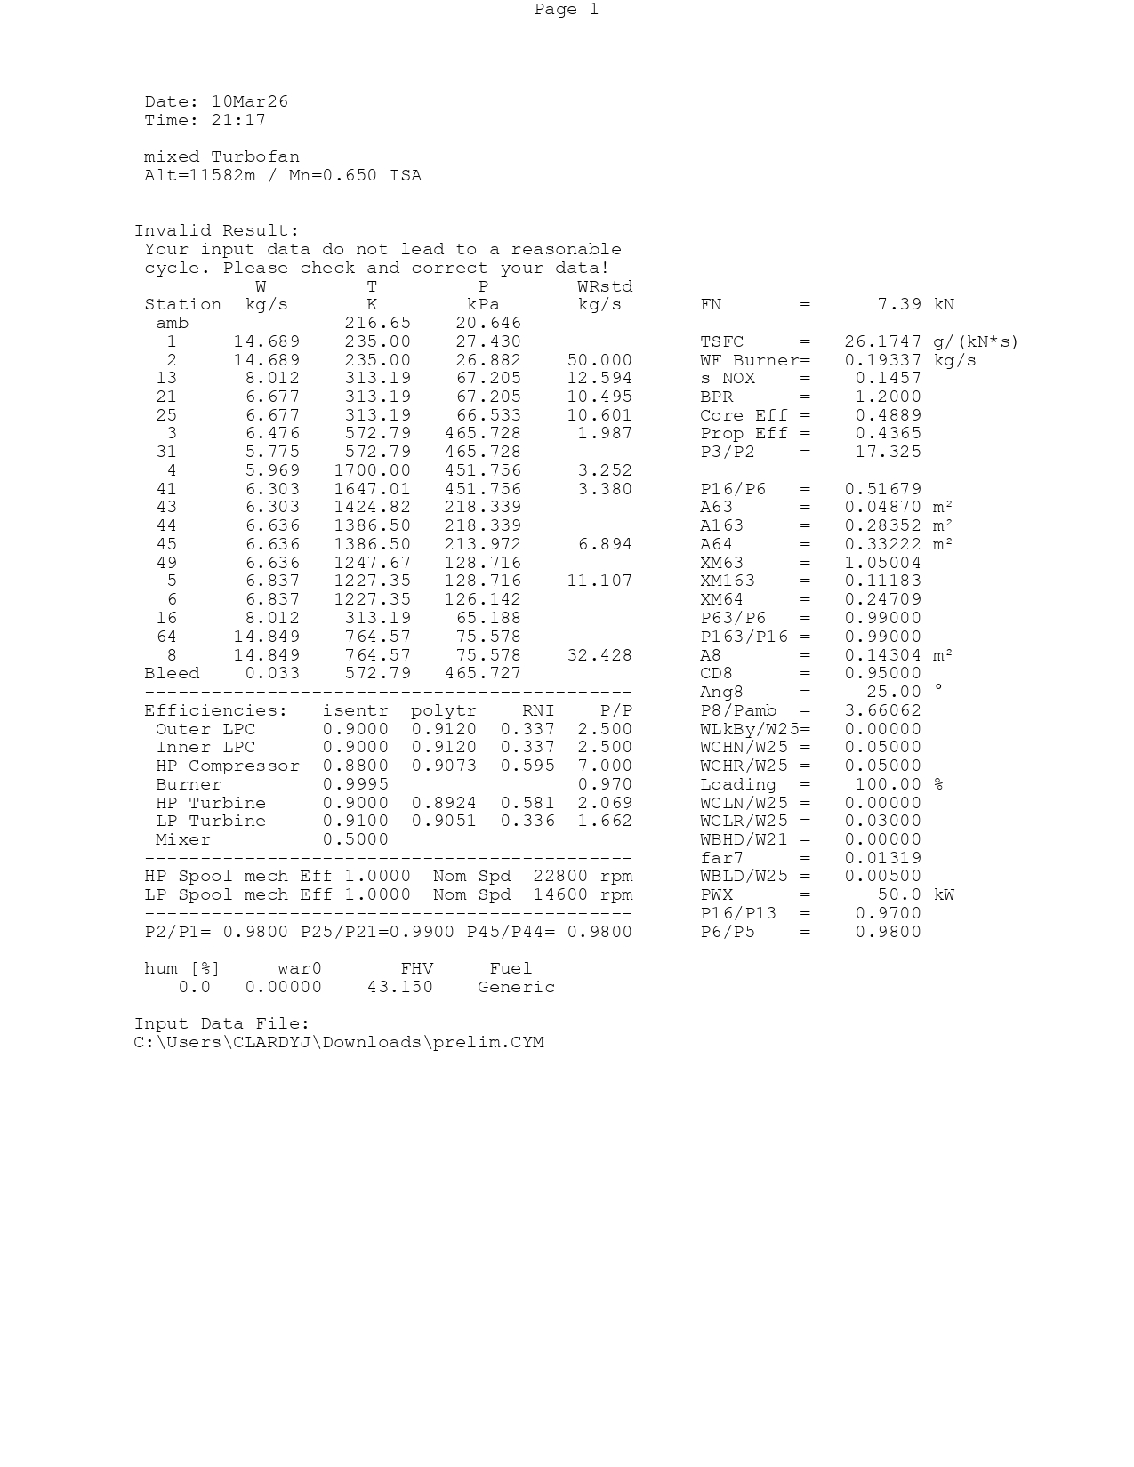
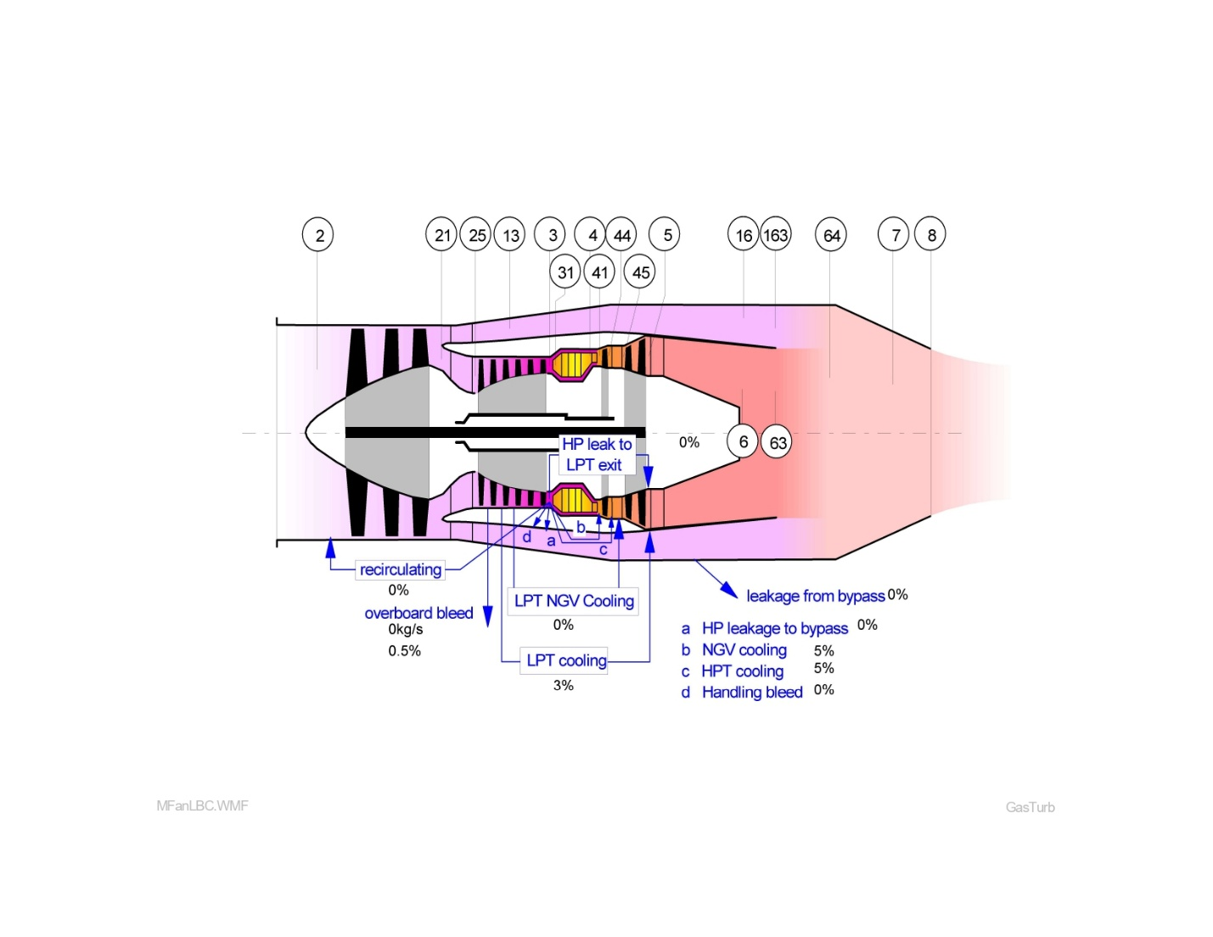

Appendix C: Optimized GasTurb Cycle
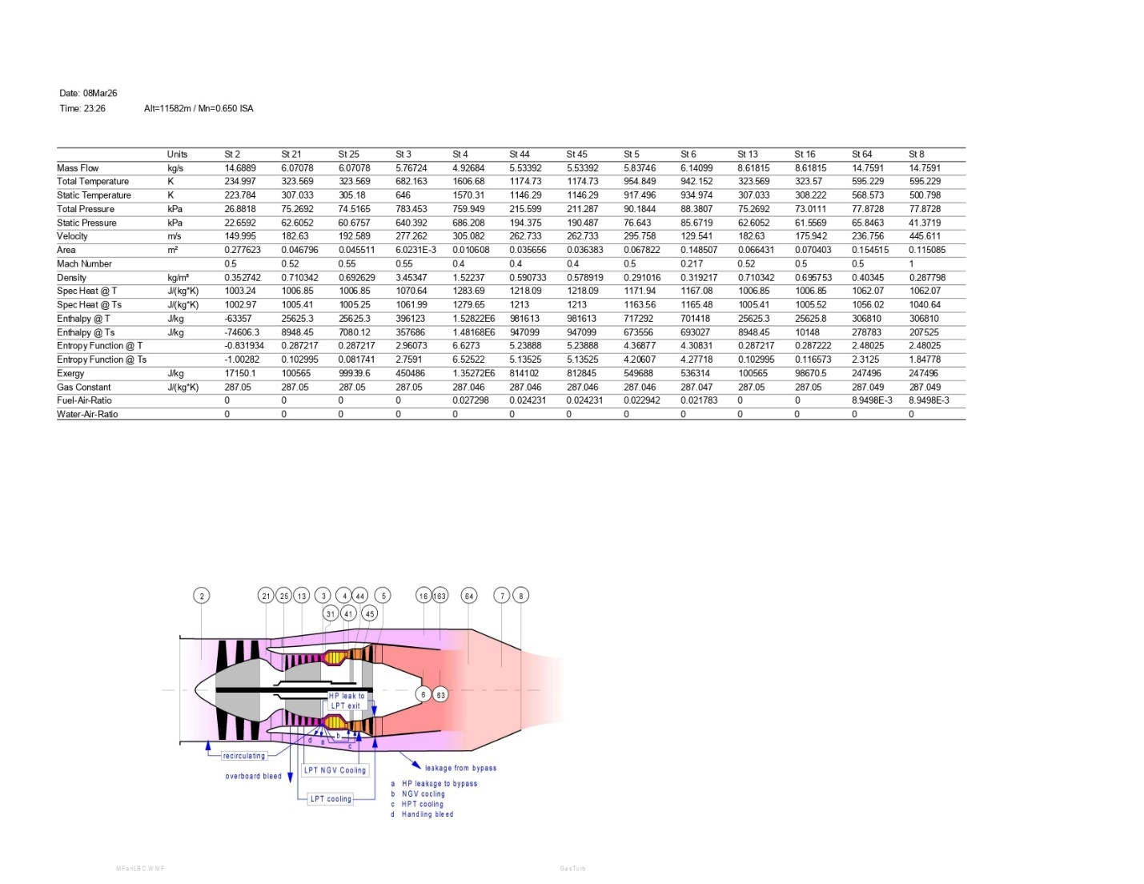
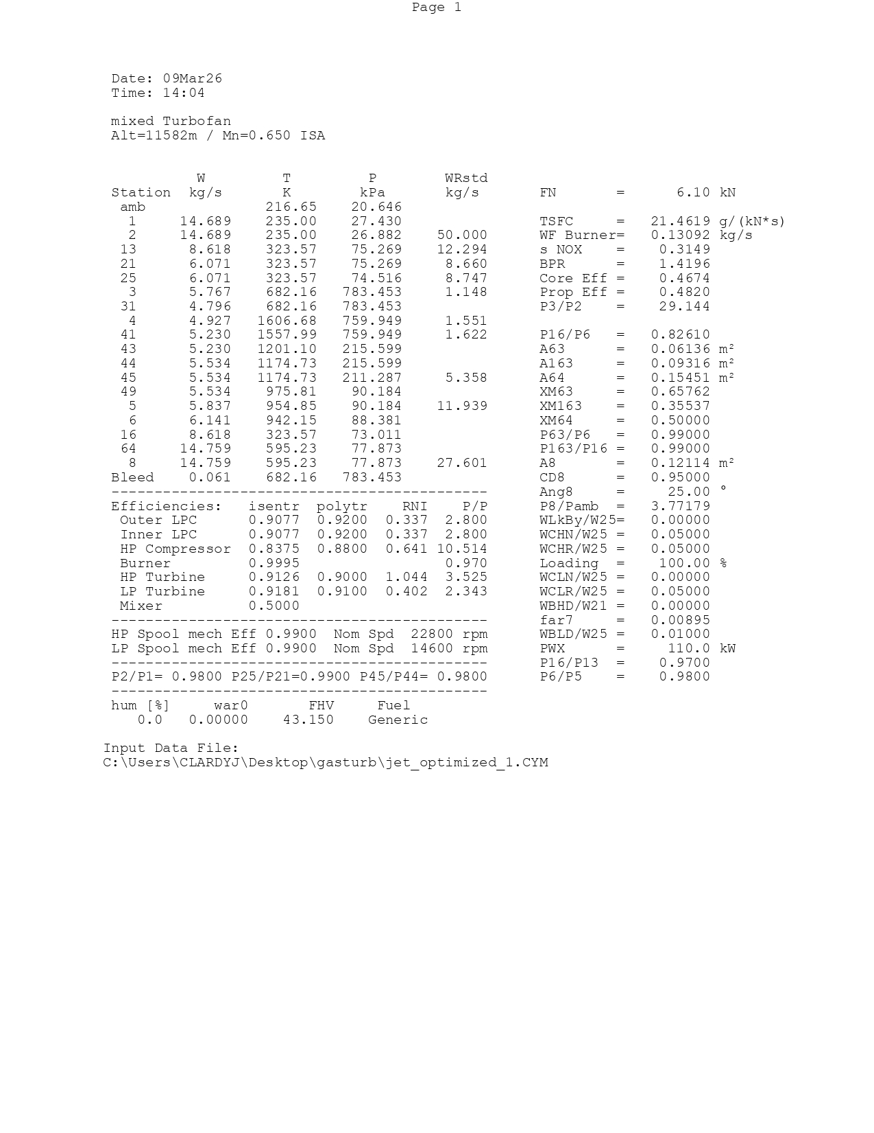
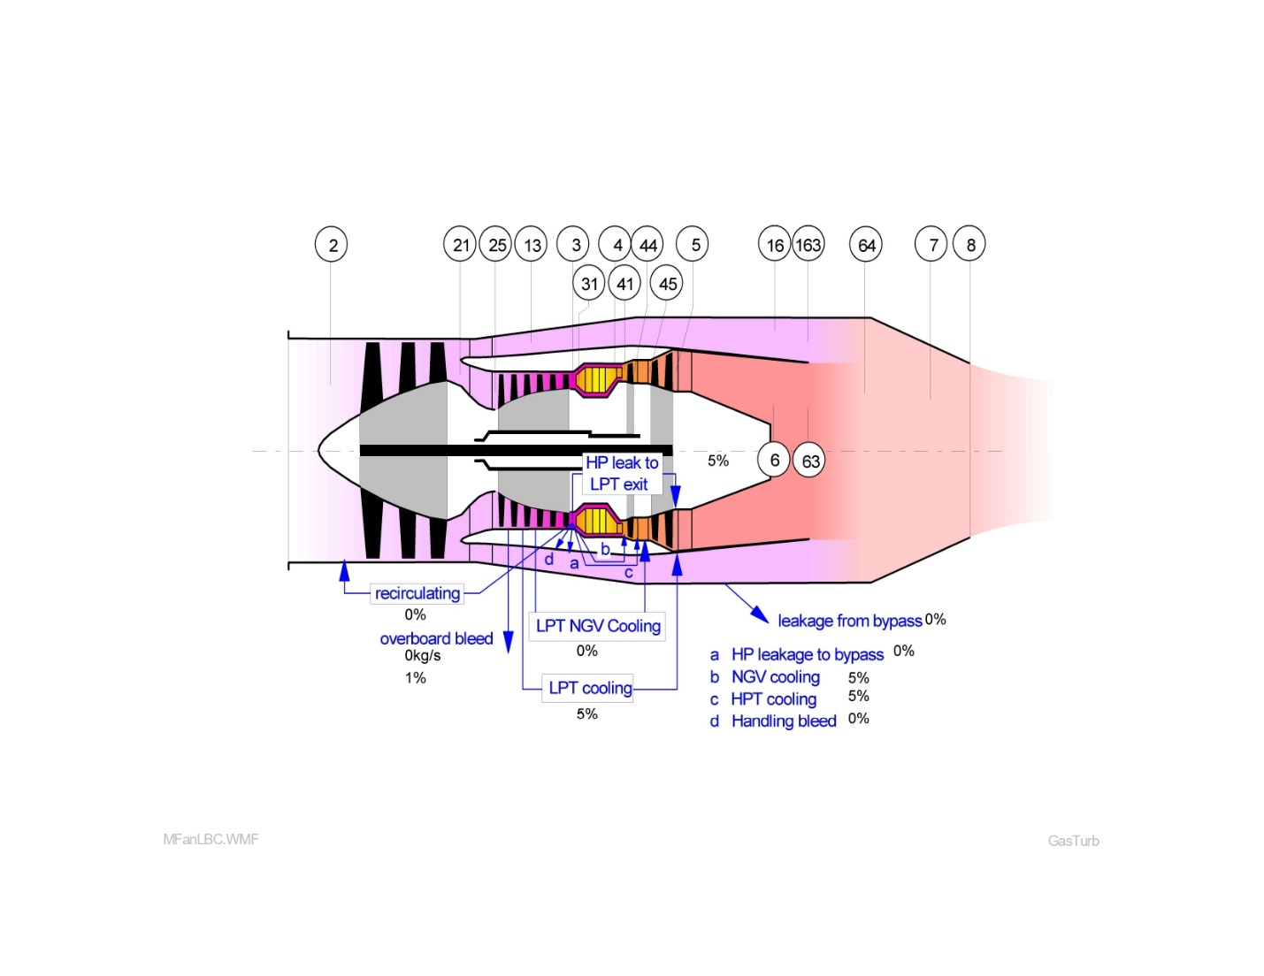

Appendix D: Final Off-Design GasTurb Cycle at Cruise

