CSI 350 Software Application Development II

Week 2 Group Project - Out-Of-Class Part

Due Date: Class Meeting Session of Week 4

Submission Type: zip file

Week 2 Group Project - Submission Specification

* Zip file name must be name with the syntax of: Week2GroupProjecttLastNamesOfTeamMembers.zip
* Zip file must contain:
  + - * + Readme.txt file that specifies
    - The content of the zip file
    - Team Members and who the PM is
    - List what work each Team Member worked on
  + This file itself, renamed as Week10GroupProjectOutOfClassPartLastNamesOfTeamMembers.docx
* Zip File must be submitted by the PM
  + Remember, each group is rotating the PM role by week

Deliverables and their Specifications

* Task 1 - Chapter 12 Screen-Snapshots
  + Do Freeman’s instructions in Chapter 12
  + Chapter 12 Screen-Snapshots required:
    - Figure 12-1, 12-5, 12-6, 12-7
    - Note, an Azure Account will need to be created as shown on Pg. 334 to deploy
  + If your team cannot replicate any Screen-Snapshot, show what any output your team did get and a short description of your team’s process in best trying to replicate the Screen-Snapshot
  + Each Figure’s Screen-Snapshots must list the Figure # from the textbook it represents
* Task 2 – Replicate his Chapter’s 12 Functionality to your team’s Web Application
  + Create your team’s Web Application Project by doing for it what he does in Chapter 9 for his Sporting Goods Application
    - The Administration Authentication/Authorization Process
    - Deployment:
      * Seeding the Database
      * Some use of the application, such as say adding an item
  + You will need a Screen-Snapshot showing each of the above functionalities, with a text description under each Screen-Snapshot
* Task 3
  + Please refer to the Output section

Output

* Task 1 Output
  + Insert space below for Screen-Snapshots from Chapter 12

12.1

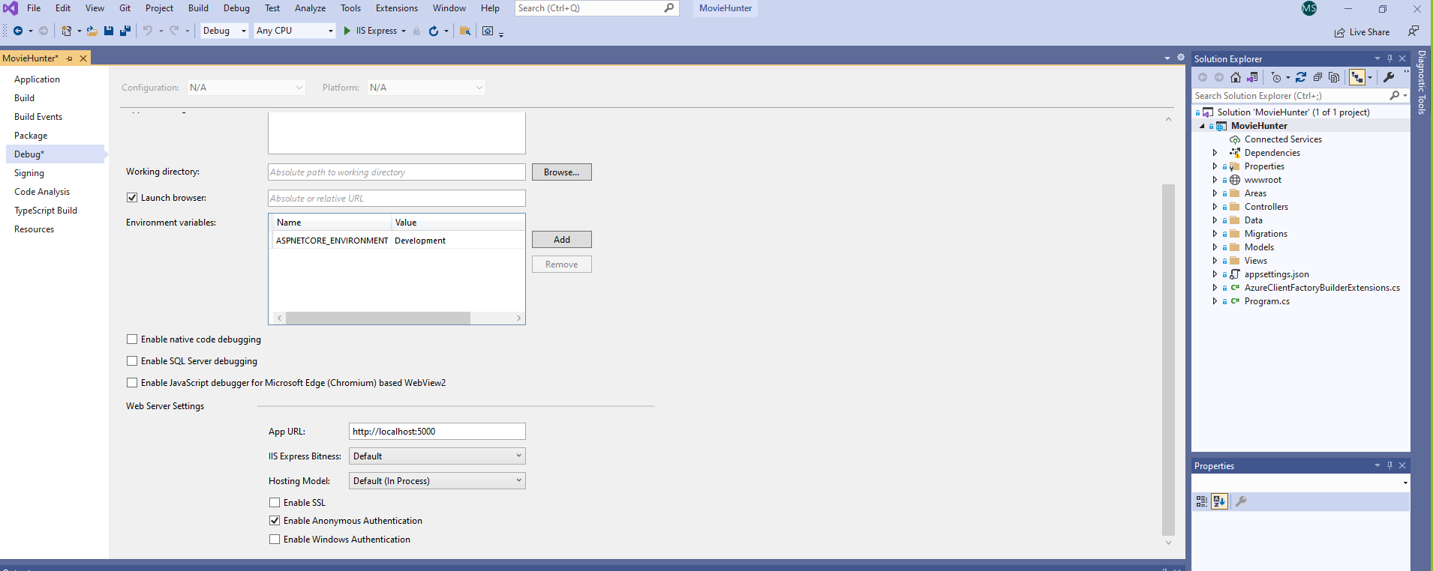

12.5

Our projects has default middleware created by the projects, we did not use any custom middleware.

*Photo from learn.microsoft.com

12.6

* Task 2 Output
  + Insert space below for Screen-Snapshots for your team’s application with regard to Chapter 12

* Task 3 Output
  + Address the below bullet-points
  + Make space in between the bullet-points to address the bullet-points
    - Address in a paragraph the concepts learned in the Chapter(s) covered for this Out-Of-Class Project
  + In this chapter we learned about the middleware (basically the middle part that join parts together, elements like UseAuthentication, UseMapRazorPages, UseRouting. You can also use custom middleware, but for now our team consider it is better to not create it, we will figure out later. Besides middleware, we learned about request pipeline, and we learn in-depth about Program and Startup classes (in our case only program because we use another .net version) .
    - What stumbling blocks were met/or areas that proved more challenging? How were they addressed? If there were no such blocks/challenges, then talk about why things went so smoothly.

There were some challenges, I knew what middleware is, but I did not understand how it is applied in .NET Core. After some readings I understood that it has to do with requests, basically is executed on every request to send a response.

* + - In terms of team dynamics, were there any lessons learned that might be relevant for the next week's deliverables?

No

Grading Rubric

|  |  |
| --- | --- |
| **Gradable Items** | **%** |
| * **Zip file/Word file named correctly** * **Zip File specifications correct** * **Readme.txt file specifications are met** * **PM is rotating** | 10% |
| * **Task 1**   + **All Figures shown in Screen-Snapshots**   + **Each Screen-Snapshot has its Figure written out in text below it**   + **Figures are listed in the correct place in the document** | 45% |
| * **Task 2**   + **All Figures shown in Screen-Snapshots**   + **Each Screen-Snapshot has its Figure written out in text below it**   + **Figures are listed in the correct place in the document** | 35% |
| * **Task 3**   + **All questions addressed?**   + **Were all questions addressed with a full paragraph? (i.e. no question is addressed with a few sentences)** | 15% |