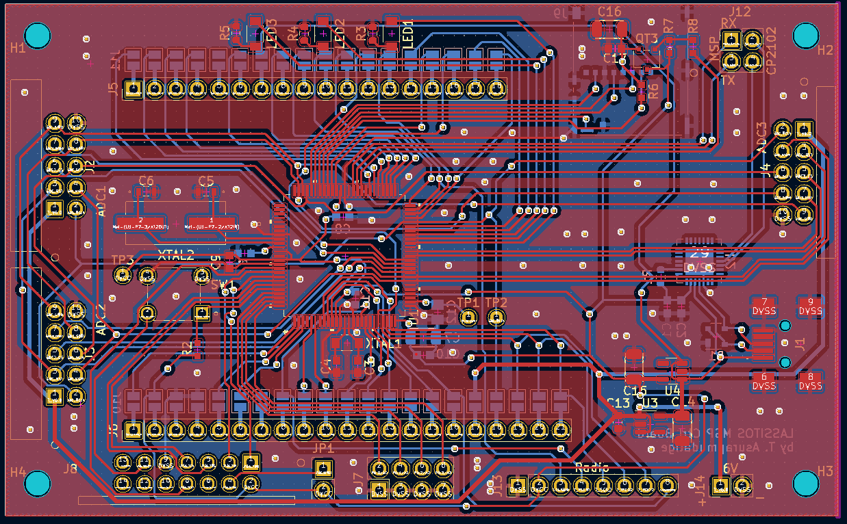

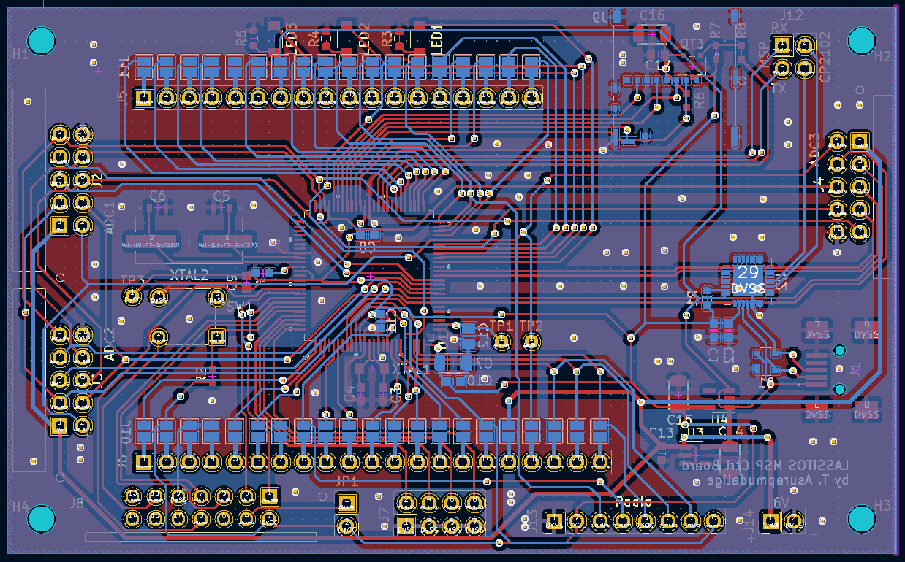

Figure : PCB of LASSITOS MSP Ctrl Board. Red is the top copper later and the blue is the bottom copper layer

Figure : Expected PCB Top view

Figure : Expected PCB bottom view